Intel® Teach Program

Designing Effective Projects

Monthly Weather Bar Graph
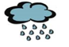




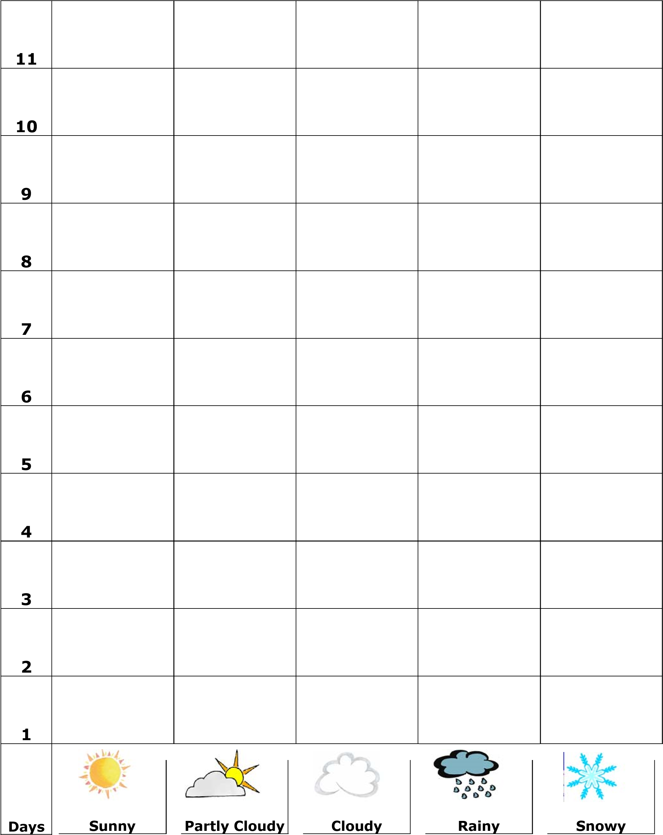
Copyright © 2010 Intel Corporation. All rights reserved. Adapted with permission. Intel, the Intel logo and the Intel Education Initiative are trademarks of Intel Corporation or its subsidiaries in the U.S. and other countries. *Other names and brands may be claimed as the property of others.

Intel® Teach Program

Designing Effective Projects

Copyright © 2010 Intel Corporation. All rights reserved. Adapted with permission. Intel, the Intel logo and the Intel Education Initiative are trademarks of Intel Corporation or its subsidiaries in the U.S. and other countries. *Other names and brands may be claimed as the property of others.

