DESIGN DECISION MATRIX
 | DESIGN #1 |  |  |  |  |  |  |  |  |  |  |  |  |  |  |  |  |  |  |  |  |  |  | DESIGN #4
 |  |  |  |  |  |  |  |  | DESIGN #2 |  |  |  |  |  |  | DESIGN #3
 |  | 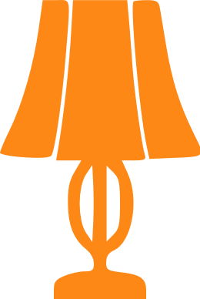 |  |  |  |  |  |  |  |  |  |  |  |  |  |  |  |  |  |  |  |  |  |  |  | 
 |  | SOLARIS NEX |  |  |  |  |  |  |  | VENUS X |  |  |  |  |  |  |  | NIGHT RAY |  |  |  |  |  |  |  | TREE-WAY
 |  | This lamp is typically slender and over 32 inches in height. They are often referred to as the taller version of the table lamp, and are designed to be featured on a buffet table to direct light downwards onto the table setting to illuminate the food, but they are also great for lighting up your entire house. |  |  |  |  |  |  |  | This type of lamp is great for a living room or a bedroom where some extra lighting is needed. The primary benefit of VENUS X is that the base creates a very sturdy and stable illumination as well as a unique design element in your home. These lamps are designed to cast light over an entire room. |  |  |  |  |  |  |  | Swing arm lamps can come equipped with an adjustable, functional arm. The main advantage of this style is that it can be very versatile, unlike other styles that are not adjustable. It allows you to target your lighting more than you would be able to with other types of lamps. |  |  |  |  |  |  |  | This is slender shape lamp, so it takes up very little space. Its shade is elevated high enough to be out of the way of your arms and food containers while eating. You can also use this lamp in your home office, where it won’t take up too much space on your already overcrowded office desk.
 |  |        |  | FEATURES | 5 |  |  |  |  |  |  | FEATURES | 4 |  |  |  |  |  |  | FEATURES | 3 |  |  |  |  |  |  | FEATURES | 2
 |  |  |  | AESTETHICS | 4 |  |  |  |  |  |  | AESTETHICS | 3 |  |  |  |  |  |  | AESTETHICS | 4 |  |  |  |  |  |  | AESTETHICS | 5
 |  |  |  | INTERACTION | 3 |  |  |  |  |  |  | INTERACTION | 4 |  |  |  |  |  |  | INTERACTION | 1 |  |  |  |  |  |  | INTERACTION | 4
 |  |  |  | NOVELTY | 2 |  |  |  |  |  |  | NOVELTY | 2 |  |  |  |  |  |  | NOVELTY | 3 |  |  |  |  |  |  | NOVELTY | 5
 |  |  |  | 14 |  |  |  |  |  |  |  | 13 |  |  |  |  |  |  |  | 11 |  |  |  |  |  |  |  | 16
 |  |  |  |  | 14 |  |  |  |  |  |  |  | 13 |  |  |  |  |  |  |  | 11 |  |  |  |  |  |  |  | 16
 | Product designers work to optimize the user experience in the solutions they make for the clients. In order for them to be able to better differentiate between design options and prototypes, they can call for help the parameters whose assessment can lead them to the overall rating of their design and thus facilitate the decision which design has the upper hand compared to the alternatives.

