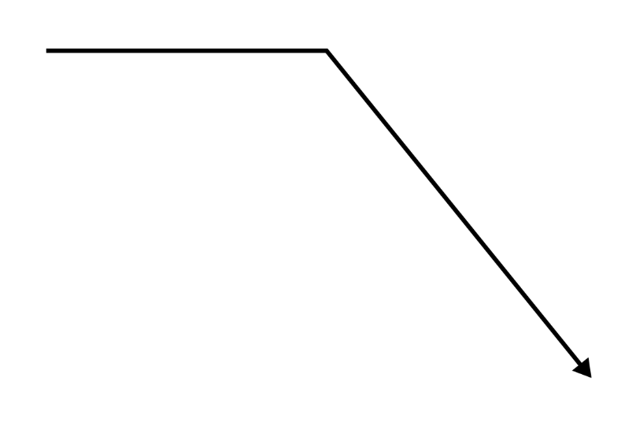

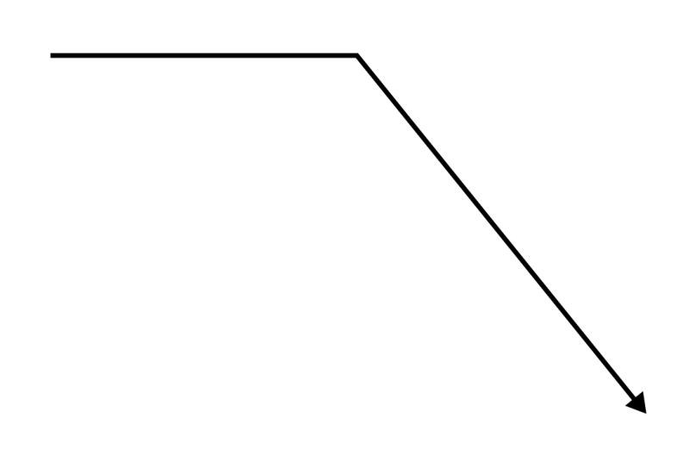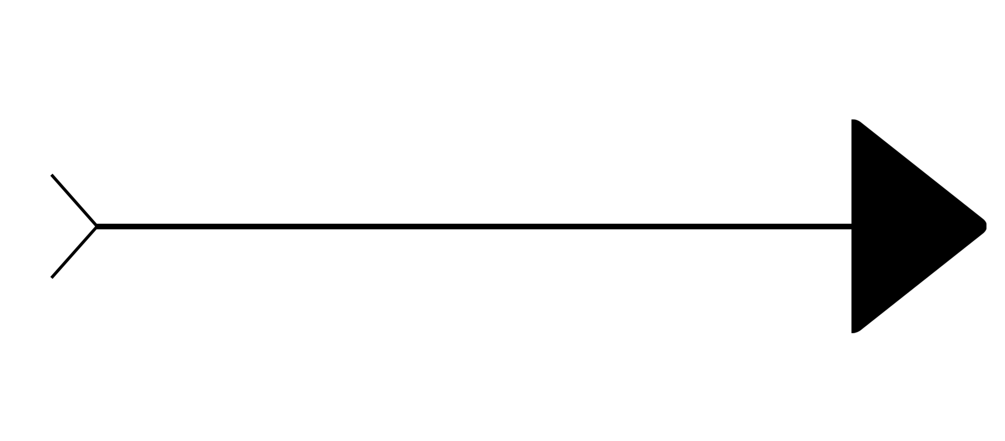
Insert
Text
here
Insert Text Here
Insert Text Here
Insert Text Here
Insert Text Here
Insert text here
Insert text here
Insert text here
Insert text here
Insert text here
Insert text here
Insert text here
Insert text here
FISHBONE DIAGRAM

