Sample Market Research & Analysis
Report

Market Research Report
For

Advanced Products, Inc

Hardwood Floor Manufacturers
In the United States

Prepared by

David Strader, Sr. Consultant

**** Special Notice****

This is a sample report is the data and analysis from an actual market research project conducted during the period listed above. Due to confidentiality, and the proprietary interests of the company for which the research was conducted this sample report has been modified and in some cases entire sections are heavily edited or not available. The target market and specific companies analyzed in this report have not been changed (the client’s name has been changed) so that we can best illustrate how we conduct market research to meet the specific requirements of our clients.

Case Study Background Information:

The EPA has just approved a newly formulated adhesive product manufactured by Advanced Products, Inc. (Fictitious Name). In addition to recent EPA and EU approval, this new formula’s characteristics include the ability to withstand prolonged exposure to moisture, temperature variation and very high foot traffic. Based on competitive research the new adhesive has characteristics¹ that are not available from current products on the market. The new formula is “Formaldehyde Free” and meets all current standards as well as all announced federal standards through 2016. Current pricing targets include a 25% margin and 12% - 15% price advantage over current market leader 3M. They now sell limited quantities of the new product line to current customers who also have wood and laminate floor manufacturing operations. Products made with this new formula may be exported to European Union Countries even after the new EU requirements become effective on January 1st of next year.

This new formula is a significant advancement developed using their experience and chemistry of the adhesives they now provide furniture, plywood and paneling manufactures (used in both residential and commercial construction.) They have 30 years experience in the Wood Industry with environmentally friendly lubricants and adhesives. API’s annual revenue last year was $10 Million with very steady growth over the last 5 years.

Currently there are only two other widely available products on the market that meet the new standard (3M and CP Adhesives). The market is dominated now by 3M with CP Adhesives filling the low cost alternative niche.

Production and delivery problems have plagued 3M. This is a relatively small market for 3M. Availability of this specific product is inconsistent especially when production schedules are tight at 3M. The primary disadvantage with 3M is product availability. The 3M product line has experienced a significant price increase and is now considered too expensive by the companies we interviewed. It does meet or exceed all regulatory requirements today (EPA & EU). It is unknown if the current formula meets future standards.

CPA’s primary market is in the wood working and consumer markets. They manufacture a product line that marginally maintains commercial wood floor manufacturing specs. CP offers a low cost product with no

1 Faster cure rate, no residual odors once fully cured, greater moisture resistance and the product meets both current and all announced future EPA standards.

other advantages over other formulas on the market. Their featured products are all in consumer size packaging, only three of their products are available in commercial size packages

Advanced Products, Inc. is well known in the wood products market place and has a strong presence in the hardwood, plywood and paneling manufacturing markets. It has maintained a highly visible market presence through trade advertising including publications, web portals and editorial contribution to trade associations. Due to poor attendance they do not currently attend trade association meetings as an exhibitor but do attend as associate members participating in the event. Trade shows have become a primary venue to wine and dine current clients and build rapport within the industry. They typically host elaborate dinner parties for their customers at trade shows. Pre 9/11 trade shows were a very important source of new accounts. To make up for the lost business opportunities they have increased both direct mail and e-commerce efforts.

API’s primary markets are small high end sawmills, veneer, and plywood manufacturers located both in the US and eastern Canada. They have no consumer products and package 75% of their adhesives and lubricants in tubes designed for automatic delivery and 1 gallon units primarily sold by the case. All but four of their adhesive formulas and all lubricants are available in 55 gallon drums. Only very large manufacturers can take advantage of the new adhesive product via bulk orders as once exposed to air the adhesives begins a chemical bonding reaction quickly. Once tapped a 55 gallon drum of adhesive must be used within 24 hours (12 hours w/o vacuum seals in place).

Current Sales force includes 6 captive sales representatives strategically located throughout the US and Canada. Reps are compensated through a base plus bonus formula. Compensation has been designed to allow reps to fully service existing accounts without fear of significant loss of income. They do not now sell through independent distributors or wholesalers but are open to that option with the new product line if it can open new markets (EU as an example).

Report Outline

- Review Objectives
  - Market Potential
  - Operational
  - Marketing
  - Sales Catalog

- Overview and Methodology of the research process

- Current Adhesive Customer Profile
  - Demographics
  - Concentrations
  - Average Annual Product Usage

- North American Market
  - Demographics
  - Trends
  - Current Market Conditions

- Identify the… Message - Challenge - Opportunities
  - The Markets Priorities and Concerns
    - Motivators and De-Motivators
    - Opportunities
    - API’s Advantages
  - Market Segment Challenges
    - Competitors
    - Alternatives
    - Technology

- Company Analysis (Confidential - NOT AVAILABLE )

- Market Risk vs. Reward Analysis

- Preliminary Recommendations (Confidential - NOT AVAILABLE )
  - Target Companies
  - Target Regions
  - Advertising Channels
  - Other Marketing Channels

4

Research Objectives

Primary:
- Determine the market potential and the concentration of the wood floor manufacturing market segment
- Find the best avenues for access to the wood floor manufacturing market segment for the newly EPA approved adhesive line.
- Evaluate Advanced Products, Inc (API) ability to meet the production, marketing and sales requirements to be successful in this market segment.
- Identify high potential prospects that current sales reps may call on while conducting sales calls on current markets.

Questions to be answered by the research.

Operational Questions
  - Will current production capacity of 4,000 units per month adequately satisfy potential US demand? Alternatives?
  - Are our current sales reps prepared for this market?
  - Will additional sales reps be necessary? Alternatives?
  - How does the market now buy adhesives?
    - Direct from the manufacturer
    - Captive Sales Reps
    - Telephone/Fax
    - Internet
    - Wholesalers and/or Independent Distributors

Marketing Questions
- What Associations and Trade Groups have influence in the market?
- Are there publications and / or web portals with high market segment readership?
- How do other products “go to market” within the segment?
- Level of market sophistication?
- Is there seasonality to the business as well as the buy/sell cycle?

The Prospect Catalog
- Identify and profile “A” prospects for the new line
- Provide a directory of all manufacturers with more than $1,000,000 in sales of wood products requiring adhesives in the manufacturing process

Methodology

This research was conducted over a 90 day period in the first quarter of 2XXX by our Research Team. The information is of a proprietary nature and upon final payment becomes the property of the research sponsors. The information contained in this report will not be made available to others without the express permission of the research sponsor. Sources of information include:

- Public information via Annual Reports to Shareholders as well as other Government Reports which are available for public review

- Company marketing information, advertising, company press releases, and state and local news sources

- Subscription based information (i.e. D&B, Business Credit Reports, Thomas, Info USA, etc.)

- On-Line research including third party references

- Trade Associations, Directories and Publications

- One on one telephone interviews with both current customers and prospects

- Various private industry sources

Every effort is made to provide accurate information. The information provided is “best available” on the day the data was gathered. Changes in personnel, company products and operations change daily. Previous projects indicate the most volatile information will be found with changes in personnel and company operations reported in the Prospect Directory.

The Strategic Marketing Group David Strader

(Modified for Confidentiality)

Current Customer Profile
API currently provides adhesives and environmentally safe lubrication products for the wood manufacturing industry. The primary product line for API has focused in the plywood, veneer and all wood paneling manufacturing markets. You currently have twelve current customers that are also manufacturers of wood flooring and use the new adhesive formula. Based on the research of the entire Wood Flooring Manufacturing sector current customers fall into a cross section of manufacturers with more than $1 Million in sales from the manufacture of solid, veneered and laminate flooring products.

Adhesive Usage Estimate: Rule of thumb adhesive usage is 100 units for every 1 Million board feet of flooring manufactured. (Hard Wood vs. Soft Wood and stabilizing sub stratus will also impact usage.)

Your Current Sales Profile: The adhesive has been sold as second sale through your sales reps while servicing existing accounts. Re-supply has primarily been accommodated through fax and phone calls to your service center. The typical order is two unbroken cartons (4 units per carton).
Shipments are fulfilled via UPS. Primary reason for trying… “Your other products work so well…” Reason for continuing to order “It works so well…”

Customers tell us that your new adhesive is an improvement over the other brands they have used and that they intend to continue to use the product until something better [Researchers Comment “Cheaper that works as well” ]

OBSERVATION: Based on telephone interviews 75% of current customers stated the primary considerations for ordering a one or two weeks supply 1) Shelf Life Concerns, 2) No Price Break for larger quantities. The average order is for 2 cartons. Average Monthly use is almost 4.5 cartons. Evaluate the benefits of a more aggressive pricing structure for larger orders. If you can move your customers to order one months supply instead of one or two weeks inventory it should reduce administration and handling cost by 50% or more.
This will be more critical as demand for your product grows.

[Statistical Report of customer interviews unavailable]

Customer Comments:
A telephone interview was conducted with your contact person at each company that now uses your new formula (For a sample of the interview guide see Appendix). A summary of the data we collected and few highlights of quotes from our interviews follow.

Plant Manager:

“The first time we used the adhesive the guys on the line thought it wasn’t any good because it did not smell like anything else we have ever used… the problem really was that it did not smell at all!”

“It works very well. We won’t ship anything that would give us a bad name so we made up a few boards and put it on the shop floor and worked it over pretty good. You name it we spilled it on the test floor… we even drove a truck or two over it multiple times to make sure. This new stuff holds up.”
Mill Owner:

“We ordered 1 gallon to test it out. The first time we used it we applied the adhesive by hand and ran the flooring through the cold press. Just to see how fast it would grab we started pulling it apart.., the adhesive held almost right away. After a couple minutes we could not pull apart the layers. We have to be more careful now when we set up machines because there are no “start over’s” if set up is bad, it sets to fast to salvage the wood and the cores.”

Production Floor Manager:

“The service is great. We knew it would be we have been using their other products for years and have been very satisfied. If we get into a bind and need more adhesive they can get it delivered by the next morning. Can’t beat the product or the service….”

Plant Manager:

“We have one problem with the new adhesive. You cannot forget to put the cap back on if you don’t use a full bottle. It only takes an hour and the top skims over and you cannot get anything usable after that. The fast set is great for production, but the operators have to be on the ball or we end up throwing away half a bottle with every startup.”

Production Manager:

“The biggest concern we have is shelf life. We had a problem right away with forgetting to cap the bottles and ended up throwing away a lot of spoiled product. Our machines take 1 and ½ gallons at start up and that will do an entire shift of normal production. That half gallon left behind gets thrown away a lot. I love the product, Steve and Ron on the floor love they don’t have to gag anymore from the smell. If I could make one suggestion could you put it in either ½ gallon or 1 ½ gallon jugs so we don’t have to remember to cap the adhesive before we finish set up?”

Current Customer Demographics
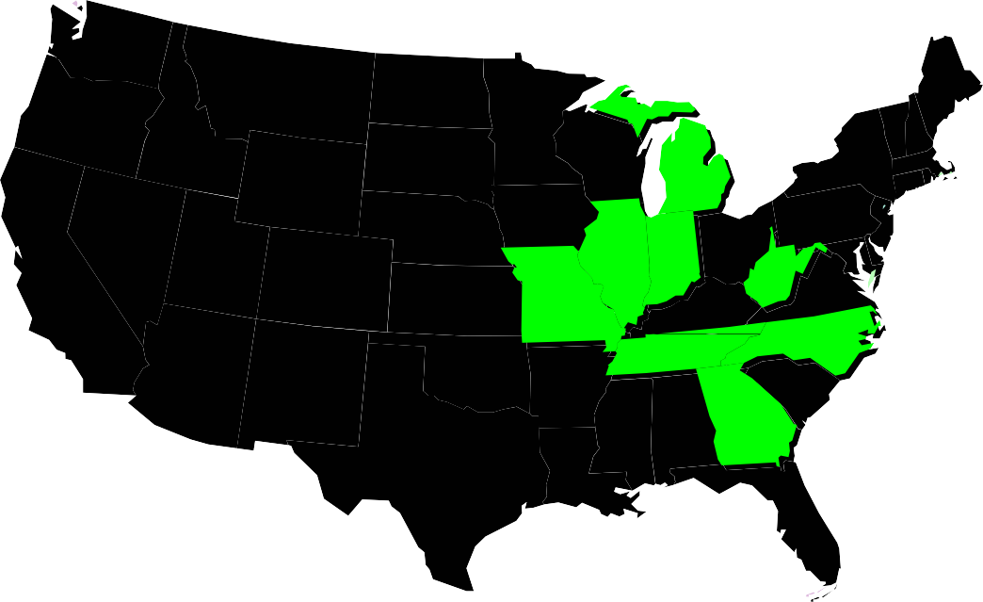
1
3
1
1
2
2
1
1
Typical Customer Profile (Excluding Appalachia and Duke Lumber)
Finished Product Sales: $ 2.5 Million Production: 4.5 Million Board Feet Employee Count: 14
Log to Finish: 72%

Geographic Location
Manufacturing Locations: Upper Midwest Sales Volume: Tennessee and West Virginia
Sales Coverage: Excellent Coverage through the Fort Wayne and Knoxville Offices

OBSERVATION: Current customers of the new adhesive can be easily serviced through your current sales reps. The members of your sale staff assigned to these accounts have longstanding relationships with both purchasing and production staff at each facility.
It is important to note that your customers consistently give very high marks to your sales team. 100% of respondents during our telephone interviews praised the personal service and quick response they now receive from your sales reps.

Typical API Customer Adhesive Use and Expenditure (Annual Estimate)
Adhesive Usage: 314 Units Adhesive Expenditures: $ 6,913

Sources of New Information (Listed by Importance)
  - Trade Associations
    - National Wood Flooring Manufacturers Association
    - National Oak Flooring Manufacturers Association
    - National Hardwood Lumber Association
    - Wood Products Manufacturing Association
  - Networking
  - Sales Reps/Vendors
  - Trade Publications (Limited Readership Reported)
    - Southern Lumberman
    - Wood Digest

Current Customer Usage and Market Comparison
(Annual Estimates)

Current Customers | Flooring Revenue (In Millions) | Board Feet (In Millions) | Estimated Adhesive  Usage (Units) | Estimated Adhesive Expense
Appalachian² | $ 50.20 | 88.0 | 8,794 | $193,468
Duke Lumber | $ 40.20 | 70.0 | 7,035 | $154,770
Quality Hardwood | $ 6.80 | 12.0 | 1,196 | $ 26,312
Brandon Co | $ 3.10 | 5.3 | 528 | $ 11,616
Mastercraft | $ 3.00 | 5.2 | 528 | $ 11,616
Cheat River | $ 1.70 | 2.9 | 296 | $ 6,512
Custom C&M | $ 1.60 | 2.8 | 281 | $ 6,182
Ecotek | $ 1.60 | 2.8 | 281 | $ 6,182
Kasper | $ 1.60 | 2.8 | 281 | $ 6,182
Unlimited | $ 1.60 | 2.8 | 281 | $ 6,182
Smooth | $ 1.20 | 2.1 | 211 | $ 4,642
Grizzly Ridge | $ 0.84 | 1.4 | 141 | $ 3,102
Totals | $113 | 198 | 19,853 | $436,766
Average (w/o top three) | $ 1.80 | 3.12 | 314.22 | $ 6,913
US Market Average | $ 2.10 | 3.1 | 312 | $ 6,864

2 Second largest manufacturer by sales in the US and API’s largest single customer for both lubricants and adhesives

North American Market

$25MM to $50MM | $5 MM - $ 9 MM | Less than $1 MM

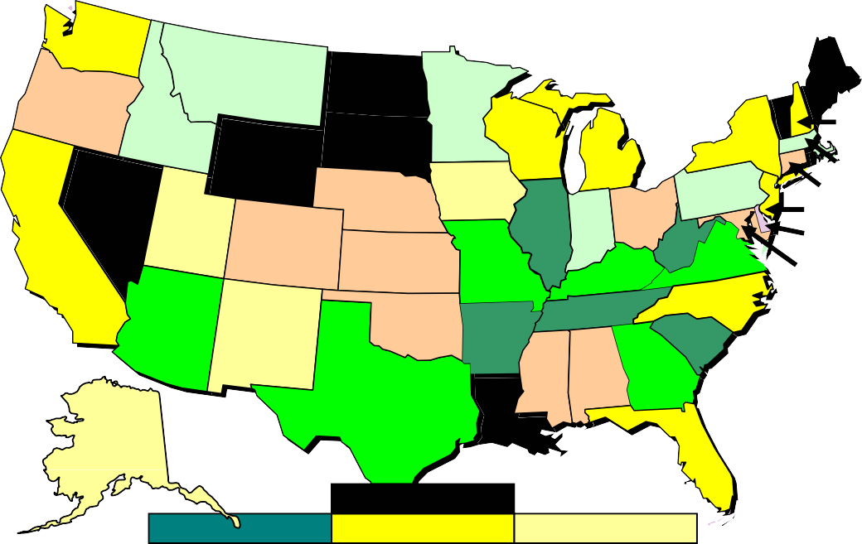
The US Wood Floor Manufacturing
10
8
3
3
4
12
14
2
2
1
7
4
1
76
5
6
23
2
5
1
35
4
7
16
1
8
1
1
5
6
2
2
14
16
29
4 3 27
24
1
12
State Sales Legend
More than 50MM $10MM - $25MM $1 MM - $ 5 MM

Market Summary:
No large national companies dominate this market segment. With the exception of three companies all manufacturers operate within a single state. The largest manufacturer is Columbia with group sales of almost
$117 million and manufacturing and distribution locations in Virginia, West Virginia and Arkansas. Many manufacturers also manufacture and market niche wood products. A majority of manufacturers’ sell their wood flooring products under various brand names that may or may not be sold on a national basis. Only the largest manufacturers provide products for national brands or distribute their product through a national channel (Home Depot, Lowes, etc.)

Industry experts predict a strong future for wood floor products. Consumer demand fueled by improvements in the durability of finish, moisture resistant characteristics and product stability is driving this continued strong outlook.

In addition to the domestic business there is a growing world wide demand for wood flooring. The export market is strong and continues to grow especially for exotic woods and European spec. ready to install flooring.
The one common element in floor manufacture today is a need for high durability adhesives and or other bonding techniques that meet both European and US EPA standards.

Wood flooring Production In the US

1,300
1,207 mbf (1955)
1,102 mbf (1965)
875 mbf (2005)
658 mbf (1995)
99 mbf (1975)
75 mbf (1985)

1,200

1,100

1,000

900

800
Million Board Feet

700

600

500

400

300

200

100

-
Year

1950's

1960's

1970's

1980's

1990's

2000's

Perspectives from the National Wood Flooring Association
(Condensation of Reports)

The $2.6 billion (retail dollars) U.S. wood flooring market has made significant inroads in the domestic floor coverings industry over the past two decades. The inroads were stimulated by growing consumer acceptance of high-end hard surface flooring, as well as more diverse offerings by wood flooring manufacturers. Manufacturers now offer a wide range of species, colors, and custom-type designs. The industry has also stimulated demand with easier and less costly to install products such as prefinished, engineered, and glueless wood floors. These new products and technologies have increased competitive pressures, especially from foreign-based manufacturers. This has led to a sluggish industry bottom line performance.

Industry Trends

U.S. shipments, exports, and price trends for hardwood and softwood flooring products continue to rise. Even in a slowing housing market the outlook for hardwood flooring remains strong due to continued demands in remodeling and commercial construction market segments. Market trends are especially strong for prefinished and engineered wood products, and for exotics, rustics, and other hardwood products.

Importation of “Ready to Install” Wood Flooring

Globally manufacturing capacity for wood flooring is significant. This could be troublesome for US manufacturers, especially noting the increased demand for more exotic woods that cannot be grown domestically. As of the end of 2006 international suppliers of finished product accounted for 10% of the US and Canadian markets. An in depth analysis of international competition paints a much brighter picture for North American Manufacturers.

(Sources: Various Industry Articles published by NWFA from 7/2005 thru 9/2006)

International Conditions
Industry and independent research has noted that even though international manufacturing has a large capacity to produce product, the raw timber required for flooring is in very short supply. Several factors have influenced the availability of timber. 1) Growing environmental pressure to preserve standing timber 2) Protectionism of foreign governments attempting to maintain large timber reserves for rapidly growing internal demand (China has limited export to 5% of domestically grown timber products). 3) US competition for exotic raw timber.

- Environmental Movement – the growing pressure from international groups like Green Peace and Save the Forest have begun to make inroads in developing nations. The impact is especially noted in Southeast Asia and the Pacific Rim with the shut down of many logging operations in the Philippines, Viet Nam and other smaller lumber producing nations. Flooring and wood product Manufacturers in Japan, Taiwan, and even in mainland China have changed over to other non timber related manufacturing succumbing to the shortage of #1 grade raw hardwoods.

- Protectionism - India began preserving its limited timber resources more than a decade ago, others are now following suit. The most notable change has been China. As vast areas of timber have been lost never to recover due to poor management has lead to an abrupt

shift away from using domestically grown lumber for export. As noted earlier the Chinese have now quietly limit export of wood products to 5% of all domestic timber harvested. The primary source of timber for China is now Viet Nam, Burma and Thailand. Other sources include South America and Eastern Africa, area’s where competition for raw timber has driven the price to all time highs.

- Timber Supply - As the American market continues to trend for more exotic looks US and Canadian manufactures have taken to importing raw timber to meet demand. As the North American market has shown a willingness to pay the increased costs related to exotic lumber products North American timber buyers have had no reluctance to outbid others for raw timber. The import of raw timber followed by the manufacturing and distributing finished product has helped maintain the domestic manufacturers’ strength. North American Production efficiencies along with an effective marketing and distribution structure place foreign competitors at a distinct disadvantage in the North American market.

Market Statistics

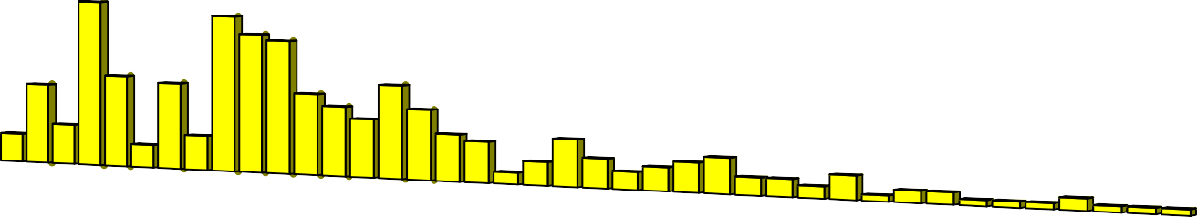
120
Facilities Per State
Sales in Millions
$106.75

100
$94.36

80
$64.66

60
$59.70
$5 74
$54.79
5.

40
$41.29
$35.96
$30.49
$26.93
$25.87

20
$22.86
$20.65
$15.71
$14.78
$14.38
$13.75
$12.89
$12.55
$10.94
$9.27

0
S1
IL, 76
WV, 5
AR, 14
VA, 7
SC, 29
TN, 16
KY, 4
MO, 15
AZ, 6
GA, 27
TX, 24
CA, 23
NY, 14
WI, 12
WA, 10
NC, 16
FL, 12
NJ, 8
MI, 7
NH, 2
MN, 4
MT, 8
MA, 5
ID, 3
PA, 4
IN, 5
OH, 6
AL, 3
OR, 3
NE, 2
MS, 4
CT, 1
CO, 2
OK, 2
DE, 1
KS, 1
MD, 1
NM, 2
AK, 1
UT, 1
IA, 1
$6.96
$6.63
$6.00
$5.69
$5.54
$4.55
$4.24
$4.22
$3.54
$3.06
$2.41
$1.98
$1.80
$1.61
$1.61
$1.01
$0.80
$0.59
$0.20
$0.17

The concentration of facilities does not necessarily correlate with the potential size of the market for adhesives or lubricants. As illustrated by the above chart Illinois has the largest number of wood flooring manufacturers and the produces the largest volume of wood flooring, but West Virginia is the second largest producer with only five very large manufacturers (one of which you already control from both lubrication and adhesive products). Compare West Virginia to its neighbor Ohio (27th) that has 6 Manufacturers but only 4.5 million in sales volume. To maximize sales and marketing efficiencies a careful plan will need to be developed using multiple avenues to aggressively go after the business.

Wholesale Flooring Sales and Adhesive Usage By State
State |  | Manufacturers | Sales Volume* | Usage (Gal.)
Illinois | IL | 76 | 106.75 | 18,681
West Virginia | WV | 5 | 94.36 | 16,512
Arkansas | AR | 14 | 64.66 | 11,315
Virginia | VA | 7 | 59.70 | 10,447
South Carolina | SC | 29 | 55.74 | 9,754
Tennessee | TN | 16 | 54.79 | 9,588
Kentucky | KY | 4 | 41.29 | 7,225
Missouri | MO | 15 | 35.96 | 6,293
Arizona | AZ | 6 | 30.49 | 5,336
Georgia | GA | 27 | 26.93 | 4,713
Texas | TX | 24 | 25.87 | 4,528
California | CA | 23 | 22.86 | 4,000
New York | NY | 14 | 20.65 | 3,614
Wisconsin | WI | 12 | 15.71 | 2,749
Washington | WA | 10 | 14.78 | 2,587
North Carolina | NC | 16 | 14.38 | 2,517
Florida | FL | 12 | 13.75 | 2,405
New Jersey | NJ | 8 | 12.89 | 2,256
Michigan | MI | 7 | 12.55 | 2,196
New Hamp. | NH | 2 | 10.94 | 1,915
Minnesota | MN | 4 | 9.27 | 1,622
Montana | MT | 8 | 6.96 | 1,218
Massachusetts | MA | 5 | 6.63 | 1,161
Idaho | ID | 3 | 6.00 | 1,050
Pennsylvania | PA | 4 | 5.69 | 996
Indiana | IN | 5 | 5.54 | 969
Ohio | OH | 6 | 4.55 | 795
Alabama | AL | 3 | 4.24 | 741
Oregon | OR | 3 | 4.22 | 739
Nebraska | NE | 2 | 3.54 | 620
Mississippi | MS | 4 | 3.06 | 535
Connecticut | CT | 1 | 2.41 | 422
Colorado | CO | 2 | 1.98 | 347
Oklahoma | OK | 2 | 1.80 | 314
Delaware | DE | 1 | 1.61 | 281
Kansas | KS | 1 | 1.61 | 281
Maryland | MD | 1 | 1.01 | 176
New Mexico | NM | 2 | 0.80 | 141
Alaska | AK | 1 | 0.59 | 103
Utah | UT | 1 | 0.20 | 35
Iowa | IA | 1 | 0.17 | 30
TOTALS |  | 387 | $806.90 | 141,208
* Flooring Sales In Millions of Dollars

From purely a logistics and selling efficiency point of view accessing this market from current offices rather than reaching to the west coast or opening new offices to cover Minnesota, Wisconsin and Iowa would not be a path to follow. Covering your current territory with a more focused approach has the potential to maximize your current production capabilities.

Top 10 Manufacturers

COMPANY | STATE | EE # | SALES | Credit Rating
Columbia Flooring | AR | 260 | $ 52,260,000 | A+
Appalachian Custom Dry Kilns | WV | 250 | $ 50,250,000 | A
Somerset Hardwood Flooring | KY | 200 | $ 40,200,000 | A
Jim Duke & Assoc | TN | 200 | $ 40,200,000 | B
Columbia Flooring | WV | 200 | $ 40,200,000 | A+
Columbia Flooring | VA | 120 | $ 24,120,000 | A+
Keyci Flooring Experts Inc | VA | 99 | $ 19,899,000 | C+
Carpet One Desert Floors | AZ | 45 | $ 13,275,000 | A+
Ozark Mountain Hardwood Inc | MO | 60 | $ 12,060,000 | A
Top 10 Total Sales |  |  | $ 292,464,000.00
Estimated Adhesive Use (in Units) |  |  | 102,362 | (8,530 Mo.)

Columbia Flooring Group Summary
Columbia Flooring | AR | 260 | $ 52,260,000.00 | A+
Columbia Flooring | WV | 200 | $ 40,200,000.00 | A+
Columbia Flooring | VA | 120 | $ 24,120,000.00 | A+
Group Totals |  | 580 | $ 116,580,000.00

The top ten manufacturers account for more than 35% of all flooring produced in the United States (Columbia with three locations account for over 14%). API currently serves two of the top 10 (Appalachian Custom and Duke Lumber). It is possible to utilize all of your production capacity with a focus only on the top ten. However Columbia has not been open to repeated attempts to open a dialogue. Shipping distance creates an inventory and shipping problem for Carpet One in Arizona. Any marketing strategy to focus exclusively in the top ten must take those factors into consideration.

Message - Challenges - Opportunities

Introducing your new adhesive to current customers is the most straightforward approach to growing sales. Your service levels, product performance and brand strength within this group is very strong. However you have already placed your product in all but two of your current customers that manufacture wood flooring.

Historically your markets have focused on lubrication of wood cutting equipment with sawmills and high end furniture manufacturing as your core constituency. API knows those markets well and continues to experience strong sales in these two market segments. To successfully access this new market some reconnaissance is important.

Wood Floor Manufacturing Priorities and Concerns
Discussions with industry experts as well as your customers have uncovered some important factors to keep in mind. There are three types of flooring manufactures: Log to Floor, Floor Mfg. only and Antique Wood Floor manufacturing. Each type of manufacturer have common circumstances and unique to their process conditions as related to the use of adhesives in the manufacturing process. Those that are in the ‘Log to Floor’ process have all the same concerns you are familiar with in the raw timber processing market, but once the log has been dried and begins the process of becoming flooring the situation changes. As for those that do not use their own raw timber there are some important factors to keep in mind.

‘Log to Floor’ Manufacturers
These producers make up a large segment of the market. They are the oldest and generally the best candidates for API to market its entire product line. This group tends to have family ownership that is involved in day to day operations and have strong loyalty to suppliers and are steady producers of wood products.

Flooring Only Manufacturers
With few exceptions (Appalachian (WV), Duke (TN) and Somerset (KY)) these are the largest manufacturers and rely on multiple sources for rough sawn, floor grade lumber to provide the raw material for their operation.
These producers tend to have staff turnover and are very sensitive to

consistent delivery and availability of product to meet a variable need. This group also produces multiple flooring options that include, solid hardwood, veneer, exotic and laminated flooring retailed under multiple brand names with varying quality and production standards.

Antique and Reclaimed Wood Flooring Manufacturers These are a unique group of producers and are primarily found in the Northeastern US. Raw material is not new timber but reclaimed timber
from old warehouses, manufacturing facilities and barns. In most cases
they use larger amounts of adhesive in that the top layer of wood used in the process is dryer and absorbs more adhesive that higher moisture content lumber. This is one of the fastest growing segments of the market. Traditionally API has not marketed to this group of manufacturers.

For easier comparison we have condensed our findings into a Quick Reference Guide found on the next page.

Quick Reference Guide

Marketing Quick Reference Guide | Log to Floor | Flooring Only | Antique
Motivators
Delivery Guarantee | Y | Y | Y
Overnight Shipping Available | - | Y | -
On Site Technical Help | Y | N | Y
Competitive Pricing | Y | Y | Y
EPA & EU Approval | Y | Y+ | -
Easy Ordering | Y | Y | Y
Secondary Products | Y | N | N
De-motivators
Product Delay | Y+ | Y+ | Y+
Online or 800 number support | N | Y | Y
Automated Re-Ordering Systems | Y | Y | Y
Inconsistent Product | Y | Y | Y
Spoilage | Y | Y | Y
Inconvenient Packaging | Y | - | Y
API Advantages
Delivery Guarantee | Y | Y | Y
Overnight Shipping | Y | Y | Y
On Site Technical Help | Y | Y | Y
Fresh Product | Y | Y | Y

Legend:

“Y+” = Deal Maker/Killer “Y”= Important Factor “-“= Neutral “N” Unimportant

Market Segment Challenges
The market is small without the potential for unlimited sales. Adhesives and other manufacturing chemicals are primarily provided by 3M. There is little advertising or marketing done with API’s product types so there is little pattern for how others “go to market” with this manufacturing group.

Adhesives are very important to the production of engineered flooring. Today 87% of the market is classified as engineered flooring utilizing multiple layers of wood bonded together to create a durable and stable flooring product. Adhesives that do not perform well or that are not approved by the EPA are not well received by those taking a long term view of their market. Very few short term producers survived the turmoil of the 70’s and 80’s.

API’s primary challenge is to create opportunities to tell their message to the key decision makers in the market. In about half the industry it will be the owner/operator. As you attempt to access larger manufacturers you will have more than one decision maker to win over: Engineer, Production Manager, and Quality Control. No competitor now has a strong hold of the market. 3M is ignoring the market and CPI is for all practical purposes in the market by default.

Even with the strong dissatisfaction with 3M the brand loyalty and image maintains a strong hold. The product works well, it is currently EPA approved, and the manufacturers are comfortable with the product. Based on discussions with manufacturers there is openness to new options but any approach will be met with some skepticism.

Competitor Quick Reference Guide | API | 3M | CPI
Motivators
Delivery Guarantee | Y | N | N
Overnight Shipping Available | Y | Y | -
On Site Technical Help | Y | N | N
Competitive Pricing | Y | N | Y
EPA & EU Approval | Y | Y | -
Easy Ordering | Y | Y | -
Secondary Products | Y | Y | N
De-motivators
Product Delay | N | Y | -
Online or 800 number support | Y | Y | Y
Automated Re-Ordering Systems | N | Y | Y
Inconsistent Product | N | N | Y
Spoilage | Y | Y | -
Inconvenient Packaging | Y | N | Y

“Y”= Yes |”N”= No | “-“= Unknown

Specific Analysis and Recommendations for this Segment Not Available for Public Review

Market Risk vs. Reward Analysis

Current Capabilities vs. Market Potential

Concerns over production capacity and meeting future demand are well founded. The highly proprietary nature of the production system of this new adhesive makes third party manufacturing unacceptable. Forecasting the timing required to add production capacity to meet demand is important to minimizing market risk due to unmet demand for product after the initial sale. (See 3M competitive summary for an example)

Current Customer Production | Annual | Monthly
Deliveries (Units) | 19,853 | 1,654
Sales Volume | $ 436,766 | $ 36,397
Sales Margin³ | 109,192 | 9,099
Remaining Available Capacity
Units | 28,152 | 2,346
Potential Revenue | $ 619,236 | $ 5,1603
Potential Sales Margin³ | $ 154,812 | $ 12,901
Maximum Current Production Capacity (80% Utilization)
Units | 48,000 | 4,000
Potential Revenue | $ 1,056,000 | $ 88,000
Potential Sales Margin³ | $ 264,000 | $ 22,000

Analysis - Based on the current market you will maximize production capabilities with a 40% market share. Your current market share is 16%. We believe you can safely double sales before adding additional production capacity.

OBSERVATION: Based on the locations of your current sales offices you can meet the 40% share by focusing on expanding sales with other customers and developing new clients within the reach of your current sales offices.

3 Based on current sales margin target of 25% of sales

- Company Capabilities Review & Analysis,
- Risk vs. Reward Analysis
  - Specific Operating and Marketing Recommendations
  - Preliminary Implementation Plan

– CONFIDENTIAL –
NOT AVAILABLE FOR PUBLIC REVIEW


Leading Trade Associations for Wood Floor Mfg

A world wide membership of more than 3500 and is a leading voice for Wood Floor manufacturers.

Founded in 1993, the Hardwood hardwood lumber and product
Hardwood Council, The - Council is a coalition of 11

associations. The Council provides technical information on North American hardwood applications for builders, architects, interior designers and remodelers.

is a non-profit hardwood lumber
 | Hardwood Manufacturers Association - HMA national trade association of more than 150 U.S. producers and processors in 34 states.
 | Maple Flooring Manufacturers Association -  Maple Flooring Manufacturers Association has es the authoritative source of technical and general

NHLA is a non-profit member firms who
 | National Hardwood Lumber Association - trade association made up of more than 1,700  produce, sell and use hardwood lumber.

Since 1909 the dminister industry
 | National Oak Flooring Manufacturers Association - principal function of NOFMA has been to formulate and a standards on hardwood flooring.

The World Floor Covering Association ative advocacy, marketing research
 | World Floor Covering Association - is a recognized industry leader in legisl and education.

Top 10 Manufactures Analysis and Sales Lead Catalog follows this page.

