Strategic Analysis Of Starbucks Corporation



By: Nithin Geereddy (ID: 80842082)

- Introduction:

Starbucks Corporation, an American company founded in 1971 in Seattle, WA, is a premier roaster, marketer and retailer of specialty coffee around world. Starbucks has about 182,000 employees across 19,767 company operated & licensed stores in 62 countries. Their product mix includes roasted and handcrafted high- quality/premium priced coffees, tea, a variety of fresh food items and other beverages. They also sell a variety of coffee and tea products and license their trademarks through other channels such as licensed stores, grocery and national foodservice accounts.¹ Starbucks also markets its products mix with other brand names within its portfolio of companies, which include Teavana, Tazo, Seattle’s Best Coffee, Starbucks VIA, Starbucks Refreshers, Evolution Fresh, La Boulange and Verismo. Starbucks had total revenue of $14.89 billion as of September 29th, 2013.²

- External Environment Of The Retail Market For Coffee & Snacks:

  - Industry Overview and Analysis:

Starbucks primarily operates and competes in the retail coffee and snacks store industry. This industry experienced a major slowdown in 2009 due to the economic crisis and changing consumer tastes, with the industry revenue in the US declining 6.6% to $25.9 billion. Before this, the industry had a decade of growth consistent. Due to the economic slump, consumers spent less on luxuries like eating out, choosing to purchase low-price items instead of high-priced coffee drinks due to shrinking budgets.³ The industry grew at a low annualized average growth rate of 0.9% from 2008 till 2013 with current industry revenues at $29 billion in the US. The industry is now forecasted to grow at an annualized rate of 3.9% over the next five years, with a potential to reach $35.1 billion revenues in the US. This growth would be mainly driven by an improving economy, increase in consumer confidence and expanding menu offerings within the industry. Starbucks dominates the industry with a market share of 36.7%, Dunkin Brands with 24.6% and other competitors like McDonalds, Costa Coffee, Tim Horton’s etc. taking the rest as shown in Appendix 1.⁴

  - Industry Life Cycle and Market Share Concentration:

This industry is in a mature stage with a medium level concentration. Starbucks and Dunkin Brands make up more than 60% of the market share (Appendix 1), giving them considerable market power in determining industry trends. Industry Structure is given in Appendix 3.

  - Industry Demand Determinants and Profitability Drivers:

The industry’s demand for premium coffee and snack products are mainly driven by a number of factors which include disposable income, per capita coffee consumption, attitudes towards health, world pricing of coffee and demographics. This industry is highly sensitive to the macroeconomic factors that affect the growth in household disposable. During the recession, the decline in household disposable income due to increased unemployment and stagnant wages, caused a downward pressure on the revenue and profitability margins in the industry. Another crucial factor for analyzing the demand in the industry is the per capita coffee consumption where the increase in coffee consumption increases the revenue of coffee & snack shops. The main driver of this consumption increase would be the increase disposable income, as the economy improves and consumers start to relax their budgets.
This driver has a positive effect on market revenue. Per capita coffee consumption is expected to increase in 2014.

As coffee beans are the primary input in the value chain of the industry participants, the prevailing volatile prices of coffee beans determines market costs and profitability margins. The world price of coffee has risen sharply in recent years due to growing demand in other countries and the resulting supply shortages. During the five years to 2018, coffee bean prices are projected to decrease, which will likely translate into lower market costs and higher profitability.⁵ Attitudes towards health also play an important role in determining the demand in the industry.

There is an expected shift towards healthy eating and diet among the consumers in 2014, and this could be a potential threat to the industry as they become more aware of issues related to weight and obesity. There has been a proactive shift among the industry participants to tailor their menus towards more organic and healthy products mix.

  - Porters Five Forces Analysis of the Retail Coffee and Snacks Industry:
Threat of New Entrants: Moderate
- There is a moderate threat of new entrants into the industry as the barriers to entry are not high enough to discourage new competitors to enter the market. (Appendix 2 shows Barriers to Entry Checklist).
- The industry’s saturation is moderately high with a monopolistic competition structure.
- For new entrants, the initial investment is not significant as they can lease stores, equipment etc. at a moderate level of investment.
- At a localized level, small coffee shops can compete with the likes of Starbucks and Dunkin Brands because there are no switching costs for the consumers. Even thought it’s a competitive industry, the possibility of new entrants to be successful in the industry is moderate.
- But this relatively easy entry into the market is usually countered by large incumbent brands identities like Starbucks who have achieved economies of scale by lowering cost, improved efficiency with a huge market share. There is a moderately high barrier for the new entrants as they differentiate themselves from Starbuck’s product quality, its prime real estate locations, and its store ecosystem ‘experience’.⁶
- The incumbent firms like Starbucks have a larger scale and scope, yielding them a learning curve advantage and favorable access to raw material with the relationship they build with their suppliers.
- The expected retaliation from well-established companies for brand equity, resources, prime real estate locations and price competition are moderately high, which creates a moderate barrier to entry.

Threat of Substitutes: High
- There are many reasonable substitute beverages to coffee, which are mainly tea, fruit juices, water, soda’s, energy drinks etc. Bars and Pubs with non/alcoholic beverages could also substitute for the social experience of Starbucks
- Consumers could also make their own home produced coffee with household premium coffee makers at a fraction of the cost for buying from premium coffee retailers like Starbucks.
- There are no switching costs for the consumers for switching to substitutes, which makes the threat high.
- But its important to note that industry leaders like Starbucks are currently trying to counter this threat by selling coffee makers, premium coffee packs in grocery stores but this threat still puts pressure their the margins.

Bargaining Power of Buyers: Moderate to Low Pressure
- There are many different buyers in this industry and no single buyer can demand price concession.
- It offers vertically differentiated products with a diverse consumer base, which make relatively low volume purchases, which erodes the buyer’s power.
- Even though there are no switching costs with high availability of substitute products, industry leaders like Starbucks prices its product mix in relation to rivals stores with prevailing market price elasticity and competitive premium pricing.
- Consumers have a moderate sensitivity in premium coffee retailing as they pay a premium for higher quality products but are watchful of excessive premium in relation product quality.

Bargaining Power of Suppliers: Low to Moderate Pressure
- The main inputs into the value chain of Starbucks is coffee beans and premium Arabica coffee grown in select regions which are standard inputs, which makes the cost of switching between substitute suppliers, moderately low.

- Starbucks, with its size and scale, has the power to take advantage of its suppliers but it maintains a Fair trade certified coffee under its coffee and farmer equity (C.A.F.E) program, which gives its suppliers a fair partnership status, which yields them some moderately, low power.⁷
- The suppliers in the industry also pose a low threat of competing against Starbucks by forward vertical integration, which lowers their power.
- Starbucks also forms a highly important part of the suppliers business, due its size and scope, which make the power of the suppliers lower. Given these factors, suppliers pose a moderately low bargaining power.

Intensity of Competitive Rivalry: High to Moderate
- The industry has a monopolistic competition, with Starbucks having the largest markets share and its closest competitors also having a significant market share, creating significant pressure on Starbucks.
- Consumers do have any cost of switching to other competitors, which crates high intensity in rivalry.
- But its important to note that Starbucks maintain some competitive advantage as it differentiates its products with premium products and services, which cause a moderate level of intensity in competition.
- The industry is mature and growth rate has been moderately low which cause the intensity of competition among the companies to be moderately high due to all of them seeking to increase market shaper from established firms like Starbucks.
- This industry does not have over capacity currently and all these factors contribute to the intensity among rivals to be moderately high.

Looking at the Porters five forces analysis, we can get an aggregate industry analysis that the strength of forces and the profitability in the retail coffee and snacks industry are Moderate.

- Internal Analysis of Starbucks Corporation:
  - Starbucks Core Competence:

The core competence of Starbucks has been its ability to effectively leverage their cornerstone product differentiation strategies by offering a premium product mix of high quality beverages and snacks. Starbuck’s brand equity is built on selling the finest quality coffee and related products, and by providing each customer a unique “Starbucks Experience”, which is derived from supreme customer service, clean and well-maintained stores that reflect the culture of the communities in which they operate, thereby building a high degree of customer loyalty with a cult following. Its other core competence is its human resource management's values- based approach for building very strong internal and external relationships with suppliers, which drives the successful deployment of its business strategy of organic expansion into international markets, horizontal integration through smart acquisitions and alliances that maintains their long-term strategic objective being the most recognized and respected brands in the world.

  - Starbucks SWOT Analysis:

Strengths:
- Strong Market Position and Global Brand Recognition: Starbucks has a significant geographical presence across the globe and maintain a 36.7% market share in the United States (Appendix 1) and has operations in over 60 countries. Starbucks is also the most recognized brand in the coffeehouse segment and is ranked 91st in the best global brands of 2013.⁸ Starbucks effectively leverages its rich brand equity by merchandizing products, licensing its brand logo out. Such strong market position and brand recognition allows the company to gain significant competitive advantage in further expanding into international markets and also help register higher growth in both domestic and international markets. Over the years, they have achieved significant economies of scale with superior distribution channels and supplier relationships.
- Products of the Highest Quality: They give the highest importance to the quality of their products and avoid standardization of their quality even for higher production output.⁹

- Location and Aesthetic appeal of its Stores: Starbucks has stores in some of the most prime and strategic location across the globe. They target premium, high-traffic, high-visibility locations near a variety of settings, including downtown and suburban retail centers, office buildings, university campuses, and in select rural and off-highway locations across the world.¹⁰ This has earned them a significant competence and advantage to be able to penetrate prime markets and tap into customers convince factor. Their stores are visually appealing and have a ‘cool’ factor attached to it with being designed to reflect the unique character of the neighborhood they serve in and environmentally friendly. They provide free wifi, great music, great service, warm atmosphere and provide an environment of community meeting spot, which forms a wider part of the ‘Starbucks
Experience’. The main aim for the firm is to make their stores a ‘third place’ besides home and work.¹¹
- Human Resource Management: Starbucks is know for its highly knowledge base employees. They are the main assets of the company and they are provided with great benefits like stock option, retirement accounts and a healthy culture. This effective human capital management translates into great customer services. It was rated 91st in the 100 best places to work for by Fortune Magazine.¹²
- Goodwill among consumers due to Social Responsibly Initiatives: Their stores are community friendly, focused on recycling and reducing waste. They build goodwill among communities where they operate.¹³
- Diverse Product Mix: Starbuck portfolio of products given in Appendix 8, that caters to all age groups demographic factors.¹⁴
- Use of Technology and Mobile Outlets: Starbucks efficiently leverages technology with its mobile application “Starbucks App’ in both apple and android software’s. They make significant investments in technology to support their growth every year.¹⁵
- Customer base loyalty: Starbucks has cult following status among consumers and they have also implemented loyalty-based programs to drive loyalty with the Starbucks Rewards programs and Starbucks Card. The Starbucks Card is a value card program that provides convenience, support gifting, and increase the frequency of store visits by cardholders and integrated with their mobile application.¹⁶

Weaknesses:
- Expensive Products: While Starbucks does differentiate their products with being highly quality couple with the whole ‘Starbucks Experience’, in times of economic sluggishness, consumers to have so switching costs to competitor’s products with lower prices and forgo paying a premium. These premium prices could also pose some weakness for it to succeed in developing countries.
- Self-Cannibalization through overcrowding: By aggressive expansion and high saturation due to overcrowding in the market leads to self cannibalization and diminishes long term growth targets of Starbucks. This is happening especially in the United States where Starbucks operates 8078 stores.¹⁷
- Overdependence in the United States market: In line with self-cannibalization of the US market with 8078 stores, Starbucks generates a huge percentage of their total revenue from the US and this makes it very sensitive to prospects of the US economy and growth.
- Negative large corporation image: Like any large corporation, Starbucks does come under increased scrutiny and have to invest in corporate social responsibility activates and maintain tight control over labor practices.
- American/European coffee culture clash with that of other countries: Starbucks coffee culture may not widely accepted in some countries as part of their international expansion strategy.

Opportunities:
- Expansion into Emerging Markets: The increase saturation and self-cannibalization of the US market makes its international strategy even more important. Starbucks has made good inroad into many countries, with India recently joining the list with a joint venture entry.¹⁸ Starbucks has a great growth potential in further expanding into the emerging and developing markets. They can leverage their size, experience, financial prowess and efficiencies to make new market share.¹⁹
- Expanding Product mix and offerings: Starbucks recently started to expand their product mix by venturing into the Tea and fresh juice product offerings with a smart acquisition strategy.²⁰ This provides significant opportunities for Starbucks.

- Expansion of retail operations: Starbucks currently sell its packed coffee products, iced beverages and
merchandizes through large box retailers. This market’s potential is yet to be fully realized and this provides Starbucks great opportunities for the future to future monetizes their brand.
- Technological advances: Starbucks has leveraged the use of mobile applications and has an investment partnership with Square, a mobile payments app that is integrated with its Starbucks app. This creates an ease of use process for customers, aligns customer loyalty through reward programs. Starbucks has already set the bar in the industry with this advancement and about 10% of its transactions in the US have been made using mobile applications.²¹ This is a growing field and would drive more business to their stores as technology advances.
- New distribution channels: Starbucks introduced a beta version of a delivery system called Mobile Pour. This presents a great opportunity for the future by expanding their end product distribution systems and could drive more revenue if the implementation is successful.²²
- Brand extension: Starbucks carries a powerful brand image and it can leverage it to extend into horizontal lines of its business and also venture into product diversification with keeping brand dilution risk in check.

Threats:
- Increased Competition: This is by far the biggest threat that Starbucks faces with the market being at a mature stage, there is increased pressure on Starbucks from its competitors like Dunkin Brands, McDonalds, Costa Coffee, Pete’s Coffee, mom and pop specialty coffee stores. Dunkin Brands had at its main threat in the US market by trailing Starbucks with a 24.6% share. (Appendix 1)
- Price Volatility in the Global Coffee Market: There has be significant fluctuations in the market prices of high quality coffee beans, which Starbucks can’t control.
- Developed Countries Market Saturation: Starbucks derives a significant amount of its revenue from the development markets and there is increased market saturation currently.
- Developed Countries Economy: In an increasingly economically integrated world, an economic crisis like the one in 2008 could have a trickle down effect from the developed markets to the developing markets. This threat would hurt revenues for Starbucks as consumers shift away from premium product mix to stay in limited budgets during economic hardships.
- Changing Consumer tastes and lifestyle choices: The shift of consumers toward more healthy products and the risk of coffee culture being just a fad represent a threat for Starbucks going into the future.

  - Starbucks Generic Value Chain: Analysis in Appendix 6

  - Starbucks VRIO Analysis: Shown in Appendix 4. The VRIO framework is used to analyze in detail the competitive position of Starbucks Corporation and its strategic positioning.

3.3) Starbucks Key Strategies:

One of the key strategy that Starbucks followed since its inception is that of product differentiation offering differentiators such as premium product mix, locations, coffee beverages reputation and supreme customer service that translated to building a premium valued brand which is costly to imitate for competitors. Starbucks has also followed a shrewd strategy of strategic alliance and making smart acquisitions. Starbucks didn’t follow franchising model and operated company oriented stores and joint ventures in international markets. Starbucks has made some key acquisitions such as Teavana (Tea products), Bay Breads (premium bread products), Evolution Fresh (fresh juice products) etc. to use the product diversification strategy. Appendix 7 gives a whole list of joint ventures, strategic alliances and acquisitions of Starbucks. Starbucks acquisition strategy, as shown in their acquisition history in Appendix, has been horizontal, product and market extensions acquisitions. Another
crucial strategy for Starbuck’s growth has been its international strategies of expanding into key developed and emerging markets to geographically diversify, and it has been highly successful with operation spanning 60 countries. All these strategies have derive considerable competitive advantage for Starbucks over its competitors.

3.6) Starbucks Financial Performance Analysis:

Looking at a six year period ratio & growth analysis of Starbucks’s financials from 2008 to 2013, we can see that the revenue growth of the company has experience a drop of -5.9% during the 2008/09 recession but from then on, Starbucks posted a healthy revenue growth of from FY2010 to FY2013 with posting a great growth of 13.7% in FY2012 and currently posted revenues $14.9 billion for FY2013. The operating income margins have increase substantially from 4.9% in FY2008 to a high of 15% in FY2012. Starbucks posted an operating loss in FY2013 and this resulted in a operating margin of -2.2% for that year and the main reason for that is due to a litigation charge of $2.8 billion to Kraft Foods for terminating an agreement with them. This charges is treated as extraordinary event and therefore should be discounted from the overall healthy operational performance of Starbucks. Starbucks ROE and ROA have been impressive with 29.2% and 17.8% respectively for FY2012.
Looking at Starbucks efficiency ratios, Starbucks has gained significant operational efficiency with impressive asset and inventory turnover ratios with a low of 1.51 and 5.4 respectively for FY2013. But its interesting to note that the company’s cash conversion cycle has increase to high 54.7 in FY2013, which is where Starbucks should concentrate on to reduce to attain higher efficiency. Starbucks boasts good financial health with low debt/leverage with a debt/equity ratio of 0.29 for FY2013 and maintains decent current and quick ratios. A detailed financial ratio and growth calculations are given in Appendix 5.

- Recommendations:
- Starbucks biggest growth is in its International segment. The emerging markets of Brazil, India, China, South Africa and Mexico with a growing middle-class population continue to offer significant opportunities to add new stores and serve more customers. Starbucks has already made significant inroads into the Chinese market but there still is a lot of untapped potential growth in these markets. Starbucks should grow in these emerging markets by winning locally Starbucks must remain relevant to the customer in order to grow in these markets, and its management teams should have the freedom to operate within their overall framework to tailor store format, introduce local product mix and price points to the needs, lifestyles and tastes of each individual market/community.
- Under Starbucks international strategy, it should transfer its core competencies and capabilities country to country and then gradually build profit drivers in several countries as it continues its global expansion in an organic way.
- Starbucks has great growth opportunities in Tea and Fresh Juice products mix. They should build up these products along the same line of their core coffee products.
- Also as consumer tastes and lifestyle shift towards more snacks and beverages options, Starbucks should tailor its menu’s and expand to give more healthy product offerings in its mix.
- Coffee beans are a significant input into Starbucks value chain and there have been wide fluctuations in the market prices of high quality coffee beans. Starbucks could mitigate this price volatility risky by implementing an effective hedging strategy like future contracts to lock in their estimated quantity inputs at a low swing price so that the future costs can be managed to a greater extent.
- Starbucks growth strategy in the saturated U.S. market should focus on getting additional penetration into untapped rural markets.
- Another growth sector is its packaged coffee packets and iced beverage products. Starbucks should build better relationships with big box retailers to get premium shelf space and increase the efficiency of this distribution channel.
- From their 10-K’s, we can see that Starbucks invest very little in advertising and marketing initiatives. It would be recommended that Starbucks make significant investments in advertising and marketing initiatives in the face of increased competition in the market.
- Further build and retain customer loyalty, by building on beta concept of on-the-go home delivery.
- Their mobile apps business drove 10% of the sales in the US, so it would be recommended for further building to stream lining ease of use and payment process which would help drive more customers, decrease wait time in stores and increase efficiency. Integrating Starbucks loyalty program with the mobile application would also be recommended.

References:
- Starbucks 2013 10-K Form for FY ended on September 29th, 2013
- Starbucks 2013 10-K Form for FY ended on September 29th, 2013
- IBIS World: The Coffee & Snack Shop Industry in the US Report, October 2013 4 IBIS World: The Coffee & Snack Shop Industry in the US Report, October 2013 5 IBIS World: The Coffee & Snack Shop Industry in the US Report, October 2013 6 http://www.starbucks.com/about-us/company-information/mission-statement
- http://www.starbucks.com/responsibility/sourcing/coffee
- http://interbrand.com/en/best-global-brands/2013/Starbucks
- Starbucks 2013 10-K Form for FY ended on September 29th, 2013 10 Starbucks 2013 10-K Form for FY ended on September 29th, 2013 11 http://www.starbucks.com/coffeehouse/store-design
- http://money.cnn.com/magazines/fortune/best-companies/2013/snapshots/94.html
- http://www.starbucks.com/responsibility/community
- GlobalData: Starbucks Corporation Research Report, March 2013
- http://blogs.wsj.com/corporate-intelligence/2013/07/26/starbucks-talks-about-its-future-more- food-more-digital/
- Starbucks 2013 10-K Form for FY ended on September 29th, 2013
- Starbucks 2013 10-K Form for FY ended on September 29th, 2013
- http://online.wsj.com/article/PR-CO-20131122-905464.html
- http://www.forbes.com/sites/walterloeb/2013/01/31/starbucks-global-coffee-giant-has-new- growth-plans/
- http://seekingalpha.com/article/637841-starbucks-smart-acquisition-strategy
- http://techcrunch.com/2013/07/26/mobile-payment-at-u-s-starbucks-locations-crosses-10-as- more-stores-get-wireless-charging/
- http://www.starbucks.com/blog/introducing-starbucks-mobile-pour
- Starbucks 2013 10-K Form for FY ended on September 29th, 2013
Supplementary Sources:

http://www.mckinsey.com/insights/growth/starbucks_quest_for_healthy_growth_an_interview_ with_howard_schultz

http://www.forbes.com/sites/walterloeb/2013/01/31/starbucks-global-coffee-giant-has-new- growth-plans/

http://seattletimes.com/html/businesstechnology/2020031178_starbucksteavanaxml.html

Appendix 1: US Coffee and Snacks retail market share
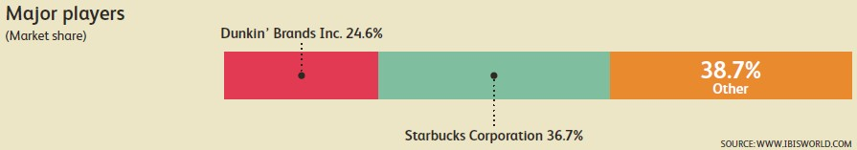

Source: IBIS World Report

Appendix 2: Barriers to Entry Checklist
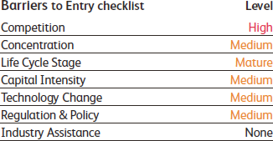

Source: IBIS World Report

Appendix 3: Industry Structure
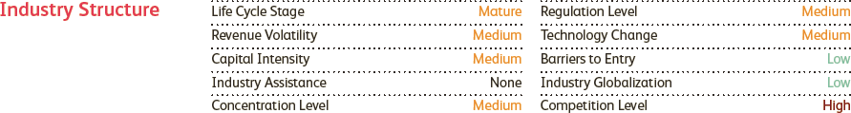

Source: IBIS World Report

Appendix 4 continued next page…

Appendix 4: Detailed VRIO Analysis of Starbucks Corporation
Resources and Capabilities of Starbucks Corporation | Value? | Rare? | Costly to Imitate? | Exploited? | Competitive Implication
Prime and Strategic Locations:  - In high-traffic, high-visibility locations near a variety of settings, including downtown and suburban retail centers, office buildings, university campuses, and in select rural and off-highway locations across the world.  - Tap into customers convince factor | Yes | Yes | No | Yes | Temporary Competitive Advantage
Global Brand Recognition & Equity  - The most recognized brand in the coffeehouse segment and is ranked 91st in the best global brands of 2013  - Effectively leverages its rich brand equity by merchandizing products, licensing its brand. | Yes | Yes | Yes | Yes | Competitive Advantage
Aesthetic Appeal and Concepts of its Stores  - Their stores are visually appealing and have a ‘cool’ factor attached to them.  - Provide free wifi, great music, great service, warm atmosphere and provide an environment of community meeting spot, which forms a wider part of the ‘Starbucks Experience’.  - Concept of the stores as being a ‘third place’ besides home and work.  - Designed to reflect the unique character of the neighborhood they serve in and environmentally friendly. | Yes | Yes | Yes | Yes | Competitive Advantage
Large Size and Strong Global Presence  - Operation in 60 countries and largest coffee/snack retailer  - Economies of scale through superior distribution channels and supplier relationships  - Lower input costs | Yes | Yes | Yes | Yes | Temporary Competitive Advantage
Human Resource Management and Company Culture  - Employees provided great benefits like stock option, retirement accounts and well taken care of  - Knowledge based employees creating a healthy corporate culture  - Ranked 91st in the 100 best places to work for by Fortune Magazine  - Great human capital management couple with great corporate culture translates into supreme customer service | Yes | Yes | Yes | Yes | Competitive Advantage
Leveraging Technology and Mobile Outlets  - Starbucks Apps on iOS and Android  - Investment in Technology | Yes | Yes | No | Yes | Temporary Competitive Advantage
Customer Loyalty and Cult Status  - They have a cult following status among consumers  - Loyalty-based programs like Starbucks Rewards and Starbucks Card drive loyalty.  - Starbucks Card is a value card program that provides convenience, support gifting, and increases the frequency of store visits by cardholders | Yes | Yes | Yes | Yes | Competitive Advantage
Good Corporate Social Responsibility Image  - Their stores are community friendly, focused on recycling and reducing waste.  - They build goodwill among communities they operate in  - Strong Social Responsibility Initiatives undertaken | Yes | Yes | No | Yes | Temporary Competitive Advantage

Appendix 5: Starbucks Corporation’s Financials

Starbucks Corporation's Financials for Fiscal Year ending September of each year (All USD figures in millions)
Key Ratio's/Accounts | FY 2008 | FY 2009 | FY 2010 | FY 2011 | FY 2012 | FY 2013
Profitability Ratio's
Revenue | 10,383 | 9,775 | 10,707 | 11,700 | 13,300 | 14,892
Gross Margin % | 19.2 | 55.8 | 58.4 | 57.7 | 56.3 | 57.1
Operating Income (USD Millions) | 504 | 562 | 1,419 | 1,729 | 1,997 | -325
Operating Income Margin % | 4.9 | 5.7 | 13.3 | 14.8 | 15 | -2.2
Net Income (USD Millions) | 316 | 391 | 946 | 1,246 | 1,384 | 8
Net Margin % | 3 | 4 | 8.8 | 10.7 | 10.4 | 0.06
Return on Equity (ROE) % | 13.2 | 14.1 | 28.14 | 30.9 | 29.2 | 0.17
Return on Assets (ROA) % | 5.73 | 7 | 16 | 18.1 | 17.8 | 0.08
Earnings Per Share (EPS) | 0.43 | 0.52 | 1.24 | 1.62 | 1.79 | 0.01
Efficiency Ratio's
Asset Turnover | 1.89 | 1.74 | 1.79 | 1.7 | 1.71 | 1.51
Inventory Turnover | 12.1 | 6.4 | 7.4 | 6.6 | 5.3 | 5.4
Fixed Asset Turnover | 3.5 | 3.5 | 4.3 | 4.9 | 5.3 | 5
Days Sales Outstanding | 10.9 | 11.2 | 9.8 | 10.75 | 12 | 12.8
Days Inventory | 30.11 | 57.3 | 49.4 | 55.6 | 69.3 | 67.3
Payable Period | 15.6 | 25 | 22.5 | 30.3 | 29.4 | 25.4
Cash Conversion Cycle | 25.4 | 43.5 | 36.7 | 36.1 | 52 | 54.7
Liquidity & Financial Health Ratio's
Current Ratio | 0.8 | 1.3 | 1.55 | 1.83 | 1.9 | 1.02
Quick Ratio | 0.3 | 0.6 | 1 | 1.17 | 1.14 | 0.71
Debt/Equity | 0.22 | 0.18 | 0.15 | 0.13 | 0.11 | 0.29
Financial Leverage | 2.28 | 1.83 | 1.74 | 1.68 | 1.61 | 2.57
Year on Year Growth %
Revenue Growth % | 10.3 | -5.9 | 9.5 | 9.3 | 13.7 | 12

Source: All Financials used here are derived from Starbucks10-K Form for Fiscal Years ended 2008, 2009, 2010, 2011, 2012, and 2013

Appendix 6: Starbucks Generic Value Chain:
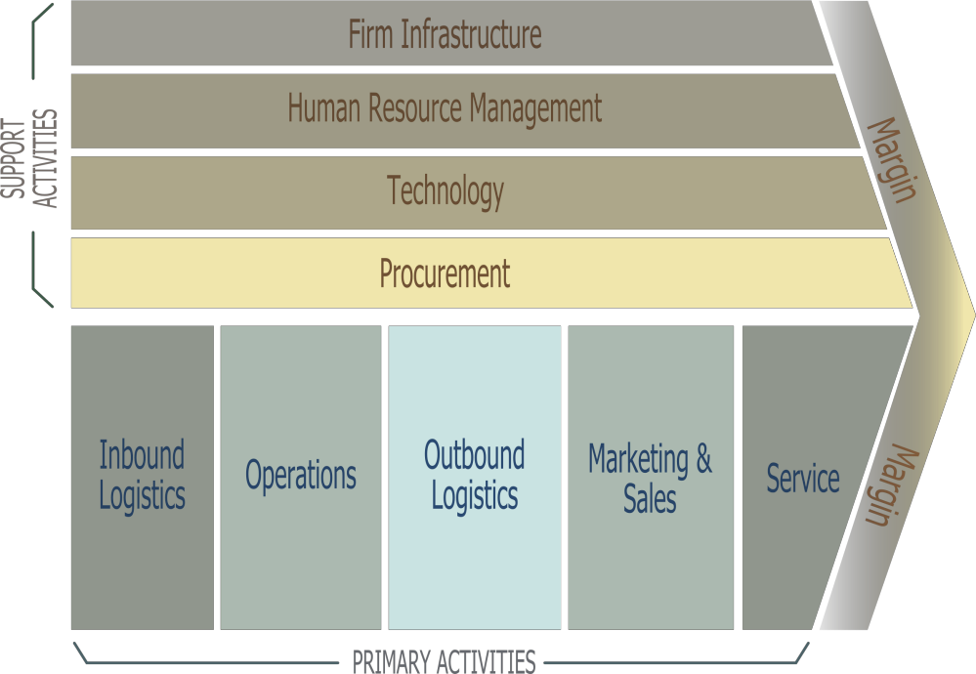

Primary activities
Inbound logistics – Sourcing coffee from diverse coffee beans producers with whom they have great relationships and built up efficient supply chain management system.

Operations – They have operation in 60 countries with their stores being modeled on company operated stores and licensed stores.

Outbound logistics – Most of its product mix are sold in-store and some through large box retailers. Payment around source through point of sale, prepaid Starbucks Cards and mobile payments.

Marketing and Sales – Traditionally, investment in marketing activities have not be significant and relied mainly on the growing reputation of premium quality product mix and superior customer services to give the ‘Starbucks Experience’ to drive customers to their stores and products.

Service - Starbucks has a reputation for providing supreme level of customer services to their consumers.

Support activities
Firm Infrastructure. They have well designed, aesthetically pleasing stores. They have efficient level of finance, accounting and legal departments to support the firm’s infrastructure.

Human Resource Management – Great benefits, employee empowerment and amazing corporate culture makes Starbucks drive efficient management of human capital.

Technology development – Investments in innovative technologies like the well like mobile app.

Procurement – Starbucks procures its products from a diverse group of supplier and has fixed contracts with some of the suppliers.²³

Appendix 7: History of Strategic Acquisition, Joint Venture, Strategic Alliances and Product Extensions
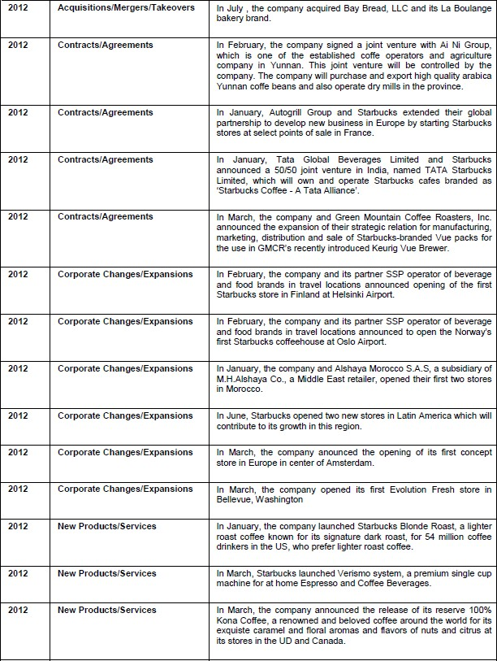

Continued next page…

Source: Global Data and MarketLine Financial Deals, Starbucks Corporation, 2013 Reports.
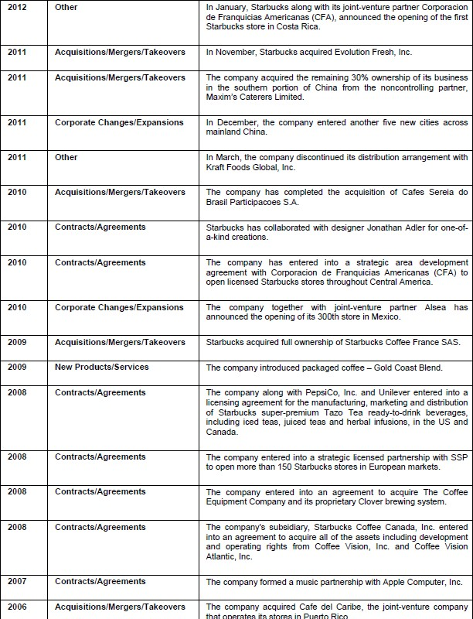

Continued next page…
Source: Global Data and MarketLine Financial Deals, Starbucks Corporation, 2013 Reports.

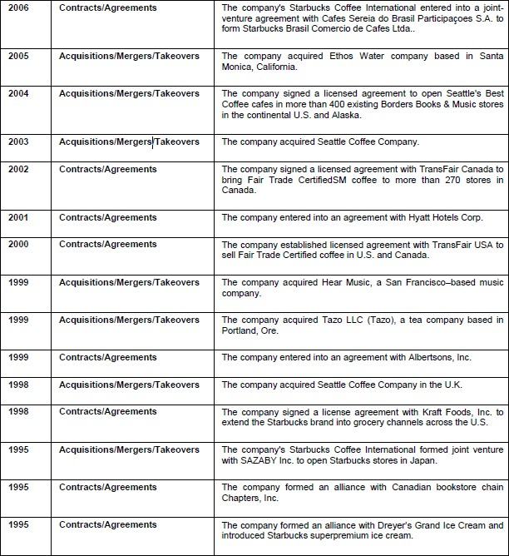

Source: Global Data and MarketLine Financial Deals, Starbucks Corporation, 2013 Reports.

Appendix 8: List of Starbucks Product Mix:
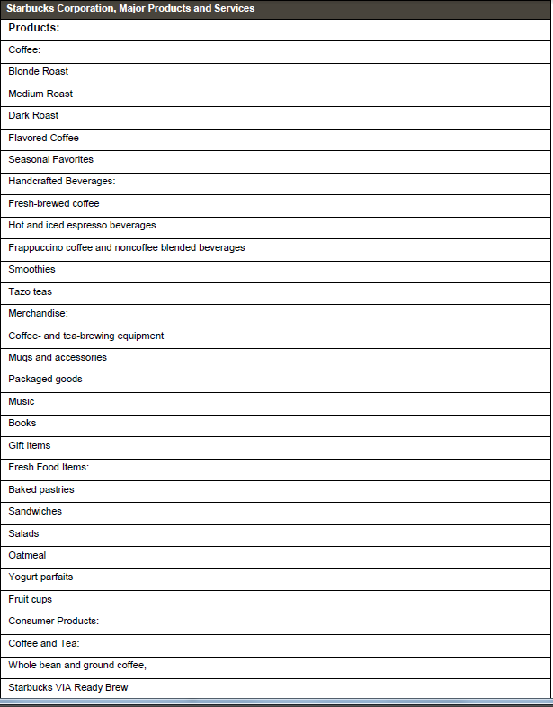

Source: GlobalData and Starbucks Website

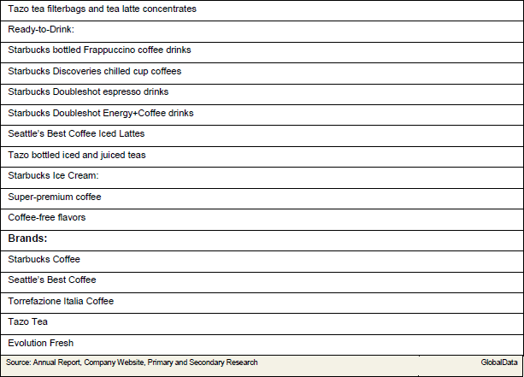

Source: GlobalData and Starbucks Website

