

Industry Analysis: Recommendation and Comparison

Ted Xiao, M.S. Electrical Engineering and Computer Science Gina Zaghi, M.S. Chemical Engineering

This work was created in an open classroom environment as part of a program within the Sutardja Center for Entrepreneurship & Technology and led by Prof. Ikhlaq Sidhu at UC Berkeley. There should be no proprietary information contained in this paper. No information contained in this paper is intended to affect or influence public relations with any firm affiliated with any of the authors. The views represented are those of the authors alone and do not reflect those of the University of California Berkeley.

Introduction

In the past years, our lives have become much more connected and internet-based. Big Data has seeped into every life, no longer constrained to the databases and metrics of high technology companies. With consumer experiences moving online, the vast array of options available online are increasing at unprecedented paces, be it consumer products, social media web apps, or shiny new widgets. The paradox of choice is a well-studied phenomenon. After a certain variety of choices, consumers actually become less satisfied with their choices and the process of sifting through a daunting amount of information and choices.

We term this behavior information overload: with huge amounts of online choices presented to consumers in a myriad of different formats, this type of Big Data overwhelms consumers, both tech-savvy consumers and those who are not.
However, even as Big Data has caused this information overload for many, Big Data may be able to solve issues even beyond online experiences.

To explore a direct example of information overload and its possible solutions, we analyze the general industry of online product experiences: product discovery and product recommendation. In this report, we begin with a description and history of this industry. We will describe our own attempts at creating a solution for this industry and what we learned. Then, we will pivot to a thorough analysis of the market and technical environment of the industry. Finally, we will synthesize these takeaways to look at the true opportunity in this space: a simplified internet browsing experience that utilizes many recommendation technologies under the hood.

Industry Description

The industries of product discovery and product recommendation have been significant parts of our online and consumer lives for the past decade. With roots in traditional marketing and advertising, these technologies have changed the way people browse and shop online. Consumers demand better curated and relevant content, and as a result, there is now a large market for solutions that address serving more efficient, automated experiences. We see this in three main subsections: product discovery, product comparison, and product recommendation.

Product Discovery
Product discovery for consumers is the technology for a holistic engagement process that introduces new products to the user in an interactive manner that prioritizes the whole experience of the user in addition to just finding new products.
It is important to know that product discovery from a consumer standpoint is
different from the ‘product discovery’ that is used in management terms; in those scenarios, product discovery is used as a term for discovering features during

product creation that may connect with users. An example of product discovery is the iOS App Store, which recommends relevant and popular apps.

Product Comparison
Product comparison is the technology for comparing products in some kind of organized manner. Product comparison can either be done implicitly or explicitly. Explicit product comparison is what we are most familiar with: side-by-side comparison of products or services that consumers actually see. These comparisons leverage quantitative information about the products, but may also include some qualitative components. Implicit product comparison happens in the backend of the applications; the system compares products using internal metrics in order to better display products for recommendation or discovery purposes. An example of explicit product comparison is on Amazon or Google when comparing items on areas like price, weight, or battery life.

Product Recommendation
Product recommendation is the technology for recommending products to users to maximize their conversion to actually use or purchase these products. Unlike product discovery, the main service provided by product recommendation is not the holistic experience, but actual click-through to the products. An example of product recommendation would the ‘Recommended for You’ sections on Amazon.
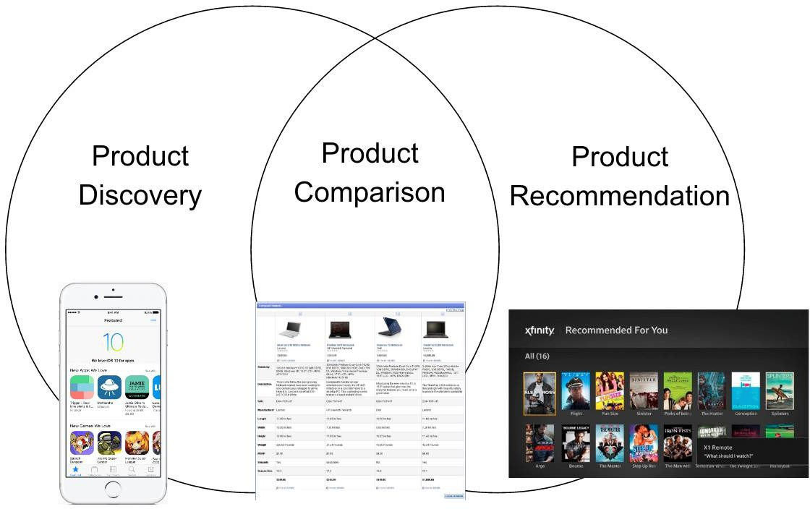

Fig 1: A representation of the relation between product discovery, comparison, and recommendation.

Practical Application: Our Attempt at Productization

As part of IEOR 290, we attempted to create a solution to address issues we saw in this space. Specifically, we approached information overload through the lens of creating a decision engine that could augment the consumer online experience.
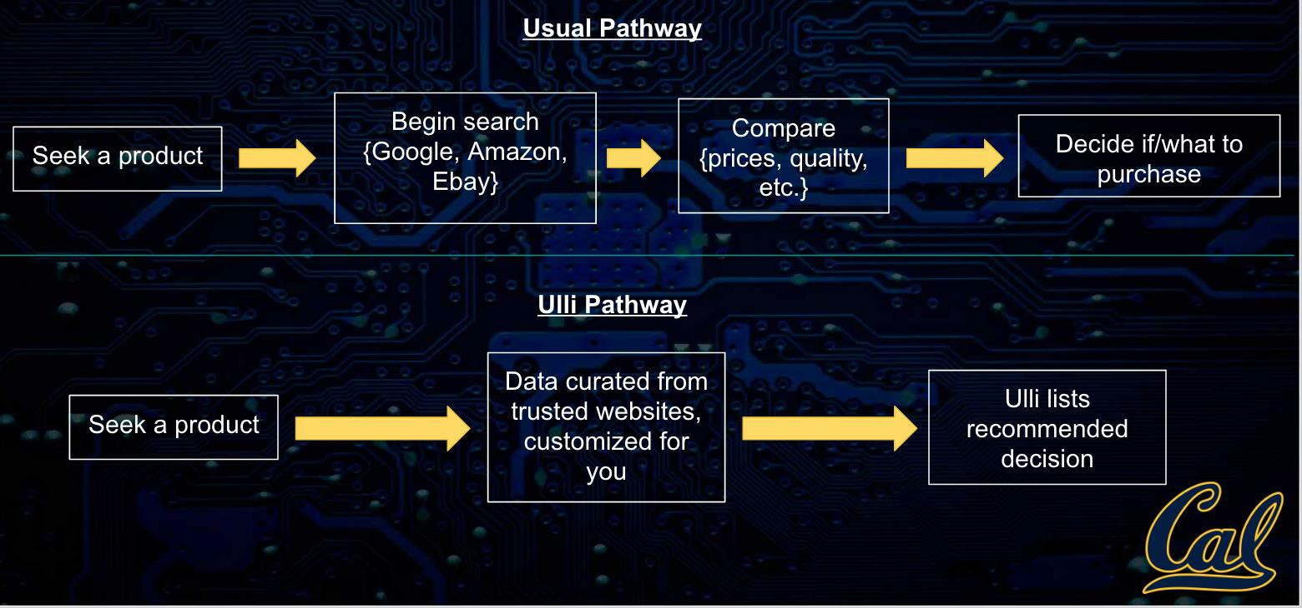

Fig. 2: A comparison of the default current process that consumers take when researching products online
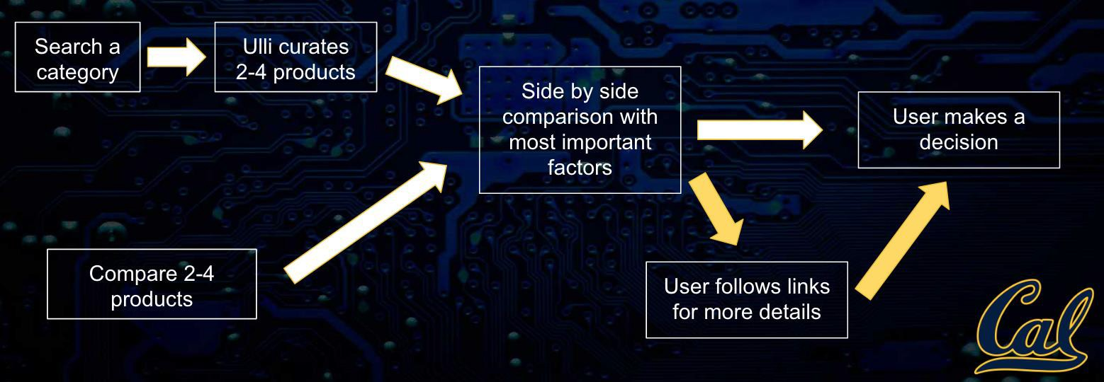

Fig. 3: A more detailed breakdown on the proposed value add of a decision engine that augments the decision process.

We began with our intuition on what consumers would need in this space, and focused on the concept of a tool to help decision processes during both product comparison and product recommendation. We viewed the current process as extremely tedious: there is a lot of noise during product research, which results in many open tabs, many review articles, and a lot of mostly useless reviews. We

hypothesized that A=a tool that could replace some of the more repetitive parts of this process would add value to any consumer who regularly purchased and researched products online.

After initial feedback from potential users and market analysis, we concluded that such a tool may be useful, but choosing the correct market would be crucial. We struggled on this for a few iterations, but settled on few key criteria our market would have to satisfy:
- Low brand loyalty
- High risk purchases
- Frequent purchasing patterns
- Can’t be saturated already

Our market research and user interviews validated our concerns. Many of the industries we had been considering were not great fits. The consumer electronics market had high brand loyalty, as a tech item you use daily in a public setting is often viewed as more than just a tool. The household products industry was not a high-risk purchase, so most people would not use a tool to exhaustively research various options (this applied to many low-risk purchases in general; if consumers currently aren’t spending time researching options for low-risk purchases, they
won’t start researching in the future without some significant market shift). The car or housing market purchasing patterns were too infrequent, as we needed users who would be using our solution on a regular manner. Finally, industries like travel and car rentals were largely saturated with solutions similar to ours.

The numbers from our market research supported our user interviews, as will be shown in a later section. We struggled with pivoting to a suitable market, and converted our venture into the industry analysis seen here. Towards the end of the course, we realized that a market that fits our criteria may be the gift-buying market. There is potential in disrupting the gift-buying industry through a tool to help consumers discover and purchase gifts for all occasions.

Technology Analysis

The past years have seen a tremendous explosion in interest in the fields of Artificial Intelligence and Machine Learning. Without doubt, these fields hold much promise, especially in an area that is so tied to machine intelligence such as product recommendation.

To analyze the current technological environment, we must first view the development of recommendation techniques from a holistic point of view. In the 1990s and the early 2000s, most recommendation techniques focussed on keyword frequency and hardcoded rules. Soon, development also focussed to matching users with similar users and recommending based on what people similar to you enjoyed.

This technique is known as collaborative filtering, and is nowadays the absolute bare minimum in state of the art recommendation techniques.

However, with the rise of Big Data and the amount of exploratory training data available, many companies are looking towards developments in Machine Learning. Perhaps the biggest area relevant to many recommendation engines that discover products based on a deeper semantic understanding (opposed to just comparing things like price) is Natural Language Processing.

Natural Language Processing (NLP) is the field of understanding human language. There has been much interest and success in recent years, ranging from language translation to intent understanding. Challenges still exist in scaling for more mediums, more domains, and more languages. However, most of the progress is directly applicable to the industry of product recommendation! Active research
challenges don’t apply to this field. One main remaining issue is detecting sarcasm in reviews, which poses a challenge to the best state of the art models.

A recent technological development posed to radically change the field of recommendation is the resurgence of Deep Neural Networks. Neural Networks are neurologically-inspired algorithms that are able to leverage huge amounts of data, such as the data we currently have available for product recommendation. Google has shown huge interest in using these Neural Networks for product recommendation, and such open-source technologies may find perfect market fits in very domain-specific applications.

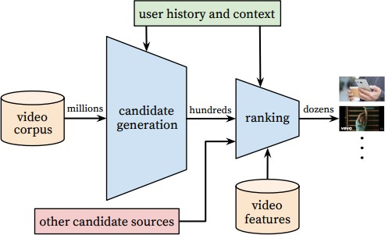

Fig. 4: The approach taken by recent research in using Neural Networks for recommendation.

The timeframe for Machine Learning technology to disrupt product recommendation on a huge scale is now. Consumers are accepting the increasing nature of ubiquitous AI that improves our lives in small ways across web platforms, and general AI advances are being brought to the recommendation space.

Market Analysis

There are a wide host of websites and applications that cover discovery and recommendations throughout different spaces via different sources, and degrees of, intelligence. All of the possible applications seem to have a very large market. The category that immediately comes to mind is the e-commerce sector. This multi- billion market is without a doubt growing at a massive rate, as seen in the below figures.
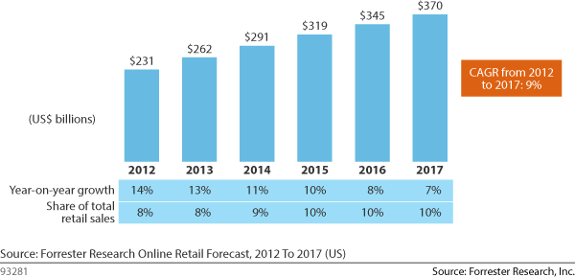

Fig. 5: The online retail market is a $300 Billion+ market that heavily uses product recommendation to drive sales.

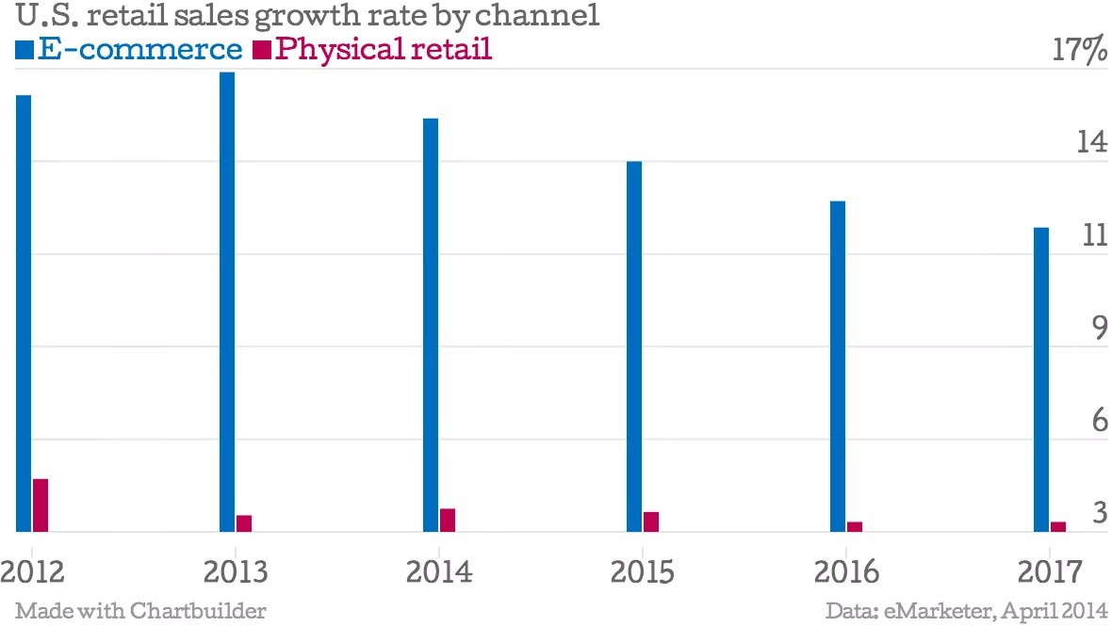
Fig. 6: Projected growth rate of the E-Commerce Industry

Beyond e-commerce, however, there are many domains that involve recommendation. Below in Figure 7, some major players are listed according to specificity of domain covered, and level of intelligence used in presenting the information.
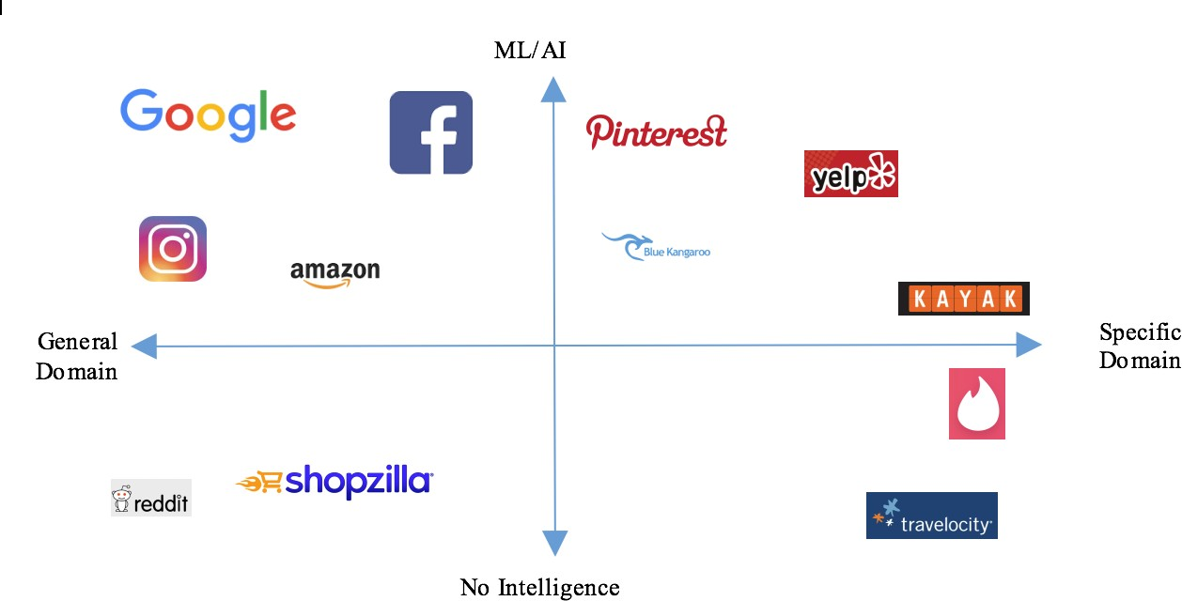

Fig. 7: A landscape analysis of some product recommendation and discovery websites and applications in terms of intelligence level and range of domains.

As shown, existing players occupy each quadrant of this landscape analysis. There are entities such as Google, Facebook and Pinterest that incorporate high levels of ML/AI to tailor outputs to the user. On the other hand, websites/apps such as Reddit and Tinder lack ML/AI, and rely on collaborative or manual filtering for their outputs. Furthermore, there are entities that cover a vast range of domains, and those who only operate in a niche space. Amazon, for example covers a large range of spaces such as consumer products, electronics, books, clothes, entertainment and more, where a website such as Kayak, operates solely within the travel industry.

Furthermore, we can look more closely into specific industries that are popular among the space of product recommendation and discovery. Figure 8 demonstrates some big players in various industries that are popular in product discovery and recommendation.

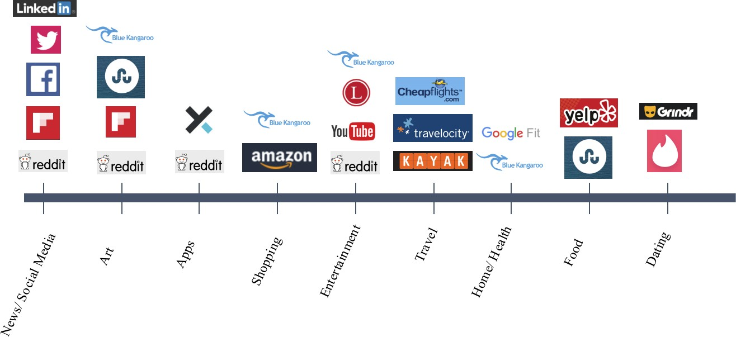

Fig. 8: A landscape analysis of some product discovery and recommendation websites and applications of common industries.

As shown, each of these industries are occupied. Although there are niche markets that are not addressed in this figure, we are ignoring them for lack of a large potential impact in the space of product discovery and recommendations as a whole. Because of the existing saturation throughout these industries, we conclude that new incumbents need to think outside the box if they want a chance to compete.
Creating incremental improvements in ML/AI algorithms to deliver a slightly better

product can be useful, but will likely not be sustaining due to lack of reframing technology or differentiation from the rest of the market.

Opportunities

In order to address a potential opportunity at hand, it is important to observe trends of the hardware that supports these websites and applications, as well as the underlying problem that has yet to be addressed by all current solutions. Typing on smartphones or smart watches is set to be obsolete. With the ubiquity of touch technology, and the growing popularity of voice commands, UX is evolving towards a system that is smarter, and requires less clicks from the end-user. Furthermore, there is still an underlying problem with all current solutions that has not been addressed: the end user is still required to prompt the website or application to open. The current solution is not smart enough to predict what engine to open at the right time. The opportunity gap for the next reframing and differentiating product should address these two areas.

There lies potential for a product that is smart enough to prompt websites to open, without your direct input, and removes the need for the end-user to type anything into a field. As of late October 2016, a player by the name of Ulli (believe it or not) has entered this space. Ulli is the world’s first “self-driving internet,” or AI search engine. It was designed in order to render the most relevant actions and content while browsing the internet, in order to navigate more seamlessly. We predict that products like Ulli are the next big market, and are sure to reframe the way we browse the internet on our smartphones and watches.

Conclusion

Throughout the course of this class, we analyzed the landscape of product discovery and recommendations, and brainstormed ways in which we can add value to this space. Through our attempt at the productization of a system that curates data to enable more facile comparison, we realized that innovation in this area is more wholesome. Though there is room for incremental improvement in the degree of intelligence offered, and the niche markets they cover, the value proposition for these projects would deem the venture unsustainable. However, there lies a “crack
in the wall” to enter this industry and create a reframing and differentiating innovation. If a solution is able to prompt websites open without an end-user’s intervention, and if that solution can virtually eliminate the need for the end-user to type information into a field, then it has the potential to succeed.

References http://www.ted.com/talks/barry_schwartz_on_the_paradox_of_choice http://blog.ted.com/does-having-choice-make-us-happy-6-studies-that-suggest-it- doesnt-always/
http://www.ijsr.net/archive/v3i11/T0NUMTQxMTY4.pdf http://files.grouplens.org/papers/FnT%20CF%20Recsys%20Survey.pdf http://www.slideshare.net/sun9413/recommendation-techniques http://www.sciencedirect.com/science/article/pii/S1110866515000341 http://www.forbes.com/sites/bernardmarr/2016/02/19/a-short-history-of- machine-learning-every-manager-should-read/#f2cd1ed323ff https://www.crunchbase.com/organization/kayak http://www.mckinsey.com/industries/retail/our-insights/how-retailers-can-keep- up-with-consumers
http://research.google.com/pubs/pub45530.html

Appendix: Industry Data for Search Engines in the US
(Source: Ibis)
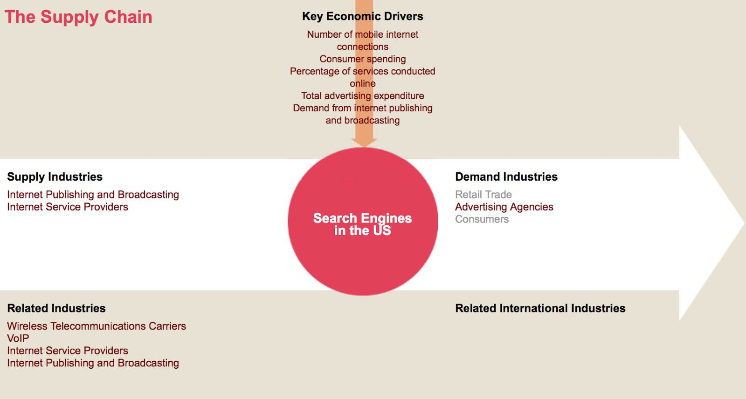



Products and services segmentation (2016)
1.1%

9.9%
Po_id placement other

17.5%
Paid placemen · drive traffic
Paid
lnd uslon
25.0%
Paid placement
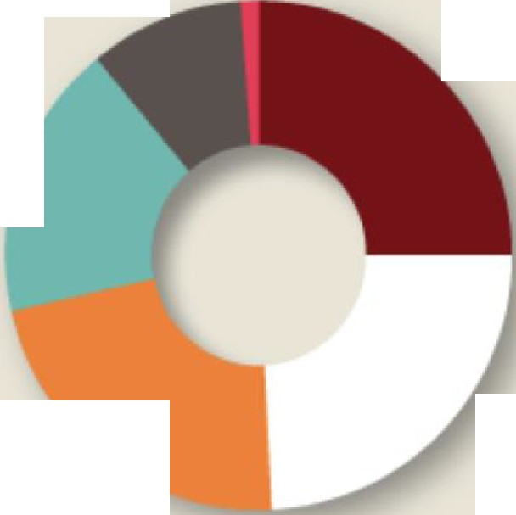

bmnd aworeness

22.3%
Paid placement: generate leads

Paid
2lt.2°/4
placement onllne

sales

 | Revenue | IVA | Establi shments | Enterprises |  | Employment | Exports | Imports | Wages | Domestic Demand | Number of  mobile internet conn ections
 | (%) | (%) | (%) | (%) |  | (%) | (%) | (%) | (%) | (%) | (%)
2007 | 20.5 | 9.6 | 6.5 | -1.5 |  | 13.5 | N/C | N/C | 2.7 | N/C | 158.1
2008 | 19.9 | 18.6 | 3.5 | 0.0 |  | 15.7 | N/C | N/C | 19.6 | N/C | 51.9
2009 | 7.0 | 0.3 | 3.2 | 6.0 |  | 14 .3 | N/C | N/C | 6.7 | N/C | 101.2
2010 | 13.1 | 22.2 | -3.7 | -4.9 |  | 5.5 | N/C | N/C | 12.8 | N/C | 76.7
2011 | 14.3 | 15.2 | -3.6 | -11.0 |  | 4.4 | N/C | N/C | 14.0 | N/C | 51.3
2012 | 19.2 | 20.4 | -3.9 | 2.3 |  | 4.2 | N/C | N/C | 18.9 | N/C | 23.7
2013 | 11.6 | 12.6 | 7.1 | 7.2 |  | 7.8 | N/C | N/C | 12.0 | N/C | 20.0
2014 | 8.7 | 10.7 | 7.4 | 7.0 |  | 5.6 | N/C | N/C | 9.4 | N/C | 13.1
2015 | 12.8 | 22.1 | 9.8 | 9.5 |  | 9.1 | N/C | N/C | 13.8 | N/C | 10.3
16 | 8.5 | 17.9 | 5.2 | 4.9 |  | 9.2 | N/C | N/C | 9.9 | N/C | 20.6
2017 | 8.9 | 9.5 | 7.0 | 6.7 |  | 9.5 | N/C | N/C | 10.2 | N/C | 6.7
2018 | 8.2 | 8.3 | 5.8 | 5.6 |  | 9.0 | N/C | N/C | 9.6 | N/C | 4.4
2019 | 7.3 | 7.4 | 5.9 | 5.6 |  | 7.5 | N/C | N/C | 8.2 | N/C | 6.0
2020 | 7.3 | 7.4 | 4.4 | 4.3 |  | 6.9 | N/C | N/C | 7.7 | N/C | 5.1
2021 | 8.4 | 8.5 | 6.3 | 6.1 |  | 8 .1 | N/C | N/C | 9.0 | N/C | 4.9
 |  |  |  |  |  |  |  |  |  |  | Number of
 |  |  |  |  |  |  |  |  |  | Domestic | mobile internet
 | Revenue | IVA | Establis hments | Enterpr ises |  | Employm ent | Export s | Import s | Wages | Demand | conn ections
...... ...... .... . .... | . ( '11) ..... ..... .... | ($'11) | (Units) | ....... (Un i ts) | .............( i ts) ... .......... |  | . ( $ '1)1 .... . ..... | .... ... ($'11) | ($ m) | ($'11) ..............J ill!- L.
2007 | 18 ,310 .6 | 8 ,1 26.2 | 781 | 670 | 25,161 |  |  |  | 4,674.6 | 16 .0
2008 | 21,9 48.7 | 9,639.3 | 808 | 670 | 29,1 06 |  |  |  | 5,589.6 | 24.3
2009 | 23,482.1 | 9,66 3 .9 | 834 | 710 | 33,254 |  |  |  | 5,965.4 | 48.9
2010 | 26,548.4 | 11,811.7 | 803 | 675 | 35,087 |  |  |  | 6,727.7 | 86.4
2011 | 30,342.9 | 13, 6 02.2 | 774 | 601 | 36,6 39 |  |  |  | 7 ,6 7 0.1 | 130 .7
2012 | 36,1 58.3 | 16 ,3 77.3 | 744 | 615 | 38,191 |  |  |  | 9,117 .3 | 161 .7
2013 | 40,365.6 | 18 ,4 35 .9 | 797 | 659 | 41,154 |  |  |  | 10,210.2 | 194.0
2014 | 43,874.8 | 20,415.6 | 856 | 705 | 43,465 |  |  |  | 11,167.7 | 219.4
2015 | 49,480.8 | 24,920.7 | 940 | 772 | 47,4 04 |  |  |  | 12,713.6 | 242.0
16 | 53 ,666. 1 | 29,379.0 | 969 | 810 | 51,750 |  |  |  | 13,969.9 | 291.9
2017 | 58 ,441.1 | 32 ,167.8 | 1,058 | 864 | 56,6 54 |  |  |  | 15,400.3 | 311.4
2018 | 63 ,22 8. 5 | 34,822.6 | 1.119 | 912 | 61 ,73 2 |  |  |  | 16,883.0 | 325.2
2019 | 67,8 71 .5 | 37, 39 7. 9 | 1,185 | 963 | 66 ,38 7 |  |  |  | 18 ,273 .4 | 344.6
2020 | 72,8 46.0 | 40,148.7 | 1,237 | 1 ,0 04 | 70,975 |  |  |  | 19 ,685.5 | 362.2
2021 | 78,995 .0 | 43 ,55 2.2 | 1,315 | 1 ,065 | 76 ,706 |  |  |  | 21,455.8 | 380.1

Panta s and Ti ng
Sut ardja Center


for Entrep reneur ship & Technology
Be rkeley Enginee ring

