!
Scientist:_____________________________________________ Date:___________________
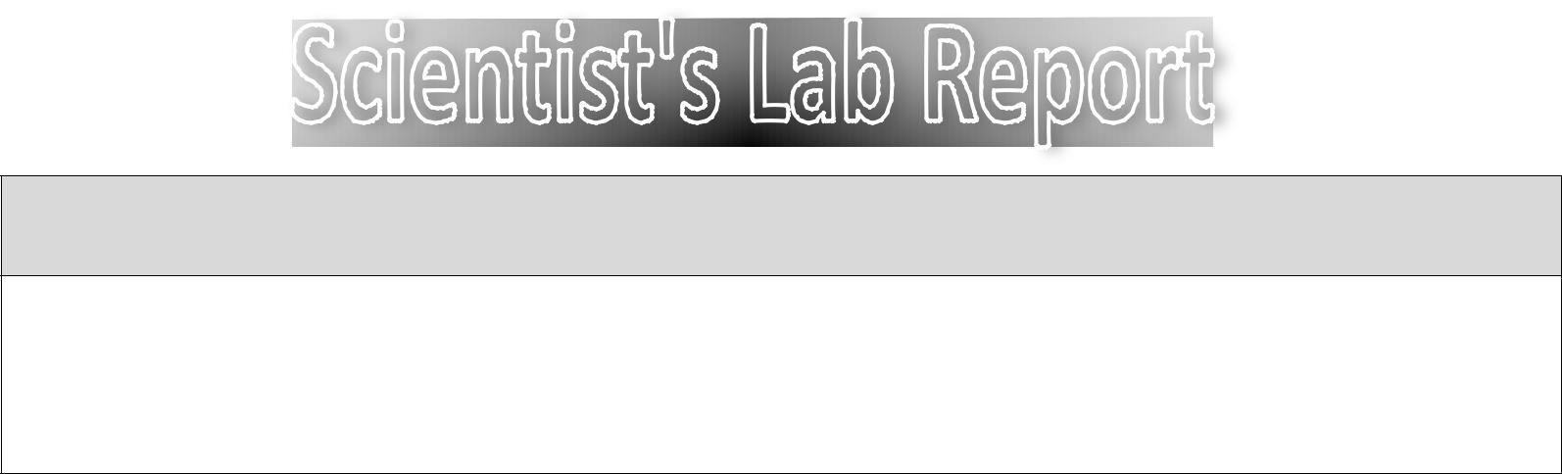

QUESTION: What are we trying to find out?


PREDICTION: What do you think is going to happen?

I predict that


PROCEDURE: What needs to be done, step-by-step?

*



OBSERVATIONS: What do you see happening?


CONCLUSION: What ended up happening? Why did it happen?

!

!
"#$%&'&#(!)*'+#,-#(!

./,0!

=6*062,'(>!)*'+#,-#(!
./,0!

)0/*1!2,!',!3,4'5676'(!82(9!:227;2<!

!

