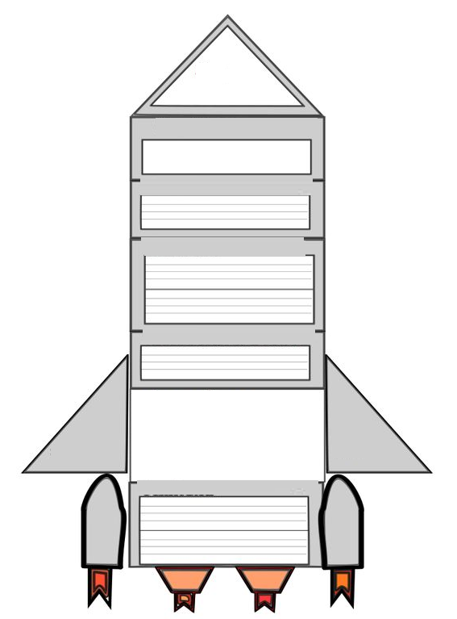
Lab Report Template
Conclusion
Chart/Data
Observsation/Result
Procedure
Hypothesis
Materials
Purpose

