
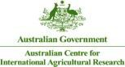
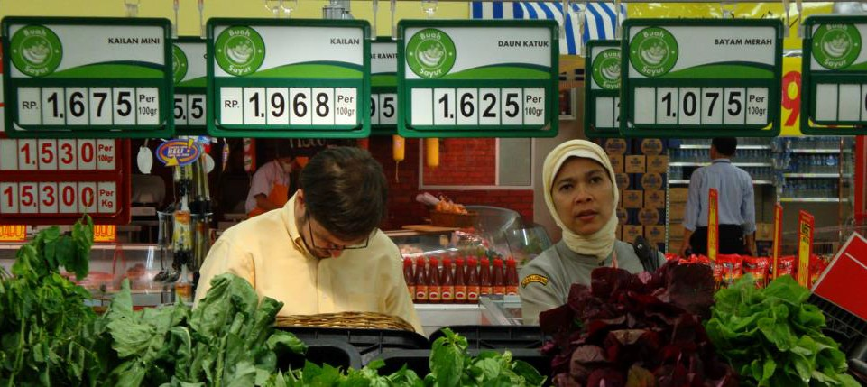
Mapping the Value Chain
Capacity Building for Research Workshop, Monday 1 September, 2014
Wendy Umberger, Ph.D.
Director & A/Professor Global Food Studies

Overview
•
Gain an understanding of terms and relationships between
- “markets”
- “value chains”
- “mapping value chains”
- “value chain analysis”
Highlight value chain mapping techniques Examples of mapping techniques
•
•

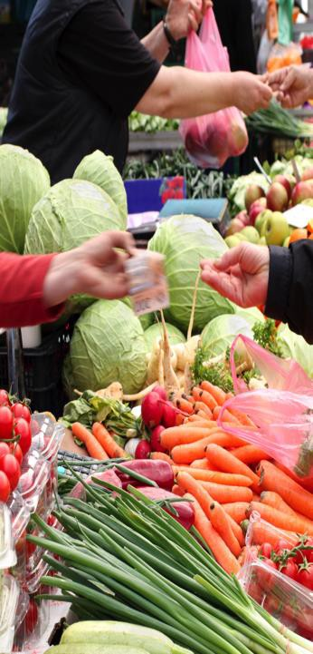
What is a “Market”
Set of all actual & potential buyers and sellers of a product
– Buyers share a particular need or want that can be satisfied through exchange with suppliers.
Many types of markets:
•
•
–
–
–
–
–
Input markets
Labour markets Commodity markets
Intermediate and wholesale markets Retail markets, end-consumer markets (e.g. food product markets)
•
Markets interrelate with each other through the
exchange process. This can occur on a local, national or even global scale

Marketing System
Environment

Competitors

End user market

Marketing inter- mediaries

Company (marketer)

Suppliers

Environment

2 Components of Markets
•
Demand-side:
Consumers, Customers, Users
of products and services etc.
- Marketers refer to the demand side as “the market”
  - Utility and Value (marginal utility)
•
Supply-side:
Producers, traders, wholesalers,
processors, retailers
- Marketers refer to the supply side as “the industry”
  - Production function and Costs (marginal costs)

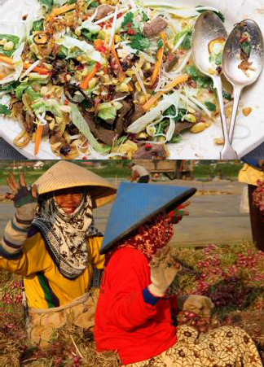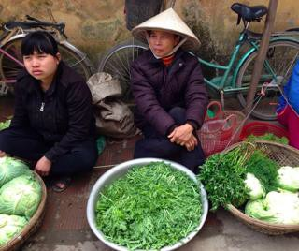
Products
‘Anything that can be offered to a market for attention, acquisition, use or consumption that might satisfy a want or need.’ (p. 9, Kotler, et al.)
Includes:
– physical objects, services, persons, places, organisations and ideas.
Satisfy consumers’ needs and wants Must be demand for product to have “value”
Vehicles for “need satisfaction”
Customer must “value”
•
•
•
•
•
•

Marketing involves
creating or refining the form, time, place and possession of commodity into a product and increasing its value to the consumer
Bringing buyers and sellers together Establishing prices
Making products more desirable Moving products
VALUE ADDING
•
•
•
•
•
•

Customer value
•
Customer Value
The difference between the values the customer gains from owning and using a product and the costs of obtaining the product.
Often times consumers perceive value differently than the product’s actual monetary value.
•


VALUE CHAIN
THINKING

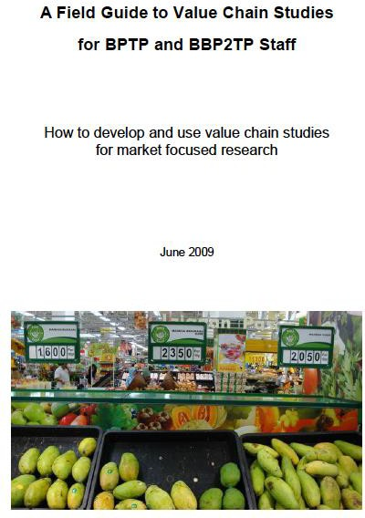
Prepared by: Prof Randy Stringer, Global Food Studies,
University of Adelaide
Australian Centre for Agricultural Research (ACIAR)

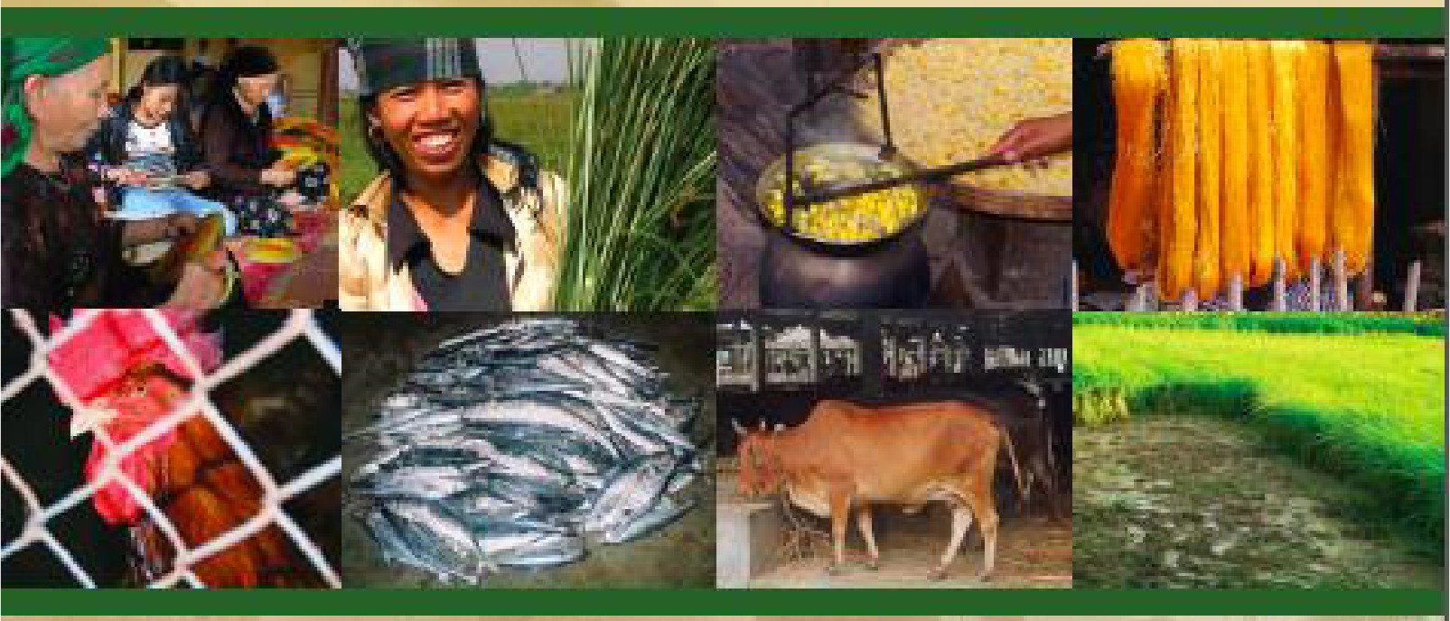
m ,
Making Value Chains
Work Better f 0 1 r the
Poor
A Toolbook for Practit ionersof Value Chain An, al ysis

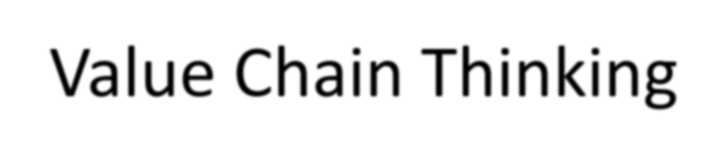
Value Chain Thinking
What is a food chain?
▪
A series of organisations that link together to deliver a product or service to a
consumer
Limitations of a traditional supply chain
▪
Each organisation concentrates on their own business and pushes the product
onto the next link in the chain
Advantages of a value chain
▪
The focus changes from supply push to consumer demand pull. Every
organisation works together to produce what the final consumer wants.

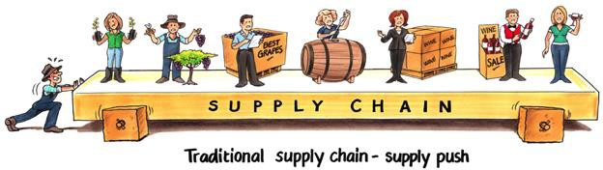
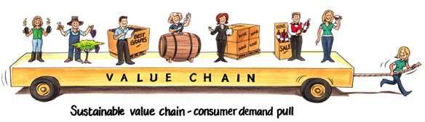

Value Chain Thinking
Traditional supply push
Value chain demand pull
Courtesy of Prof Andrew Fearne

Food Value Chain
Input Suppliers
Primary Producers
Processor
Retailer
Consumer
Information – Behavioural & Attitudinal
Relationships - Collaborative
Financial – Value Added
Wholesaler/Agent
Wholesaler/Agent
Service Providers (e.g. agronomy, veterinary, logistics, finance, waste management)

Value Chains vs Supply Chains
Supply chains
Input
suppliers
Traders, and
collectors
Wholesalers
and retailers
Consumers
Farmers
Supply side push
Upgrading options Distributional issues Governance
Input
suppliers
Traders, and
collectors
Wholesalers
and retailers
Consumers
Farmers
Market demand pull
Value chains
Knowledge, information, innovation, power, efficiency, value

A Value Chain Approach
•
Examination of interactions between different
actors (firms) in the chain and influencing the chain
- Descriptive
- Analytical
Different methods
“Right” or “Best” depends on
- What questions you want answered
- Budget (financial and time) available
•
•

Overview of Value Chain Analysis
(VCA)
VCA normally focuses on a very specific chain Product is followed through (mapped) each step in an existing chain to the final consumer
Mapping can involve determining
- Product Flow
- Information Flow
- Relationships
Used as a diagnostic tool to identify collaborative implementation projects that can benefit the whole chain
•
•
•
•

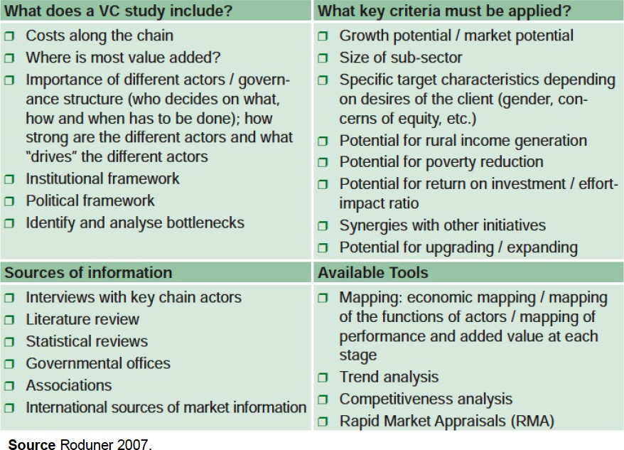
Value Chain Analysis

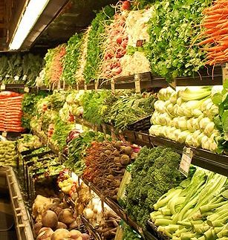
Objectives of Mapping
Value Chain
Part of value chain analysis Overview of the value chain
Identify constraints or blockages in chain Understand role of poor or targeted actors in the chain
Visualize networks and relationships Understand structure
Create awareness of all actors, markets and factors (e.g. infrastructure, policies, processes) affecting the performance of the value chain
•
•
•
•
•
•
•


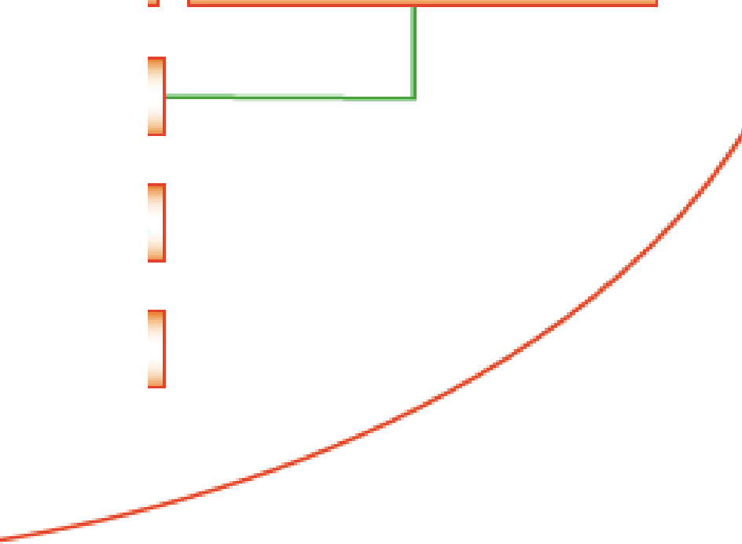
·e
n,
a
nce
U lp
g
1
A
h y·p
ot h et iea l value-chain in agr·i cultur,e
F,a nrners/ P'rodueers 1-- -
- G ove rn a 1nce
- Up,g r a d ing
- Distributional l·ssue:s
- ----1
Affe:mb, le r:s/Traders
P'roc e :ssor:s
R:,et
a
il-er:s
Tr a d er:s
Exporters
End -{u ser :s
Fioreig n Trader:s
- Goverinanc:e
- Upgrading
- Dis1ributiona I Issues
- ----1 Fio r,ei g n Di ·strib u:lio r:s
1-- -
-
Fior ,ei g rn R:e ta il-ers
t

Key Questions Addressed (1)
Who are the main actors and how many of each type are there?
What are the main activities and processes required
- E.g. what does each actor actually do? What is their “value add”?
How does product flow?
What is the volume of product handled by each actor or type of actor?
- Purchased, transformed and sold?
How do information and knowledge flow?
•
•
•
•
•
–
–
–
e.g. information about end market, prices, quality, timing, supply
Does information flow up the chain from the retailer?
Do firms share their market knowledge?

Key Questions Addressed (2)
What is the the relative monetary value of the product at each link
How many people are employed at each link?
- Socio-economic characteristics
What type of relationships and linkages exist between the businesses?
- Strength, length or history
- Power
What support services feed into the chain?
What are the key constraints faced by actors n the chain? What external factors are affecting the chain?
•
•
•
•
•
•

Market Structure and Conduct
Number of buyers and sellers
Homogeneity
– Type, variety, quality and end-use characteristics
Number of close substitutes
•
•
•
–
More substitutes means buyers are more price sensitive
•
•
Storability or perishability
Transparency of price formation
–
Open auctions or contracting
•
•
Ease of entry and exit (asset specificity)
Ease of commodity transfer between buyers and sellers
–
More mobile means more spatial price differences
•
Artificial restrictions on market
–
Government, policy, trade, collusion

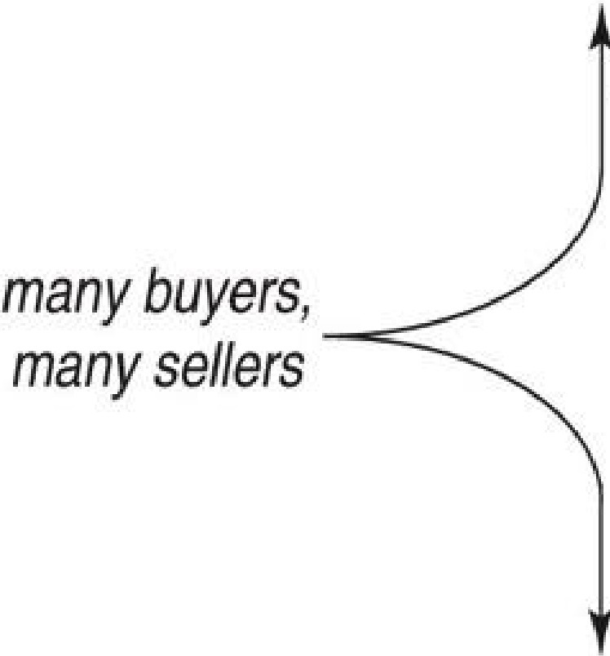
higher
price, lowerI
many buyersJ
one seller
_ IM_o,n_o_po_lY._ _
)
total surp,Jus
0 1lli gopoly
)
A thin market has
few buyers and
fe'W sellers.
Whethe r price is
m competitive
h
. h
Perfect
.
pnce, . 1., g
0
" i:
high or/ow depends on their relative negotiating power.
a..
_co_m_1 p_e_it1_oit_n-_
total surplus
)
lower price,I lower tota.l
surplus
one, buyer,
many- sellers
Mon, opsony
, Qligopsony

Food Marketing Environment
Food market is affected by many different forces
- sociological
- government regulations and policy
- international trade conditions
- science and technology
- weather and other conditions affecting harvest conditions
  - Climate change
- economic cycles
- competitive conditions
- media
•


Examples of Value
Chain Mapping

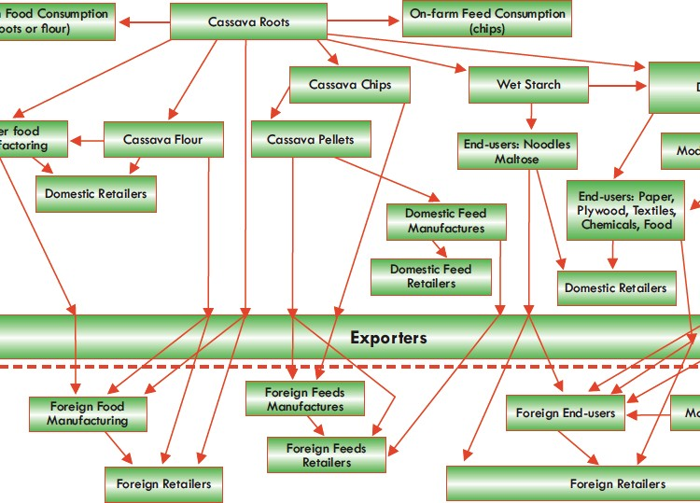
Example:
Mapping of Processes in Cassava VC

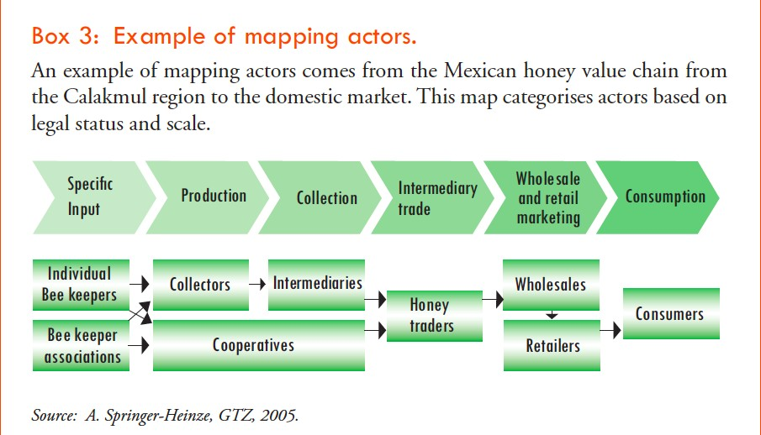
Mapping Actors

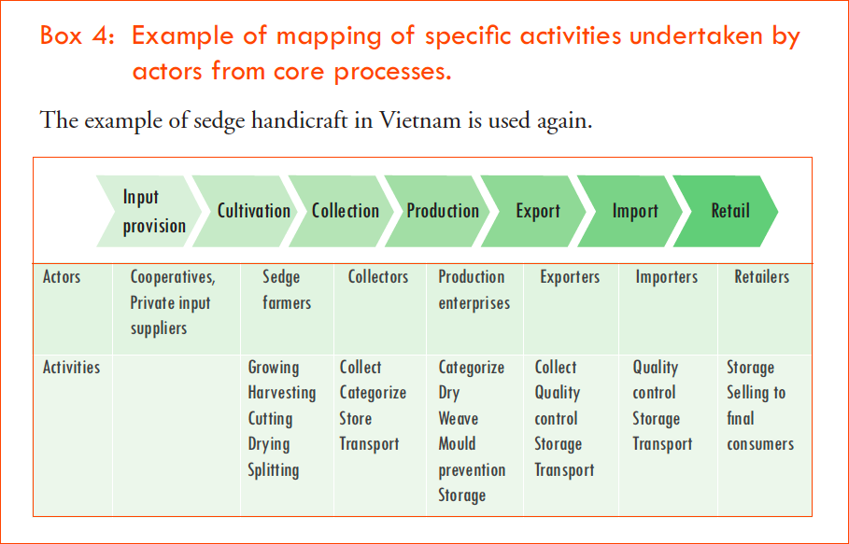
Mapping Activities Undertaken by Actors

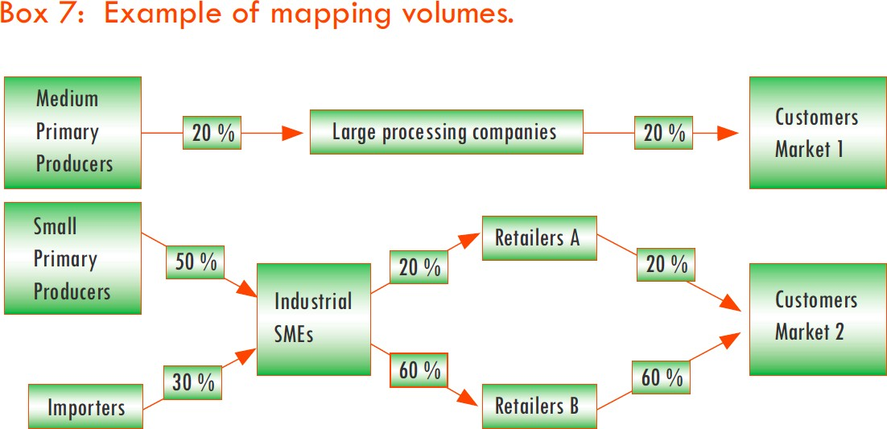
Mapping Volume by Actors (1)

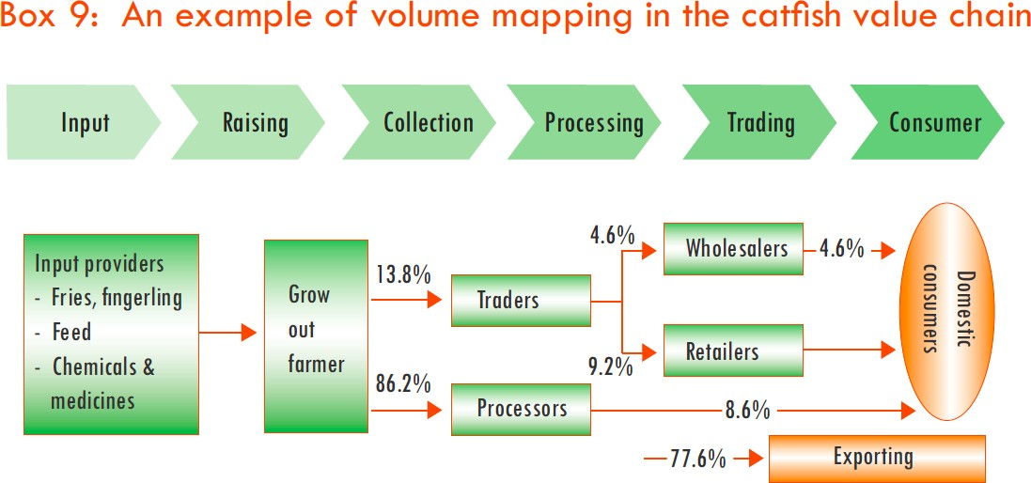
Mapping Volume by Actors (2)

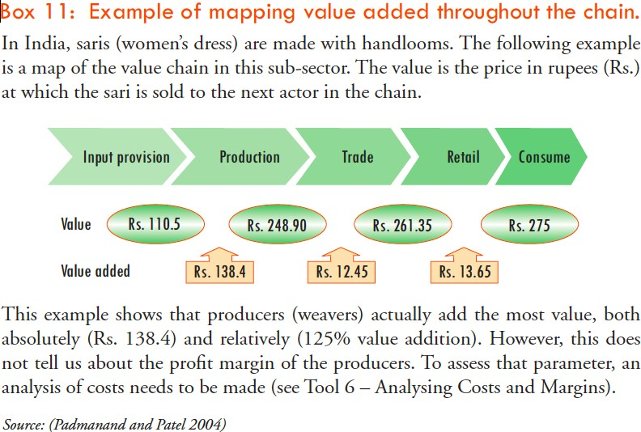
Mapping Value Adding

Interviews for Mapping
Aim is to develop a comprehensive picture entire value chain.
Multiple Stages:
Key Informant Interviews:
- identifying and meeting key partners and participants in the chain to understand any significant relationships among and between actors.
- Scoping study
In-depth interviews
- develop a comprehensive picture of the value chain from the supply of farming inputs, via production, processing, logistics, retailing and finally to consumption.
•
•
1.
2.

Main Interview Questions:
Procurement
Products & forms of product and volumes
purchased
Number & types of sellers, proportions from each Location of suppliers and purchases
What:
Who:
Where:
How much:
How much: How:
How:
Purchase price and other procurement costs
Risks (physical loss, theft, price change, etc) Technology of activity (vehicles, assets, methods)
Degree of coordination or integration with suppliers
» Credit, contracts, info exchange, resource provision, etc.
» Sources of information about suppliers, search cost
Seasonality and volatility Changes over past 5 years
Ask any surprising or interesting information
When:
When: Why:

Main Interview Questions:
Value Adding
Value added activities & volumes
» e.g Transportation, storage, sorting, packaging, cleaning, processing
What:
How much:
How much: Where:
How:
Composition of costs for each activity
Risks (physical loss, theft, prices etc.) Location of activities
Technology of activity
» assets, machinery, storage facilities, methods
Seasonality and volatility Changes over past 5 years
Any surprising or interesting information
When:
When: Why:

Main Interview Questions:
Value Adding
Value added activities & volumes
» e.g Transportation, storage, sorting, packaging, cleaning, processing
What:
How much:
How much: Where:
How:
Composition of costs for each activity
Risks (physical loss, theft, prices etc.) Location of activities
Technology of activity
» assets, machinery, storage facilities, methods
Seasonality and volatility Changes over past 5 years
Any surprising or interesting information
When:
When: Why:

Main Interview Questions:
Sales and Marketing
Products & forms of product & volumes Numbers and types of buyers, proportion to each Location of buyers and sales transaction
What:
Who: Where:
How much:
How much: Where: How:
How:
Sale price and costs of marketing activities
Risks
Location of activity Technology of activity
Degree of coordination or integration with buyers
» Credit, contracts, info exchange, resource provision, etc.
» Source of information about buyers, search cost
Seasonality and volatility Changes over past five years
Any surprising or interesting information
When:
When:
Why:

Main Interview Questions:
Business Environment
Who is your main competition? How do you compete?
What external threats do you face?
How do government policies, programs, and regulations affect you
What support from government would be useful?
•
•
•
•
•

Thinking About Market Structure
•
•
Number of actors at each stage
Type of actor (large, medium, small, vertically integrated?)
Total volume that different actors handle Market power, i.e. who has bargaining power
Has structure changed or is it changing?
•
•
•

Food Value Chain Research
Governance, Regulations, Policy
Social
Issues
(Health, Safety,
Culture)
Environmental Resource
Issues
Input Suppliers
Primary Producers
Processor
Retailer
Consumer
Information – Behavioural & Attitudinal
Relationships - Collaborative
Financial – Value Added
Wholesaler/Agent
Wholesaler/Agent
Service Providers (e.g. agronomy, veterinary, logistics, finance, waste management)

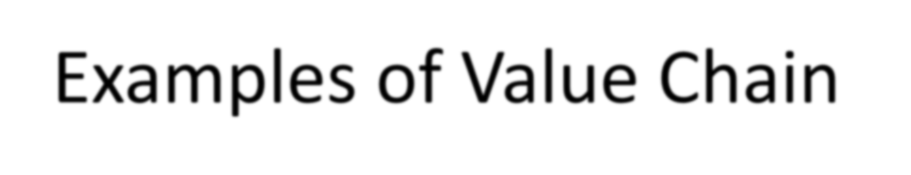
Examples of Value Chain
Mapping
Source: Craig Johns,
University of Adelaide




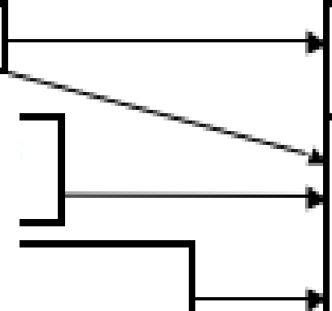
JQ
_·A, . lt
H IH c.on li!
mptlc n
ii'i
m
3l
,,,,
m
e
N.oJJ.GKSl
iOoops
8
C
::I
-....,
(J
0
._
!r,',1 1;;1
•
..'
I!!;!
§:
.I.l.l
,,:i
.i,
..!!:
;
G KSI
, C o o p s
,!i:1 -
..c :z
-
•
I
I:
d;i
!
:Ii
:E
:t,a
:::,
-
I:
'=

-
"CJ
"Q!;;I
-
>
I',!
I
i
OJI,
ee
-;,
i miiiiiil
-
<!_ Cl
"al
m,
.... :E
-
ca ,
C
C
C,orpornte
Fa ,m s
Oir.el!ln ffle ld s (IEal!l't .!l:arv.al
f .a or ia,lilf U·S.
mpar ted
a .i w M .Jbtir l ill ii □
fl lsll e dl pll'>!ld Ci t ·rt>!;
'T .:i t;:i□d M.a.l;:i:,cs:l il. A
INZ
,

m
0::
w
:Ii
::,
m
z
0
0

◄-
C

o w□ p raDaS<s:l □g;
II!; & a hll llil

e.iwJ c:a If faad ng
o,cal
Nlla1r k et ,

Processors,
Nesl le, f lil'e, sche Vlag, I d om ii , , l H/1:r aJ,a a ,
In d:olla to , S,ali1 : 1usada , Ot hers

D1 o m es,ti c
M,a- ket

Moden 1
!Reta !lers;
Hyi:ienn:am t ,
:Sui:ienn:am t ,
.. nl-m:am t

IIFood Sewv1·c, e;
IHo tetli!, · •eBl::a.111r .antli!. IHios Jta9t , Sc oo h:1

Pro dlu 1 c t s
Pas, e rit:sre MI k, UHT & .s ,·t erl lsed Ll qu id M Ik., IMIl · Powder,
sweetenedl Cond ensed!
MIii ' Cu l llllr, erJ MIi k Dr 11 ks ., Dril'n lktng
Yo gllil1u rt., Ic e ereaim

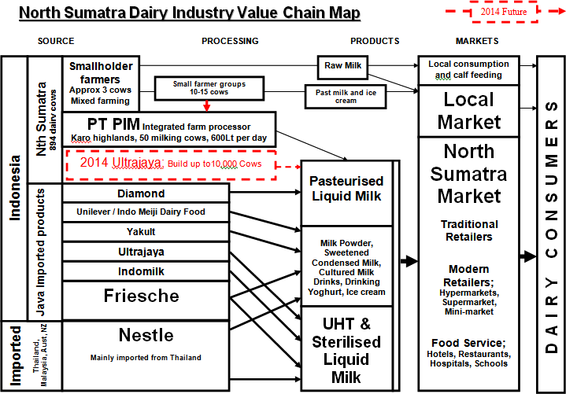
Source: Johns, Craig 2013. “Indo Dairy Trip Report Nth Sumatra / Java”

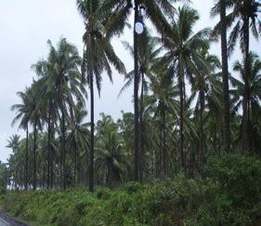
PACIFIC PROJECT
CASE STUDY

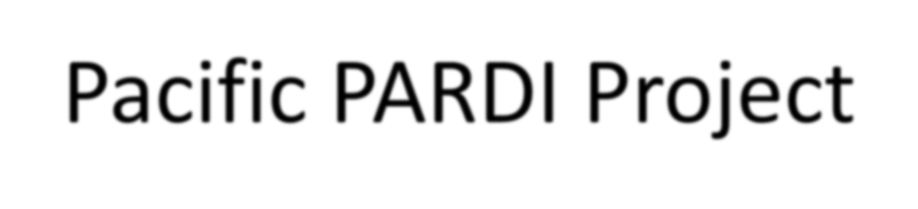
Pacific PARDI Project
▪
PARDI stands for ‘Pacific Agribusiness Research for
Development Initiative’
Funding is through the Australian Centre for International Agricultural Research (ACIAR)
University of Adelaide’s role in PARDI is to;
▪
▪
▪
▪
▪
Identify market and chains capable of increasing livelihood benefits Identify researchable constraints in these chains
Develop research based interventions with our collaborative
partners

Pacific PARDI Project
▪
Covers 6 Pacific countries
- Fiji, Vanuatu, Solomon's, Samoa, Tonga, Kiribati
▪
Across 3 broad Sectors
- Crops, Forestry and Marine
▪
Activities are both sector and country based i.e.
- Sectors; Canarium Nut, Cocoa, Pearls, Tilapia, Sea Cucumber, Taro, Breadfruit, Vegetables, Tamarind and Teak
- Cross sector; Fiji Retail Transformation

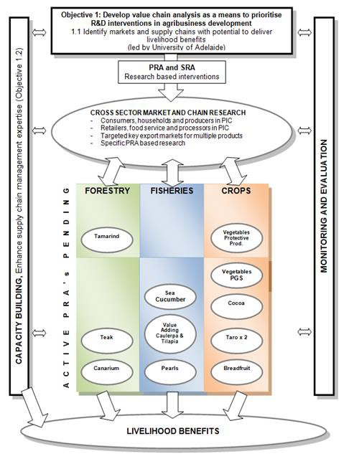
PARDI Framework


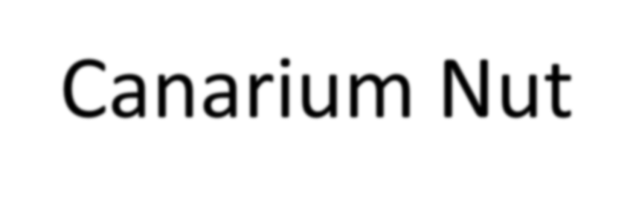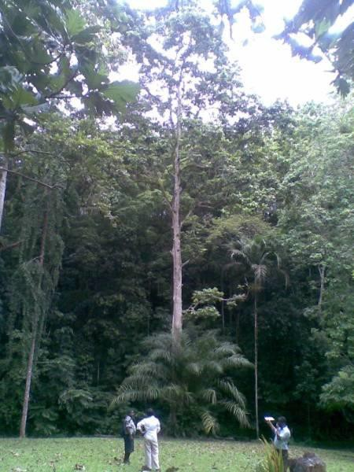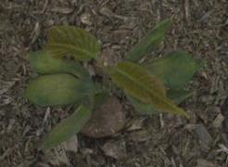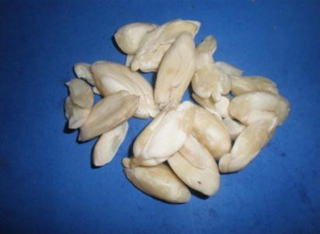
Canarium Nut
▪
Grows throughout the
South Pacific
▪
▪
▪
Vanuatu
Solomon Islands
PNG
▪
▪
Traditional cultural food
Traditional processing techniques

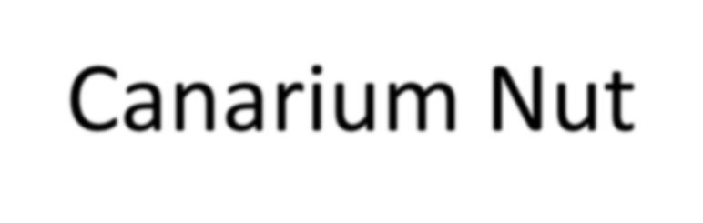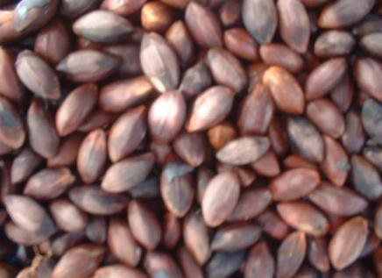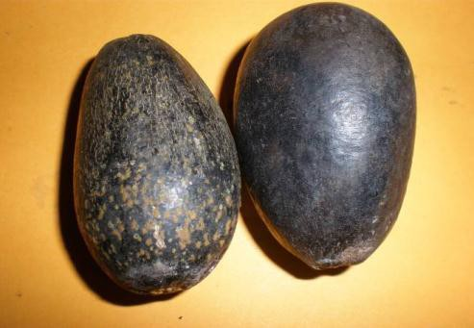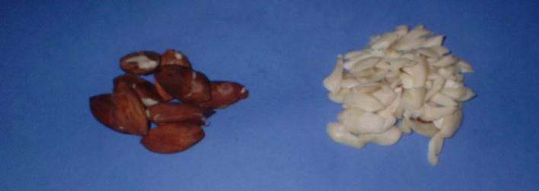
Canarium Nut
Nut- in- pulp
Nut –in-shell
Kernel
Kernel-in-testa


Solomon ls,lands Canari'um Nut
Industry
MARKETS
SE0 0 1NDA RY PROCESSING
-
F,oo dl Se rv ice, HoteIs, Cafe s, R.estatuarnits
I
■
I
■
Shane Tat ua
C om m un ity Based
r gan i sat i on
,(CBO ' s)
......
-
-•
>-
rt:
..
Mara:ghoto
_..,;;.
1---._
O
s
■
<a(
--
C
J ed CITT1 O r ga n i c
-
-
rt:
-■
Superm a r ets,
--
0:::
w
:!:
::J
en
z
0
0
SmalI Rietaile rs
Var iv.ao
-
-
n.C'ii
z
C -
0:::
-
Frarngiparni
.iJ;;e_u ea mi
•
wzoo
:!: <a( a:,
1Gentm l Mar et Sm alI Sta lIs
CI IC:ICI
w
z u
0:::
C] IC] CJ
1
<(00
Lill.. ₋ _{r,:}
I- _{CL}
u
::J)
I-
::J
z
....
...
C
ONI SU
M
E W
D IT
AT
HIOME, INI
VILLAGE OR BARTERED
C
0
HIIINI OR
, ( Raw
B E TWEEINI VILLAGES
, Roasted or Value Addedt
rt:
....._ I
CL
II
...... .
HARVESTED BlJJrf REJIE,CT ED
."."." .I NOT HARVESTED
II
I COMME-RCI.!ti . lli"OJNFIDENCX

u.,
I-
::J
z

Lill..
0

w
:!:
::J
...J
0
>

...J

<(
I-
0
I-



Vanuatu Canar ium Nut Industry
FARMERS
MARKETS
C1<llcs.met i e s IMa n u f act u r e r s 1to LIII Volcan ic Earth, Ib..@ Summ it, Bru ce Hann et
-,
J_
I
FO OD SER'ilil.C E HOTELS
00
I-
::J
z
:J
.
L APITA CA FE
nuts, bi.so u i ts and (!Iii )
""
C
(
· ·
--'
"-.
CHA!IN RETAJIILER S
■
-
' "'
-
.-.
- .
IIINll "1I1D UAL REf AIIL OUTLETS
SOUTH PAC.IFIC. NUTS
Ortai[]l sn.igar snack 11 uts.)
■
0::
w
..
0:: e
'-
W CL
-
■
u..
0
KA.VA STORE
■
I I
I I
I
ACTIV (.sn ack nuts and (]) ii )
::J
00
z
AC ll lrV st o re
..._
w
I
I
1§
II""
0:: .'I.:!
<( ...
..I
S1MALl!.JEIR IP1R!OOESSO RS
I
::J
..J
0
>
0
0
URBAN MlARKEI S
u.. -
V
-
.1.......
FARMER S SE LL A.S NIU T' IINI .SH E LL O R AS RAW KERNIE L .S
E
-
-
I-
::J
z
RURAL IM IAR K EI
S A N D SI AL L S
lJII"'"
:,-
.I!....
-
..J
1 0
0
NSUM ED AT HOME, IN VIL LA1 GE OR BARTERED WITHIN OR BE TWEEN
<(
I-
0
I-
VILLAGE S 1{Ra
w o r Value A(l1d, 1edl
:;_.
-
IP"
-
I
H A R V E SI ED B U I R E J ECIED
11"'" ■
I
.
Iii..
NOi HAR.V E SI ED
,..,

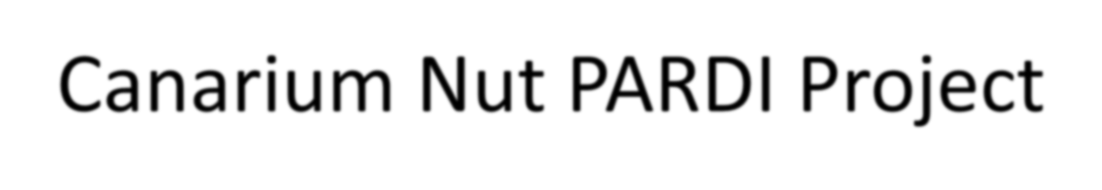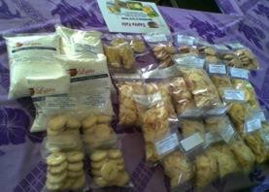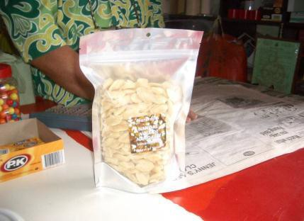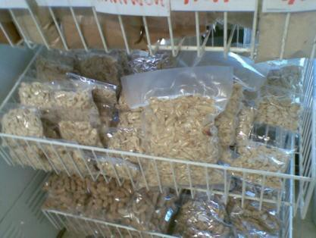
Canarium Nut PARDI Project
Priority issues and opportunities
▪
Unfulfilled domestic demand
Processing of the nut to stabilise it to ensure
consistent quality
Need to know more about consumer demand
▪
▪
Target Markets identified
▪
▪
Domestic Market; tourists in Vanuatu
Domestic Market; food service and hotels in Solomon Islands
Export Markets; to be explored more once domestic
demand is fulfilled and product quality improves
▪

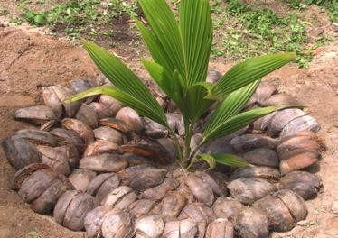
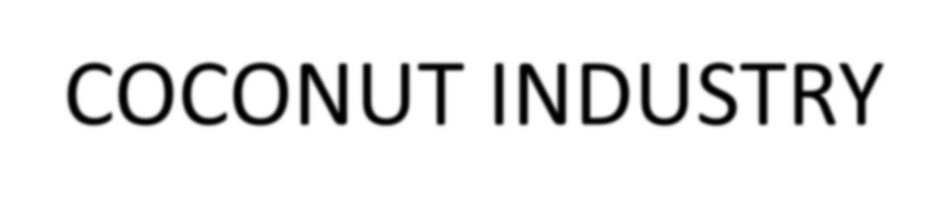
COCONUT INDUSTRY
▪
Grows throughout the
Pacific
▪
▪
All of the islands Specifically looking at Fiji,
Solomon Islands, Samoa and
Vanuatu
▪
Traditional uses
▪
Various products made
from the tree and the nut


COCONUT PRODUCT LIST
▪
Virgin Coconut Oil Edible
▪
▪
▪
Nutraceutical, functional food, health supplement
Ingredient in salads, smoothies, ice cream, butter replacement, confectionary etc Cooking oil; roasting, frying, baking cakes, popcorn, crackers, cookies etc
Virgin Coconut oil Inedible
- Soaps, cosmetics, spa products, body lotions etc
- Treatment of skin conditions and to promote hair growth
▪
By products
- Pressed dry cake for animal feed
- Shells, handicrafts, charcoal, activated carbon, biochar, coir fibre
▪
▪
Whole nuts, coconut water, milk, sugar, powder, cream, honey,
flour, dried pieces, biofuels, timber


FIJI COC,ONUT INDUSTRY
lflRlMAJ,t:_'t lflft:.OCIE:SSlttG
(closer to 1he grower)
SIECOttDAJJ',t:_'t lflR.OCIE:SSlttG
(mo re centralised and Iinked to the market)
lfllRODUCl S
MA.RKIE:l S
-.I
I-.
Adrian Tarte Organic 6.JIM vco
0/S Processoc
Virgin Coconut Oil
Organlc/H ACCP/Fll lrirlld8
RETAIL
V'J
z
'
cI-:::
_.,
,.
HEALTH SHOPS
_.,
(f)
PURE
FIJI
0
-
a.
-
Harish aiIM vco
-
I-
u
0
PHARMACY
X
LLJ
-
-
I-
ccw
-
_.,
_.,
_.,
_.,
Food:
llg8 rbon 1'0r I183I1:n COOMlng OIi
Food lngrMl8nt
r
■
Jagdish BJIM vco
ROUTE TRADE
.
.. ■
RETAIL
Cl
.
>-
...I
0.
0.
::::,
en
- ■
■
G. Haynes aw. ..-o:.
u
-'
0
cc:
I-
z
j:::
_.,
HEALTH SHOPS
Body:
I-
I-
V'J
.. ■
■
.
LLJ
Women Groups
:5;
0
C
PHARMACY
C01m81:lc1
Soap El:id;• ol I Spa
(I..
cc -::{
...J 0
a.
:r:
Mokosoi
-
l?
IDD3I m3r1t ti:, TDUr1 Q"T1 Tnld In
l-ln+.lr: i:.lmnr-+RTI
I-
Peni vcor8ta11
By-Products
[r,' ClM 8, Sil 811, COIr Abr8
Whole of Nut Approach;
Anlm 3I 1'Md, Soap, Sll8 II ll3ndl crart1, a1moal, Act! 3bd Clrbon (fllbr 1:i. ,
MUICll. Eco m 3h. I ut flllH
_.,
■
r:-.
z
Others
--- I-
-
-
0
I-
::::,
z
0
0
0
0
V'J
c:::
u
0
u
J
I
-
- -
Sport & Hnltll dr1nM I, Vln8Q3 r
Mobile Unit
-
Coconut Water
I
Cl
-
LLJ :z
c-
...J ll.
ll.
0
??
Sap Sugar
??
-
-
I
cc:
w
??
??
-
BIIVH,:, MIi , MIi PD'.".'ll r,
i""rll:.m Rnm·
I
I
I
0
:::c
OJm 811:lc Go t Po \'/H, air
1, G8nH3tori.
Outer Is. cr Central
- ■ ■
- ■
""
I
...J 0
(f)
PalITW11ood Fiji
Local I E1port to Fr.in C8 & Au1t ( El:iral)
Tirrber, floor1ng, 1'uml"b.Jr8
■
...J""
cc w
:5; I-
z
0
u
....
I
■
others
...
-
Export Processor
-
RBD & Crude Oil
-
-
....
I
- Export Processor
...
CMFL

:z
V'J
I
Copra
-
■
I
Ir
Biodiesel

??

VANUATU C:QC,ONUT INDUSTRY
,
GR
OWER
PRIMAR¥ PROCESSING
t0itne grower)
Sl!C0 1 ND AR¥ PROCESSING
, ce_111,traI edan dIinlil:e.dtlili tne mart e.t)
PR01 DU CTS
MARK.ET S
,
.....
.
.i
,C,o p ra
,,Co p ra Traders
...
Export
C
0
I
I
-
:.:::;
I
IH
I
u
::I
00
I-
u
::J
0
0
0:::
Cl.
Biodi,esel
D[lfltesfic Govl:,IP owe
r , Ca
r s, Genera fo rs.
.
'C
...
0
D..
...
m
COPSL
Copra Mill
Export
..
I
•
lo..
C.
Crude Oil
r-+
_.,
Kl
0
0...
·u
C
C1)
,:(
...I
0
I
•
Qll
3:
0...
.A111i m -'II Frere,cill J N7
F xncrrt ff islil,?
Copra Meal fCake
C,
F""lil
_.
Virgin Coconut Oil
RETAIL
_.
I-
HEALTH SHOPS
::J
z
0
u
0
u
0
D..
wX
-
PHARMACY
I
.,
I
•
I
•
Food:
II nge sfi DJ1 fo:r h ea llth Coo k ,i nEJ,o i I
IF ,oo cl,i n 1:1re d ie nt
R:OUTE TRADE
HEALTH SHOPS
-
_.,
_.
0
Body:
Cosme ti c s S,oa ,p IBoclyo il
S:pa
I-
RETAIL
(I.II
w
0
C
0::::
w
::ii
::J
00
z
0
u
PHARMACY
I
.,
....
f---t
IUH:al 111131'M!!11. T OUJlfilll Tralte Ill 1Hn te111. AllpOlit iatc
Oth er
By-Products
Dry Cake, Sh,ell, Coir Fibr,e
I
.,
Animal feed, Mulch,
Activated carbon, Flour

I
C O:M:ME R.CIAL IN COl..T. IDEKCE
I

GRANT BOWKER
vco Mill

-

rCe:: (.)
·(-.) ·q-::
(.)
<( a".'.

Sec,o nd ary
Pro c ,e sso rs lik 1e
, v o l ca n i c Earth

Small Sc,ale V1OO Pro d u ,c ,e,rs
,(DNlm!Y i n Port Vil a
using DME)
a, Cl
Qll C
u i::'
C
Qll C...
Cl m
,:( C.
...I 0
0 0

>-
...J
a.
a.
::::)

(I)

I-
::J
z
0
0
0
0

(I.II
z
0
-
I-
,:( w
I-_,
z 1-
I-
,:(

...I
0
D..
:I:

-- I-
-
(I.II

ct::
el
w :z
c_
...I Ill..
o a.
0
:::c
...I
0
...I

,:( w

I-

(I.II :z
-

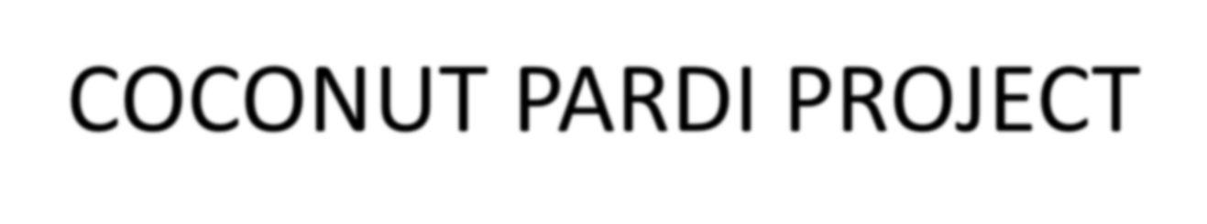
COCONUT PARDI PROJECT
Priority issues and opportunities
▪
▪
Research on health benefits
What is the point of difference to competitor countries
▪
Whole of coconut approach. Produce a mix of products depending on
location, size and the business and social justification
Target Markets identified
▪
Domestic Market; locals and tourists through health store, pharmacy, hotels
etc.
▪
▪
Niche Export: high value differentiated products
VCO consumers who are informed, health conscious and supportive of fair
trade, organic and the Pacific brand

Summary
•
•
•
Value Chain Mapping is part of Value Chain Analysis
No single “right” way to map Useful tool for identifying
–
–
–
–
–
–
Actors
Product flows Information Flows Relationships Issues in the chain
Opportunities for improvement
•
Government, Industry Associations and Universities can
play a role and all benefit from working together

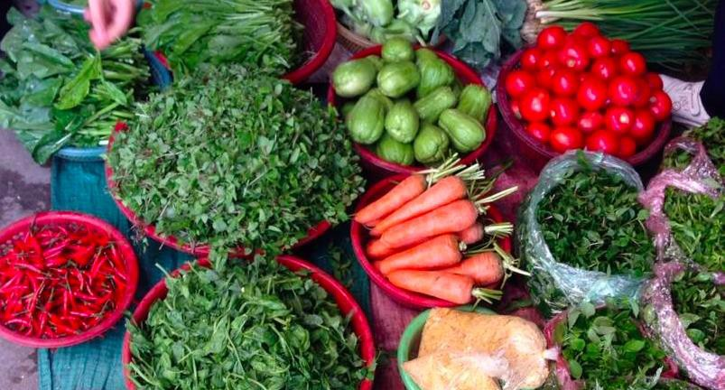

References
•
The Operational Guide for the Making Markets
Work for the Poor (M4P) Approach, DFID & SDC, UK and Switzerland, pp7-70
Kaplinsky, R & Morris, M 2001, A handbook for value chain research, IDRC.
Springer-Heinze, A 2007, ValueLinks manual: The methodology of value chain promotion.
Webber, M 2007, Using value chain approaches in agribusiness and agriculture in sub-saharan
•
•
•
Africa
World Bank

