
3
C h a p t e r
Value chain mapping: understanding relationships
63
Chapter 3
Value chainmapping: understanding relationships


Value chain mapping: understanding relationships
Summary sheet: value chain mapping
3.1 What is a value chain map and why is it useful?
Value chain mapping, research and development: the context
Value chain mapping is often confused with value chain research or development itself (many value chain guides focus to a large extent on mapping rather than the actual purpose of mapping: facili- tating value chain development). However, drawing a value chain map is only a tool, an aid to illustrate (and perhaps simplify) the complexities of sectors and their value chains. Value chain research needs to go beyond the simple mapping of value chains in sectors: it needs to understand the nature of relationships between market players (see nextChapter 3); it needs to understand the reasons for constraints that are preventing value chains from achieving the desired outcomes (step- ping-up strategies); it needs to identify alternative opportunities for income and employment creation (stepping-out strategies). Based then on the findings of the value chain research, strategies can be formulated that that will eventually lead to value chain development (seeChapter 6).
64

Summary:
This chapter briefly describes the construction of two different value chain maps, which each ful- fil different purposes:
- Value chain as flow chart:this value chain map looks at the different functions in a value chain and illustrates them as process leading from conception / raw material to final consumption. This very generic map can then be used further for creating an inventory of market players along the chain.
- Value chain as grid chart: this map illustrates the different market channels within a sector, thus underlining the fact that value chains are never simple linear relationships, but rather a complex system with market players feeding into different chains and markets. This map is important in value chain research and analysis (Chapters 4 and 5) in order to understand the nature of specific relationships – value chain governance, but also to formulate appropriate intervention strategies that effectively target specific channels.

Outcomes
- A value chain flow chart
- A value chain grid chart
- A first inventory of market players

Value chain mapping: understanding relationships
What a value chain map is useful for
As a standard tool in value chain research and analysis, a value chain map is not an objective in itself, but a means of realizing these objectives. It has very practical implications for a value chain initiative:
•
It helps to illustrate and understand the processby which a product goes through several stages until it reaches the final customer (i.e. the core transactions). Knowing about the different levels in a value chain is also a precondition for identifying bottlenecks that are preventing the achieve- ment of certain targets (e.g. the five drivers of value chain development, seeIntroduction and Chapter 7).
A value chain map can serve as a way ofidentifying and categorizing key market players. Such value chain maps (or inventories) have been used in projects to invite market players to various workshops and events, arrange interview appointments with them or form steering groups com- prising key market players.
Apart from businesses involved in core transactions, value chain maps can also illustrate which other supporting organizations(government, BDS, NGOs, associations, etc.) are available, and which value chain levels they concentrate their services on.
If a value chain initiative intends to explore market opportunities, value chain maps canshow up different market channelsthrough which products and services reach the final customer. These maps can also provide additional information on the relevance of individual market channels and the nature of relationships (e.g. number of competitors, size of market, number of workers, value chain governance, etc.)
A value chain map can help companies investing in Emerging Markets to orient their activities, i.e. to identify important stakeholders, possible marketing or supply channels, competitors, weak links in the chain, etc. In other words, it is a who’s-who map.
•
•
•
•
25Taken from McCormick and Schmitz (2001): p. 39
65
Chapter 3
Value chainmapping: understanding relationships

Definition of value chain mapping
Mapping a chain means creating a visual representation of the connections between businesses in value chains as well as other market players. In its simplest form it is merely a flow diagram (i.e. illustrating the core transactions of value chains). More sophisticated versions show that some enterprises differ in size and that some connections are more important than others; and they help to identify bottlenecks and leverage points. Value chain maps help to get a quick grasp of complicated realities, also illustrating, for example, how core transactions in value chains are connected with the market players in the immediate and wider business environment. 25

Value chain mapping: understanding relationships
Box 3.1: Attempts to standardize value chain maps
3.2 How to map value chains
Constructing two value chain maps:
Constructing a map is not a quick job. How long it takes depends on how much you already know about the enterprises and workers whose situation in the (global) market system you are trying to capture. 26 In this guide we suggest the construction of two value chain maps, which have proved useful in ILO projects:
1. Flow chart
- A simple flow chart that illustrates different levels in the value chain and serves as a basis for an inventory of market players as well as an analysis of opportunities and constraints by value chain level27, or for showing key information for each level (e.g. prices).
- Grid chart
2. A more sophisticated grid chart that illustrates different market channels and includes further relevant information such as size of enterprise, number of workers, nature of relationships, etc.
Value chain maps evolve during the value chain research
It is always easier to start with a simple flow chart and subsequently expand the map to include more information and to expand it to show different market channels, etc. The construction of value chain maps therefore spans the research period of a value chain initiative: starting with a rough ini- tial map in the build-up phase (Chapter 1) and ending up with a more detailed and precise map in the analysis phase (Chapter 4).
No one-size-fits-all map ? you have to experiment
There are of course many different ways of constructing value chain maps, and the reader is encour- aged also to look at the references given at the end of this chapter – but most importantly: to experiment; to adapt the value chain map to the local context and needs of the value chain initia- tive. There is no one-size-fits-all template for value chain maps, but this chapter can give some guidance on how you might go about constructing your map.
26McCormick and Schmitz (2001): p. 39
27Analysis of opportunities and constraints (similar to a SWOT analysis) by value chain level is referred to as “GAP-analysis” by GTZ. For reference see Richter, Peter (2006): Value chain promotion and business environment reforms – experiences from Sri Lanka, GTZ-Integration, Colombo, Sri Lanka.
66

There are currently attempts under donor agencies tostandardize the format of value chain mapsin order to find common ground for understanding and to facilitate the exchange of learning experi- ences. The German Technical Cooperation Agency (GTZ) has played a leading role in this. To read more about standardized value chain maps, please refer to
- GTZ (2007): ValueLinks Manual – The methodology of value chain promotion, German Technical Cooperation (GTZ), first edition, Eschborn (Germany). Available from
www.value-links.org
- VandenBerg, Michael et al. (undated):Making value chains work better for the poor: A tool book for practitioners of value chain analysis. Available from www.markets4poor.org

Value chain mapping: understanding relationships
3.2.1 Value chain map as a flow chart
Definition of a flow chart for value chains
A flow chart illustrates the process by which a product or service goes through several stages in the value chain until it reaches the final customer.It is a very simple way to start mapping value chains and can later be further expanded by including more information about each value chain level in the flow chart.
Using a value chain flow chart for an inventory of market players
Initially the flow chart is useful for creating an inventory of market players, which again is useful when sending out invitations for various workshops or arranging appointments for interviews with key players from different value chain levels and supporting organizations. This should be part of the build-up stage of a value chain initiative (seeChapter 1) and done before starting with the more elaborate value chain research (Chapter 3).
Adding information to the flow chart after value chain research
During the value chain research then, you will gather more information that helps to understand particular opportunities and constraints for each value chain level and the relationship between businesses of different levels. You might collect data, for example, on prices and value addition, production and delivery time, number of workers/target group, etc. All this can later be added to the flow chart, and presented in a comprehensive way to your stakeholders.
The following steps guide you through the construction of a flow chart for value chains:
67
Chapter 3
Value chainmapping: understanding relationships

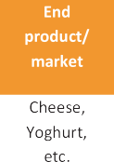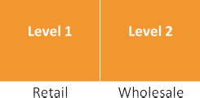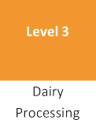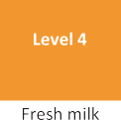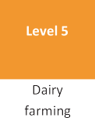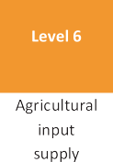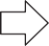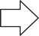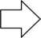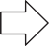
Value chain mapping: understanding relationships
68
S t e p 1 :
Mapping value chains through a simple flow chart
Begin by identifying the core transactions in your target sector – i.e. the simple process from design/raw material to the end customer: first identify the end product (or service) that will be going to consumers. Write down the name of the product as well as the target market in the first column in Box 3.2 below.
Starting with the end product/services and identifying steps for getting there
Once you have identified the end product and market, ask “What happens to the product (or service) just before it gets here?” Write this answer into the next column inBox 3.2 (‘level 1’). Repeat this question until all the levels from supply (design, raw materials, inputs, etc.) to production, marketing and distribution have been captured. Initially only enter the functions of each value chain level in the columns, for example: distribution, marketing, packaging, transport, processing, collection, farming, input supplies.
Keep it simple!
Note that you often have to simplify the process by grouping related activities and functions under one value chain level (for example heating, flavouring, cooling, packaging, etc. under “chocolate pro- duction”), and by drawing a line which limits the value chain to a certain number of levels and location (suppliers for example have their separate value chains, and could therefore simply be grouped under the label “suppliers”) – otherwise your value chain map will become too complex.The purpose of the flow chart is to focus only on core transactions within a sectoSr.o keep it simple.

Box 3.2: Mapping value chain levels through a simple flow chart

When and where to map the flow chart, and who should do so
The mapping of value chain levels through a simple flow chart should be done as early as possible, for example at your first workshop with the core and support teams (seeChapter 1, Section 1.2.2, Event 2). The presence of participants from your target sector – i.e. your support team – is of partic- ular importance, as they will be able to provide inside knowledge that will make the mapping exercise easier. The steps mentioned above should take you no more than half an hour. You might also make use of the card methodology as explained inBox 2.5 in Chapter 2 or a flipchart.

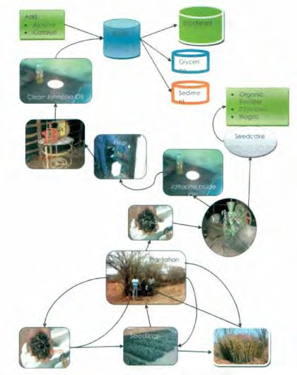
Value chain mapping: understanding relationships
Box 3.3
Examples for simple flow charts from ILO BDS, Zambia
Source: Sinkala and Chitembo (2007): An analysis of the global jatropha industry and case study of the local value chain in Zambia, International Labour Organization, BDS Zambia project, Lusaka (see www.bdszambia.com).
69
Chapter 3
Value chainmapping: understanding relationships

Value chain mapping: understanding relationships
70
S t e p 2 :
Creating an inventory of market players
Having identified the core transactions of a value chain in a sector – i.e. the steps that lead from design/raw material to the final products – you can now use this flow chart to identify and map key market players. This should also be done as early as possible in your value chain initiative, as this inventory of market playershas a practical use that helps you to organize workshops, interviews and focus group discussions for your value chain research.

1. Identify names of businesses in core transactions
- Look at your flow chart above and identify what businesses are involved in core market transactions in the value chain (i.e. within the geographic area that you are analysing). These would probably be mainly private sector enterprises, ranging from micro and small over medium to large-scale national and international companies – but they could also be government-owned companies and organizations. The purpose of this exercise is to identify those enterprises that are directly related to one (or more) levels of your value chain. It is therefore important to be as precise as possible: write down all the names of enterprises that come to mind in the first column of Box 3.4 below.
If contact persons and addresses are known, then add them to the name of the enterprise. Examples are given below. Together with your core and support teams (seeChapter 1) try to find names for every level of the value chain.
- Identify names of supporting organizations (other market players)
2. Remember our market system model (Introduction, Box 4 and Chapter 8)? In order to facilitate systemic change in the market system, we need to know the other market players who are not directly involved in core business transactions within the value chain. These are government authorities and institutions, business and worker membership organizations, business service providers, informal networks, NGOs, etc. all of these organizations have an important role to play in one way or another in your target sector (e.g. government laying down laws and regulations). So fill in the names of all supporting organizations that come to mind in the third column of Box 3.4 below. For example, ask yourself: “What kinds of business services are available for dairy farmers?” Repeat this for every level of your flow chart.

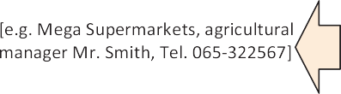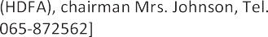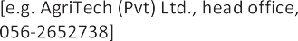
Value chain mapping: understanding relationships
Box 3.4: Inventory of key market players
71
Chapter 3
Value chainmapping: understanding relationships

Value chain mapping: understanding relationships
Box 3.5: Using the value chain inventory to publish information on available BDS for SMEs
Source: For more information see intervention reports for various sectors, available from www.entergrowth.com
72

The Enterprise for Pro-Poor Growth project of the ILO conducted a value chain initiative for the coir industry in the North-Western Province of Sri Lanka. Coir is a fibre extracted from coconut husk, which can be used for various purposes ranging from simple ropes and yarn, brooms and brushes, and twisted and rubberized fibre for car seats to more sophisticated geo-textiles used for soil erosion control and road construction.
The coir industry consists of large export companies that produce many products themselves but rely to a large extent on supply from small and medium-sized suppliers (coir mills where fibre is extracted, as well as small industries producing preliminary goods). The industry faces severe supply shortages, since the productivity of small and medium enterprises in the sector is low, quality is poor and bad working conditions are preventing the recruitment of skilled labour. The industry is now facing competitive pressure from other countries also entering the global market for coir fibre products.
One reason for the poor performance of small and medium-sized enterprises at the lower end of the value chain is the lack of access to information on available business development services (BDS), such as management training, financial services, input supplies, technical services, etc. Since SMEs do not make use of such services, their performance is poor.
The ILO value chain initiative together with its local partner, the Industrial Development Board of Sri Lanka, therefore compiled and published a leaflet giving information on all relevant BDS providers and input suppliers, their services as well as contact details. The initiative then distrib- uted these leaflets through various associations in the industry. This was not so difficult, since the value chain initiative had already collected the names and contact details of various key market players in its value chain research.

Note that you will not be able to immediately come up with all names of enterprises for every value chain level at this stage. The names gathered here, are just a start and you will definitely come across more during the course of your value chain research. However, you will need some names to start with, which is why it is so important that members from the target sector participate in this mapping exercise.
The construction of an inventory of market players should therefore be done after the first step above (flow chart) in the same team workshop – again by using cards or flipcharts, for example, as a partic- ipatory workshop methodology. The exercises should take you about one hour. Once you have gathered names and contact details, you need to continuously update this value chain inventory in the course of your research. The example below shows that it can become very useful later on.

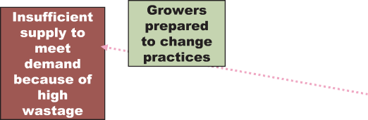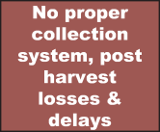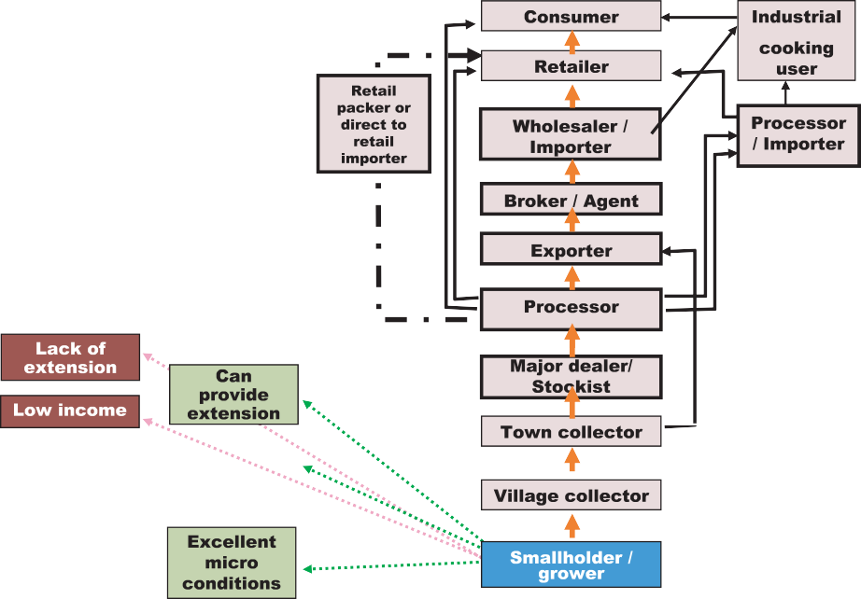
Value chain mapping: understanding relationships
Box 3.6::
Flow chart showing strengths and weaknesses per value chain level
28GAP analysis: Where in the value chain are the bottlenecks that are preventing the sector from achieving optimal performance? The analysis tries to identify gaps in the value chain, for example, that are obstructing SME access to market information, or knowledge and skills, or business services, etc.
73
Chapter 3
Value chainmapping: understanding relationships

1. Strengths and weaknesses of spice growers (small holders)

S t e p 3 :
Using the flow chart to illustrate opportunities and constraints (GAP analysis)
A simple flow chart of a value chain can also serve as an illustration for opportunities and constraints (or SWOT) identified at each value chain level. This method has been used by the GTZ in Sri Lanka, summarizing the main findings of a GAP analysis28 for the value chain. Adding this information to your value chain flow chart will require some research – i.e. you will only be able to complete the chart after conducting thorough value chain research (seeChapter 4).
Box 3.6 below gives you an example of a flow chart showing the strengths and weaknesses of two particular levels in the Sri Lankan spice sector value chain.

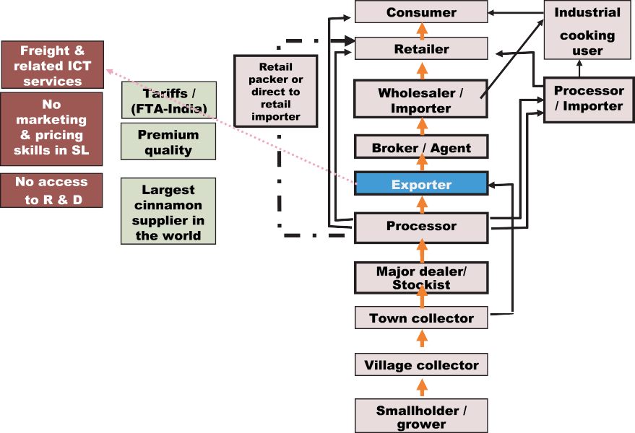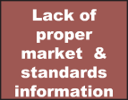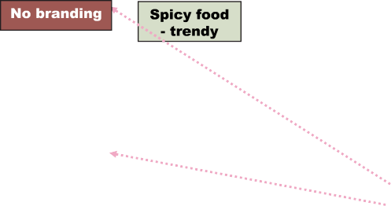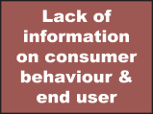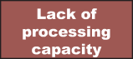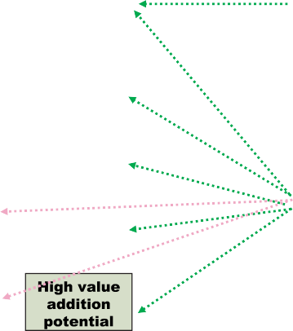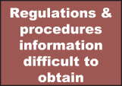
Value chain mapping: understanding relationships
Source: GTZ-Integration, Value Chain Promotion Component, by Gratian Peiris, Colombo, Sri Lanka. Also see: Richter, Peter (2006): Value chain promotion and business environment reforms – Experiences from Sri Lanka, Colombo.
74
S t e p 4 :
Using the flow chart to illustrate relevant information
Whereas the example above in step 3 has shown how to use a flow chart to add qualitative informa- tion on opportunities and constraints identified during the value chain research on particular levels, you can also use the same flow chart to add quantitative information. For example, this could be the number of women working at particular value chain levels, average income or net profit per level, sales prices, the number of fall-outs due to health hazards at work per level, working hours, etc. There is no limit.
The following is an example from the chocolate value chain: it looks in particular at the production and retail level – i.e. raw material sourcing (such as cocoa beans), preliminary processing, shipment, storage etc. are not considered. The example tries to explain, why a consumer in Germany has to pay 69 cents for a 100 gr. chocolate bar which he purchases at the supermarket.

2. Strengths and weaknesses of spice exporter

Value chain mapping: understanding relationships
Box 3.7: Example for adding more information to a value chain flow chart
Source: Gillies, Judith-Maria (2004): “Viel Glück, wenig Gewinn ”, in: McK Wissen 11, December edition (German article). By McKinsey.
A flow chart is a simplification of the value chain process
Market realities are complex, and a flow chart as explained in this section is merely an abstraction – asimplification of theprocessthat brings a product from its conception to the final consumer. This is useful when you need to capture the broader picture. It helps you to
•
Identify the main market players – from businesses engaged in core transactions to relevant government institutions, membership organizations, business services, NGOs, etc.
Get an overview of what is happeningin your target sector, i.e. where in the value chain the main opportunities and constraints (bottlenecks) lie, that are preventing the achievement of certain economic targets.
Organize data and informationwhich you have collected in your value chain research, illustrating for example such things as value addition (cost factors, profits, prices, etc.) by value chain level.
•
•
75
Chapter 3
Value chainmapping: understanding relationships

A inistration, int st Rteailer p fit Ingr i ts L istics 2 c ts Rnet, e rgy 1 c t 18 c ts* Pr uction 2 c ts Pers nel 5 c ts
6 c ts Ta s 8 c ts Administration 1 c t 2 c ts

Pr ucer p fit
Packagi 3 c ts AVT
4 c ts St k 5 c ts
Advert ng, mar ting 4 c ts 8 c ts
Pr uction eRtail

* of whi 11 c tsraeapidofrococa beans

Value chain mapping: understanding relationships
3.2.2 Value chain map as a grid chart
Definition: Value chain map as grid chart
Agrid chart not only illustrates different value chain levels – i.e. the vertical process from conception to final consumer – but also the horizontal allocation of different market channels within a sectoOr.ne could say that the vertical flow chart above is now stretched horizontally, which is why the grid chart can be seen as a step following the flow chart.
Away from linear value chains towards multidimensional grids
It is generally dangerous and misleading to see value chains only as one-dimensional linear flow charts. This view can put a stranglehold on innovation at a time when the greatest opportunities for value creation (and the most significant threats to long-term survival) often originate outside the tra- ditional linear view. “Thus, companies need to focus on three areas: (1) opportunities to influence customer demand both upstream and downstream, (2) opportunities to modify information access in either direction, and (3) opportunities to explore penetration points in multiple tiers that are not immediately adjacent. These types of opportunities emerge from thinking nonlinearly within the tra- ditional value chain, which constitutes the vertical dimension of the value grid.”29
Seeing sectors as “value grids” enhances choices and innovation
This also has serious implications for governments, membership organizations and development agencies: rather than making market choices on behalf of your target group (e.g. selecting a group of farmers and training them to cultivate a certain product and sell to a selected buyer), value chain development needs to enhance informed choices rather than limiting them. Innovation and compet- itiveness can only evolve out of an increase in freedom to make informed choices (see alsoChapters 6 and 7). The grid chart for value chains is therefore a way of illustrating the various market choic- es and opportunities available.
The identification of different market channels within a sector therefore has multiple purposes, depending on your objectives:
Purposes of a grid chart for value chains
•
It helps to identify potential distribution channels and business partnersfor companies that want to enter Emerging Markets. This includes distribution/supply channels with a large number of SMEs in rural areas.
It helps to understand the competitive situation of a sector - i.e. who else is selling on the local market and how they are integrated into supply and marketing channels.
It highlights the various choices and market opportunities available to market player–s not only upstream and downstream, but also in other related channels.
•
•
The following steps will guide you through the construction of a grid chart for value chains:
29 Pil and Holweg (2006): Evolving from value chain to value grid, in: MIT Sloan Management Review, Volume 47 No.4, Massachusetts Institute of Technology (MIT), Cambridge.
76

Value chain mapping: understanding relationships
77
Chapter 3
Value chainmapping: understanding relationships

S t e p 1 :
Identifying the different markets for a product/service
Categorize into main end markets or products. Go back to your value chain flow chart above, in which you have identified the core transactions that bring a product from its conception to the final con- sumer. Start at the top – with the market and end consumer: try to identify the main markets on which you/the target group’s products are sold.If you are only dealing with a preliminary product it is also important to know the end products.
For example: coconut fibre (coir) extracted from rural mills is mainly sold to large firms that manu- facture and export various products. End products include mats and mattresses, brooms and brushes, geo-textiles for road construction and soil erosion control, rubberized coir for car uphol- stery, coir pith and husk for horticulture, coir yarn and netting for gardening and construction, etc. End markets are mainly export markets: Europe (especially Germany and the Netherlands), China, Japan, Korea, the Middle East and the US. Only a small proportion is sold on the domestic market.
You might come up with a large number of end products and markets. In order to make sense of your grid chart later on, you need to group the information into main categories – i.e. the main markets for your product. In ILO projects focusing on local economic development (LED), a common distinc- tion has been between local/rural, national and export markets or between market channels involving different types of market players (e.g. large supermarket companies, cooperatives, market-based relations). However, a distinction between product categories might also make sense (especially when your intention is to identify market channels with the highest potential for value addition and job and income creation). In other words: you need to experiment a bit.
You can use the table in Box 3.8 to fill in the main markets/end products (row 1). The following checklist gives you some ideas for questions you might want to think about to do so.

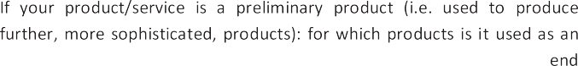
Value chain mapping: understanding relationships
Box 3.8: Checklist for end products and markets
78
When to construct a grid chart
This and the following steps can only be done once you have collected some information about your target sector – i.e. between initial research (Chapter 1) and your more detailed value chain research (Chapter 3). The value chain flow chart as described in Section 2.2.1 above is also a precondition.
Starting with an initial map
Start with an initial map or sketch already in your initial research, which you can then refine while conducting interviews and focus group discussions and as you find out more information in your research. The initial grid chart is best done at a team meeting to which you invite the core and sup- port teams. The support team, consisting of members from the target sector, will be able to provide inside information. You can then use the initial value chain grid chart at the start-up event, where you can ask participants to check the map, make corrections and/or add further information (as sug- gested in Chapter 1.2.2). You will very probably only be able to finalize your grid chart in your evaluation workshop (Chapter 5).
Using card methodology in teammeetings
The card methodology is a useful and simple way of constructing a value chain grid chart at a team meeting or workshop (see Box 2.5, Chapter 2).

•

•

•

•

•

Value chain mapping: understanding relationships
Box 3.9: Template for a value chain grid chart (insert names of market players)
79
Chapter 3
Value chainmapping: understanding relationships

S t e p 2 :
Identifying the way by which products and services reach end markets
Once you have identified the main end markets and products and filled them into a chart as shown in Box 3.9 below, go back to your value chain flow chart, in which you have identified the names of main market players (Box 3.2 in Section 3.2.1). Ask yourself: which of these market players is catering for which market? Try to allocate each market player to a specific end market or product. Keep in mind that this exercise only concerns businesses involved in core transactions within the value chain, not supporting services (such as the government, BDS, NGOs, etc.).

Value chain mapping: understanding relationships
Box 3.10: Example of an initial value chain grid chart (distinction between local and national market)
Source: A local dairy value chain initiative in Kurunegala district (North-Western Province) by ILO Enter-Growth in Sri Lanka.For more information see: www.entergrowth.com
80

Fre m ilk

S ll-scale dai
far rs (target gr p)
Vari s milk far r soc t s & ocllecting centres (oft belogni ot
t pr essor)

Lar -s le
pr essors: Milco & Nestlé, Rich Life Araliya Kele

oCoperative (CT ) ntoin Ridig & Ibbagamuwa

S ll-scale
pr essors

N s
Waya.Govi.Sa n.Pa &
Anib.Dev.Foun dati

Procseesd pr ucts: mlik packa s, yog rt,
btuter, mlikopwder, cheese
Procseesd pr ucts: fresh imlk, yog rt,
mi toff s
Lcoal rket
(s ll s s, srteet ven rs, super rkets and sa s out ts ofiMlco
and CT )

Nati al rket
(iMlc/oCoop and C U have own sa s uotlets)

Dividing the sector into several market channels
Once you have allocated market players under specific market or product categories, this should help you to identify different market channels within a sector. As shown in the example below, you can now link the different boxes with market players in the table above to a comprehensive value chain grid chart that illustrates the different market channels within you sector.

An example from Sri Lanka: dairy sector
The example shows a grid chart for the dairy sector in a small district in Sri Lanka (Kurunegala). You will notice that it makes a distinction between two main markets: local markets (i.e. within the dis- trict) and national markets. There are five market channels that serve these markets: (1) processed dairy products made by local small-scale processors who buy fresh milk from farmers direct; (2) two NGOs that also buy from farmers direct and market their products locally; (3) a fresh milk market channel by which fresh milk is sold directly from the farm gate to the local consumer; (4) large scale dairy companies such as Nestlé which source fresh milk supply for their factories through local collec- tion centres and farmer societies and market their products countrywide; (5) a provincial cooperative owned by the government which also collects milk through farmer societies and collection centres and distributes processed dairy products such as cheese, butter, milk powder etc. on the national market.

Value chain mapping: understanding relationships
30Different forms of value chain governance can also be illustrated by the thickness of lines between market players in different market channels. For more information read McCormick and Schmitz (2001).
81
Chapter 3
Value chainmapping: understanding relationships
S t e p 3 :
Adding information to the grid chart
Value chain grid charts are particularly useful for displaying information and characteristics of specif- ic market channels. This could for example be the number of women/homeworkers/ disadvantaged groups working in particular channels and at particular value chain levels; or information about value chain governance and the nature of relationships between market players in the value chain; or the size of different market channels (number of potential buyers/ suppliers). Towards the end of your value chain research, you will have collected a considerable amount of information and data, which you can add to the grid chart.
Using the value chain grid chart to illustrate value chain governance
Box 3.11 gives an example from the ILO BDS project in Zambia which has conducted value chain research on the dairy sector, and identified 6 major market channels through which fresh milk and dairy products enter local, regional and even export markets. Apart from displaying the market chan- nels, the chart also gives us some information on value chain governance (see Chapter 5 for definition): whereas channels 1 and 2 are largely characterized by market-based relationships (i.e. many small and medium-scale businesses negotiate prices on a daily basis; the cost of switching from one channel to another is low), channels 3 and 4 indicate more hierarchical relationships with medium and large-scale commercial farmers who have close ties with medium-scale processors (rela- tional to captive relationships; switching costs are high). Channel 6 indicates large integrated firms that control the entire value chain from farming to marketing.
Knowing about governance is crucial for intervention strategies
Knowledge of how value chains and individual market channels are governed is crucial for intervention strategies. A value chain grid chart can help to shed some light on this issue, as the example shows3.0

The value chain grid chart helps to identify market opportunities
Although it is simple, this kind of grid chart already gives us some idea of the market opportunities available to dairy farmers (presuming that dairy farmers are our target group). The value chain research now has to provide more information on specific channels – for example:
- Which of the market channels within the sector has the highest potential for job and income creation?
- Which of the market channels generates the highest income for your target group?
- How are individual market channels organized? Who controls them, and how high are switching costs (value chain governance)?
- Which of these market channels is the most competitive (with regard to the five drivers of value chain development)?
- Which of these market channels serves my company’s objectives best (e.g. exploring new market distribution opportunities)?
- Etc.

Value chain mapping: understanding relationships
Box 3.11: Dairy grid chart of the ILO BDS project in Zambia
Source: Manje, L and Muzira T. 2007. Initial mapping of the dairy subsector industry and value chain in Zambia, International Labour Organization, Business Development Services project, Lusaka, Zambia.
82

Adding information to the value chain grid chart – an example
The following value chain map by McCormick and Schmitz (2001) illustrates the type of relationship between market players in core transactions and also provides information about the number of enterprises at each level and in each market channel. The purpose here was to understand the posi- tion of homeworkers in the garment industry. The lines between the different market players indicate the type of relationship:
market-based relationships: firms deal with each other in “arms-length” exchange transactions
balanced network: firms form networks in which no one firm exercises undue control over others
directed network: firms form networks directed by a lead firm; for example a buyer-driven chain
hierarchy: firms are vertically integrated; the parent company controls its subsidiaries

Exporting • Regional
- International

Marketing • Local retailers
- Local wholesalers

- Packaging
Processing • Pasturising
- Milk separation for
other dairy products
- Cooling

Quality • Pricing
- Milk grading
control • Milk sampling &
testing

- Transport
Collection • Calibrated scales for
weigh bidges
- Testing kits

- Veterinary services
Production • Cross breeding
- Artiﬁcial insemination

R MLIK PAST ISED DIARY PR UCTS & L G L EIMLK

CHA EL 6
eVrtical integrati
CHA EL 5
I orted mi
p der pr .
CHA EL 4
Lar s le
pr ucers
CHA EL 3
Medi s le
CHA EL 2
iMlk Centre
CHA EL 1
Far r aMrket

S llholder far rs
S llholder far rs
oC-operative (imlk c tre)

iMlk
h kers

Medi
s le
p cessros
S ll,
meuidm, lar s le
p cessros

Medi
s le
p cessros

Lar
co ercial
far rs

Lar s le
p cessros

I ort
mi p der
Local rket
L al rket
L al
amrket

Medi
s le
p cessros

Medi
s le commerc
L al rket
L al rket
Regi al & inter tioanl ex rt
amrket

Value chain mapping: understanding relationships
Box 3.12: Value chain grid chart displaying numbers of enterprises and type of relationships
Source: McCormick and Schmitz, 2001: p.55.
Rule for value chain maps: form follows function!
There are no limits to value chain maps, and no rules on what they must look like. The only rule that might be applied is that form follows function. Value chain maps facilitate the formulation of appro- priate intervention strategies. The information thus illustrated by maps needs to serve the overall objectives of the value chain initiative. Before you start drawing up a value chain map, you therefore need to need know who your target group is, and what your objectives are (seeChapter 2).
83
Chapter 3
Value chainmapping: understanding relationships

Re tail 003 06
Whoelsa 9

Pr ucti
003 H e 04 21
owrkers
1,

Suppliers of Equipment
I ts yarn and cloth suppliers
41 16

Suppliers of accessories and packaging 84

201

Value chain mapping: understanding relationships
3.3
Further reading on value chain mapping
84

- Agriculture and Food Council of Alberta (2004):Value chain guidebook – a process for value chain development, Value Chain Initiative, Alberta, Canada (available from www.agfoodcouncil.com).
- Springer-Heinze, Andreas (2007):ValueLinks Manual – The methodology of value chain promotion, German Technical Cooperation Agency (GTZ), first edition, Eschborn (Germany). Available from www.value-links.org
- Mayoux, Linda and Mackie, Grania (2008):Making the strongest link – a practical guide to mainstreaming gender analysis in value chain development, International Labour Organization, Sub-Regional Office Addis Ababa.
- McCormick and Schmitz (2001): Manual for value chain research on homeworkers in the garment industry, Institute for Development Studies, University of Sussex, UK (available from www.globalvaluechains.org)
- Van den Berg, Michael et al. (undated):Making value chains work better for the poor: A tool book for practitioners of value chain analysis. Available from www.markets4poor.org

