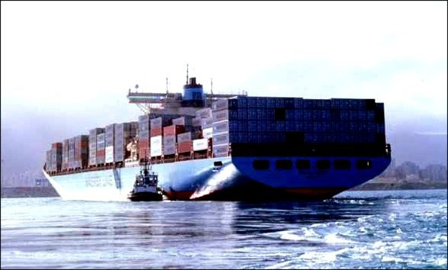



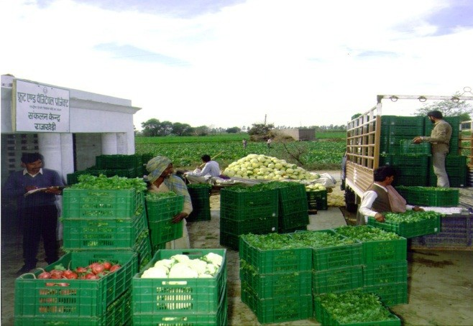
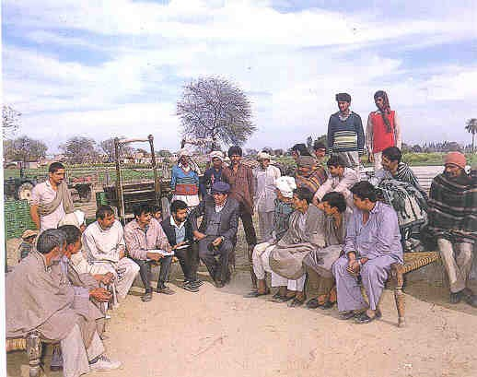
Value Chain: Concept, history and approaches
for
socio-economic and policy analysis
Jean Balié, FAO
International agricultural seminar: The value chain approach.
Collectif Stratégies Alimentaires (CSA), 27 November 2013, Brussels

Outline
1.
2.
What is a value chain?
What is the history / background of this concept?
3.
What
is
the
relationship
between
the value
producers and other agents in
chain really about?
Value chain analysis for what?
4.
Why such
interest for value chain-based policies and
investment programmes?
5.
So
what
?
Is
value
chain
analysis
the
solution for better policy making?



A value chain is a portion of an economic system where upstream agents
(producers)
are
linked
to
downstream
partners
by
technical,
economic,
territorial, institutional and social relationships.

Producers Country
Collectors

Processors
Exporters/
Wholesalers Importers

Retailers

Consumers
Border

International Market

What is a value chain ?

History of value chain
•
•
Value chain concept: Michael Porter, 1980s
Anglophone: concept of Global Commodity Chains (Gereffi, 1990 s)
→ linking households, enterprises and states to one another within the world economy
Francophone: concept of “Filière” (INRA/CIRAD, 1960s)
→ meso-economy; interdependence; technical and technological changes along the chain (Morvan, 1985)
3 main types of analysis :
•
•
- Technical / physical
- Economic / financial
- Organizational / institutional
and/or
and/or

Incentives and Governance
Product flow
Financial/economic flows
Information flow

Sale

Processing

Product/Production

Inputs

Critical dimensions in a value chain

Understand how a portion of the
economic system works and could better
work.
Identify the role of the government and
related policy options.
Quantify in physical/monetary terms
the likely impacts of policy options.
Monitor/assess value chain
performances
VCA dimensions: Qualitative – quantitative Physical - monetary Private - Public Economic – social Economic-environmental Short - long term
Ex-ante – monitoring

Exhaustive -complementary
Why Value Chain Analysis (VCA) is important for policy-making?

Comparative Analysis (WiP-WoP)

Scenario with policy (WiP)

Indicators with policy (WiP)
Base Scenario (WoP)

Reference Indicators (WoP)
Policy Options’ impacts?

Policy Options

Development Objectives

Quantitative VCA for policy making: counterfactual analysis

Qualitative: assessing in qualitative terms selected VC features, e.g. “five
forces” (bargaining power of suppliers and customers .....) or the “diamond” elements (production factors’ conditions, rivalry stimulating innovation. )
(Porter 1985,1990)
Quantitative: assessing in quantitative terms selected dimension above,
possibly building multi-criteria indicators,
Building consistent accounting frameworks in both physical quantities and monetary terms, encompassing all the value chain’s layers and providing consolidated accounts of the whole value chain under different policy-relevant scenarios for counterfactual analysis
Qualitative versus quantitative VCA

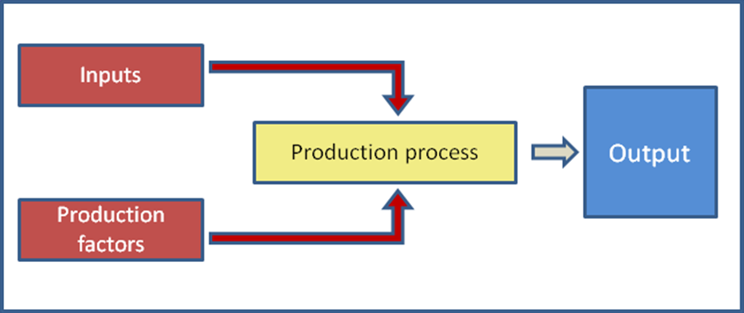
Physical: measuring input-output relationships for each upstream-
downstream pair of layers in physical terms to ensure consistency of physical flows along the chain (“calibrated” value chains)
Monetary: appraise revenues, costs and margins (value added net benefits)
of each activity, each agent, segments of the value chain and the whole value
chain, using specific sets of prices for inputs, production factors and outputs.
Physical versus monetary VCA

Private perspective. Agents engage in VC activities only if they see an interest
(monetary or non monetary). In VCA, values, as perceived by private agents are expressed in terms of “market prices”.
Public perspective. The government (the society) promotes VCs through
public policies only if they increase social welfare. In VCA, social values
are expressed in terms of “reference prices”.
VCA is carried out both at “market” and “reference” prices, to provide decision makers and other stakeholders with anticipated evidence on both social and private net benefits brought by a specific policy measure.
Private versus public perspective in VCA

Economic perspective. How much value is generated by a given VC? To what
extent a specific policy measure aimed at favouring that VC is likely to increase the GDP? Which policy measures favour a more efficient use of (scarce) domestic resources?
Social perspective. Which layers of the society benefit from a specific policy measure? Is that policy measure likely to improve food security and/or reduce poverty? To what extent women (smallholders, children etc) benefit from that policy?
Through disaggregate accounts for specific social categories, VCA helps investigating policy-induced changes in goods/income available to them. Through account aggregation and consolidation instead, VCA provides anticipated evidence on overall value added changes.

Economic versus social perspective in VCA

•
How do we know if producer are receiving incentives to
produce? Consumers to consumer? Traders to trade? Comparing social and private net benefits signals whether private agents in a specific VC are supported or penalized? Are agents receiving public transfers which protect them from (domestic or international) competition ? (or vice versa To which extent does a specific policy measure alter incentives ? provide protection?
•
•
•
•
The Policy Analysis Matrices (PAMs): a tool to analyze
information on VC through indicators on profitability, value added, transfers and protection (Monke and Pearson, 1989) Cost-Benefit Analysis of public polices
•
Incentives and disincentives in VCA

Country

Year

Value chain

Policy measure

Burkina Faso

2010

2010

2007

Rice
increase the use of HQ seeds and extension of the rice- growing area

Fisheries

increase the purchase of fish eggs and ehance the human capital through specialized trainings to the fishermen
Firewood

improve the management and productivity of the
forests

Kenya

2009
Sugarcane
increase the number of the extension agents
2009
Cotton
increase the use of HQ seeds through subsidies

2009

Mango

establishment of producer marketing organizations (collective marketing) - input at lower prices
Nigeria
2013
Cassava
Baseline only
Ecuador
2013
Bananas
Conventional scenario / Organic scenario

Syria

2010
2010
2010
2010
Fisheries
no policies
Cotton
re-introduction of the cotton seeds in the chain
Potatoes
Baseline only
Haricot
Baseline only
VCA : country examples of policy measures...

Limits: Accounting framework, partial, comparative static analyses only. Complementarities:
4.Computable General Equilibrium (CGE)
8. Macro-micro integrated approach (Extended CGE)
7. Social Accounting Matrix (SAM) multipl.
3. Multi-Market equilibrium Models (MMM)
Policy impact analysis

2. Partial Equilibrium Analysis (PEA)
6. Accounting chain frameworks (Value Chain Analysis- VCA)
5. Multi-period of Cost- Benefit Analysis (CBA)
1. Micro-accounting approaches

VCA for policy making: limits and complementarities

THANK YOU!
The End

Panel A: Base scenario: inefficient activity

Panel B: Policy option 1 reduction of input costs and increase of factor use

Panel C: Policy option 2 increase of input cost and decrease of factor use

REVENUES

COSTS
PROFITS

Tradable Inputs
Domestic Factors
At market prices
2000
1500
400
100
60
40
At reference prices
1800
1600
140
Wedges
200
-100
260

REVENUES

COSTS
PROFITS

Tradable Inputs
Domestic Factors
At market prices
2000
1100
800
100
250
-150
At reference prices
2100
1050
800
Wedges
-100
50
0

REVENUES

COSTS

PROFITS

Tradable Inputs
Domestic Factors
At market prices
2000
1300
700
0
-50
50
At reference prices
1900
1250
700
Wedges
100
50
0
Policy Analysis Matrices under different policy scenarios

Expanded Policy Analysis Matrices (PAMs) (Monke and Pearson, 1989):
Total Wedges = effects of policy and market failures + effects of policies for efficiency

Indicator

Acronym

Base scenario

Policy option 1 Factor intensive technology
Policy option 2 Input intensive technology
Private Cost Ratio
PCR
1.00
0.89
0.80
Private Value Added Ratio
PVAR
0.35
0.45
0.25
Domestic Resource Cost Ratio
DRC
1.08
0.76
0.70
Social Value Added Ratio
SVAR
0.34
0.50
0.11
Nominal Protection Coefficient on Outputs
NPCO
1.05
0.95
1.11
Nominal Protection Coefficient on Inputs
NPCI
1.04
1.05
0.94
Effective Protection Coefficient
EPC
1.08
0.86
2.50
Domestic Factors Ratio
DOFAR
1.00
1.00
0.86
Subsidy Ratio to Private Agents
SURPA
0.026
-0.071
0.022
PAM-based indicators

