

1
Value Chain Dynamics
Professor Charles Fine Massachusetts Institute of Technology
Sloan School of Management
Cambridge, Massachusetts
May 2004
02142
Some material in this presentation is based on: Fine, Charles. Clockspeed: Winning Industry Control in the Age of Temporary Advantage. Perseus Publishing, 1999. ISBN: 0-7382-0153-7.

2
Value Chains and Supply Chains
Value Chains
System Design
-Core competences
-Make/Buy
-Relationship Design
-Strategic Intent
-Clockspeed
-Dynamics of
-Disintermediation
-Disintegration
-Dependence
-Capability development
“The Biology of Evolution”
Supply Chains
Order fulfillment
-Inventory
-Quality, cost & service
-Flexibility
-Response times
-Logistics
-Distribution
-Procurement
-Forecasting
-Transportation
-Quantity accuracy
-Timing accuracy
“The Physics of Flow”

3
Dynamic Analysis to Support Industry & Technology Roadmapping
Corporate Strategy Dynamics
Regulatory Policy Dynamics
Industry Structure Dynamics
Technology Dynamics
Customer Preference Dynamics
Business Cycle Dynamics
Capital Market Dynamics


4
The Three Chains of Enterprise Design:
Fulfillment, Development, & Technology Chains
Capability Supply Chain
(Intel, Airbus, Citibank)
Develop
3-D
Concurrent Engineering
Voice of the
Customer
Launch
Fulfillment Supply Chain (Dell, Walmart, Amazon)
Development Chain (BMW, Nokia, Toyota)
Distribute
Production
Sell
Supply
Design
Supply

5
Supply Chain Design in a Fast-Clockspeed World: Study the Industry Fruitflies
Evolution in
the industrial world: INFOTAINMENT is faster than MICROCHIPS is faster than AUTOS evolve faster than AIRCRAFT evolve faster than MINERAL EXTRACTION
THE KEY TOOL: Cross-INDUSTRY
Benchmarking
of Dynamic Forces

Evolution in
the natural world:
FRUITFLIES
evolve faster than
MAMMALS
evolve faster than
REPTILES
THE KEY TOOL:
Cross-SPECIES Benchmarking
of Dynamic Forces

6
The Strategic Impact of Project Design:
(Who let Intel Inside?)
1980:
IBM designs a product, a process, & a value ch
Consumers/ Users
Distribution Channel(s)
Subsystem Suppliers
OEM
The Outcome:
A phenomenonally successful product design A disastrous value chain design (for IBM)
Microsoft

IBM
Intel Inside

Intel

7
LESSONS FROM A FRUIT FLY:
THE PERSONAL COMPUTER
1.
BEWARE OF INTEL INSIDE
(Regardless of your industry)
MAKE/BUY IS NOT ABOUT WHETHER IT IS TWO CENTS CHEAPER OR TWO DAYS FASTER TO OUTSOURCE VERSUS INSOURCE.
DEVELOPMENT PARTNERSHIP DESIGN CAN DETERMINE THE FATE OF COMPANIES AND INDUSTRIES, AND OF PROFIT AND POWER
THE LOCUS OF VALUE CHAIN CONTROL CAN SHIFT IN UNPREDICTABLE WAYS
2.
3.
4.

8
VALUE CHAIN DESIGN:
Three Components
1. Insourcing/OutSourcing
(The Make/Buy or Vertical Integration Decision)
2. Partner Selection
(Choice of suppliers and partners for the chain)
3. The Contractual Relationship
(Arm’s length, joint venture, long-term contract, strategic alliance, equity participation, etc.)

9
Buzz Groups
When have you seen sourcing decisions
have a significant impact on a key innovations in the value chain?
What are the strengths and weaknesses of
how sourcing strategy works at your company?

10
Vertical Industry Structure with Integral Product Architecture
Computer Industry Structure, 1975-85
For this diagram, see:
A. Grove, Intel; and Farrell, Joseph, Hunter Monroe, and Garth Saloner. "The Vertical Organization of Industry:
Systems Competition versus Component Competition." Journal of Economics & Management Strategy 7, no. 2 (1998): 143-182.

Horizontal Industry Structure with Modular Product Architecture
11
Computer Industry Structure, 1985-95
For this diagram, see:
A. Grove, Intel; and Farrell, Joseph, Hunter Monroe, and Garth Saloner. "The Vertical Organization of Industry:
Systems Competition versus Component Competition." Journal of Economics & Management Strategy 7, no. 2 (1998): 143-182.

THE DYNAMICS OF PRODUCT ARCHITECTURE AND VALUE CHAIN STRUCTURE:
THE DOUBLE HELIX
12
Source: Fine, Charles, and Daniel Whitney. “Is the Make-Buy Decision Process a Core Competence?" MIT Center for Technology, Policy, and Industrial Development, February 1996. Used with permission.
PROPRIETARY SYSTEM PROFITABILITY
ORGANIZATIONAL RIGIDITIES
SUPPLIER MARKET POWER
HIGH•
DIMENSIONAL COMPLEXITY
TECHNICAL ADVANCES
NICHE COMPETITORS
INTEGRAL PRODUCT VERTICAL INDUSTRY

MODULAR PRODUCT HORIZONTAL INDUSTRY

PRESSURE TO DIS-INTEGRATE

PRESSURE TO INTEGRATE

13
THE DOUBLE HELIX
BUZZ GROUPS:
IN
OTHER INDUSTRIES
- HOW HAS THE DOUBLE HELIX AFFECTED A VALUE CHAIN THAT YOU ARE FAMILIAR WITH?
- WERE THERE ANY “EARLY WARNING SIGNALS” AS TO THE COMING INTEGRATION OR DISTINTEGRATION?
- WHAT DO YOU THINK MIGHT BE SOME HELPFUL “EARLY WARNING SIGNALS?”

14
THE DOUBLE HELIX
IN
OTHER INDUSTRIES
•
TELECOMMUNICATIONS--
- “MA BELL” was Vertical /Integral
- BABY BELLS & LONG LINES & CELLULAR are Horizontal/Modular
- Today’s Verizon is going back to Vertical /Integral
AUTOMOTI�VE--
- Detroit in the 1890’s was Horizontal/Modular
•
–
–
Ford & GM in the mid 1900’s were Vertical /Integral
Today’s Auto Industry is going back to Horizontal/Modular
•
TELEVISION--
– RCA was Vertical /Integral
–
–
1970’S THROUGH 1990’S were
Horizontal/Modular
Today’s media giants are going back to Vertical /Integral
•
BICYCLES--
– Safety Bikes to 1890’s boom to Schwinn to Shimano Inside

15
INDUSTRY CLOCKSPEED IS A COMPOSITE: OF PRODUCT, PROCESS, AND ORGANIZATIONAL CLOCKSPEEDS
Mobile Phone INDUSTRY CLOCKSPEED
THE
Mobile Phone
product technology
THE
Mobile Phone MANUFACTURING COMPANY
organization
THE
Mobile Phone PRODUCTION PROCESS
process technology

16
Mobile Phone System CLOCKSPEED is a mix of Transmission Standards, Software and Handsets
Mobile Phone System
TRANSMISSION STANDARD
slow clockspeed
SOFTWARE APPLICATIONS
medium clockspeed
OPERATING
SYSTEM
HAND SET
fast clockspeed
SERVICES
fast clockspeed
slow clockspeed
ISSUE:
THE FIRMS THAT ARE FORCED
TO RUN AT THE FASTEST CLOCKSPEED
ARE THE MOST LIKELY TO STAY AHEAD OF THE GAME.

17
Automobile CLOCKSPEED IS A MIX OF
ENGINE, BODY & ELECTRONICS
Automobile
ELECTRONICS
fast clockspeed
BODY
medium clockspeed
ENGINE
slow clockspeed
ISSUE:
MOST AUTO FIRMS
OPERATE AT
ENGINE OR BODY CLOCKSPEEDS; FUTURE THEY WILL NEED TO RUN AT ELECTRONICS CLOCKSPEED.
IN THE

18
Buzz Groups
What’s the fastest clockspeed component
of your company’s value chain?
How is your company responding to the
speed of this fast-moving component?

19
Clockspeed drives
Business Strategy Cadence
BUSINESS STRATEGY & CORE
CAPABILITIES
Project Design & Tactical Decisions
Dynamics between New Projects and Core Capability Development: PROJECTS MUST MAKE MONEY AND BUILD CAPABILITIES

3-D Concurrent Engineering &
20
the imperative of concurrency
Product
Process (Project Plan)
Supply Chain
(Deliverable
(Partners/Suppliers)
Development & Tech. Chains
Fulfillment Supply Chain
Fulfillment Architecture Technology
Supply Logistics
Chain & Coord
Architecture System
Sourcing Information
Selection Inventory
Relationship Integration

Production System
Objectives Systems People Capacity
Unit Processes
Technology Equipment

Product/ System Architecture
Modular/ Integral
Life Cycles
Detailed Design
Specs Materials Functions

21
Controlling the Chain Through Distribution:
The End of P&G Inside ?
•
•
Controlling the Channel Through Closeness to Customers:
consumer research, pricing, promotion, product development
Customers
Retailer

Retailer
P&G

Retailer

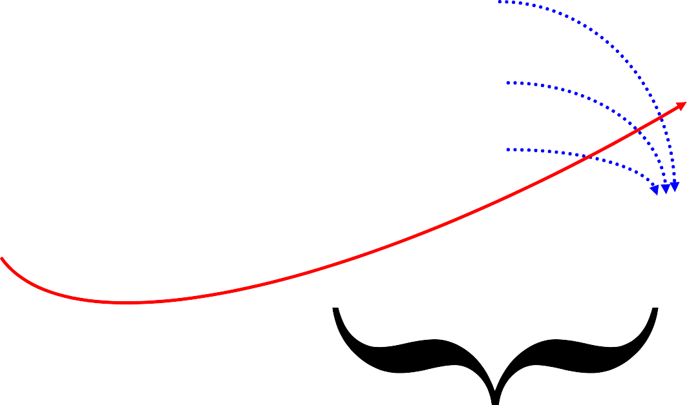
22
Controlling the Chain Through Distribution:
Beware of Walmart Outside
Controlling the Channel Through Closeness to Customers:
Chain Proximity
Customers
Vertical Growth on the Double Helix
WalMart Private Label

P&G

WalMart

Retailer

Retailer
Retailer

23
lockspeeds accelerate as you head downstream closer to the final customer ;
Clockspeed = f(technology push, customer pull, system complexity)
Automobile
Vehicle Electronics Architecture
Telematics System
In-Vehicle Services
Chip maker
PC Maker
Semiconductor Equipment Maker
Web Site Developer
New Phone Applications
Handset Platforms
Telecom Equipment

Optical Components

24
ALL COMPETITIVE ADVANTAGE
IS TEMPORARY
Autos:
Ford in 1920, GM in 1955, Toyota in 1990
Computing:
IBM in 1970, DEC in 1980, Wintel in 1990
World Dominion:
Greece in 500 BC, Rome in 100AD, G.B. in 1800
Sports:
Bruins in 1971, Celtics in 1986, Yankees no end
The faster the clockspeed, the shorter the reign

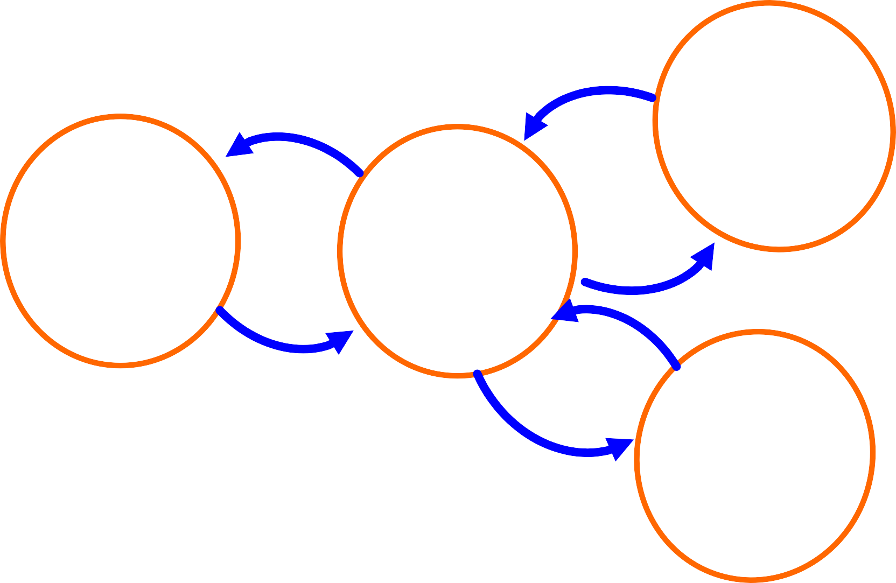
25
Projects Serve Three Masters: Capabilities, Customers, & Corporate Profit
PROJECT DESIGN
(New products, new processes, new suppliers)
CORE CAPABILITIES

26
IMPLEMENTATION OF PROJECT DESIGN:
FRAME IT AS 3-D CONCURRENT ENGINEERING
Recipe, Unit Process
PRODUCT
Performance Specifications
PROCESS
Technology, & Process Planning
Details, Strategy
Product Architecture, Make/Buy components
Time, Space, Availability
VALUE CHAIN
Manufacturing System, Make/Buy processes

27
ARCHITECTURES IN 3-D
INTEGRALITY VS. MODULARITY
Integral product architectures feature close coupling among the elements
- Elements perform many functions
- Elements are in close spacial proximity
- Elements are tightly synchronized
- Ex: jet engine, airplane wing, microprocessor
Modular product architectures feature separation among the elements
- Elements are interchangeable
- Elements are individually upgradeable
- Element interfaces are standardized
- System failures can be localized
- Ex: stereo system, desktop PC, bicycle

28
VALUE CHAIN ARCHITECTURE
Integral value-chain architecture
features close proximity among its elements
- Proximity metrics: Geographic, Organizational
Cultural, Electronic
-
-
-
Example: Example: Example:
Toyota city
Ma Bell (AT&T in New Jersey)
IBM mainframes & Hudson River Valley
Modular value-chain architecture features multiple, interchangeable supplier and standard interfaces
- Example:
- Example:
- Example:
- Example:
Garment industry PC industry
General Motors’ global sourcing Telephones and telephone service

29
BUSINESS SYSTEMS
ALIGNING ARCHITECTURES:
& TECHNOLOGICAL SYSTEMS
BUSINESS SYSTEM/SUPPLY CHAIN ARCHITECTURE
(Geog., Organ., Cultural, Elec.)
INTEGRAL
MODULAR
TECHNOLOGY/PRODUCT ARCHITECTURE
Microprocessors
Mercedes & BMW
vehicles

Lucent Nortel

Polaroid

MSFT Windows

Chrysler vehicles

Cisco

Digital Rights/ Music Distribution

Dell PC’S Bicycles

30
Demand-Supply Chain Management @ Dell
Demand Management: Forecast = Buy = Sell
Buy to Plan, but Build to Order
Inventory Velocity is a wonderful thing …



•
•
Customers have immediate access to the latest technology.
Suppliers get their products to market quickly Quality is improved with fewer touches.
Cash is generated through negative cash cycle.
Model efficiencies drive Market Share gain.
•
•
•
•

31
“Dell Direct” Work for Autos?
Can
- Appealing to OEM’s on Many Dimensions
–Satisfy customer need for Speed
–Reduce Supply Line Inventories
–Reduce mismatches and discounting
–Direct OEM-Customer Relationships (& Data!)
–Information Transparency
Ideas adapted from Prof. John Paul MacDuffie, IMVP (International Motor Vehicle Program at MIT) and The Wharton School of the University of Pennsylvania

33
BUT,
A Car is not a Computer!!
Ideas adapted from Prof. John Paul MacDuffie, IMVP (International Motor
Vehicle Program at MIT) and The Wharton School of the University of Pennsylvania
- Car
- ~ 4000 components
- 100 key subsystems
- 300 key suppliers
- 12 month validation
- 1,000,000
variations
- Integral
Architecture

- Personal Computer
- ~50 components
- 8-10 key parts
- 40 key suppliers
- 24 hour burn-in
- 100 design
variations
- Modular Architecture

34
Strategic Sourcing as a Driver of Dynamic Evolution of Capabilities Along the Value Chain
Distinguish between
dependence for knowledge or dependence for capacity
Independence
Dependence
Amount of Work
Outsourced
knowledge
Amount of
Work Done In-house
knowledge
+
+
+
+
+/or supply
+/or supply
Supplier Capability
Internal Capability
Amount of Supplier Learning
Amount of Internal Learning
+
+


Technology Dynamics in the Aircraft Industry:
LEARNING FROM THE DINOSAURS
35
Japanese appeal as
+
U.S. firms’ appeal as subcontractors
subcontractors
+
+
Japanese Industry
Boeing outsources
to Japan
Autonomy
+
(Mitsubishi Inside?)
Japanese
U.S.
industry size &
industry size &
+
-
capability
capability

36
SOURCEABLE ELEMENTS
PROCESS ELEMENTS
ENGINEERING
ASSY
TEST
CONTROLLER
I4
V6
V8
PRODUCTS
VALVETRAIN
BLOCK
SUBSYSTEMS

37
Strategic Make/Buy Decisions:
Assess Critical Knowledge & Product Architecture
INDEPENDENT FOR KNOWLEDGE & DEPENDENT FOR
DEPENDENT FOR KNOWLEDGE
& CAPACITY
INDEPENDENT FOR KNOWLEDGE & CAPACITY
Adapted from: Fine, Charles, and Daniel Whitney. “Is the Make-Buy Decision Process a Core Competence?" MIT Center for Technology, Policy, and Industrial Development, February 1996. Used with permission.
ITEM IS INTEGRAL ITEM IS MODULAR

A POTENTIAL
OUTSOURCING TRAP

CAPACITY

BEST OUTSOURCING OPPORTUNITY

OVERKILL IN VERTICAL
INTEGRATION

WORST OUTSOURCING SITUATION

CAN LIVE WITH
OUTSOURCING

BEST INSOURCING SITUATION

43
Value Chain Mapping
Organizational Supply Chain
Technology Supply Chain
Capability Chain
Underlying Assumption:
You have to draw
the maps before you can assess their dynamics.
R&D

NVH engineering

Quality assurance

Supply Chain Management

clay chemistry

casting manufacturing
process

valve lifters

engines

clay supplier
casting supplier

Eaton

Chrysler

44
VALUE CHAIN DESIGN IS
THE ULTIMATE
CORE COMPETENCY
Since all advantages are temporary,
the only lasting competency is to continuously build and assemble capabilities chains.
KEY SUB-COMPETENCIES:
1.
Forecasting the dynamic evolution of market
power and market opportunities
- Anticipating Windows of Opportunity
- 3-D Concurrent Engineering: Product, Process, Value Chain
CAPABILITIES
PROJECTS
Fortune Favors the Prepared Firm


45
PROCESS
FOR
VALUE CHAIN DESIGN
1.
2.
Benchmark the Fruit Flies Map your Supply Chain
-Organizational Value Chain
-Technology Value Chain
-Competence Chain Dynamic Chain Analysis
at each node of each chain map Identify Windows of Opportunity
DOUBLE
HELIX
BOEING
3.
4.
5.
Exploit Competency Development Dynamics with 3-D Concurrent Engineering
CAPABILITIES
PROJECTS

46
DOT.COM COMPETITION: FOCUS ON THE SUPPLY CHAIN
Napster’s New Supply Chain Strategy
(go to the end and steal everything!)
Record Music
Customer Consumption

Alternate Solution: partner with your competitor
Press CD’s

Steal Songs
Sell to Retail

Promote Music

Develop Songs

Vertically Integrated Music Giants
Identify Talent

47
STRATEGY IN 3-D:
CASE EXAMPLES
Boeing:
Static 3-D in airplane Projects Dynamic, Strategic Value Chain,
unintegrated w/ Product & Process
Intel:
Modular Product vs. Process Integral Process and Value Chain
Chrysler:
Modular Product & Value Chain (weak on process?)
Toyota:
Integral 3-D in Nagoya (weak on global 3-D?)

48
Team Exercise: Value Chain Analysis
Consider one of these five industries (or one of your own):
-Food
-Defense aircraft
-Automobiles
-Handheld electronic organizers/communicators
-Music
What are the key elements in the value chain?
What are the key dynamic processes influencing power in the chain?
What are the key dependency relationships in the value chain? What is driving the clockspeed in the chain?
What are the opportunities for outsourcing ? What are the windows of opportunity in the chain?

49
Dynamic Analysis to Support Industry & Technology Roadmapping
Corporate Strategy Dynamics
Regulatory Policy Dynamics
Industry Structure Dynamics
Technology Dynamics
Customer Preference Dynamics
Business Cycle Dynamics
Capital Market Dynamics

50
Cisco’s End-to-End Integration for
its Fulfillment Supply Chain
Cisco
Finished Product flows direct to customer via logistics supplier
Order info flows direct to
Cisco and suppliers
Basic Design Principle:
Arm’s length
Relationship with Fulfillment Chain Partners
Component
Suppliers & Distributors
- Single enterprise information system
- Dynamic replenishment, direct fulfillment, merge in transit
- Customer orders through Cisco Connection online
Contract Manufacturers

Customers

- New product development on-line with supply base
- Technology Supply Chain Design:
Innovation through Acquisition

51
Cisco’s Strategy for Technology Supply Chain Design
- Integrate technology around the router to be a communications network provider.
- Leverage acquired technology with
  - sales muscle and reach
  - end-to-end IT
  - outsourced manufacturing
  - market growth
- Leverage venture capital to supply R&D
Basic Design Principle:
Acquisition
Relationship with Technology Chain Partners

52
Volatility Amplification in the Supply Chain:
“The Bullwhip Effect”
Customer
Retailer
Distributor
Factory
Equipment
Tier 1 Supplier
Information lags Delivery lags
Over- and underordering Misperceptions of feedback Lumpiness in ordering Chain accumulations
SOLUTIONS:
Countercyclical Markets Countercyclical Technologies Collaborative channel mgmt. (Cincinnati Milacron & Boeing)

53
Supply Chain Volatility Amplification: Machine Tools at the tip of the Bullwhip
For this chart, see:
Anderson Jr., Edward G., Charles H. Fine, and Geoffrey G. Parker. "Upstream Volatility in the Supply Chain: The Machine Tool Industry as a Case Study." Production and Operations Management 9, no. 3 (Fall 2000): 239-261.

55
LESSONS FROM A FRUIT FLY:
CISCO SYSTEMS
- KNOW YOUR LOCATION IN THE VALUE CHAIN
- UNDERSTAND THE DYNAMICS
OF VALUE CHAIN FLUCTUATIONS
- THINK CAREFULLY ABOUT THE ROLE
OF VERTICAL COLLABORATIVE RELATIONSHIPS
- INFORMATION AND LOGISTICS SPEED DO NOT REPEAL BUSINESS CYCLES OR THE BULLWHIP.
Bonus Question:
How does clockspeed impact volatility?

56
BUZZ GROUPS
- HOW HAS THE BULLWHIP AFFECTED A BUSINESS THAT YOU ARE FAMILIAR WITH?
- HOW FAR UPSTREAM OR DOWNSTREAM DID YOU SENSE THE IMPACT OF THE BULLWHIP?
- WHAT MIGHT HAVE BEEN DONE DIFFERENTLY TO REDUCE THE NEGATIVE IMPACT OF THE BUILLWHIP?

57
Dynamic Analysis to Support Industry & Technology Roadmapping
Corporate Strategy Dynamics
Regulatory Policy Dynamics
Industry Structure Dynamics
Technology Dynamics
Customer Preference Dynamics
Business Cycle Dynamics
Capital Market Dynamics

58
All Conclusions are Temporary
Clockspeeds are increasing almost everywhere
Many technologies and industries exhibits fast clockspeed & high volatility
Value chain design and service system competencies
key
Study of
Fruit Flies can help with crafting
strategy

