School Self - Evaluation Form

School | Green Lane Infant School
Headteacher | Trudy Lower |  |  | Reviewed |  | February 2015


Section 1: Introduction

School Context, Key Strengths and areas for improvement

Context

The school is larger than average size and has a high proportion of pupils from minority ethnic groups and homes where English is not the first language. Most of these pupils are from India, Pakistan and Bangladesh. The proportion of pupils who are known to be eligible for free school meals is 12%. The number of pupils who have special needs and/or disabilities is 7%. The school is a central part of the community - e.g. the school grounds are usually opened during the summer holidays so that families could meet and children play; the school facilitates family orientated courses.

These figures are taken from the LA Sure Start Children’s Centre Booklet

September 2014

 |  | Green Lane area | National Average
Income deprivation affecting
children index (IDACI)
proportion of all children | 47.3% |  | 20.4%
aged 0-15 living in income
deprived families
Proportion of children living
in poverty | 37% |  | 20.6%
Low birth weight
(less than 2500g) | 11.2% |  | 7.5%
Underweight in
Reception Year | 3.1% |  | 0.9%

Teaching staff work collaboratively and effectively in year group teams.

Relationships are good, supportive and caring. The quality of relationships influences the communication between staff and children and this, in turn, influences the attitude and work ethic of the pupils - which is good.

The percentage attendance for the year 2013-2014 was 95% up from 93.3% the previous year.

We keep a constant focus on attendance and punctuality. Our young children are susceptible to many early childhood illnesses and some of our parents continue to take their children on extended holidays abroad, despite our work with the EWO and issuing fines.

The SLT consists of a Deputy/Inclusion Lead, FS lead, KS1 lead and Assessment Lead, led by an enthusiastic Headteacher.

The children who are on the SEN register range from speech and language difficulties (our largest number); social and emotional difficulties; moderate learning difficulties; visual impairment and ASD. The majority of teaching is at least good (percentage of teaching that is good/outstanding is currently at least 78%) and the result is that the children move from low starting points in Nursery (Foundation 1) to just below average at the end of Year 2.

The curriculum is effective in meeting the needs of the pupils and is responsive to the pupil’s interests and reflective of the local community.


Section 2: Areas for whole school development

- SMARTer targets are needed for staff following Pupil Progress Meetings

- The further development of children’s oracy skills through Let’s Talk training and implementation.
- Improvement issues arising from data analysis of pupil achievement.
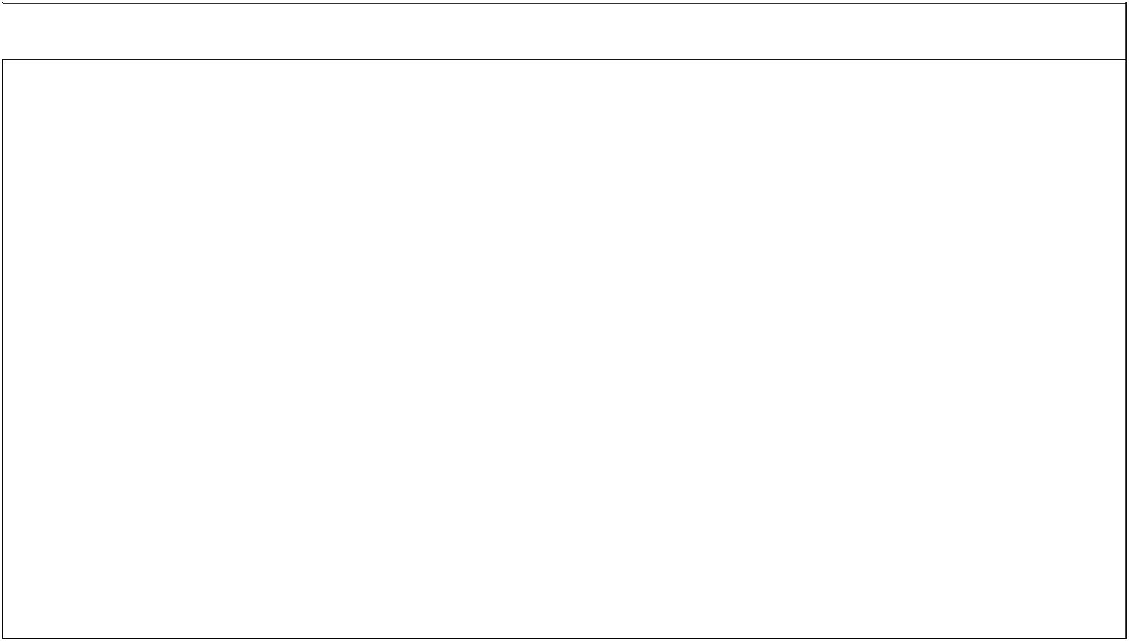

Section 3: Progress in previous inspection key issues

From the inspection in June 2011 these are -

Build on the strategies that already exist to improve the quality of teaching, and raise achievement in writing, especially for the more able, by:

- Making clear to pupils through marking and verbal feedback what they need to do to

improve their work

A ‘Response Policy’ has been written for writing so that the flow of teachers’ actions is appropriate to the level of the pupils (i.e. not necessarily their year group). Target setting is also now more focused and pupils are increasingly aware of their next steps.

- Providing pupils with opportunities to respond to teachers' marking

In Year 2 time is given for pupils to reflect on their previous piece of writing to identify their next steps. Year 1 are currently trailing this to see if it is suitable for the age group.

- Ensuring that all teachers and teaching assistants provide consistently challenging work

for all pupils.
This is regularly monitored through differentiated planning, evaluation of intervention groups and the use of extension activities. Our school improvement partner has undertaken staff development on the use of challenge points.


Section 4: Achievement

Attainment, progress and the quality of learning, for individuals, different groups, particularly SEND pupils

The children enter the school with levels well below the expected for their age, in all areas.

On average the children are operated at least 15 months lower than the norm on entry, with this gap being over 2 years on occasions.

Foundation Stage Profile Results

Early Years Foundation Stage Profile 2014

The percentage of children achieving a good level of development (GLD) this year was 42.4% compared to 28.9% in 2013. A good level of development is defined as achieving the expected (or exceeding) level of development in each of the prime areas (Personal, Social & Emotional Development, Physical Development and Communication & Language) and also in Literacy and Mathematics.

 |  |  | Green Lane Infant School |  |  |  | Local Authority
 |  |  | 2013 |  | 2014 |  | 2014
 |  |  | % | % |  | %
 | GLD |  | 28.9 |  | 42.4 |  | 41.2
 | All Prime Areas + Literacy |  | 34.4 |  | 44.6 |  | 42.5
 | All Prime Areas + Mathematics |  | 28.9 |  | 44.6 |  | 47.4
 | All Prime Areas |  | 38.9 |  | 54.3 |  | 58.3
 | All Specific Areas |  | 20.0 |  | 39.1 |  | 36.9
 | All Areas |  | 20.0 |  | 38.0 |  | 35.9


Percentage of children achieving the expected (exp) or exceeding (exc) level of development in each Area of Learning:

Area of Learning |  |  | Green Lane Infant School |  |  |  |  |  |  |  |  |  | Local Authority
Area of Learning |  |  | 2013 |  |  |  |  | 2014 |  |  |  |  |  | 2014
 |  | % |  |  | % |  | % |  |  | % |  |  | % |  |  | %
 |  | Exp & |  |  | Exceeding |  | Exp & |  |  | Exceeding |  |  | Exp & |  |  | Exceeding
 |  | Exc |  |  |  |  | Exc |  |  |  |  |  | Exc
Personal, Social & Emotional |  | 46.7 |  |  | 0 |  | 62.0 |  |  | 1.1 |  |  | 68.2 |  |  | 5.1
Development
Physical Development |  | 63.3 |  |  | 0 |  | 90.2 |  |  | 1.1 |  |  | 73.5 |  |  | 3.9
Communication & Language |  | 45.6 |  |  | 0 |  | 57.6 |  |  | 1.1 |  |  | 65.1 |  |  | 5.7
Literacy |  | 40.0 |  |  | 0 |  | 46.7 |  |  | 0 |  |  | 45.4 |  |  | 1.4
Mathematics |  | 35.6 |  |  | 0 |  | 47.8 |  |  | 1.1 |  |  | 52.8 |  |  | 0.9
Understanding the World |  | 32.2 |  |  | 0 |  | 54.3 |  |  | 0 |  |  | 59.2 |  |  | 0.9
Expressive Arts & Design |  | 41.1 |  |  | 0 |  | 77.2 |  |  | 1.1 |  |  | 63.3 |  |  | 2.5

There was an increase in the results for each area of learning. Several children achieved the exceeding level of development in 15 of the 17 aspects of the foundation stage profile.

Direct comparison cannot be made for Foundation Stage scores prior to 2013 due to changes to the assessment criteria in the EYFS.!

End of KS1 Results 2014
 | Read |  | 2011 |  | 2012 |  | 2013 |  | 2014
 | 2+ |  | 82 |  | 82 |  | 83 |  | 79.5
 | 2b+ |  | 65 |  | 62 |  | 75 |  | 67.8
 | 3 |  | 11 |  | 14 |  | 12 |  | 15
 | APS |  | 14.8 (15.8) |  | 14.7(16) |  | 14.8 (16.3) |  | 14.8
 | Writing |  | 2011 |  | 2012 |  | 2013 |  | 2014
 | 2+ |  | 78 |  | 80 |  | 79 |  | 74
 | 2b+ |  | 54 |  | 58 |  | 51 |  | 53.7
 | 3 |  | 1 |  | 4 |  | 1 |  | 2
 | APS |  | 13.6(14.4) |  | 13.9(14.7) |  | 13.4 (14.9) |  | 13.32
 | Maths |  | 2011 |  | 2012 |  | 2013 |  | 2014
 | 2+ |  | 93 |  | 89 |  | 90 |  | 81
 | 2b+ |  | 61 |  | 64 |  | 58 |  | 60
 | 3 |  | 6 |  | 6 |  | 9 |  | 8
 | APS |  | 14.8(15.7) |  | 14.6(15.9) |  | 14.7 (16.1) |  | 14

64!children!who!were!non!late!

entry!

!
!

!

78.1%!

!
!

!

!!!
!

!

!
!

!

!
!

64.1%!

!
!

!

!
!

!

!
!

!

!

!
!

70.3%!

!
!

!

!!


This cohort had an increased number than previous years. The three children that took the cohort beyond the 90 are either NTE or SEN.

Without these children the percentage would be increase by 2-4% for both 2C+ and 2B+, in all areas.

Although the percentage of 2B+ is down slightly in some areas than last year, the expected APS is likely to be roughly the same due to the increased number of level 2a

and 3.

A higher percentage of girls reached 2b+ in all areas but more boys reached level 3 in maths. Biggest gap between girls and boys is in writing: 19.3%, the smallest gap is in maths: 3.5%. APS gender comparison not yet available.

In all but maths the attainment of children eligible for pupil premium is higher than children who are not eligible. In maths the % at 2B+ decreased by 3.7% though the year.

The area where the percentage of PP children reaching 2B+ increased the most was writing (up by 14%). This is also the area where the biggest gap between PP and non PP children is (gap 16.3%).
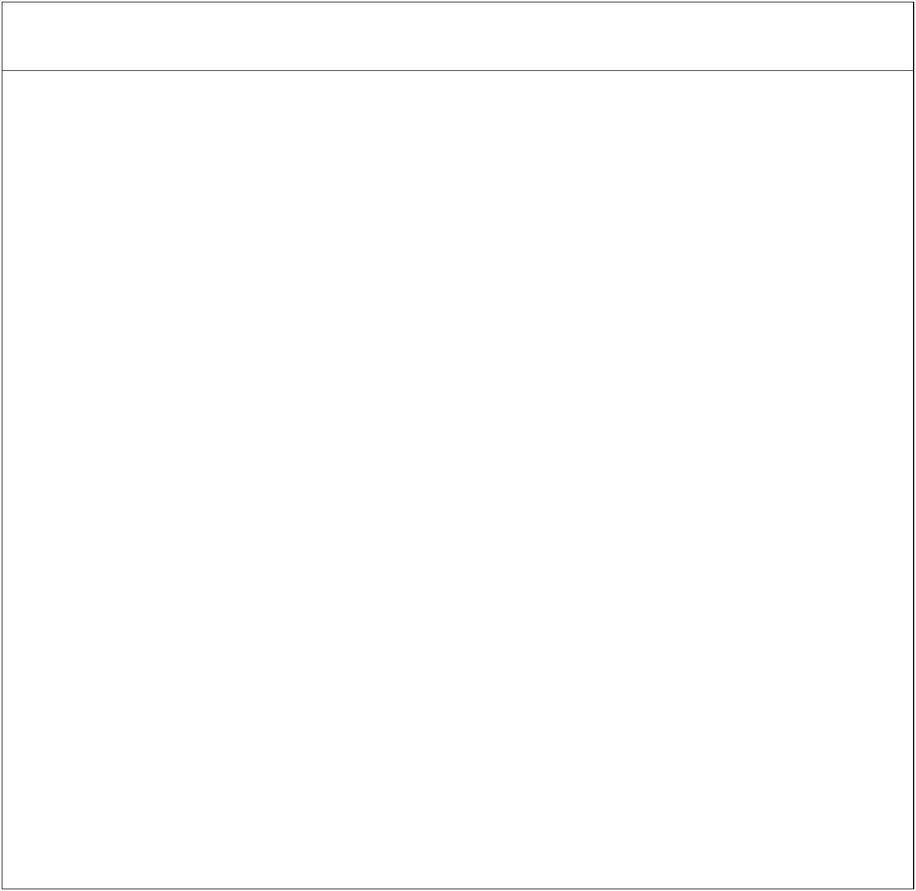

Section 5: Quality of teaching

Expectations, engagement, motivation, challenge, independence, reading and literacy skills, assessment and next steps in learning

The majority of teaching is at least good (the percentage of teaching that is good/outstanding is currently at least 78%) and the result is that the children move from low starting points in the Nursery (Foundation 1) to just below average at the end of Year 2.

Learning is focused & effective as a result of planning & lesson delivery being informed by assessment outcomes. As a result of teaching that is good, pupils are achieving good progress from very low starting points. A rich learning environment caters for the different learning styles of the children. Teachers’ subject knowledge about the teaching of phonics is now embedded as a result of both their determination to improve and focused training and monitoring.

Expectations of the children are high but also realistic.
Teachers’ motivation, enthusiasm and commitment to learning is high.
The pupils’ learning of basic skills - reading, writing and communication is often hampered by their joining the school speaking no English. The school therefore places a great deal of emphasis on communication, for example, putting good adult/child ratios into the Nursery where they split into small groups according to language needs.

The majority of teachers are skilled at matching their teaching to pupils’ learning needs. Their good listening, observation and questioning skills mean that the majority of pupils’ progress at a good rate. Teachers are confident in deepening pupils’ knowledge and understanding and cross curricular links are used to enhance this.

Recently increased regular and effective moderation ensures the consistency and accuracy of assessment and accurate assessment of prior skills means that lessons are planned well to enable pupils to progress.

The quality and effectiveness of teaching strategies, interventions and support are regularly evaluated by the SLT to ensure that the pupils are benefiting.

The majority of children are keen to learn, well behaved and on task.

The majority of parents encourage their children to complete homework tasks and this can have a significant impact on attitudes to learning - e.g. following on from work completed in Y2 about the Autumn environment, a child wrote a poem about a tree with their parents; a Reception child was taken to the local park with a parent to look for conkers.

The school has good systems in place for the assessment of pupil progress and feedback to pupils is both frequent and detailed, becoming more formal for the older pupils.
There is a consistent whole school approach to encourage, motivate and raise the self-esteem of the children through SEAL/Circle Time and Golden Time.
Through differentiated planning, evaluation of intervention groups and the use of extension activities SEN and Gifted children are well supported and make good progress.


Areas for development

- The further development of children’s oracy skills through Let’s Talk training and implementation.
- Strengthening moderation within the school to ensure greater consistency.
- SMARTer targets for staff following Pupil Progress Meetings.
- Development of the teaching of vocabulary.


Section 6: Pupil’s Behaviour and Safety

Including conduct in lessons and around the school, attendance and punctuality, attitudes to others, how well protected from bullying, views of pupils, parents and carers.

Children want to come to school and have a good attitude to learning. The school was awarded the Anti-Bullying Community Award in July 2013. (See Local Authority Feedback Report)

The local authority Health and Safety team gave us an ‘excellent’ grade in their health and safety audit in September 2014.

Pupil interviews are conducted regularly. Those from January 2014 are summarised - The children were confident and ready to answer questions and give their views. They were polite and listened well to each others’ opinions. When asked about the things they liked about school they identified the big playground with exciting things to do, playing with friends, the activities arranged by the teachers, learning Science and trips outside school. They felt that the teachers were kind and helpful to them and kept them safe. They voiced that school was for learning things like Literacy and Maths, that there were loads of interesting things to do such as Art and how to make a light bulb light up. Nearly all the children said they liked having a school lunch. They felt that all children were good at learning and that the more you learnt, the more there was to learn.

Pupils are very considerate, respectful and courteous to staff and each other and they move about school in a calm and purposeful way.

In lessons pupils’ levels of engagement are good.

Pupils are well behaved and feel safe in school:-

- Feedback from the Anti-bullying Community Award (July 2013) - ‘Embedded ethos promoting inclusion, developing emotional health and well-being, confidence and self esteem . . . . .

Central to this is the school ethos which clearly welcomes and includes all members of the community. Children and adults repeated that the school was a happy place where everyone felt safe and supported to speak and voice their opinion.’

- SIP pupil interviews January 2014 - ‘The children felt secure and confident enough to share their views with a person new to them. They were good at listening to others’ views and giving their own views. They were proud of their school and the many opportunities it offered for work and play. They felt that the teachers were kind and helpful and kept them safe.’

- Ofsted June 2011 - ‘The school is a welcoming and harmonious place where pupils from all backgrounds achieve equally well and get on well together…. Behaviour is outstanding and pupils say that incidents of racial harassment are non-existent . . . Pupils are happy and they enjoy coming to school. They say they feel safe and that adults care for them very well.’

Any occasional concerns expressed by parents/staff or pupils are dealt with fully and promptly. Punctuality is generally good but needs constant focus, e.g. we have now introduced late signing sheets at the office.
Pupils respond well to positive behaviour management strategies - e.g. Golden Time.
The school maintains a high level of pupil behaviour. Bullying is discussed with children in SEAL work and results in very few incidents. Where rare incidents of bullying or disruptive behaviour do occur they are dealt with firmly and promptly.

We maintain a constant focus on attendance. In the Autumn Term the percentage attendance was 96%. Unfortunately after a run of flu and Norovirus is it currently 94.8%


Areas for development

- We continue to work with our families to address attendance/lateness issues. In September 2013, the EWO ran attendance workshops for each year group. She now is running them every year with Reception parents.
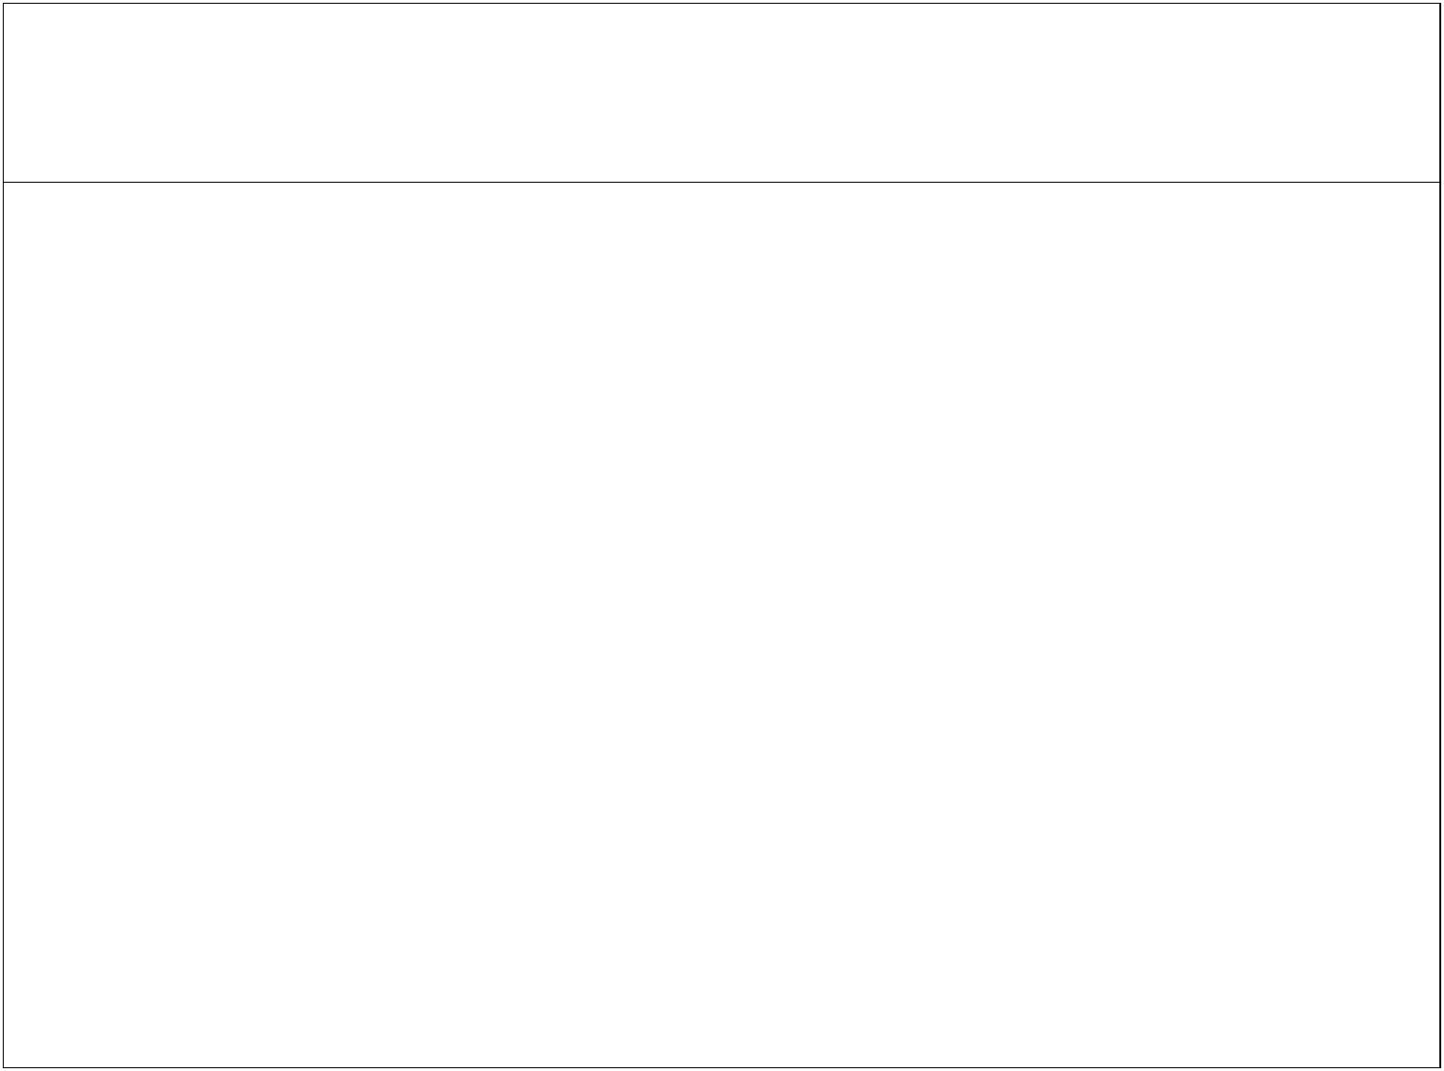

Section 7: Effectiveness of leadership and management

How leaders and managers demonstrate ambition for pupils in their achievement, improve teaching and learning, support/develop staff, and capacity for improvement. Also accuracy of SSE, appropriateness of curriculum, governance, safeguarding, equality of opportunity, parental engagement and partnerships

Leaders and managers display high expectations of the children.

The Governing Body increasingly challenge the Headteacher and staff to aspire and improve. They are engaged and make positive contributions during meetings. There is an increasingly constructive relationship with the feeder junior school, including both Headteacher’s attending each other’s Governing Body meetings.

Experienced staff generously share their expertise with other colleagues. There is a strong improvement culture in the school staff who show high levels of enthusiasm and commitment to their work.

Self evaluation is embedded in all aspects of school life. Identified areas for development are promptly dealt with and, as a result, pupil progress and achievement is at least good. The school provides varied opportunities for staff development and an appraisal system is in place.

The predominately practical curriculum provides children with exciting and varied learning opportunities. As a result children are alive to learning and highly engaged in their activities. Their positive behaviour and safety supports their achievement and contributes to their spiritual, moral, social and cultural development.

The school is imaginative in its work with parents, especially supporting families for whom learning is a challenge.

Safeguarding meets statutory requirements.

Areas for development

- Some further strengthening of Governance is needed e.g. engaging Governors to participate in visits to the school.

- Embedding skills on the relatively new SLT to monitor their own areas of responsibility.


Section 8: Overall Effectiveness

Our evaluation of the overall effectiveness is that it is a good school.

As a result of good planning, teaching, assessment and monitoring pupils’ progress and achievement is good.

Children make good progress throughout Foundation Stage and Key Stage 1 from their generally low starting points on entry.
The majority of teaching and learning is good with many examples of outstanding performance.

The behaviour of pupils is very good. Their attitudes and dispositions to learning are highly positive and they report that they feel safe and secure in school.
Whole school leadership and management is effective as it is focused on the improvement of teaching and learning. The Governing Body are becoming increasingly able to challenge the school.

This happy and secure school ensures that all children achieve well and make good progress. The capacity to further improve is good.

