Employee Self Evaluation Form

Name: |  | Department:
Title: |  | Date:

Instructions for Completing this Form

- Complete this form prior to the annual performance review with your supervisor.

- Make a copy of the completed Self Evaluation Form for your supervisor in advance of the review meeting.
- The goal of this form is to provide information from which you and your supervisor, working together, can create goals and action plans.

- Select a rating for each of the core competencies using the rating guide below.

Rating Guide - The rating scale below is to be used to evaluate performance in each of the competency areas.

Exceeds Standard: Performance is repeatedly above expectation.

Meets Standard: Performance meets expectation.

Needs Improvement: Performance is sometimes below expectation.

Leader Attributes

Fundamental qualities and characteristics

Using the drop down arrow, select the measurement you think best describes your performance in each skill area. In the comment section, please describe how you exhibit performance in this area.

RATING SCALE | Exceeds Standard: | Performance is repeatedly above expectation.
 | Meets Standard: | Performance meets expectation.
 | Needs Improvement: | Performance is sometimes below expectation.

Attributes (Fundamental qualities and characteristics)
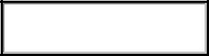
1. Mental - Possess desire, will and initiative. How I exhibit positive performance in this area:

How I can improve in this area:


- Physical - Appropriate appearance, decorum. How I exhibit positive performance in this area:
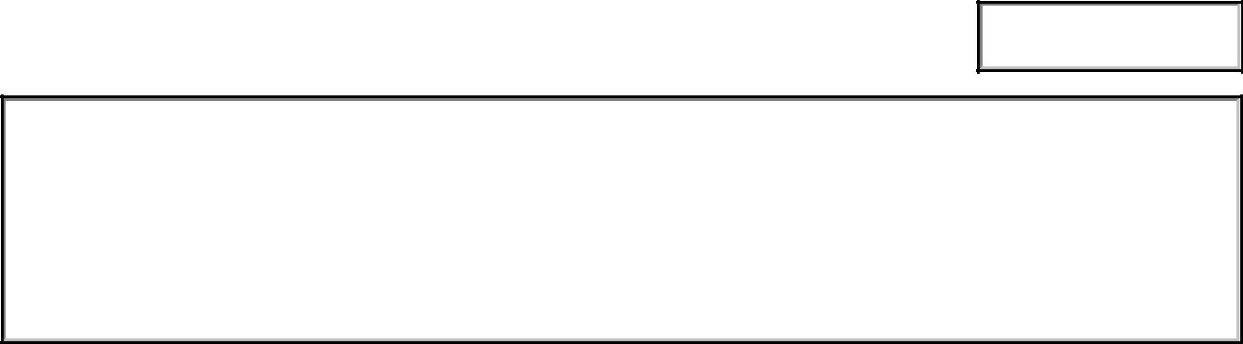

How I can improve in this area:
Leader Attributes - continued

Fundamental qualities and characteristics

- Emotional. Displays self-control; calm user pressure. How I exhibit positive performance in this area:

How I can improve in this area:

Training and development needed in this area:

Knowledge/Skill Level of Proficiency Required
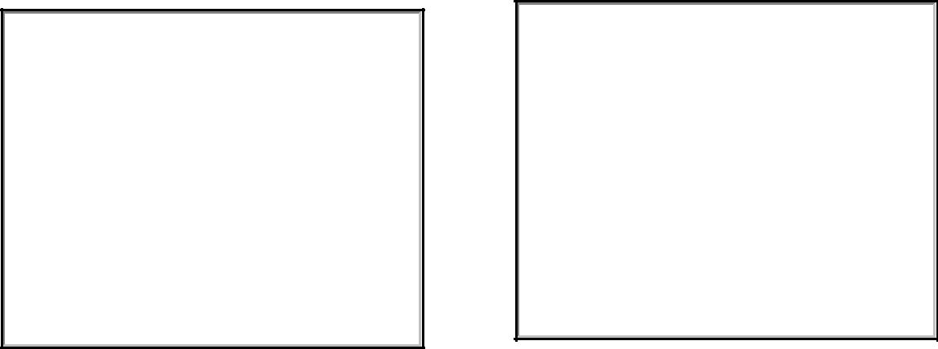
SKILLS (Competence)

Skill development is part of self-development; prerequisite to action.

- Conceptual – Demonstrates sound judgment critical/creative thinking and reasoning.

How I exhibit positive performance in this area:

How I can improve in this area:

- Interpersonal - Shows skill with people; coaching, teaching, counseling, mentoring, empowering.

How I exhibit positive performance in this area:

How I can improve in this area:
SKILLS (Competence) – continued

- Technical – Possesses the necessary expertise to accomplish all tasks and functions.

How I exhibit positive performance in this area:

How I can improve in this area:

Training and development needed in this area:

Knowledge/Skill Level of Proficiency Required

Actions (Leadership)

Major activities you perform, influencing, operating, and improving.

- Influencing – method of reaching goals while operating / improving. How I exhibit positive performance in this area:

How I can improve in this area:

- Communicating - Displays good oral, written and listening skills for individuals/groups.

How I exhibit positive performance in this area:

How I can improve in this area:
Actions (Leadership) – continued

Major activities you perform, influencing, operating, and improving.

- Decision Making - Employs sound judgment, logical reasoning and uses resources wisely.

How I exhibit positive performance in this area:

How I can improve in this area:

- Planning - Develops detailed executable plans that are feasible, acceptable, and suitable.

How I exhibit positive performance in this area:
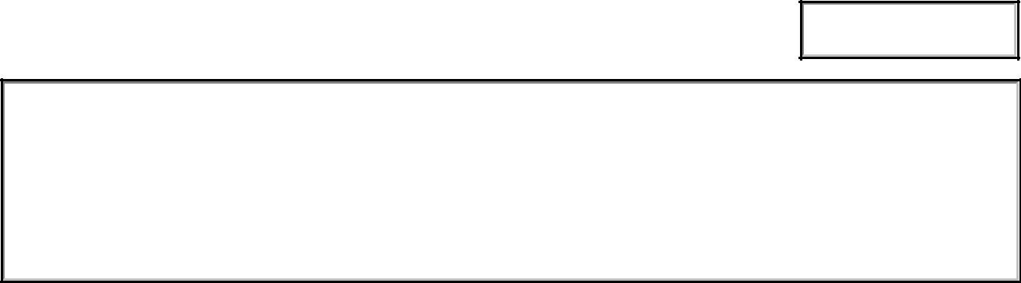

How I can improve in this area:
Actions (Leadership) - Continued

Major activities you perform, influencing, operating, and improving.

- Executing - Shows proficiency, meets task, and takes care of people/resources

How I exhibit positive performance in this area:

How I can improve in this area:

- Assessing - Uses after-action and evaluation tools to facilitate consistent improvement.

How I exhibit positive performance in this area:

How I can improve in this area:
Actions (Leadership) - Continued

Major activities you perform, influencing, operating, and improving.

- Developing - Invests adequate time / effort to develop individual subordinates.

How I exhibit positive performance in this area:

How I can improve in this area:

8. Building - Spends time and resources improving teams groups and units;
fosters ethical climate.

How I exhibit positive performance in this area:

How I can improve in this area:
Actions (Leadership) - Continued

Major activities you perform, influencing, operating, and improving.

- Learning - Seeks self-improvement and organizational growth; envisioning adapting and leading change.

How I exhibit positive performance in this area:

How I can improve in this area:

Training and development needed in this area:

Knowledge/Skill Level of Proficiency Required



Print Form

