Instructor Growth Self-Evaluation Form

Questions for Self-Appraisal
Name: | Date:

Directions:

In each of the six sections below, mark the appropriate box to identify your strength in each area and to identify areas that require your attention.

Use the question and the blank space at the end of each section to reflect on these areas and set appropriate goals. Take action to improve your skills in the areas necessary.

Key:

- I feel that I am sufficiently strong this area.

- Some attention is required in this area, but it is not a high priority.

- This area requires my attention, but I can develop these skills on my own.

- I urgently need help in this area from a peer or supervisor.

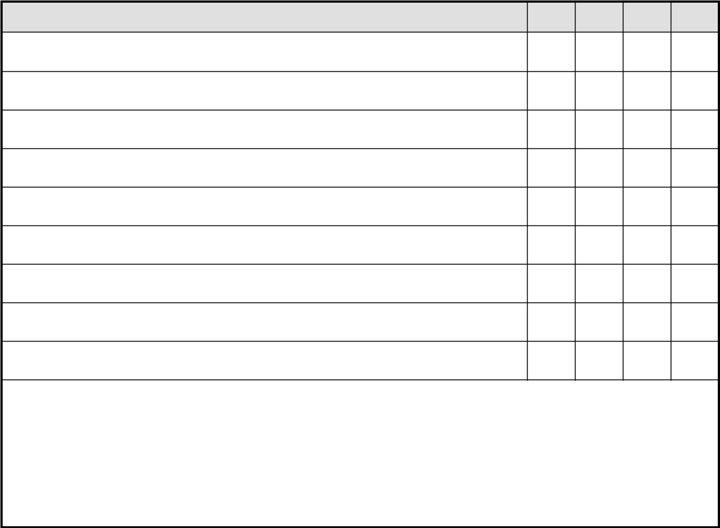
Knowledge of Subject and Organization of Subject Delivery | 1 | 2 | 3 | 4

My knowledge of the subject is up to date and relevant.

I have mastered this subject matter.

I am able to respond readily to questions from students on the subject matter.

I use correct grammar and technical terminology while teaching.

Material is organized and presented systematically and sequentially.

I carefully plan lectures, demonstrations, discussions, and other classroom activities.

I use real life examples to illuminate core learning concepts and increase subject matter relevance for students.

I deliver the material at a depth, breadth, and pace that is appropriate for the level of my student groups.

Other:

As I look at my responses to this section, I would like to work on:


1271 Sugarbush Drive, Evergreen, Colorado 80439-7966; 800-458-2267; abmp.com

  Instructional Methods | 1 | 2 | 3 | 4

I use teaching strategies that help guide students to be independent learners.

I alert students to the intended learning objectives for the class at the beginning of class and check that learning outcomes have been met in a review at the end of the class.

I use teaching strategies that challenge and extend students’ assumptions, competence, and understandings.

I encourage cooperation and active learning by asking students to evaluate the work of one another, work together on tasks, and explain difficult ideas to each other.

I give my students real life situations to analyze and I use simulations, role-playing, research, and independent study in my classes.

I encourage students to challenge my ideas, the ideas of other students, or those presented in textbooks or course materials. Class discussions are lively and purposeful.

I help students set challenging goals for their own learning.

I help students identify their learning styles and I use methods to address the needs of each learning style in every class.

I deliver well-planned lectures, illustrated with visual aids.

I regularly link new concepts back to old concepts or to content taught in other classes.

I use planned repetition strategies and regularly check that students understand material before moving on to new material.

I provide appropriate supervision during practical activities and give students in-the-moment feedback on practical skills.

I use instructional methods that require active participation and responses from students.

Learning experiences are diversified and I regularly utilize a variety of methods, including lecture, demonstration, group discussion, independent study projects, and hands-on work.

I make use of equipment and supplies during class time including visual aids, overhead or

PowerPoint projections, models, video, diagrams, and the chalkboard/whiteboard.

Other:

As I look at my responses to this section, I would like to work on:


1271 Sugarbush Drive, Evergreen, Colorado 80439-7966; 800-458-2267; abmp.com

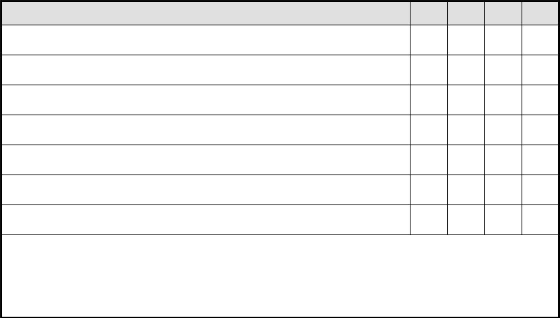  General Classroom Management | 1 | 2 | 3 | 4

Classes start on time and end on time. Class time is used effectively to promote learning of the subject matter.

I make clear my expectations, verbally and in writing, at the beginning of the course and periodically during the course.

I understand and uphold the policies and classroom rules of the school where I work (i.e., no eating in the classroom, attention to dress code, attendance policy).

I am attentive to cultural diversity, generational diversity, and I prohibit sexual innuendo in my classes. In my classes, I regularly raise awareness of ways to desexualize massage.

I discourage snide remarks, sarcasm, kidding, and other classroom behaviors that may embarrass some students or promote an unsafe learning environment.

I set a positive tone for the class and handle classroom tensions in a timely manner.

Other:

As I look at my responses to this section, I would like to work on:
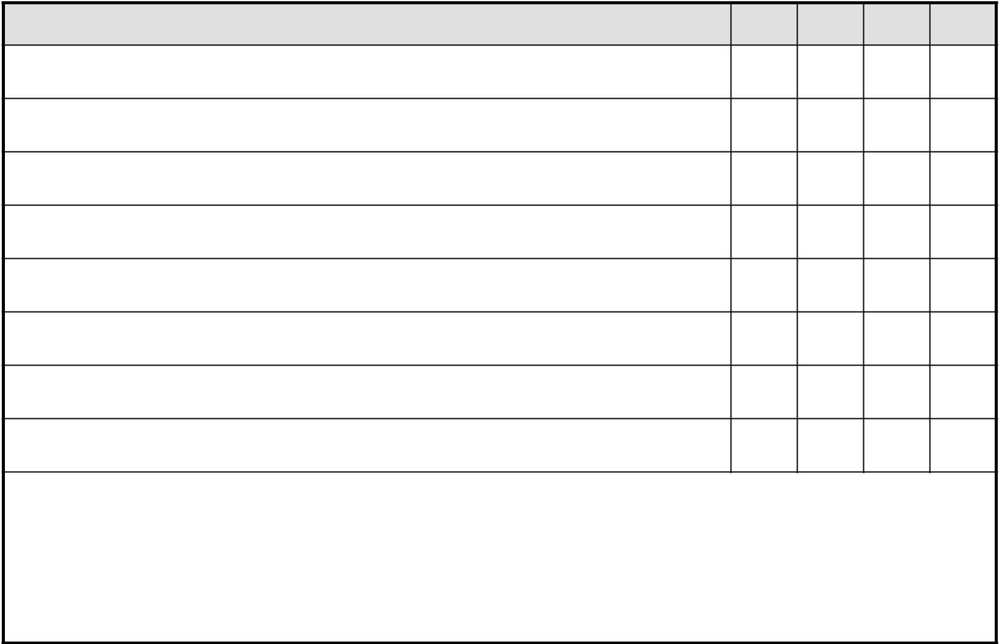

Feedback to and from Students | 1 | 2 | 3 | 4

I have an efficient system to provide feedback to students on their progress.

I prepare practical exercises that give students immediate feedback on particular skills and allow them to adjust techniques right away.

I return examinations and homework assignments promptly and take the time to give written feedback on progress.

I give students detailed feedback on their work early in the term.

I follow up with students who are not making adequate progress in class, and form learning contracts to help them get back on track.

I reinforce positive behaviors and progress in students.

I ask for and graciously receive feedback from students on class structure and progress.

Other:

As I look at my responses to this section, I would like to work on:

1271 Sugarbush Drive, Evergreen, Colorado 80439-7966; 800-458-2267; abmp.com

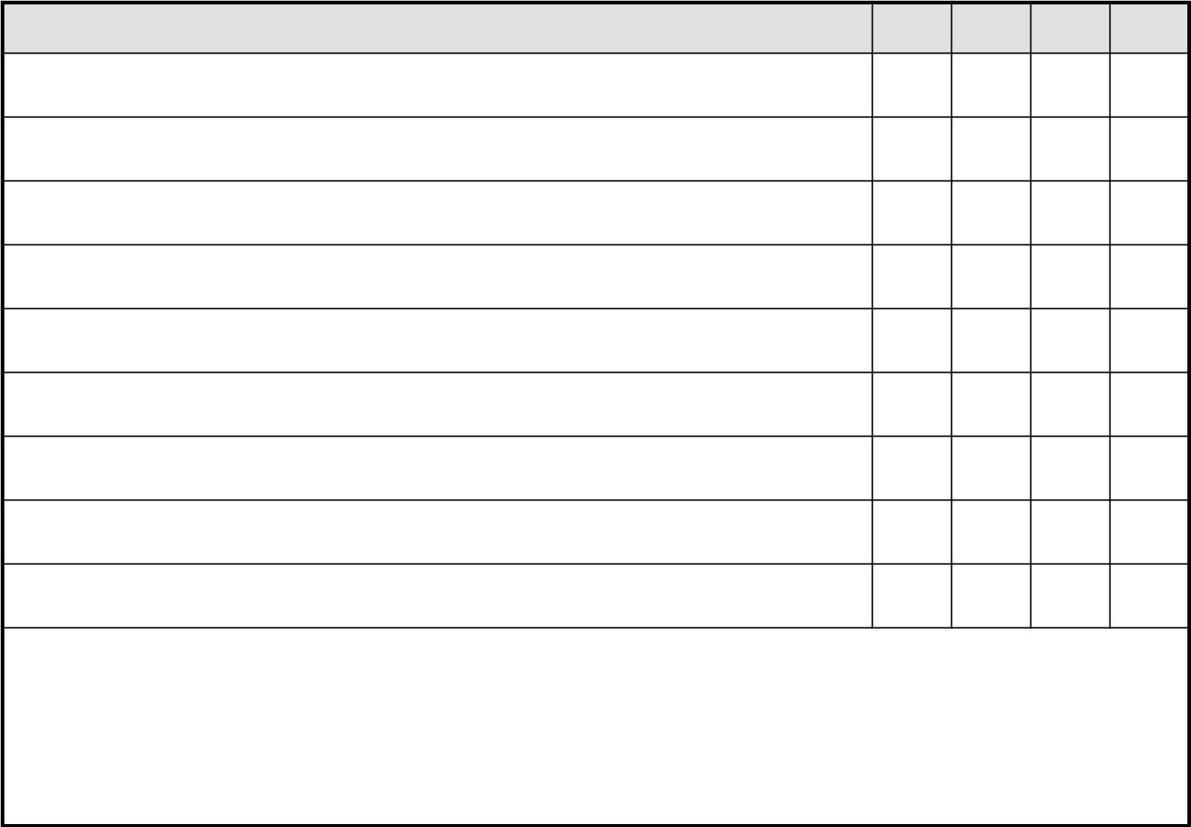  Student Relations | 1 | 2 | 3 | 4

Students perceive me as being helpful and available to discuss their concerns about their progress and difficulties with course content.

I know my students by name by the end of the first two weeks of the term.

I meet with students who fall behind to discuss their study habits, schedules, and other commitments. I help students brainstorm workable solutions.

I periodically hold a class discussion to determine how students are feeling about class content and school in general.

I encourage students to speak up when they don’t understand.

I listen to students carefully when they ask a question or offer a comment. I treat all students respectfully and fairly.

I feel confident in my ability to understand and capitalize on classroom dynamics. I can balance various student personalities, work with students at many different levels, and be respectful of different cultural identities.

When I look out at my students, they appear attentive, enthusiastic, interested, and focused.

I know from their attitudes that I am able to engage them in class content.

Other:

As I look at my responses to this section, I would like to work on:
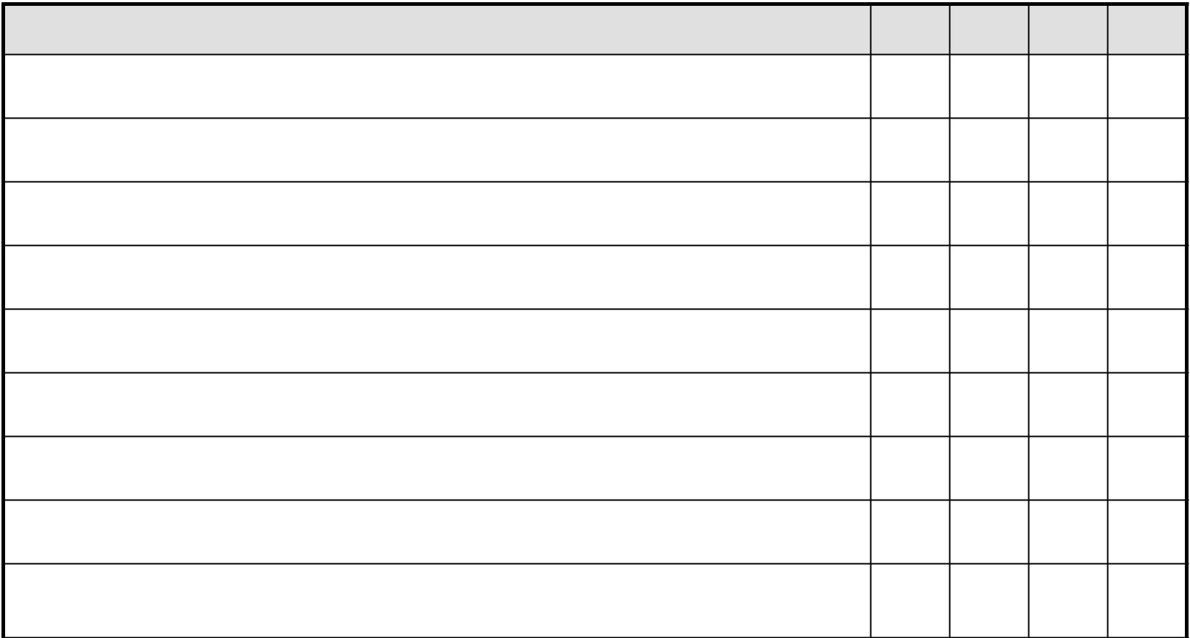

Ideal Teacher Characteristics. I would describe myself as … | 1 | 2 | 3 | 4

Fair to all students, not partial to some students.

Responsive to student needs.

Understanding of students’ commitments and conflicts, while upholding the highest standards.

Stimulating—I encourage students to think outside the box, to offer opinions, to participate, and to get excited.

Responsible and reliable. I own my mistakes and model accountability. I do not evade students when I may fail to return homework or examinations in a timely manner.

Confident. I know my stuff and it shows. I still allow room for student opinions and exploration.

Adaptable. I always have a plan, but can go with the flow if it will improve student comprehension.

Dedicated to integrating class content to other classes, real life experiences, and professional life.

Enthusiastic. I enjoy teaching; I enjoy the students; I enjoy the class content, and I share this enthusiasm with my students.

1271 Sugarbush Drive, Evergreen, Colorado 80439-7966; 800-458-2267; abmp.com

Open-minded. I welcome other viewpoints and make room for student-generated information in class.

Aware. I look for and capitalize on “teachable” moments. I look for and capitalize on “a ha!” moments.

Humorous. I use humor appropriately in the classroom to facilitate active learning.

Audible and grammatically appropriate. My students can hear me easily during lectures, demonstrations, and discussions. I use proper grammar and terminology.

Optimistic. I regularly state high expectations to the students and expect students to meet challenges. I believe in my students’ abilities and I reinforce their capacity to be successful.

Other:

As I look at my responses to this section, I would like to work on:

As I review this self-evaluation, the goals I would like to work on this month and the tasks I will undertake to meet these goals are:

Goal 1: ___________________________________________________________________________________________

Tasks:

Goal 2: ___________________________________________________________________________________________

Tasks:

Month End Evaluation:

The new skills I have learned are:

My ability to meet my goals has changed in the following ways:


 1271 Sugarbush Drive, Evergreen, Colorado 80439-7966; 800-458-2267; abmp.com

