TRAINING MANUAL

By:

Date
Publisher

Introduction

About this Manual

About the Training Program

Content of the Manual

Target Groups

Sustainable Communities
____________________________________________________________________________________________________________________________________________________________________________________________________________________________________________________________________________________________________________________________________________________

Business Skills

____________________________________________________________________________________________________________________________________________________________________________________________________________________________________________________________________________________________________________________________________________________

Creating a Learning Space

____________________________________________________________________________________________________________________________________________________________________________________________________________________________________________________________________________________________________________________________________________________

Training Activities

____________________________________________________________________________________________________________________________________________________________________________________________________________________________________________________________________________________________________________________________________________________

Training Delivery
____________________________________________________________________________________________________________________________________________________________________________________________________________________________________________________________________________________________________________________________________________________

Materials
____________________________________________________________________________________________________________________________________________________________________________________________________________________________________________________________________________________________________________________________________________________

Training Frame

Day 1

Day 2 Day 3

The Business Plan
____________________________________________________________________________________________________________________________________________________________________________________________________________________________________________________________________________________________________________________________________________________
Business Ideas
____________________________________________________________________________________________________________________________________________________________________________________________________________________________________________________________________________________________________________________________________________________

Evaluation
HOW CAN WE IMPROVE?
What topic was missing?
What topic could we leave out?
What topic should we spend more time on?
What topic should we spend less time on?
How could we improve the training?
What should we remember next time?
WHAT SKILLS DO YOU HAVE NOW?
How confident do you feel about the following task:
I know how to fill out the business plan | No! | Not sure | Yes!
I know how to fill out the money plan | No! | Not sure | Yes!
I know how to repay a loan | No! | Not sure | Yes!
I know how to take out money for living | No! | Not sure | Yes!
I know how to choose my marketing mix | No! | Not sure | Yes!
I know how to make my business sustainable | No! | Not sure | Yes!
I know how to start a business | No! | Not sure | Yes!
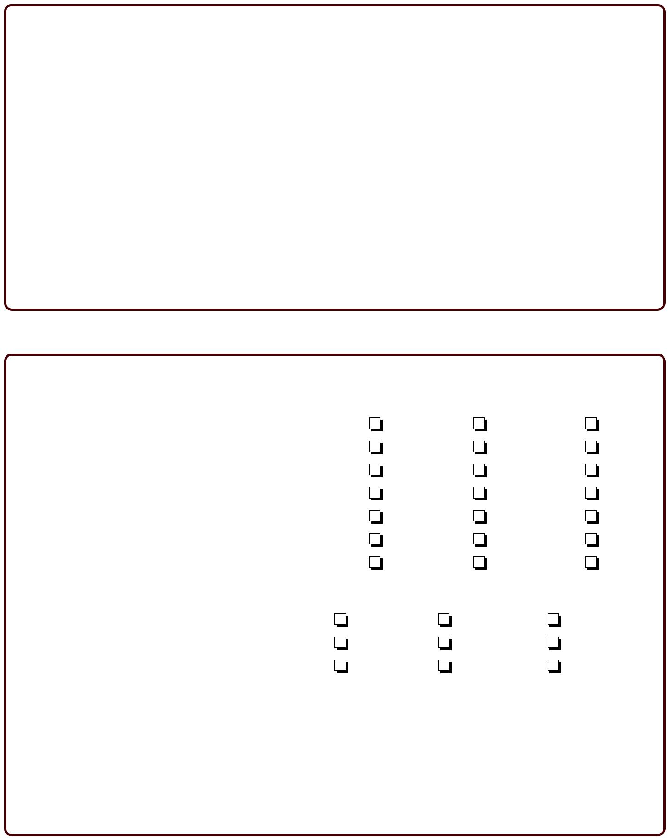

HOW FAR DID YOU GET?
How far did you get with your business plan? | Not started | On my way | Completed
How far did you get with your money plan? | Not started | On my way | Completed
Do you plan to apply for a micro loan? | No | Maybe | Yes

What is your greatest challenge to starting a business?
Conclusion
____________________________________________________________________________________________________________________________________________________________________________________________________________________________________________________________________________________________________________________________________________________

