
Michael Seidel
Description
Sex: Male Height: 5’10’’
Hair: Blonde Weight: 155 lbs.
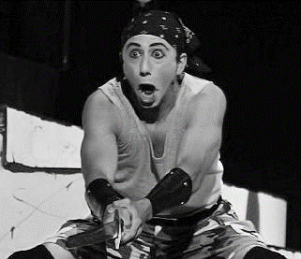
Eyes: Blue Vocal: Baritone

Notable experience
Mark Rent Rhino Theater
Marius Les Miserable Rhino Theater
Peter/Jesus (unds) JCSS Rhino Theater
Tim the Enchanter Spamalot Smiling Rhino Theater
Lewis Pippen Snug Harbor, ny
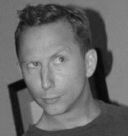
Joe Pitt angels in america tcnj one acts
Vladimir Waiting for godot Wagner College, ny
Warbucks Annie Notre Dame Academy
Danny Zuko Grease Blair Academy Players

Training
BA theater education K-12 2001-2005 Wagner College Staten Island, NY
Studies Include:
Stage Movement, Combat, Musical Theater
Stanislavski / Hagen / Meisner acting technique
Dance Basics: Jazz, Ballet, Modern
Voice and Diction training: Stage Dialects/Accents
Stage Production and Design: Sound/Lighting, Craft
Primary Address
20 Cayuga Avenue
Lake Hiawatha, NJ 07034

Phone: 908.227.3436 (c)

E-mail: mseidel12@yahoo.com

Voice Training: Studied recorded artist, Peter Gillis

Special Skills
NJ Certified Teacher Of Drama k-12, Accents/Dialects Capable,Certified Wilderness Survival Guide, Adventure bound High Ropes Instructor, public speaker, Bartender / Waiter, Impressionist

