

February 22, 2008

Re: Mr. John Smith

Personal Letter of Excellence

Greetings;

I first hired John Smith as a Reservation Sales Agent for Keystone Resort in October of 1998. I was immediately impressed with his enthusiasm and action oriented approach to the specific questions that were asked of him. John was hired and he went on to become the #1 sales agent for a ski-resort which books $75Million in lodging and components annually.

I was thrilled when, after I moved to Copper Mountain Resort to become the Director of Lodging, that John was willing to transition to Intrawest with me. I was again confident in his ability to tackle complex sales and hospitality service issues. John did not disappoint and proceeded to have a diverse and rewarding career with Intrawest, including making the elite Operational Excellence Team as a lean six-sigma Blackbelt.

John has a passion for his life and his work that is rare to find. I recommend him for your organization with my full endorsements. Please feel free to connect with me by phone if you would like additional insight on John’s performance attributes.

Kind Regards,
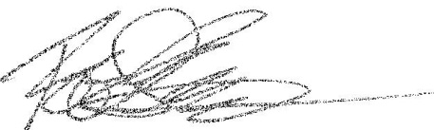

Robert Stenhammer

843-686-8120
General Manager
ResortQuest Hilton Head
MBA-Hospitality & Tourism
rstenhammer@resortquest.com

