

To
Quality Solutions for a Secure Environment
Whom it may concern
Name Bus Cell.
Fax (Bus)

E-Mail Address

Your Reference Our Reference Date
Sam Lessing
+ 27 (0) 12 548 4922
+ 27 (0) 82 556 6565
+ 27 (0) 86 556 5433
info@securitell-int.com N/A
131002-STL-LOI
2nd October 2013

LETTER OF INTRODUCTION, COMPANY AND PRODUCT OVERVIEW

Dear Sir / Madam

Thank you for the opportunity and privilege to introduce the solutions and services offered by Securitell.

COMPANY OVERVIEW

Brief History
Securitell is owned by Samuel Izaac Lessing. Sam Lessing worked in the Telecommunications industry for over thirty years, of which twenty five were with Siemens Telecommunications (Pty) Ltd. I started as a technician and worked my way up to the Head of the Installation and Maintenance Division; from there I entered into the Sales and Project Management arena achieving positions such as Head Sales and Projects - Africa, Head of Projects and later Account Director for their Africa Business in which we achieved turnovers of up to four hundred million Rand per annum. In this period I played an integral role, as Head of Sales and Projects, in achieving three first in the world projects for Siemens Telecommunications and also at that time, the fasted GSM Start-Up Roll Out in the world, which was executed in Congo Brazzaville.

Strategically, I transferred to Siemens Building Technologies (Siemens Electronic Security Department in South Africa) for three and half years, with two years hands on experience and one and a half years as Head of Sales and Business Development. At this point I left Siemens and started Securitell which has been in operation since October 2009.

View Sam Lessing’s profile and reputation on LinkedIn: http://za.linkedin.com/in/samlessing.

Brief Company Overview
Securitell predominantly supplies very sophisticated and reliable Perimeter Security Sensor and Surveillance Systems. We are currently the only distributor in Southern Africa for Ascendant’s CCTV Systems which are imported from Canada and Sicurit’s Perimeter Intrusion Detection Systems which are imported from Italy. In addition we are one of the few privileged companies allowed to supply the IMPI Perimeter Security Intrusion Detection / Monitoring System, which is not advertised at all due to the confidentiality of this system. IMPI was originally designed by the CSIR and later taken over privately and further developed for commercial use and is currently in use both locally and internationally. IMPI is manufactured in South Africa. A more detailed overview of these systems is available further in this document.

Securitell started as a supplier and integrator of locally available high end Electronic Security Solutions and had very good results for a small start-up company, but on seeing a niche market for higher end security systems we changed strategy and started importing the above mentioned systems for re-sale to integrators only, with the intention of empowering smaller security companies to become independent commercially viable enterprises. This turned out to be a bit of an illusion of grandeur, and after two years of following our

Postal Address
P O Box 2299
Montana Park Pretoria
0159
South Africa

Binopath (Pty) Ltd. T/A Securitell
Company Registration Number: 2009/020754/07
Registered Address: 925 Besembiesie Road, Montana Park, Extension 20, 0186 VAT Registration Number: 4740254406
Director: S I Lessing

Physical Address 925 Besembiesie Rd Montana Park Pretoria
0186
South Africa
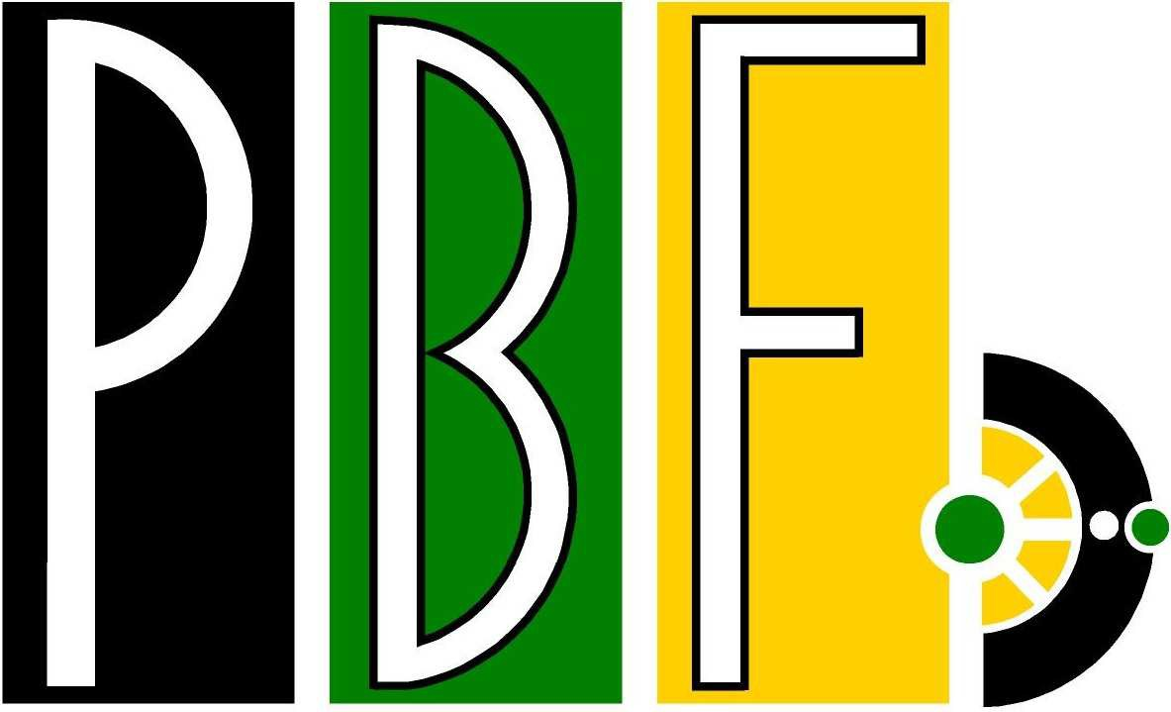
Progressive Business Forum Member


PSIRA Reg. 1983512

130625 - Letter of Introduction - Company Profile - General.docx Page 1 of 9

strategy of not approaching end users and relying on our selected Integrators to promote our systems, we have changed course with zest and now also directly supply to end users and make use of selected integrators small and large to install and commission our systems, when required. Again this is done in a manner that allows these integrators, and ourselves, to mutually benefit from projects acquired.

Our pricing policy with respect to the integrators that we contract / partner with is to minimise our mark-up on their pricing allowing them to make a respectable profit and at the same time reducing our labour costs to offset the cost of our higher end systems.

Our approach when supplying to the end user is quite straightforward, we either sell directly to the end user who can then make use of their own / preferred installers and integrators or alternatively we provide a Turnkey Solution to the end user.

Value Add
Securitell works closely with our customers, especially in the design phase, to ensure that the customer receives a system that will perform the functionality that the customer requires. For example, and in short, for CCTV Systems: the process starts with understanding what the customer wants to achieve and from that point the following are calculated: correct camera placement, camera functionality, choice of camera lenses, which is done with the aid of tools which determine the cameras Field of View and distant object sizes etc., Camera illumination requirements for viewing in darkness, DVR functionality – including recording and playback speeds, DVR hard Disk Sizing, CCTV functionality and specialised analytics if required, video transmission media etc., integration with other systems, control room functionality, remote viewing, lightning and surge protection, UPS systems, etc. Although Securitell can perform most of these functions alone, we do also make use of our supplier’s experts as and when required.

A Security System is in reality a system that is supposed to protect ones assets and people, and when it comes down to this, we will not purposefully supply inferior equipment to our customers just to win an order or to make more profit. Securitell only supplies quality equipment suited for purpose, which at a first glance may appear a bit more expensive than that of others, but when one takes the performance and reliability of this equipment into account, the end result often proves differently. At this point I would like to make it clear that our general range of products, which is available for commercial use, is of the best in the world. We also supply military spec. equipment that is subject to US and European Export Regulations (ITAR); these systems are not publicly advertised by us. There are however a few suppliers that do have specific higher end individual systems – but generally they do not operate as a One Stop Shop, which Securitell is continuously striving to achieve. Below are a few links to our web sites that you can peruse to satisfy yourselves with on the quality and functionality of our equipment.
Securitell Web Site http://securitell-int.com/home
Demo Videos http://www.youtube.com/SecuritellRSA
Commercial References http://securitell-int.com/references

Our equipment is often purpose built and generally does not require basic add-ons to improve their performance and or reliability. We do have specific add-ons available to enhance performance in specific areas, for specific conditions, but these are built for the equipment that we supply. What this, together with the high functionality of our equipment means to the end user, besides the fact that the individual core equipment is technically integrated and thus has a better end result, is that the original planned security infrastructure can often be reduced by up to around fifty percent resulting in equivalent cost savings. For example on a CCTV system: Most Day / Night CCTV cameras specify an illumination distance of let’s say 75 meters, but In reality the usable (Effective) infrared illumination distance is around 50 meters (30% less). Whereas we specify the usable effective distance of the Illumination, in short if we specify 100 meters of infrared illumination the useable distance is 100 meters. So what this means is that consultants and customers often plan the CCTV coverage of a perimeter at around 50 metres and often forget to add the “Blind Area” of about 10 meters to the viewing distance required, but with our infrared CCTV Camera you can redesign your system for CCTV coverage / camera placement at 100M and be certain that we can also cover the “Blind Area” which is now around 20 meters or more. The end result being 50% less infrastructure I.e. Cameras, Camera Poles, Digital Video Recorders, Power Supplies, Transmission Media, Labour etc. Not to mention a large saving on maintenance. Our day night cameras use different kinds of integrated illumination allowing us to effectively illuminate from distance of a mere 30M to between 5 and 8KM, sometimes further, climatic conditions affect

viewing and illumination distances. Our smaller cameras are also of a high standard and are sometimes used in very high security areas where detail especially in poor light conditions is a pre-requisite.

In addition to the core equipment that we offer, which is better described further on this document, we also supply, install, commission and integrate other CCTV and Access Control systems, predominantly:
CCTV: Dallmeier, Mobotix, Samsung and GeoVison. Dallmeier and Mobotix being market leaders.
Access Control: Babylon and Saflec. Babylon being a market leader and Saflec a South African product.

We provide the following services to our customers.
- Consulting
- Site Survey
- Design
- Engineering
- Detailed and Priced Bills of Quantity
- Prime Contractor Status (overall responsibility for project)
- Project Management
- Logistics
- Site Management – Outsourced / Partnered
- Installation - Outsourced / Partnered
- Commissioning and Integration – In co-operation with Integrator
- As Built Drawings – In co-operation with Integrator
- After Sales Support – Direct and if required / more practical: partially sub-contracted
- Quality Control
- Occupational Health and Safety (OHS) – Outsourced
- Project Closure – In co-operation with Integrator
- Guaranty / Warranty

CORE EQUIPMENT OVERVIEW

CCTV
Our CCTV products are imported from Ascendent Technologies based in Canada. These products comply with many US, Canadian and European Standards. Ascendent builds quality Hi-Tech systems that are often used for monitoring and securing homeland and critical infrastructure. Our range of cameras varies from standard indoor / outdoor, day / night cameras to ruggedised (Military / Industrial Specification) or Explosion Proof (ATEX Certified) PTZ and Fixed Cameras with extreme long range day / night capabilities, utilising Infrared, ZLID (Zoom Laser Infrared Diode), low power laser illumination or high power pulsed laser illumination (up 300watts), SWIR, EMCCD and FLIR Thermal Imaging technology. Some of our higher end cameras make use of a few of the aforementioned technologies allowing the user to see in the most difficult conditions with the use of one integrated camera.

Due the stringent requirements and harsh environments that some of our cameras are required to operate in, we only utilise quality products and in some cases we go to the extreme where our lenses are of NASA standard. Our lenses vary from the simple fixed lens with manual iris to our 4700mm optics without the use of a lens doubler (using a doubler we achieve a 9400mm optical zoom lens). With the use of Beam Splitters etc. we can accommodate up to around four different cameras into one unit. Our CCDs range from ¼” to 1”. We also offer IP cameras, but analogue cameras are our preference when it comes to precision long distance viewing and recording.

As Ascendent also custom builds CCTV cameras to the customers’ requirements we have a vast amount of models and variants at our disposal. This allows us to conform to virtually any of our customers’ requirements,

Ascendent's digital video solutions have a long and proud track record of success in a host of vertical markets and industries. Ascendent's products are mature and stable and have been used in mission critical environments for over 10 years due to their unparalleled performance and legendary reliability. Ascendent understands DVRs must run 24/7 and offers a number of optional customisations for unparalleled reliability. Please visit http://www.ascendentgroup.com/ for a more detailed overview of their products and solutions.

Day / Night Viewing and Recording: Active IR, in principle, functions the same for all CCTV Cameras in that the lens will determine how much detail you will be able to see and the images will be black and white by night and colour by day. However it is the engineering, quality of Illuminators, CCDs, camera software / firmware, lenses, workmanship and the way the IR Illumination is specified that differentiates our CCTV cameras from the majority. With the use of either Standard Infrared 800-840nm, Stealth Infrared 940nm, ZLID (Zoom Laser Infrared Diodes) or Laser of up to 300 Watt Pulsed we can illuminate from a mere 30m up to between 5 and 8Km in total darkness – sometimes further, for our Optical Cameras. Then of course we can add any available FLIR Thermal Imager, SWIR or EMCCD to the package, some of these technologies may be subject to US and European Export Control Regulation. Most of our cameras have advanced software and hardware technology built into the cameras, and in some cases as add-on modules, allowing our cameras to function better than most both difficult lighting conditions and in total darkness.

Our Digital Video Recorders and Analogue to IP Video Servers mostly have an additional remote monitoring functionality that allows the user to remotely monitor a site on almost any IP, Radio or GSM / GPRS network even at very low bandwidths. Some of our DVR models can broadcast at extremely low bandwidths; these DVRs are also available in ruggedised mobile versions that have GPS functionality allowing the user to track his vehicles on Google Maps.

Some of the key features of the Ascendent CCTV Solutions is the technology utilised in their cameras.
- Unparalleled Active IR Imaging. Unlike traditional IR night vision cameras that use standard CCD's, lenses and LEDs that operate autonomously, Ascendent's Active IR cameras have integrated AMC (Automatic Processor Control) and EPC (Electronic Photocell Control), MICF and a host of other technologies, to ensure the Optics, image sensor, lens, MICF and super bright IR LEDs work in tandem to eliminate hot-spots, washout, and under exposure usually associated with IR cameras. For flawless active IR performance up to 200m (650ft) Ascendent's IR LEDs are optimally spaced and use different sized and angled LEDs to provide evenly distributed IR for both long range and wide angle illumination. The (MICF) mechanical IR cut filter blocks parasitic light before it reaches the sensor further enhancing the image clarity. Ascendent's IR cameras are designed to offer absolute performance and use the highest quality components and unique manufacturing processes to increase performance and reliability such as dual PC board design and hand welding of all the IR LEDs (Vista and Apex Series). All these components are integrated into various housings, some of which are rugged IP 66-68 Nema 4X enclosures constructed of extruded aluminium and thick, high- impact, optically pure polycarbonate to withstand the most brutal assaults and extreme climates for 24/7 surveillance in mission critical applications.
- Zoom Laser IR Diode (ZLID). Ascendent's ZLID laser illuminators combine laser diode technology with precision engineered optics and sophisticated electronics to provide extreme long range Active IR illumination greatly exceeding both performance and distance of traditional IR LED illumination in applications that require over 200m (650ft) of illumination. Ascendent's ZLID (Zoom Laser IR Diodes) Technology (IR Laser) synchronizes IR intensity and area illumination with a motorized zoom lens for outstanding active IR performance, eliminating overexposure, washout, and hot-spots for unparalleled performance of recognition at distances up to 3.5km (11,500ft) in complete darkness.

Laser Infrared vs. Thermal Imaging
Most of the laser series offer significant advantages over thermal imaging by producing images with up to 500% higher resolution. Active IR also has the ability to illuminate through windows and other optically pure substances at night for both recognition and identification making it ideal for military installations, homeland defence, airports and critical infrastructure scenarios.
- Thermal Imaging. Ascendent generally utilise FLIR (Generation 2) Thermal Imagers with 17UM pixel size, which produce about a 30% sharper image than the older imagers, thus we offer the latest Thermal Imaging technology supplied by the company with the most utilised thermal imagers in the world. Both uncooled and cooled systems are available. Our Thermal germanium lenses range from around 19mm fixed lenses up 1100mm varifocal lenses for 22km of human detection and 30km of Vehicle detection. The imagers are generally 336×256 or 640×512 with 17UM pixel size.

ULR - ULTRA LONG RANGE
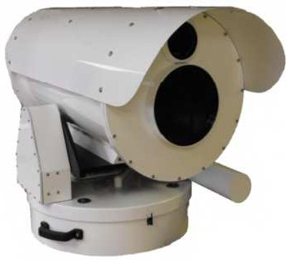
The fully customisable ULR is designed by Ascendent specifically for critical infrastructure protection and perimeter protection. The ULR offers a compelling alternative to the conventional one camera systems. The dual sensors payload enables the ULR to provide images in virtually any environment from heavy fog to complete darkness The FLIR thermal imager provides long range wide angle detection allowing you to properly assess potential hazards, and threats at great distances of around 30km with a high level of accuracy. The precise high-resolution optical camera with a zoom lens capability of 9400mm together with its applicable illuminator provides superior detail over thermal imaging and yields high details to identify threats and trespassers making the ULR the clear choice for mission critical applications and security professionals worldwide

SIGMA - EXTREME LONG RANGE
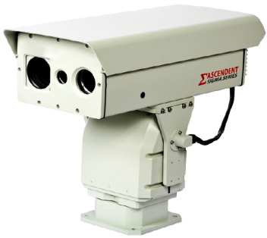
The range of cameras is designed by Ascendent specifically for critical infrastructure and perimeter protection. It offers a compelling alternative to the conventional single-camera system. The dual sensor payload enables the Sigma Series to provide images in virtually any environment from heavy fog to complete darkness. The FLIR thermal imager provides long-range, wide-angle detection allowing proper assessment of potential hazards and threats at great distances with a high level of accuracy. The high-resolution optical camera with a zoom lens capability of 4000mm together with its applicable illuminator provides superior clarity over thermal imaging and yields high detail to identify threats and trespassers even in complete darkness.

SAMPLES OF OUR HIGH PERFORMANCE INDUSTRIAL AND CORPORATE RANGE OF CAMERAS.

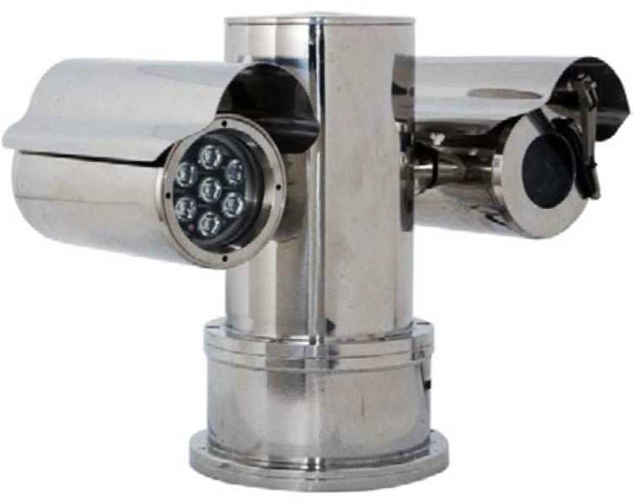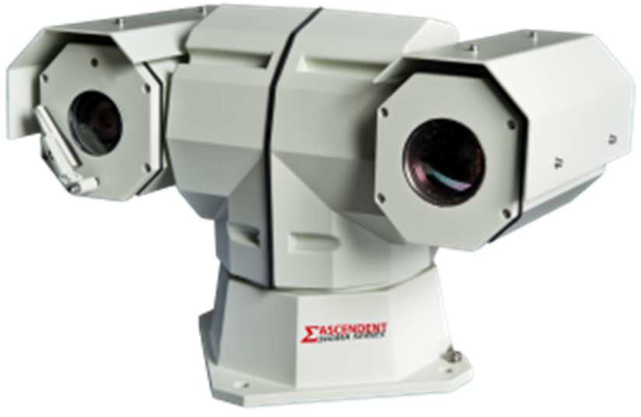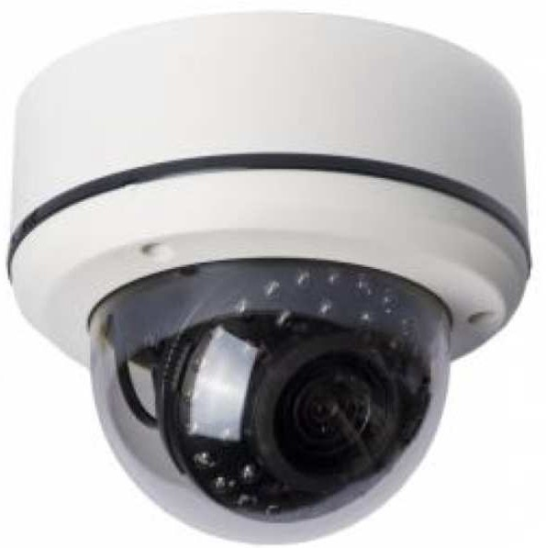

ATEX Certified Explosion Proof Day / Night Cameras
Dual-Sensor PTZ systems that boast 37X or higher zoom lens, ultra-high resolution colour CCD, highly tuned thermal imagers for true 24/7 performance.
Infrared Vandal Protected Day / Night, Colour Dome Cameras,
IP68, 30M of active IR Illumination, 700 TVL Resolution and a host of other advanced features, enabling quality video.

Most High End cameras are purpose built to customer specification, on request.

PERIMETER INTRUSION DETECTION AND MONITORING
Our Core Perimeter Intrusion Detection / Sensing Systems are imported from Sicurit based in Italy. These products comply with many European Standards. Sicurit builds quality Hi-Tech systems that are often used for

monitoring and securing critical infrastructure. This range of perimeter intrusion detection systems basically compromises of: Microwave Intrusion Detection Barriers, Infrared Intrusion Detection Barriers, Dual and Triple Technology Intrusion Detection Barriers as well as Long Range Passive Infrared Detectors, Fence and Cable detection systems. We also supply Museum and Artefact / Object Protection Solutions from Sicurit.

More than 30 Years of experience in the field allows SICURIT to be known as one of the most reliable and technologically advanced companies in the perimeter security market, providing state of the art outdoor perimeter solutions for different applications. Please visit http://www.sicurit.net/ for a more detailed overview of their products and solutions.

Some of the differentiators of our more sophisticated solutions are the low false alarm rates and the stability of the synchronised detectors, as shown the examples below.
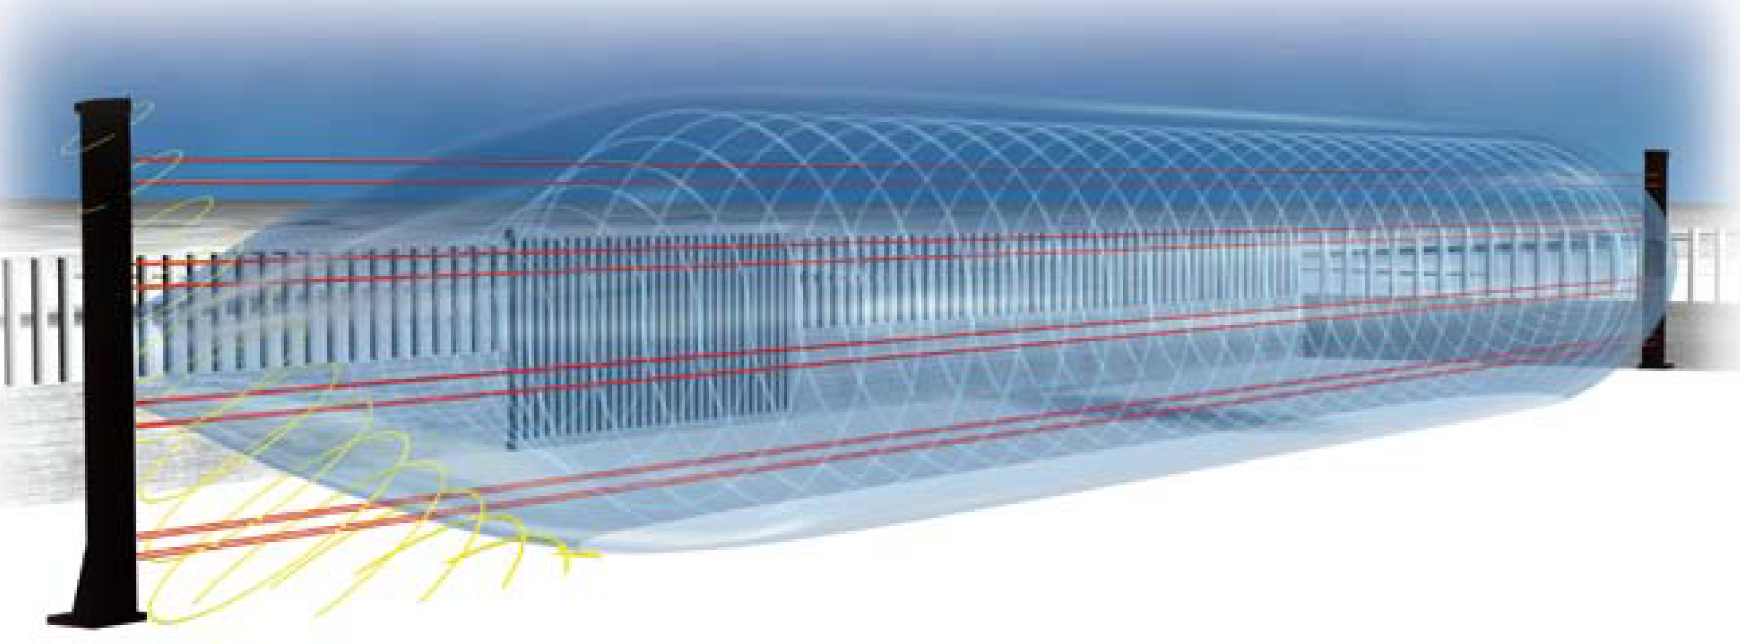

ABSOLUTE PLUS is a high security Dual Technology Barrier that combines Microwave and Infrared Technology to enhance the capability of detection while drastically reducing false alarm rates (FAR). Available in 3 ranges (200/80/50mt.), ABSOLUTE PLUS consists in a pair (TX and RX) of extruded aluminium columns in which Infrared Beam and Microwave Technology are combined into one unit; both sensing elements are located in a single casing, and are connected electronically using a special “AND” Logic Function. Since the two sensors will not detect an intrusion precisely at the same time the system has been designed to generate an alarm when both sensors produce an output in a pre-selected time interval.
The main innovation is the implementation of the New SICURIT patented 6 Lens IR Beams, that thanks to its bi-directional concept (3Tx + 3Rx in the same Head), enables the Beam to be completely immune to sunshine reflections, which are often the main cause of false alarms during sunrise and sunset.
The sensors can be installed along a perimeter line, a fence or a delineated buffer zone, or as a defence against intruders approaching a gate or a wall. To further enhance the information performance, image/video recorder equipment can also be installed to survey the intrusion/approach zone. In addition to increasing the detection potential this capability permits security personnel to assess the nature of the “intrusion/alarm” immediately and remotely. This unit utilises Doppler Microwave to protect the "dead areas" of the beam at the pillars as well as a "Climb Over" detector for the pillars.

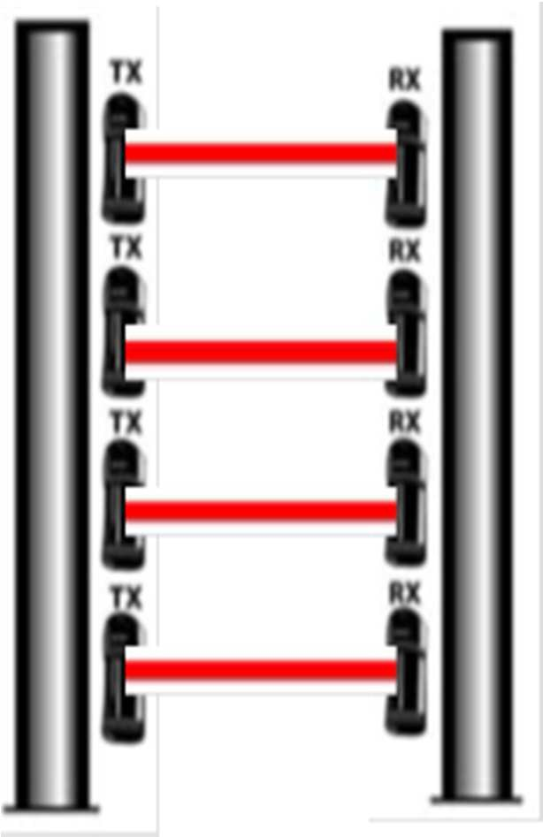
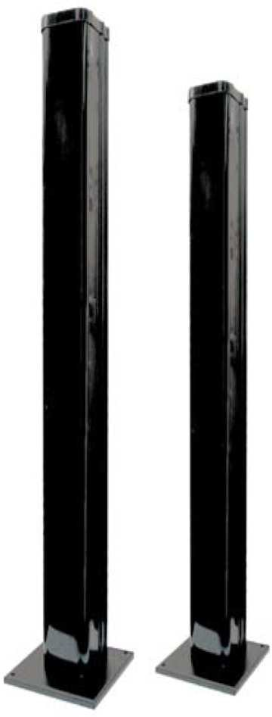
INFRARED MULTI-BEAM DETECTION SYSTEMS
SICURIT provides state of the art towers with all the accessories necessary to customise these barriers for specific applications. BEC and BET towers are available in different heights, from 1.5 to 3M. Thanks to the digital frequency channels, up to 8 BSBE with 6 X IR beams each can be assembled in SICURIT towers for higher security grades. These systems are available in 4 ranges (200, 150, 100 and 50M). These beams are resistive to strong light, up to 50,000 Lux, with built-in automatic adjustment, a strong light filtering system to avoid them being affected by strong sunshine and lights. Fully protected by integrated structural design, which allows the equipment to operate normally in severe weather conditions

These systems also have their own management Platform “HYPERPOWER”

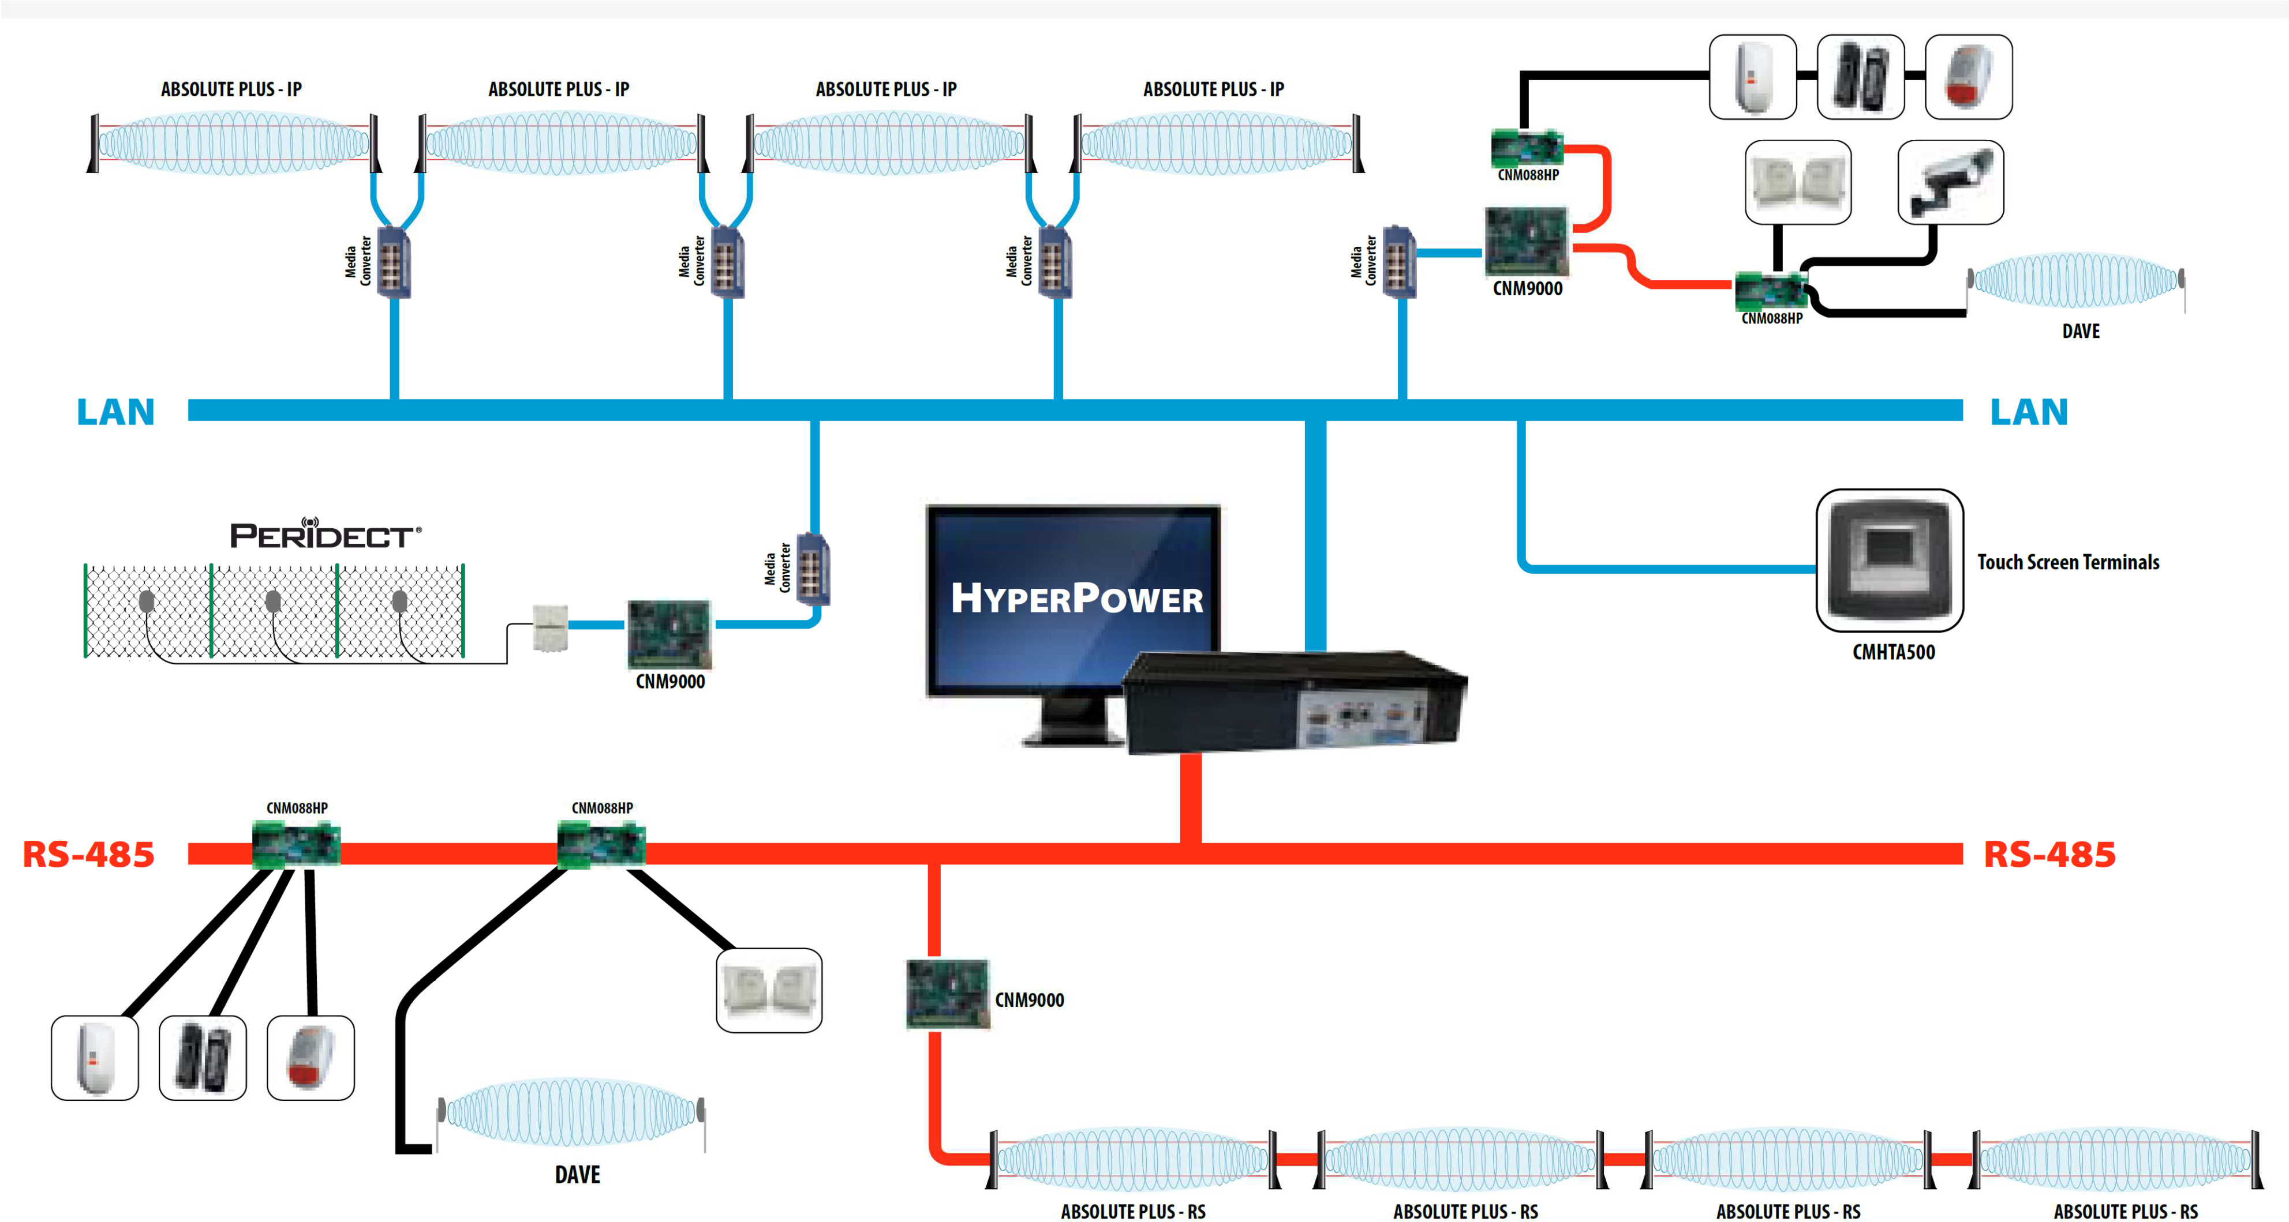

IMPI Perimeter Security Intrusion Detection / Monitoring System with ARTIFICIAL INTELLIGENCE Securitell is one of the few privileged companies that offers the IMPI Perimeter Security Intrusion Detection / Monitoring System from Girocon South Africa, which you will not find advertised due to the confidentiality of this system. It was originally designed by the CSIR and later taken over privately for commercial use and is currently in use locally and internationally. IMPI is manufactured in South Africa.

IMPI Technology: Is a knowledge system that
- Interprets the information it detects
- The sensor settings are done from Control Room
- The System reliability is high
- The Management software, duplex Ethernet communication, power and lightning protection are an integral part of the system
- Supports the operators in their tasks
- Has almost no nuisance alarms when the computer is fully trained

IMPI uses a multimode fibre optic cable as its primary sensor, but allows other mediums to integrate as “Value Add” sensors to the system. Although the fibre optic sensing medium is used by other intrusion detection systems, IMPI can be regarded as a total paradigm shift in perimeter detection systems as the unique software uses Artificial Intelligence “AI” to interpret the signals detected by the sensors. This intelligent information then assists the operator to plan and execute the most appropriate action.

Artificial Intelligence “AI”
In conventional computing the computer is given data with a step-by-step program that determines how the data must reach an answer.
With Artificial Intelligence, the computer is given knowledge about the subject and the AI program determines the specific procedure for arriving at an answer.




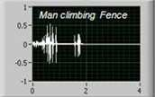


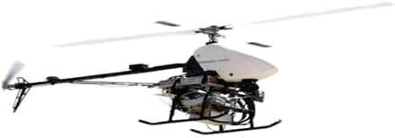
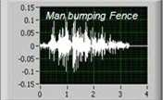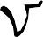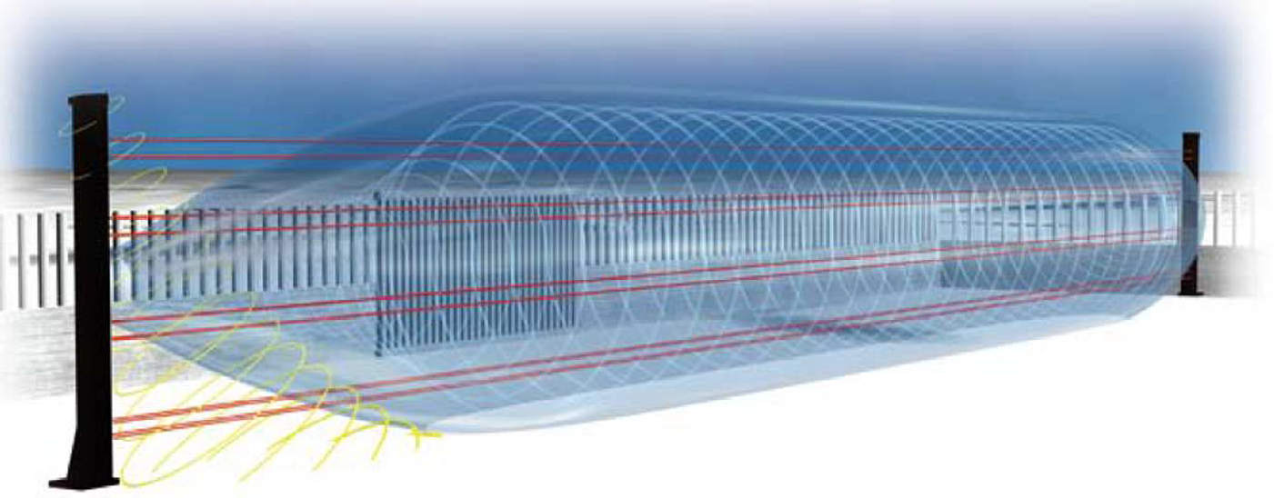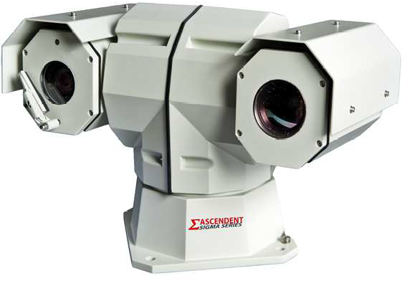
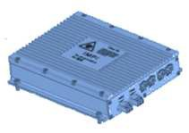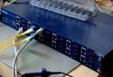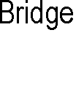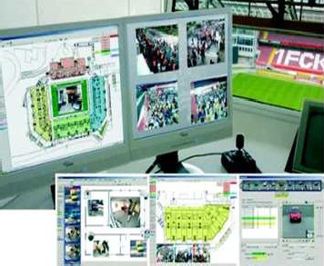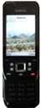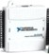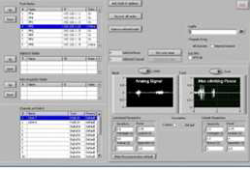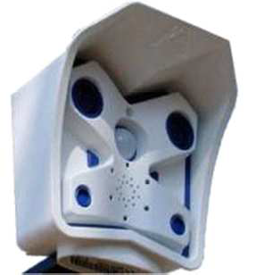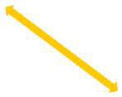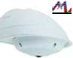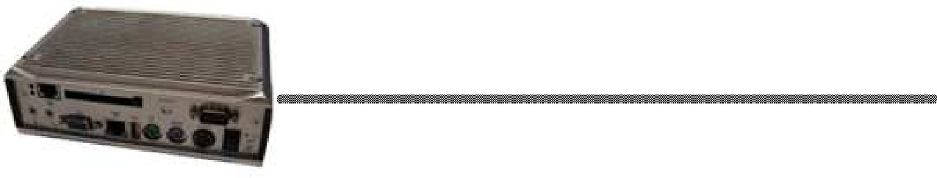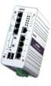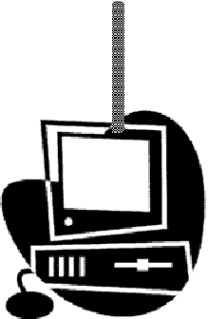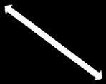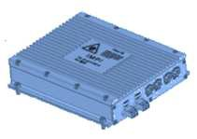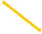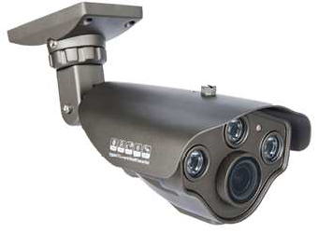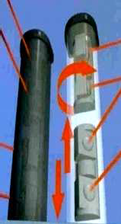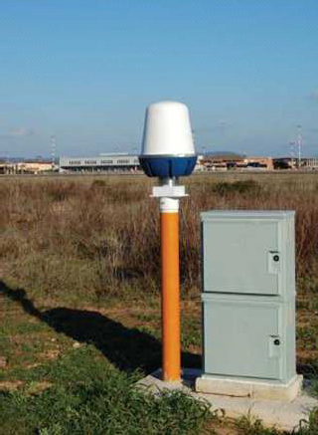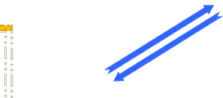
... ; .
'
.. , ; .
-
'
'
- - - - - ₋ \ _ ,-,.,,...._-
ti
/
ti
\





With this range of products and solutions in addition to the various other brands we offer, plus the supporting infrastructure we have, we firmly believe that Securitell is well positioned and able to provide our customers with Turnkey Solutions that add value to their business.

We are in a position to offer rental agreements to businesses that qualify, thus allowing you to re-deploy your CAPEX.

We look forward to being able to discuss any requirements you may have, currently and in the future.

Yours Faithfully
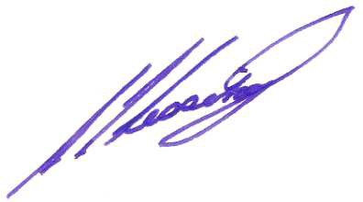
S. I. Lessing Director

Web Site http://securitell-int.com/home
Demo Videos http://www.youtube.com/SecuritellRSA
References http://securitell-int.com/references

