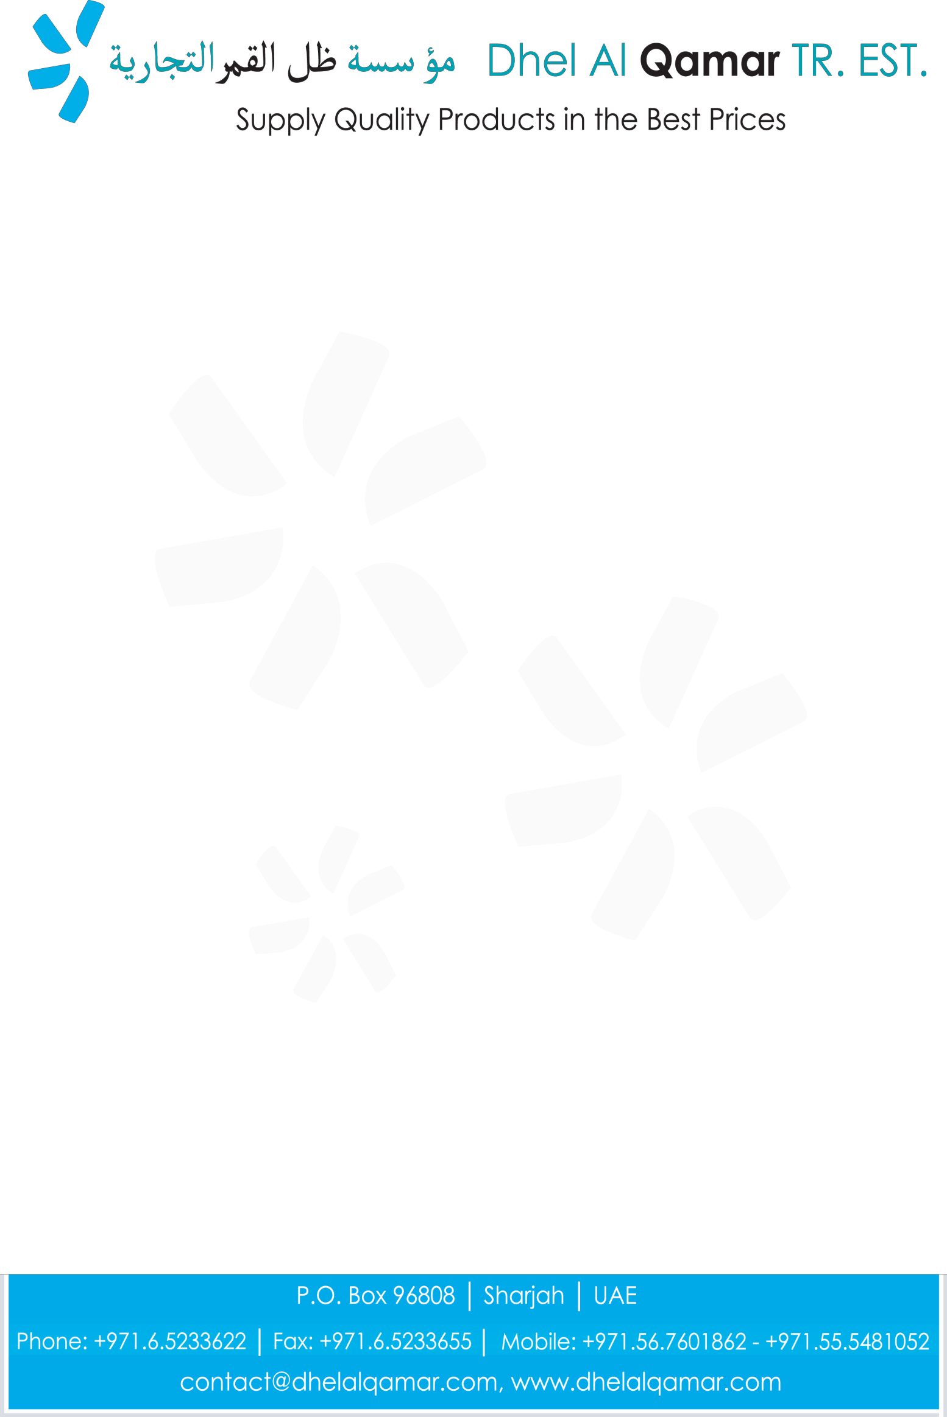

Company Introduction Letter

Dhel Al Qamar Tr. Est. is the Sharjah, U.A.E based Supply Company. We’re the team professionals who understand what customer needs is and trying to full fill those requirements in appropriate span of time with suitable price.

We believe in “Supply quality products in the best prices”

We Deal in Hardware, Electrical, Cleaning Chemical & Equipment products & general items as per the customer’s requirement.

Our Customers belongs from manufacture industries, ship store, oil & gas fields, traders, hotels, hospitals, janitorial cleaning service provider and constructions companies.

Products at a glance: We have a complete range of personal safety products, screws, fasteners, hand tools, tool sets, tool storage, tapes, cleaning cloths (for e.g. cotton rugs), and cleaning chemical (for e.g. floor cleaners, polishes etc.) and industrial oils (lubricants products).

For more information kindly visit our website: www.dhelalqamar.com

We would like to have business relationship with you and work for your venture. One of our company representatives would like to personally meet you and discuss how we could help to you.
If you are interested please don’t hesitate to contact us and discuss for further steps. Sincerely,
Tahir Idris
Business Development Manager
Dhel Al Qamar │ P.O. Box 96808 │ Sharjah │ UAE
Phone: +971.6.5233622 │ Fax: +971.6.5233655 │ Mobile: +971.56.7601862
contact@dhelalqamar.com │ www.dhelalqamar.com

