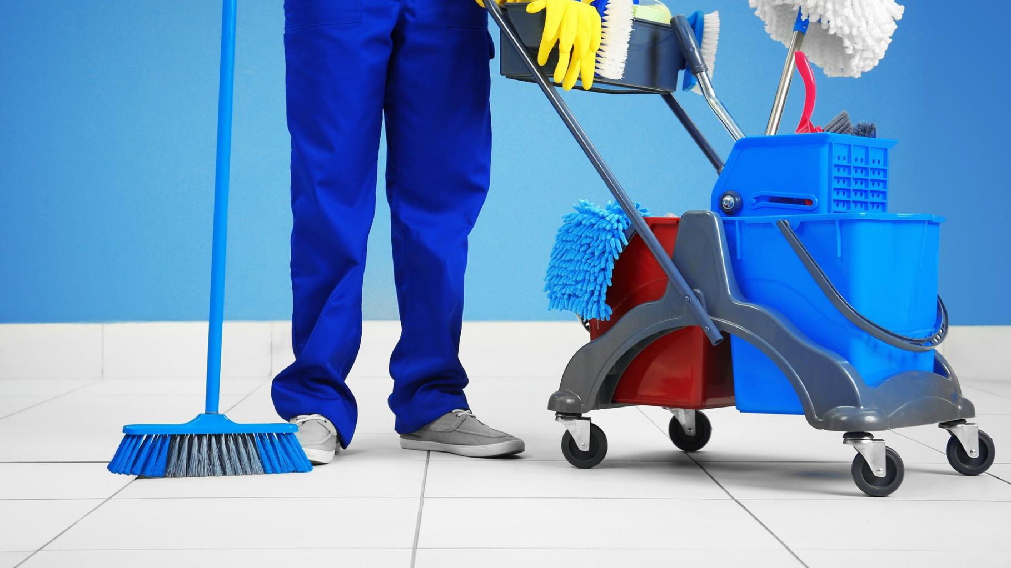
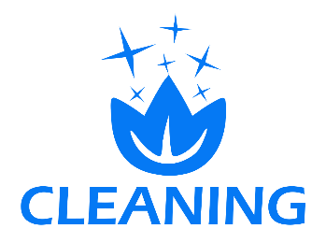

124 Clean Station Road
BellaVista, NY 21558 USA
(555) 123 4567 8900
office@cleaningcompany.com
www.cleaningcompanyxyz.com
HEALTH AND
HYGIENE FIRST
People everywhere need to know they are visiting and working in places that are clean, safe and hygienic. It’s not enough that it’s spotless. Every day, our custom cleaning services keep people healthy and safe, nurture wellbeing and shape strong and reputable workplaces – offering smart technology, best-in-class products and expertly trained people to give you peace of mind.
Lorem ipsum dolor sit amet, consectetuer adipiscing elit. Maecenas porttitor congue massa. Fusce posuere, magna sed pulvinar ultricies, purus lectus malesuada libero, sit amet commodo magna eros quis urna. Nunc viverra imperdiet enim. Fusce est. Vivamus a tellus. Pellentesque habitant morbi tristique senectus et netus et malesuada fames ac turpis egestas. Proin pharetra nonummy pede. Mauris et orci. Aenean nec lorem. In porttitor. Donec laoreet nonummy augue. Suspendisse dui purus, scelerisque at, vulputate vitae, pretium mattis, nunc. Mauris eget neque at sem venenatis eleifend. Ut nonummy. Fusce aliquet pede non pede. Suspendisse dapibus lorem pellentesque magna. Integer nulla. Donec blandit feugiat ligula. Donec hendrerit, felis et imperdiet.

