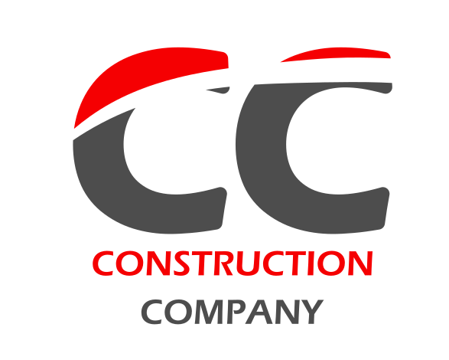
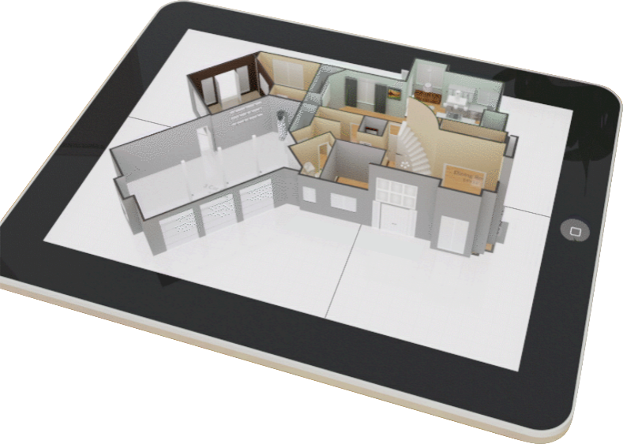

The Intelligent Way to Plan.
CONSTRUCTION
COMPANY
The Construction Company was established in 1959 and is a general contractor offering construction services in terms of Site Analysis, Feasibility Studies, Preliminary Design Studies, Permit/Zoning Applications, etc. We handle various industrial, distribution, manufacturing, office, retail, recreational, healthcare and commercial projects in the Chicago area and midwest regional markets.

Construction Company is a leader in providing value-added construction services to our customers by creating a successful partnership with them throughout the construction process. Our pledge is to establish lasting relationships with our customers by exceeding their expectations and gaining their trust through exceptional performance by every member of the construction team.
Our Mission.
Dedication to providing quality construction, technical and management services to our customers. We will strive to implement a long term relationship with our clients, based on safety, quality, timely service and an anticipation of their needs. To help fulfill this mission, we will treat all employees fairly and involve them in the quality improvement process to insure responsiveness and cost effective work execution.
We are easy to find.
Let us know your needs.
Address: 155 Construction Road
Greenville, 20446 Illinois
Phone: (123) 555 8877 2656
Email: ccconstruction@gmail.com
Web: ccconstructioncompany.com
Lorem ipsum dolor sit amet, consectetuer. Maecenas porttitor congue. Adipiscing elit.
Broad vision. Careful thought. Hand-crafted design.
Our reputation is as solid as concrete.
Building your visions. Creating reality.
Put us to the test, we are better than the rest.
Listen better. Plan better. Build better.
Committed to superior quality and results.

