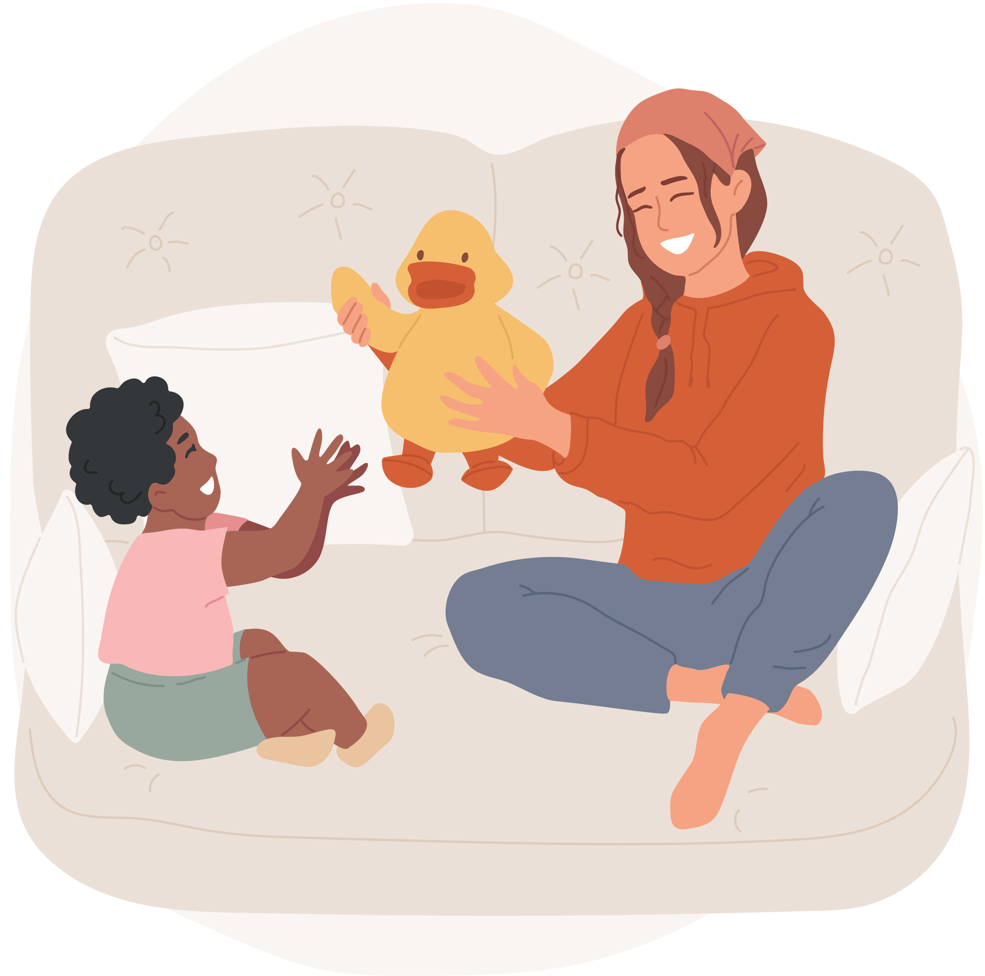


ONE NIGHT FREE OF
BABYSITTING
THIS COUPON HAS A VALUE OF THREE HOURS WORTH OF BABYSITTING YOUR LOVELY NUGGETS. FOR FREE.
VALID UNTIL JANUARY 09, 2022

