
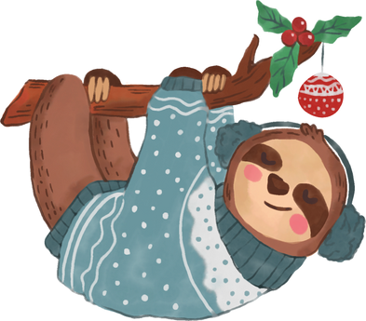
$50
TICKET CODE : 00-00-01
123 Anywhere St., Any City
123-456-7890
FOR USE IN-STORE ONLY
2025 DEC 24
END DATE
START DATE
2025 DEC 05
CHRISTMAS COUPON
The Story Name

