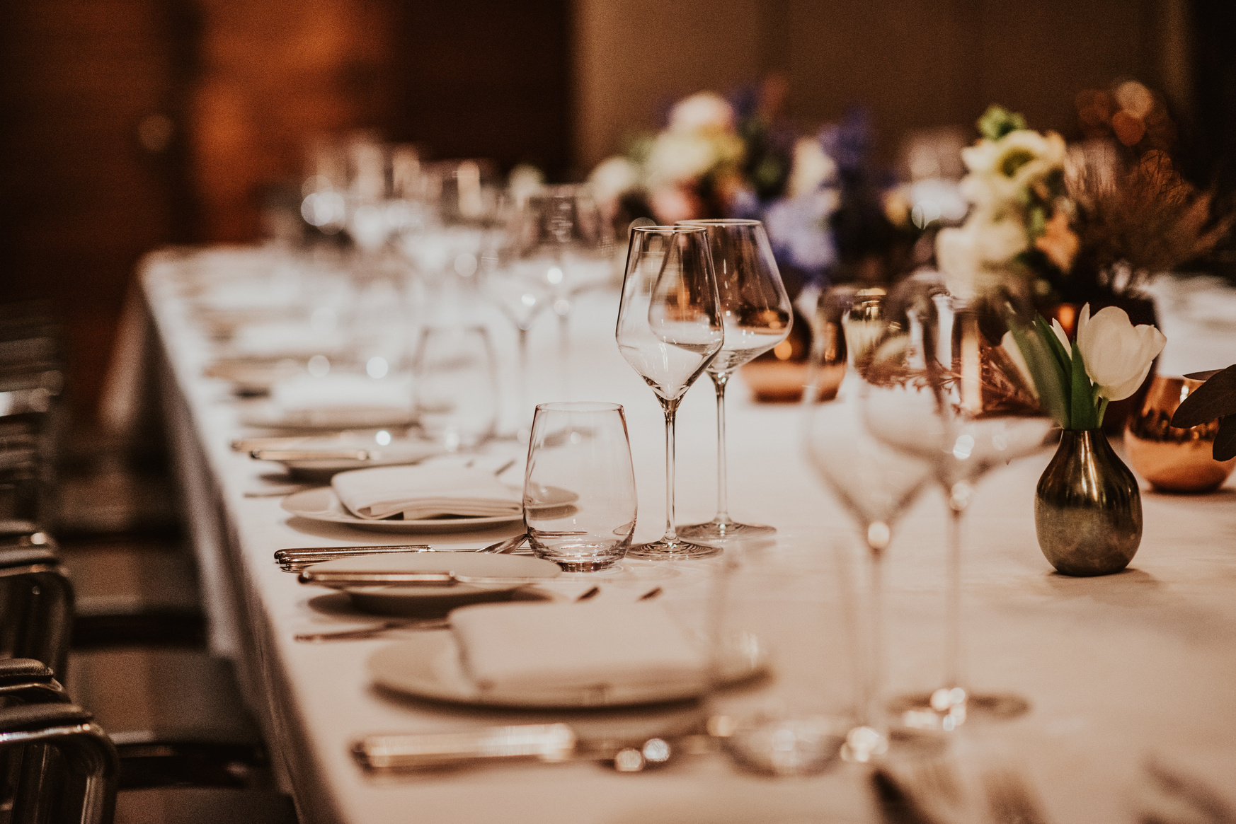
JANUARY 24-31, 2022
10% off
Enjoy your dinner in ABC Restaurant
123 ANYWHERE ST. ANY CITY

