
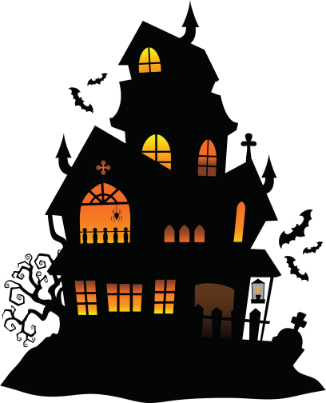


123 Anywhere St., Any City
AT 10 PM
OCTOBER 31, 2029
FOR DRINKS
USE IN THE PARTY BEFORE 11:30PM
Halloween
Party
Buy 2 get 1

