Grant Proposal template

Pilot Project Call PP-2-2016

COVER PAGE

TITLE OF PROPOSAL

LIST OF APPLICANTS

Applicant No* | Applicant organisation name | Country

1 (Coordinator)

2

3

4

* Please use the same applicant numbering as that used in the administrative proposal forms.

TABLE OF CONTENTS

- Page 2 / 12

Document Version 1.00 dated 30/03/2016

- PROBLEM ANALYSIS INCLUDING EVIDENCE BASE

  - Your proposal must describe the problem statement, analysis of the causes and evidence base of the proposed measure(s) and methods.

- AIMS AND OBJECTIVES OF THE PROJECT

2.1. General objective of the project
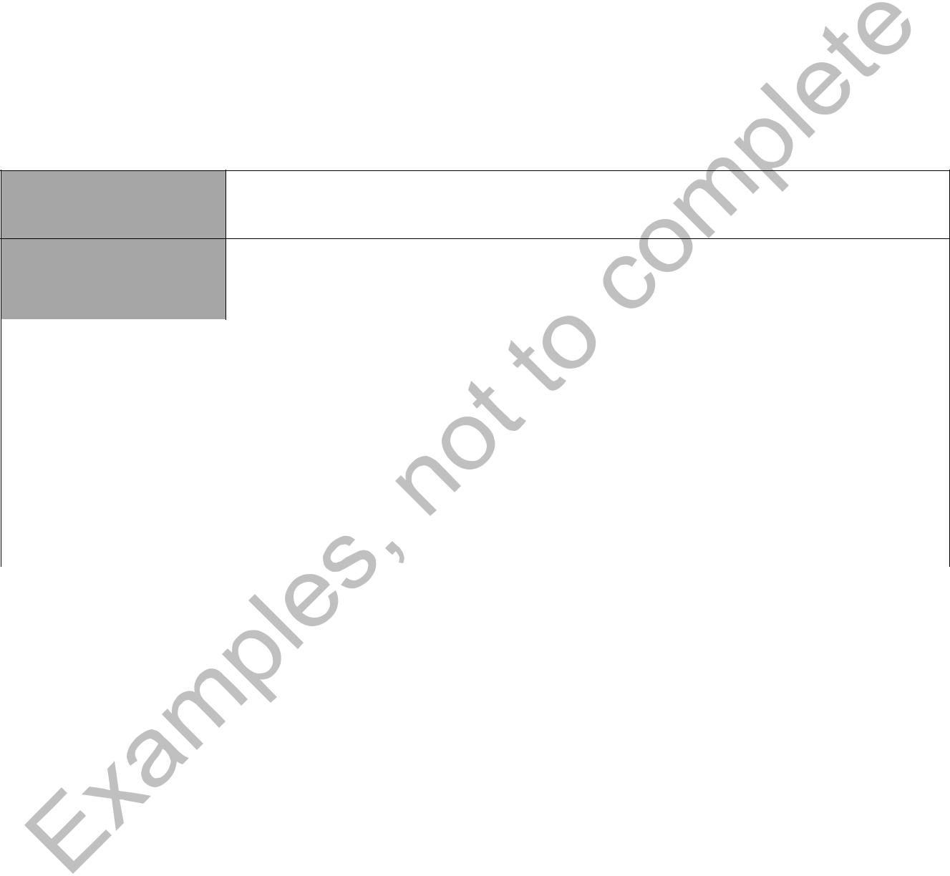

2.2. Specific objective(s) of the project

- Please describe your specific objectives following the SMART approach.

- Please state the planned methods of verification that you reached your objectives using clear and precise indicators.

Specific Objective
Number

Specific Objective

Process Indicator(s) | Target
(repeat line as needed)
Output Indicator(s) | Target
(repeat line as needed)
Outcome/Impact Indicator(s) | Target
(repeat line as needed)

- Page 3 / 12

Document Version 1.00 dated 30/03/2016

- TARGET GROUPS

- POLITICAL RELEVANCE

4.1. Contribution to meeting the objectives and priorities defined in the annual work programme


4.2. Added value at EU level in the field of public health

4.3. Pertinence of geographical coverage

4.4. Consideration of the social, cultural and political context

5. METHODS AND MEANS


6. EXPECTED OUTCOMES


- Page 4 / 12

Document Version 1.00 dated 30/03/2016

7. WORK PACKAGES

7.1. Overview on work packages

WP | Title |  |  | Description
number
1 | Coordination of the project |  |  | Actions undertaken to manage the project and to make
 |  |  |  | sure that it is implemented as planned
2 | Dissemination | of | the | Actions undertaken to ensure that the results and
 | project |  |  | deliverables of the project will be made available to the
 |  |  |  | target groups
3 | Evaluation of the project |  |  | Actions undertaken to verify if the project is being
 |  |  |  | implemented as planned and reaches the objectives
4
5
6
…
x


- Page 5 / 12

Document Version 1.00 dated 30/03/2016

- Work package descriptions

  - For each work package, your proposal must describe a table as below


Work package number

Work package title

Starting month Ending month

Leading applicant

Applicants Nr

Applicants Acronym

Person month per applicant

Objectives

Description of work (where appropriate, broken down into tasks), lead partner and role of applicants

Deliverables linked to this work package (brief description, month of delivery, reference to the list of deliverables)

Milestones to be reached by this WP 

- Page 6 / 12

Document Version 1.00 dated 30/03/2016

- Timetable or Gantt Chart

  - Your proposal must illustrate the work packages, milestones and delivery dates of deliverables in a graphical form, such as a timetable or Gantt chart.

- MILESTONES AND DELIVERABLES

  - Your proposal must indicate milestones and deliverables.

  - Deliverable numbers in order of delivery dates. Please use the numbering convention <WPnumber>.<number of deliverable within that WP>. For example, deliverable 4.2 would be the second deliverable from work package 4.

  - Dissemination level: Use one of the following codes:

PU = Public, fully open, e.g. web

CO = Confidential, restricted under conditions set out in Model Grant Agreement

  - Delivery month: Measured in months from the project start date (month 1). If a deliverable consists of several parts (eg. a newsletter to be delivered in M6, M12 and M18) please list it as 1 deliverable and state the different delivery month in the last column.

  - Technical reports (Periodic Report or Final Report), Leaflet, Layman Brochure and website are considered mandatory deliverables. They are already included in the table below and must be kept. They are named ("MD.x").


Deliverable |  | Deliverable |  | Work | Leading | Content specification |  |  |  |  |  | Dissemination |  | Delivery
Number |  | Name |  | package | applicant |  |  |  |  |  |  | level |  | month
 |  |  |  | number | acronym
Mandatory
deliverables
(MD)
MD.1 |  |  | Interim report(s) | 1 | The | This report describes the activities
 |  |  |  |  | coordinator | carried out, milestones and results
 |  |  |  |  |  | achieved in the first half of the
 |  |  |  |  |  | project. | Deliverables |  | can |  | be
 |  |  |  |  |  | attached as annexes.
MD.2 |  |  | Final report | 1 | The | This report describes |  |  | the | project |  |  |  | Endof
 |  |  |  |  | coordinator | implementation |  | and | the | results |  |  |  | project
 |  |  |  |  |  | achieved. | The | deliverables |  |  | are
 |  |  |  |  |  | annexed.
MD.3 |  |  | Leaflet | 2 |  | A leaflet | to promote |  | the | project |  | P |  | 3
 |  |  |  |  |  | must be produced at the beginning
- |  |  |  |  |  |  |  |  |  |  |  |  | Page 7 / 12
 | Document Version 1.00 dated 30/03/2016

MD.4 | Layman version | 2 |  | This is a short (e.g. 10 pages) | P | Endof
 | of the final report |  |  | version of the final report, written |  | project
 |  |  |  | for the interested public as a target
 |  |  |  | group.
MD.5 | Web-site | 2 |  | Each project must have a dedicated | P (and C) | 3
 |  |  |  | web-site / web-pages. This can have
 |  |  |  | a public part and another one
 |  |  |  | accessible only to the applicants.

- Page 8 / 12

Document Version 1.00 dated 30/03/2016

9. PROJECT MANAGEMENT STRUCTURE

- Quality of the partnership

- Capacity of the staff

- External and internal risk analysis and contingency planning
Identified Risk | Likelihood | Impact | Contingency planning

9.4. Financial management


- Page 9 / 12

Document Version 1.00 dated 30/03/2016

10. BUDGET

10.1. Content description and justification

• Please describe how you have built the budget and the rationale for doing so.

10.2. Summary of staff effort
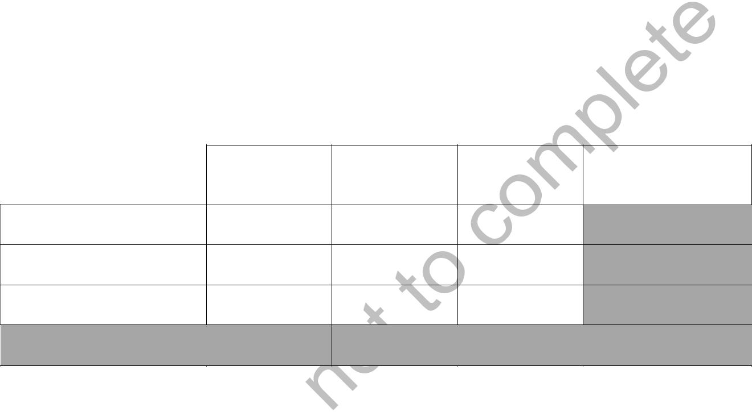
- Please indicate the number of person/months over the whole duration of the planned work, for each work package, for each applicant.

- Identify the work-package leader for each WP by showing the relevant person-month figure in bold.

WP n | WP n+1 | WP n+2 | Total Person/
 |  |  | Months per
 |  |  | Applicant

Applicant Number/

Short Name

Applicant Number/

Short Name

Applicant Number/

Short Name

Total Person/Months

- Page 10 / 12

Document Version 1.00 dated 30/03/2016

10.3. Detailed budget

- Please complete the table below for each applicant/ affiliated entity. If a particular applicant is an affiliated entity, please state to which partner it is affiliated (second line).

- Please provide a detailed justification and explanation in the textboxes. The justification, among other parts of your application, will be used for the evaluation of the award criteria on budget.
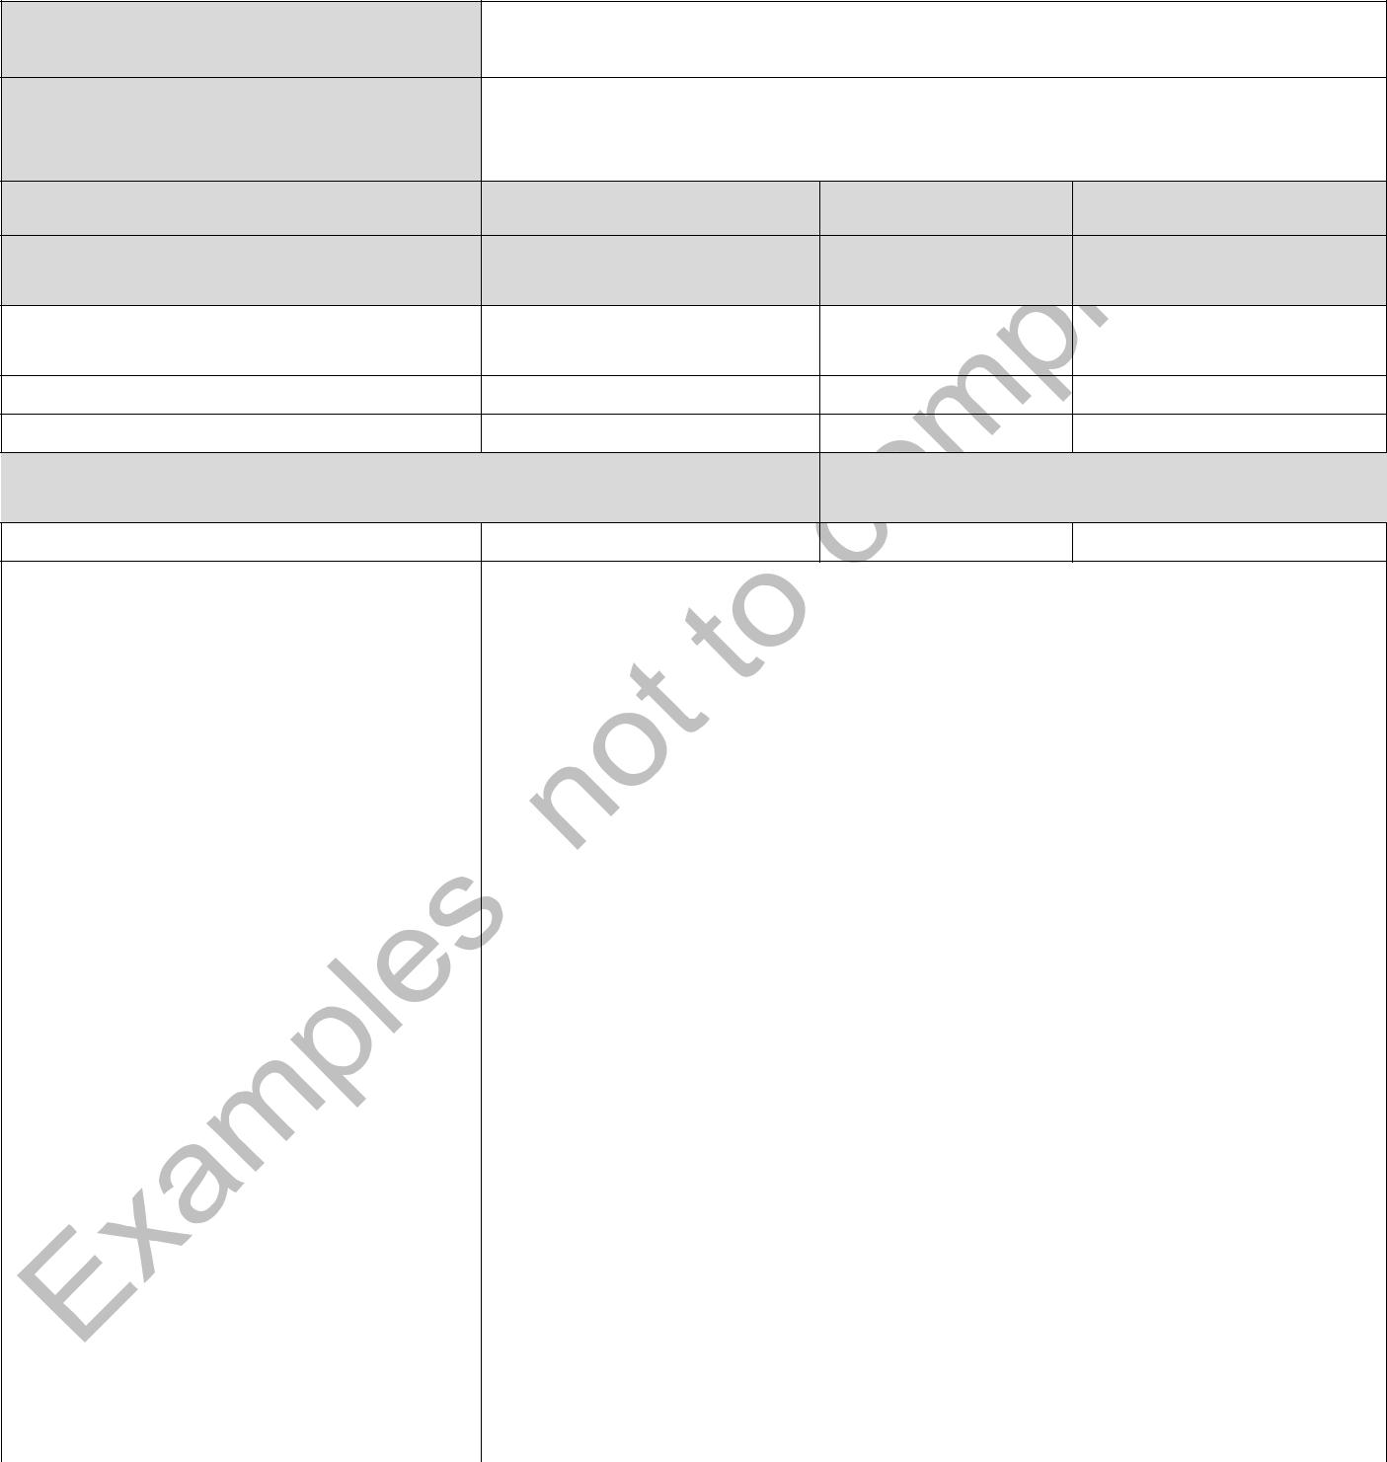
Applicant Number/

Short Name

(If affiliated entity: Affiliated to

which Applicant number/Short

name)

(A) Direct personnel costs

Staff function Monthly Cost Estimated Sum Cost (€)
Person-month

(Please repeat line for each staff function category)

Total person Total Costs (€) for (A) month

 |  |  | Justification
 | (B) Direct costs of sub- |  | Costs (€) |  | Task(s)/Justification
 | contracting
 | (please repeat line for each
 | subcontract foreseen)
 | Total Costs (€) of (B)
 |  |  | Justification
 | (C) Other direct costs
 | (C.1) Travel |  | Costs (€) |  |  | Justification
 | (C.2) Equipment |  | Costs (€) |  |  | Justification
 | (C.3) Other goods and services |  | Costs (€) |  |  | Justification
 | Total Costs (€) of (C)
 | (D) Indirect Costs |  | Total Costs (€)
 | (Max. 7% on A, B and C)
 | Total estimated eligible costs

- Page 11 / 12

Document Version 1.00 dated 30/03/2016

11. PREVIOUS AND CURRENT GRANTS RELEVANT TO THE PROGRAMME (LIMITED TO THE LAST 3 YEARS) - N/A

- CURRENT APPLICATIONS RELEVANT TO THE PROGRAMME- N/A

- EXCEPTIONAL UTILITY – N/A

Please describe, if and how your proposal would fulfil the criteria for exceptional utility.

14. COLLABORATING STAKEHOLDERS

Collaborating stakeholders and/or external experts are organisations or individual persons, which:

- May significantly increase the technical and scientific content of the project, as well as its relevance for different users in the Union.

- have no contractual relationship with the Agency

- nor do receive any EU funding from this particular grant;
Please give a list of up to 20 most important collaborating stakeholders and/or external experts participating in your project. Note that it is not mandatory to involve collaborating stakeholders and/or external experts.

Institution | Contact person | City & Country
 | (First name and last name)

- Page 12 / 12

Document Version 1.00 dated 30/03/2016

