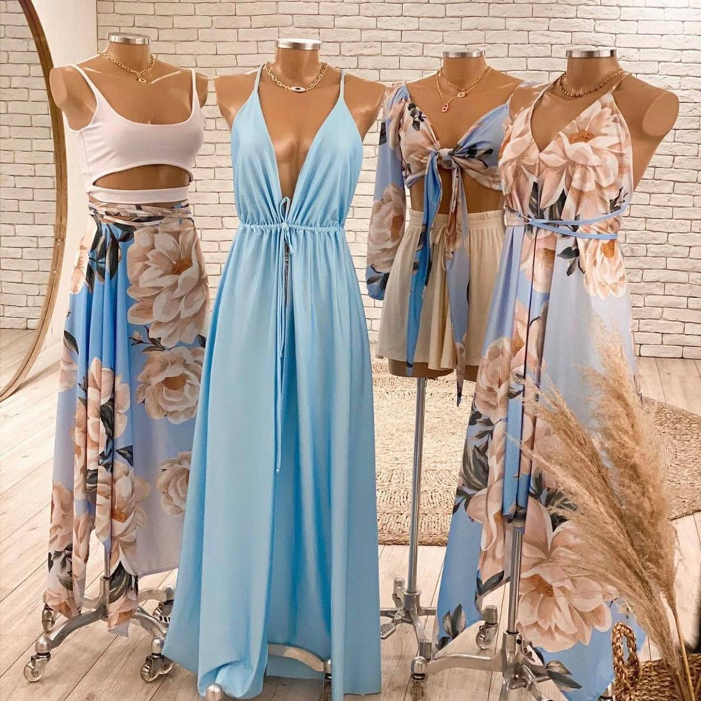








SHOP NOW
Delivering newsletters through email is one of the best ways to build a strong
NAME
SHOP NOW
Delivering newsletters through email is one of the best ways to build a strong
NAME
SHOP NOW
Delivering newsletters through email is one of the best ways to build a strong
NAME
fashion newsletter
NEW ARRIVAL
COLLECTION
NEW COLLECTION
SHOP NOW
Delivering newsletters through email is one of the best ways to build a strong
NAME
SHOP NOW
Delivering newsletters through email is one of the best ways to build a strong
NAME
SHOP NOW
Delivering newsletters through email is one of the best ways to build a strong
NAME
SHOP NOW
Delivering newsletters through email is one of the best ways to build a strong
NAME
SHOP NOW
Delivering newsletters through email is one of the best ways to build a strong
NAME

