

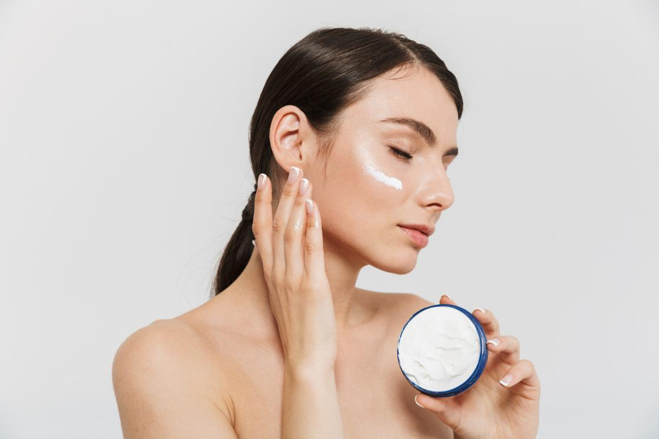

january - 2023
our latest product
Going back to nature is one of the best ways to maintain healthy skin. This exclusive product is suitable for those of you who want to treat your skin in a natural but effective way.
MONTHLY NEWSLETTER
COMPANY NAME
www.companyname.com
contact@companyname.com
SHOP NOW
New Organic Skincare Product
For that, we are organic skincare that brings the goodness of nature. This skincare contains ingredients derived from organic plants grown and cultivated by us.
SHOP NOW

