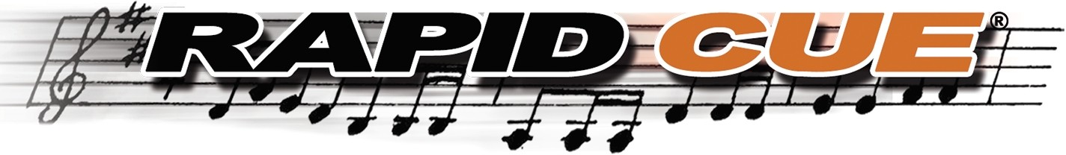

ONE SHEET TEMPLATE

Cue Sheet Classification (use drop-down) Date Prepared
Initial Airdate

Category (use drop-down)
Version (use drop-down]
Network / Source (use drop-down] Program/Show Duration - Mins. & Secs. Total Music Duration - Auto Calculated
Program Title Program Title AKA[ s] Episode Title
Episode Title AKA[ s) Episode Number Production Number Production Company Mailing Address

Cue Sheet Prepared by Email Address (preparer's)



Cue Title: Title of the music performed, in sequence

Usage Codes (use drop-down): The way in which music was performed, as noted below:

- Bl = Background Instrumental: Underscore and non-visual [off camera] source
- BV = Background Vocal: Underscore with vocal or non-visual vocal source
- VI = Visual Instrumental: On camera instrumental performance
- W = Visual Vocal: On camera vocal performance
- MT = Main Title Theme: Opening title theme
- ET = End Title Theme: Closing title theme
- Logo = Company logo
Cue Duration: Timing length of each cue [Mins. & Secs.] from start (time in] to end (time out)

Role (use drop-down):
Upon selecting 'role' the template will shade areas where you may not type information
- Composer: Writer - First Name / Last Name
- Publisher: Individual or corporation responsible for
- Arranger: Arranges musical composition

Affiliation (use drop-down):
- Select Performance Rights Organization [PRO] affiliation
- Public Domain [PD): Works in the public domain are those whose intellectual property rights have expired, have been forfeited, or are inapplicable. The public owns these works, not an individual author, publisher or artist.
Shares: Ownership of music, 100% total for composer 100% total for publisher - Not required for licensed music

Submit completed final cue sheets to cuesheets@rapidcue.com
Please direct all inquiries about the new cue sheet template to info@rapidcue.com

