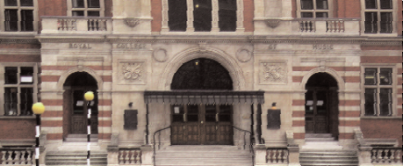
London Music Program with the Royal College of Music

COURSES
Students receive all music instruction through the RCM including Music Theory, Music History, Alexander Technique as well as one- on-one music lessons. Students also join the RCM Orchestra, Chamber groups, and Choral Ensemble.

Before students begin taking classes at RCM, students take an intense liberal arts course. This course, AH 381 London Architecture and Urbanism, is taught by BU British Programmes faculty through a combination of lectures and walking tours.
LONDON, ENGLAND > STUDY ABROAD

Boston University’s London Music Program offers students the opportunity to live and study in one of the world’s most important cities for music performance. The program is offered in collaboration with the Royal College of Music in London, an internationally recognized institution specializing in musical education and professional training for performers and composers. The London Music Program will expand the existing academic and artistic offerings of the School of Music and will provide students with an opportunity to further their theoretical and musicological studies.

Upon successful completion of the program, students earn 16 to 20 Boston University credits.

ROYAL COLLEGE OF MUSIC
Situated across from Royal Albert Hall in South Kensington, the Royal College of Music has a student body of only 500 with representatives from over 50 nations. Since its founding in 1882, the school has attracted some of Britain's most influential composers, singers, and instrumentalists. Gustav Holtz, Dame Joan Sutherland, and James Galway are among the luminaries who have studied at this prestigious institution.

HOUSING
Student live in furnished apartments with other students in BU Study Abroad London's programs. The apartments are within walking distance of the BU London Academic Center in South Kensington. They vary in size, configura- tion, and style of decoration. Most students (95%+) live in shared bedrooms, often in bunk beds, with ensuite shower room, a shared kitchen and living/dining room area. British Programs staff and RAs live in BU's building along with the students, helping to ensure a high level of maintenance and security. There is WiFI access in the residences.

ADMISSIONS
- Boston University students only
- Refer to our policy on eligibility/admissions at www.bu.edu/abroad/admissions

PROGRAM DATES
Fall Semester: late August–mid-December

APPLICATION DEADLINE
Fall Semester: March 1

2014/2015 PROGRAM COST
$27,443 per semester. Cost includes tuition, housing, round-trip airfare from a designated US city, program-related field trips, emergency travel assistance coverage, and overseas medical insurance. Financial aid is available.




617-353-9888 bu.edu/abroad facebook.com/BUabroad twitter.com/BUabroad


