“Climate Refugees” is an important and timely documentary film that uncovers the unbelievable plight of people around the world displaced by climatically-induced environmental disasters. The film illuminates -for the first time- the human face of climate change as civilization now finds itself, facing the confluence of overpopulation, lack of resources and a changing climate.

Actor and Sundance Founder, Robert Redford called the film, “an agent for social change.” NY Times

“Climate Refugees” was the centerpiece film at the United Nations’ Climate Summit in Copenhagen last December, premiered at the Sundance Film Festival 2010, played at dozens of film festivals around the world to rave reviews, multiple awards and an overwhelming audience response.

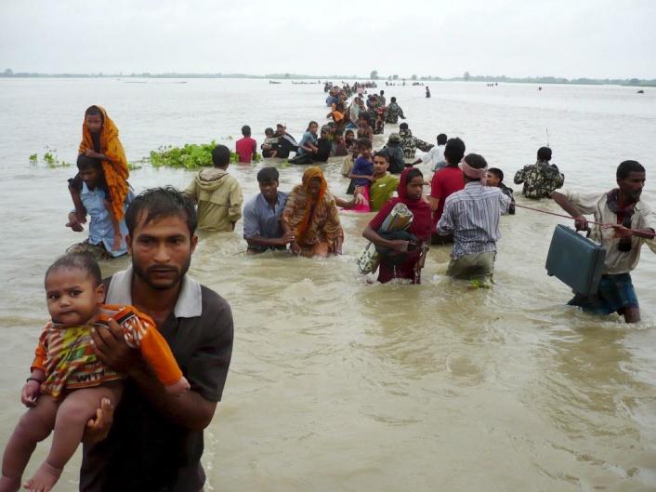
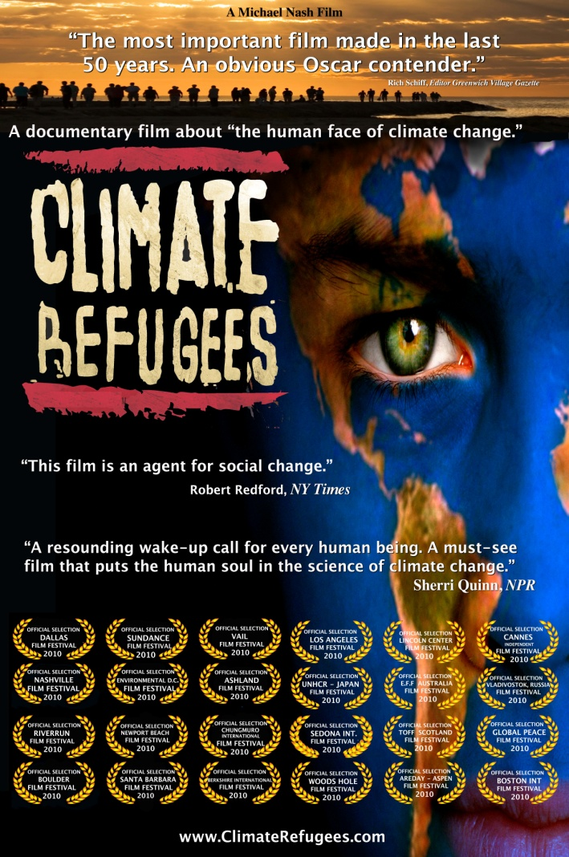
“Climate Refugees” is a “resounding wake up call for every human being to go green immediately. It is a must see film that puts the human soul in the science of climate change.” Sherri Quinn, National Public Radio

After traveling the world and interviewing several of the 25 million climate refugees now on the run, along with scholars, politicians and the like, “Climate Refugees” brings to light the heart-wrenching truth of what is quickly becoming mankind’s greatest challenge.
The film examines the creation — and migration — of hundreds of millions of climate refugees that will be displaced as a result of climate change. A cautionary tale, the film demonstrates that climate change isn’t a political issue; it’s a geopolitical one, one that literally transcends the concepts of nationhood and ethnicity.
“Climate change is the threat multiplier for overpopulation, over-consumption and lack of natural resources. Our mission is to create a platform that will illuminate the facts about climate refugees, their lack of international protection, our national security issues and solutions to these civilization-altering issues,” writer/director/producer Michael Nash.
“Climate Refugees” was filmed in Bangladesh, Belgium, Chad, China, Denmark, Fiji, France, Germany, Holland, Ireland, Kenya, Maldives, Poland, Switzerland, Tuvalu, UK and the US.

Some high-profile figures featured in the film include: Senator John Kerry, Speaker of the House Nancy Pelosi, Former Speaker of the House Newt Gingrich, Nobel Peace Prize Winner Professor Wangari Maathai, Dr. Rajendra Pachauri (Head of IPCC) and many others.
“With leading researchers and high profile political figures, ‘Climate Refugees’ presents a swell of compelling opinion about the challenges such change puts on the global populations,”Peter Debruge, Variety

For more information please visit us at www.climaterefugees.com or on
Facebook and Twitter @climaterefugees



