

. D U O .

“I was blown away by We’re about 9 almost as soon as they’d arrived on stage; both Katie Graybeal and Brian Gundersdorf have great voices for folk music, their songs are incredibly vibrant, and their lyrics are funny and smart. Not to mention the fact that they kept the audience laughing with banter between songs. Why had I never heard of this band before? The first set came and went, I bought an album. I came back for the second set. The folk music became more personal, more low-key, and the appeal remained the same.”

The Glorious Hum

The story of We're About 9 begins at the Jahva House in historic Ellicott City, MD. Katie and Brian’s weekly open mic captured the attention of the Sheriff's Department with attendance regularly flooding both floors of the café and spilling out into the street. After the open mic ended each week, the music would continue outside in Parking Lot D. It was in this auspicious location that Katie Graybeal, Brian Gundersdorf, and We’re About 9 trio member, Pat Klink, first started singing harmony together. The name We’re About 9 was a quick decision--they just needed a name to put down on the open mic signup sheet.

Fast forward two years to 2002, and The We're About 9 Trio has just won the emerging artist showcase vote at Falcon Ridge Folk Festival. Within another two years, We're About 9 will have played the main stage of Falcon Ridge Folk Fest, Philadelphia Folk Fest, Clearwater Revival, Bele Chere, Green River Festival, Four Corners Folk Fest, Mountain Stage New Song Fest and many more--at the same time touring the east coast folk club, coffeehouse, house concert, and college venues.

In 2008 We're About 9 released “Paperdust :: Stardust,” the first album featuring the duo of Brian (vocals, acoustic guitar) and Katie (vocals, electric bass). The We're About 9 Duo main- tains their signature striking vocal harmonies, but draws more of a focus on their completely unique style of songwriting. Every duo show is a new adventure in audience interaction with one-off segments like “30 Second Movie Synopsis” (Katie and Brian sing the synopsis, the audience guesses the movie), “Stalk Your Fans” (details of this one are confidential), and impromptu songs about the venue or town or opening act.

The We’re About 9 Trio still frequently plays in MD, VA, NY, and New York City. The We’re About 9 Duo plays throughout New England, and has built a particularly loyal following in the greater Boston area, due largely to the amazing support of Club Passim.

"Thick with foreshadow and subplots … like pressing Richard Shindell's next ideas through a 20-something cappuccino machine … You feel each song is a hit before you've any idea what the hell is going on … Musical Prowess, careful writing, an engaging stage presence and dynamic vocals that blend or stand alone."

SingOut!

"Gritty and witty at the same time."

Music Monthly

"Stretches of imagination seldom seen anywhere … I've just gotten that explosion in my chest that I get when someone new has walked into my life and lit the fuse to another thrill."

Acoustic Live! In NY

"Wildly entertaining."

The Gazette
"Positively enthralling."

Singer Magazine

"Rollicking melodies, quirky lyrics full of SAT words."

Song Circle

"Downright remarkable in quality."

George Graham, WVIA

"The stage presence and vocal chops to be a major star."

Gay Life Magazine

"Soaring harmonies."

The Washington Post

"Clear warm voices, comfortable music and lucid lyrics."

The Baltimore Sun

"Profound and fun at the same time."

Chris Darling, WMPG

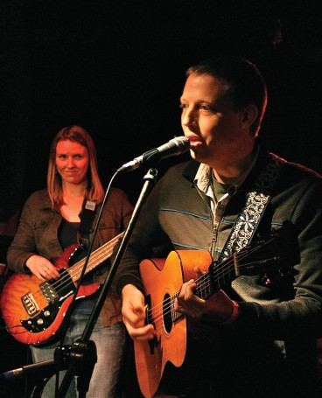
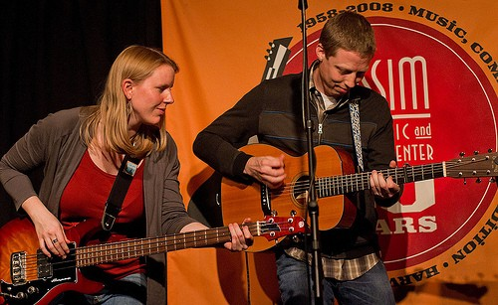
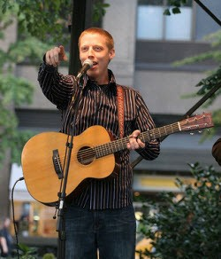
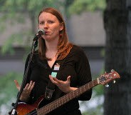
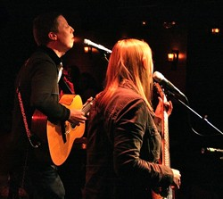
“Anyone who has ever seen We’re About 9 on stage knows them as fun-loving and energetic. Their charm and on-stage charisma keep their performance engaging, but ultimately these traits are trumped by the wisdom inherent in their writing.” - The Takoma Voice

