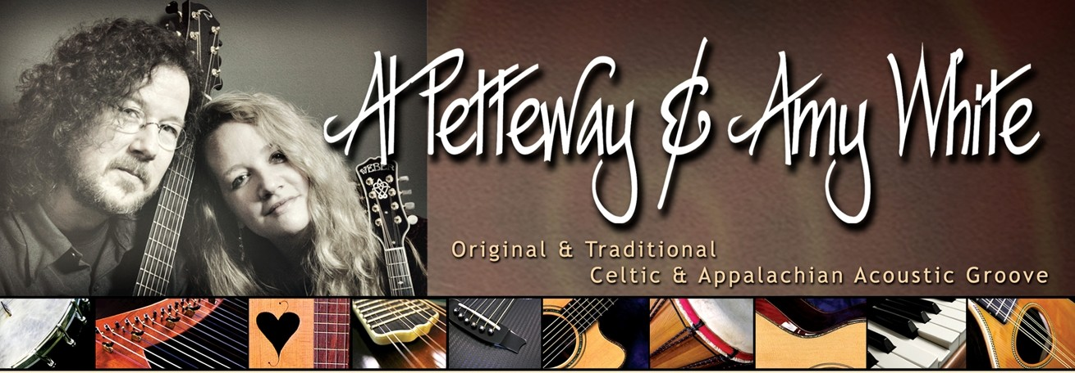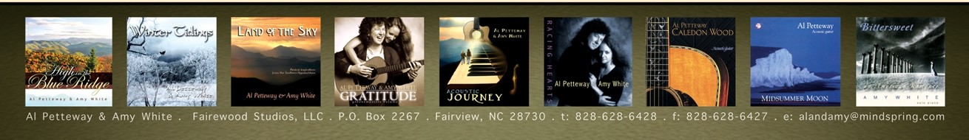
GRAMMY AWARD-WINNING GUITARIST . INDIE AWARD-WINNING DUO
as heard on the Ken Burns documentary, The National Parks: Amer ica's Best Idea
Award-winning, critically acclaimed, passionate and playful, Al & Amy offer an intoxicating blend of musical styles. Their repertoire includes original, traditional, contemporary Celtic- and Appalachian­ influenced music with occasional nods to rock and jazz. Their performances feature acoustic guitar, mandolin, Celtic harp,piano, banjo, lap dulcimer, world percussion, and a touch of vocals.
Before moving f rom the Washington, DC area to the mountains of Western North Carolina, Al & Amy won 50 WAMMIE Awards from the Washington Area Music Assoc iation.In addition, they were awarded 5 separate grants from the Maryland State Arts Council for both music composition and instrumental performance. They won an INDIE from The Assoc iation for Independent Music,and Alwon a GRAMMY from the National Academy of Recording Arts and Sciences.Al was voted one of the Top 50 Guitarists of all time by the readers of Acoustic Guitar Magazine and in 2008 he won Silver and Bronze medals in the magazine's "Players' Choice Awards."
Al & Amy's music was featured throughout the soundtrack of the 2009 Ken Burns EMMY-winning documentary , The National Parks: America 's Best Idea. And in 2010, their album, Caledon Wood, (which includes the main theme of the National Parks documentary) was counted among the essential albums of the past 20 years in the Acoustic Guitar Magazine 20th anniversary issue.
Al & Amy enjoy living in their mountain aerie at 4300 feet elevation,with stunning long-range views and wildlife as constant inspiration. This mountain-top setting has greatly influenced their recent musical works,and has also spurred their return to photography. Both Al & Amy's photographs are represented by The National Geographic Society's Image Collection, where Al worked as an image editor for 18 years. In addition to concerts and workshops, Al & Amy now also offer winter-themed and 4-season multi-media shows which feature live music performed against a backdrop of nature photography.
Among many other pursuits, Al continues to teach private lessons and records video lessons for "Dream Guitars," a high-end music store in the Asheville area. He also coordinates "Guitar Week" for the world famous music camp, The Swannanoa Gathering. And in early 2010, Amy launched Cat Angel Press which released its first full-color gift-book ,Cat Angels: The Secret Lives of Cats. There are more angels and books to come.
High in the Blue Ridge,Al & Amy's most recent recording of Appalachian- and Celtic-inspired melodies, was released in early 2011. Due to high demand, the duo is currently planning a DVD of nature photography and original music as a companion to their popular multi-media shows. In the meantime, you are welcome to follow Al& Amy on Facebook and YouTube. You can also sign up on their mailing list to be alerted to their new releases, upcoming concert dates, and more.
"...caffeinated, jazz-spiked acoustic brew."
-- THE WASHINGTON CITY PAPER
"...music of transporting power and beauty...shaped not only by a keen sense of lyricism and dynamics, but also a quiet soulfulness that continually draws in the listener:'
-- THE WASHINGTON POS T
"...a sonorous and often sensual spell which is impossible to shake off...
a musical odyssey worth investigating:'
--FOLK ROOTS MAGAZINE
"Simply one of the finest albums of Celtic­ influenced music you are likely to hear... stunning...awesome...majestic..."
-- DIRTY LINEN
"Mesmerizing tone poems... just pure music...
sumptuous portraits of life situations with a remarkable measure of clarity and color."
-- JAZZTIMES
"Petteway's guitar and White's piano twist and climb with a sharp, deep playfulness through essentially bittersweet territory... I felt as if I had been escorted over the hard edge by angels:'
-- THE WASHINGTON POS T
Avail abl e for Con certs,
www.AlandAmy.com
M ul ti-M ed ia Per forma nces, Work shops & M aster Cl asse s in Fi ng er st yl e G uita r & Alt e red Tu n i n gs
www.facebook.com/ AlandAmy
www.youtube.com/user IAIPetteway AmyWhite

