



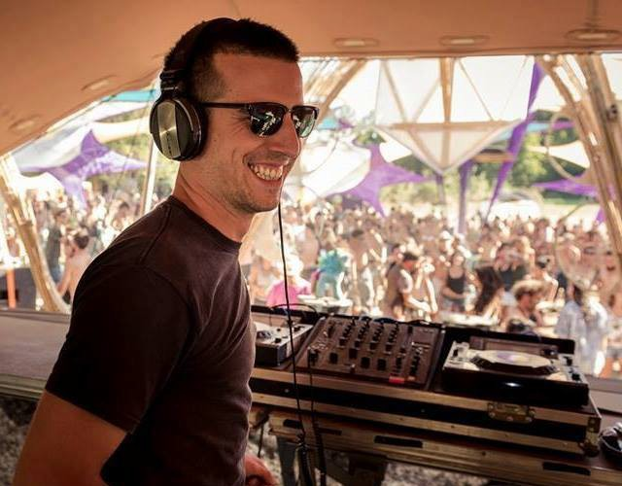
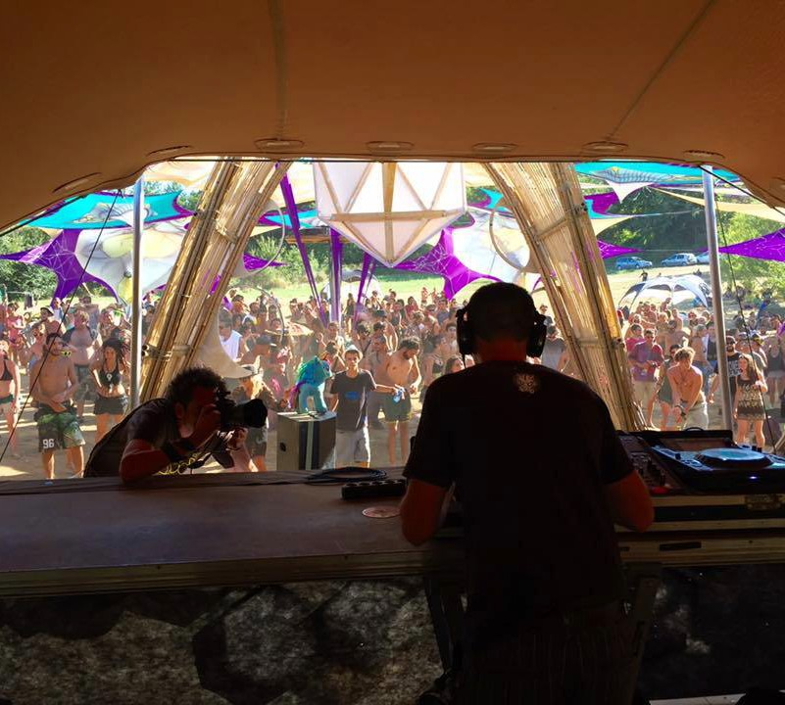
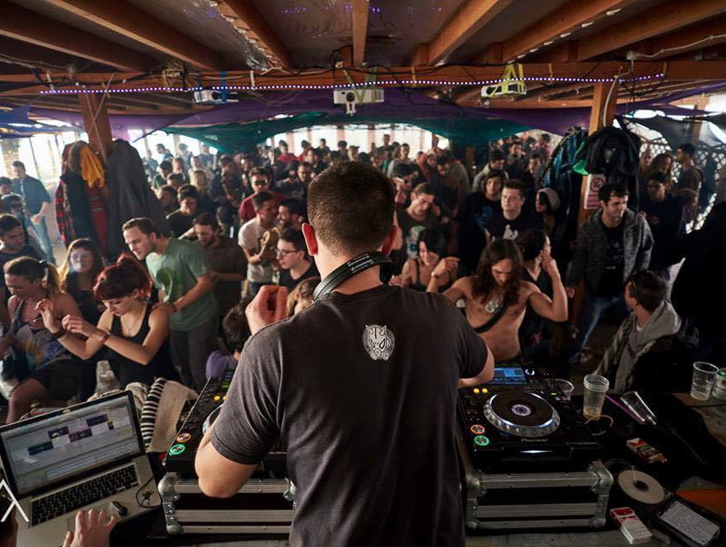
PRESS KIT
DORO
DJ
PERFORMANCE INFO
- Sounds like: Psytrance
- Recommended length: 2 hours max
- Type: DJ Set
- Technical requirements: CDJ
- Travelling from: Pauda, Italy
BOOK NOW
www.blackliterecords.com Booking & Management: booking@blackliterecords.com General Info: info@blackliterecords.com
BIO
Doro is a full power psytrance DJ hailing from Italy. Born in Padua in 1988, he has been passionately involved with the psytrance scene since 2004. It was love from the start and from that very beginning there was no turning away from the music and vibe that is trance. One year later he bought his first consolle and together with his two best friends and DJ’s Ilai and Acid Mind formed the Davya Crew. In 2007 Davya Crew started creating parties and with their growing recognition also playing around Italy often alongside major international artists such as Tristan, Rinkadink, Atomic Pulse, Quantum, AMD, Painkiller and many others. As a DJ, Doro has become known for his powerful basslines and blasting tracks which alternate between hard grooves and crowd jumping pieces. In 2015 he met Astralex and joined the 24/7 Records label and today he is now a Blackliter and member of the Blacklite Records family.
SOUNDCLOUD
soundcloud.com/doro24-7
READ MORE
blackliterecords.com/doro
FACEBOOK
facebook.com/dorodj/

