



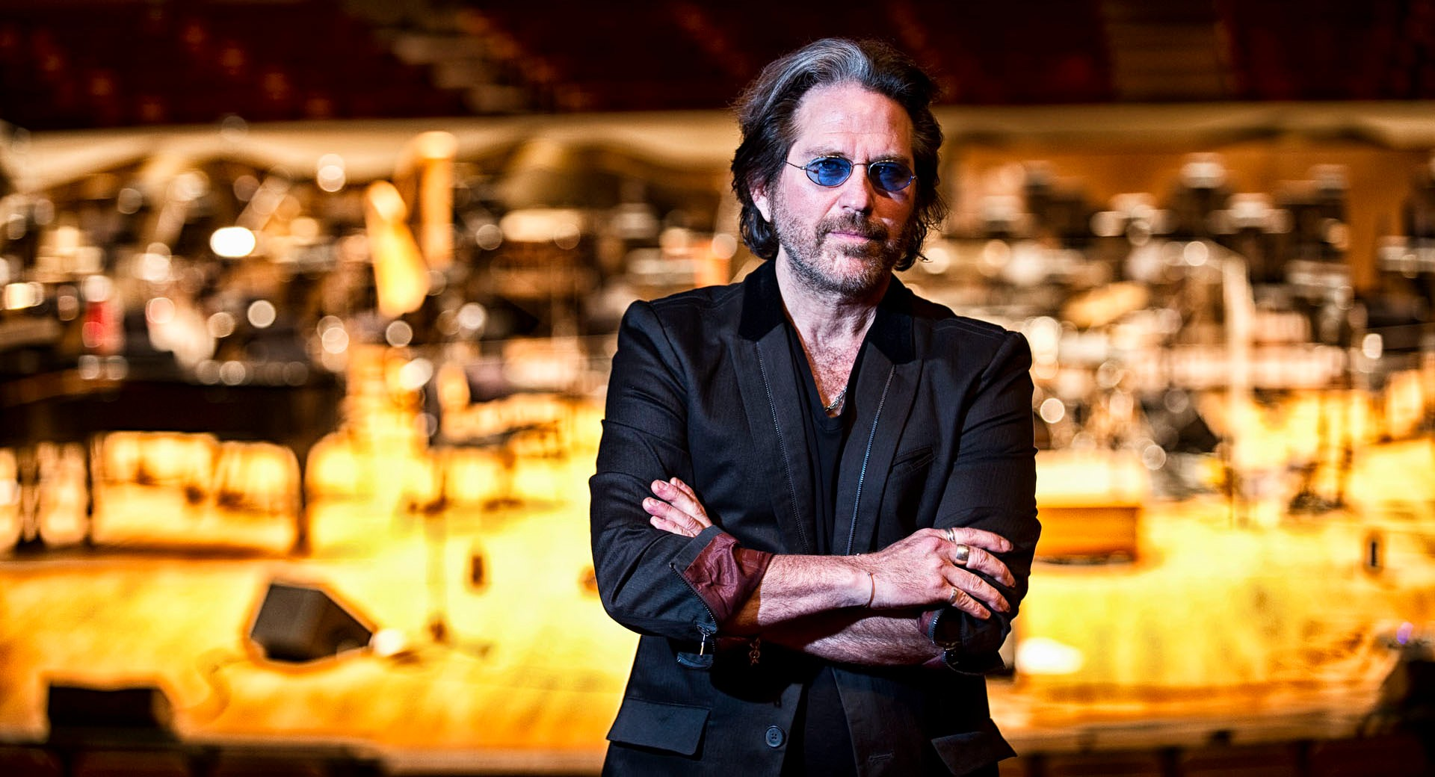

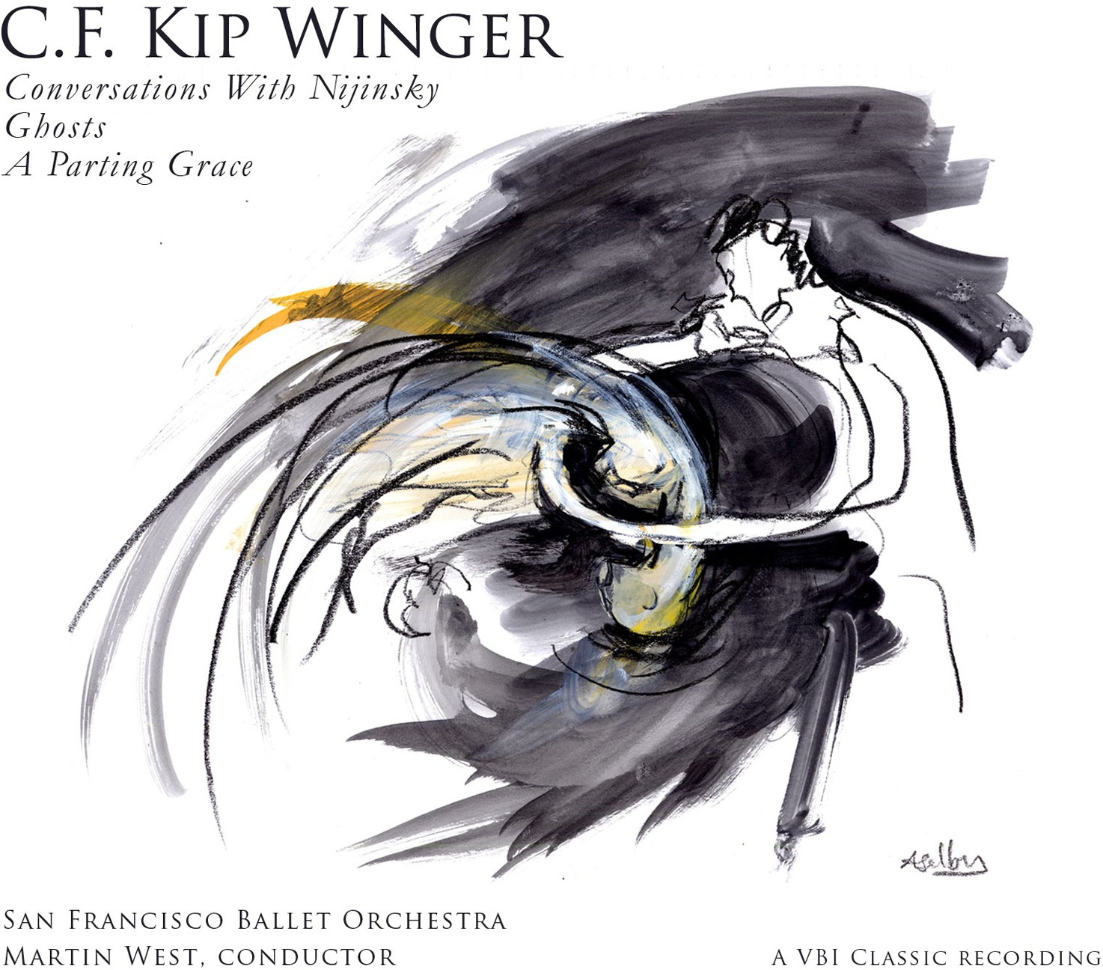
Performed by the San Francisco Ballet Orchestra with Martin West conducting, and recorded by Grammy-­‐ winning recording engineer Leslie Ann Jones, C.F. Kip Winger’s world-­‐premiere recording declares loudly and clearly that, while he may be the front man of the rock band Winger, he is a force to be reckoned with as a classical composer.
Winger’s music has had performances at Lincoln Center in New York, Sadler’s Wells Theatre in London, the War Memorial Opera House in San Francisco, and the Théâtre du Châtelet in Paris. But his transition to classical composing was no overnight decision. Winger dug deep into the process, studying ear training and composition with such prominent teachers as Richard Danielpour, Michael Kurek and Richard Hermann. His traditional approach has resulted in commissions from the Colorado Symphony Orchestra, Sun River Music Festival (Oregon), and the Tucson Symphony.
Artist: San Francisco Ballet Orchestra; Martin West, conductor
Title: C.F. Kip Winger
Produced by: C.F. Kip Winger and Leslie Ann Jones
Label: VBI Classic Recording
Genre: Classical
Packaging:
UPC: 640970742021
Release Date: May 27, 2016
Project Manager: Brian Horner, bhorner@soundartistsupport.com (615) 364-7656
“…Winger capitalizes on the full range of orchestral capabilities using a diverse palette of tone colors to paint a complex picture…”
– The Stanford Arts Review
“A superb new work… ‘Conversations with Nijinsky’ by
C.F. Kip Winger is a winner. It has everything in spades…”
– Piedmont Post
Track Listing
Conversations with Nijinsky
I Chaconne de feu II Waltz Solitaire III Souvenir Noir IV L’Imortal
Ghosts
I Misterioso II Vivace
III Adagio IV Allegro
A Parting Grace
4:33
5:38
5:03
7:18
6:22
4:27
6:57
7:31
6:53

