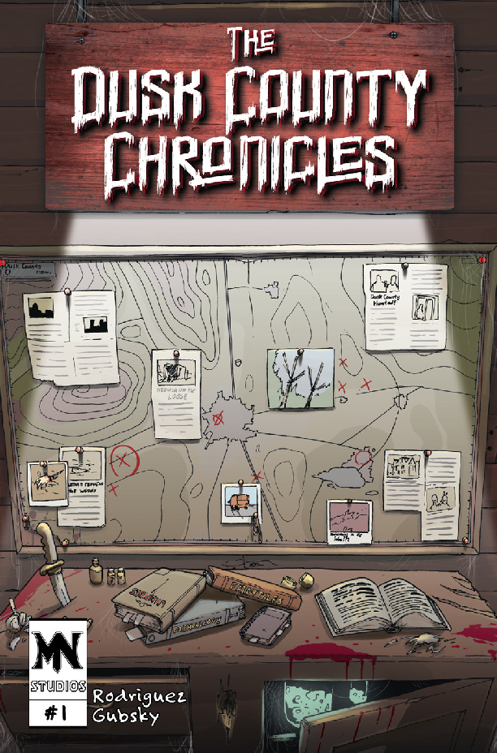
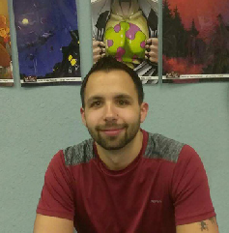
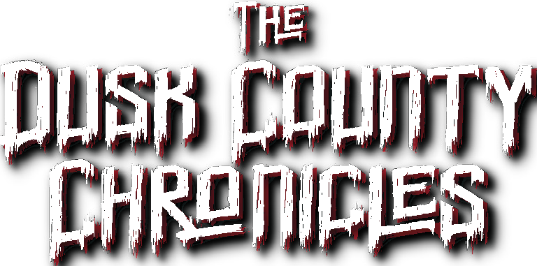
Have you ever wondered what it would be like if “Toy Story” was a slasher?
What about if “Peter Pan” required a sacrifice to enter Never- land?
Answer to these questions and more will be answered within the pages of The Dusk County Chronicles, a 24 page horror-parody mini-anthology set for release in mid-2019 from Metal Ninja Studios.
SAMPLE Q&A
What is the overall theme of The Dusk County Chronicles?
I wanted the stories to all be quick and fun reads.
They are five pages each, so there isn’t much of a time investment required to get through them. However, I also wanted them to have some emotional pull. I have never been a fan of violence for the sake of violence. It has to serve the story and the characters.
So with these stories, they are all about contradic- tions and realizing that things are not always what they seem. The art, by the talented Roman Gubsky, plays a key role in that second part. If you look at the covers for each of the stories, A Friend in Me for example, it doesn’t look like a horror story. It looks like a story about some cute toys; which it is. They just happen to be getting murdered by their friend.
INF ORMA TION
Title: The Dusk County Chronicles Category: Comic
Production Studio: Metal Ninja Studios Writer: Joel Rodriguez
Pencils: Roman Gubsky Inks: Roman Gubsky Color: Roman Gubsky Letters: Joel Rodriguez
Genre: Horror-Parody / Mashup
Format: Saddle Stiched Single-Issue Floppy Pages: 24
Price: TBD
Publication Date: Mid 2019 Available from: TBD
MEE T
THE CREA T OR
Joel Rodriguez is a comics buff whos writing blurs the line be-
tween joyful nostalgia and surprising horror.
Contact Info:
metalninjastudios.com / joelrodriguez@metalninjastudios.com / 407-995-4431

WEL COME T O DUSK COUNTY

AUTHOR BIOS
Short Bio: Joel Rodriguez is a comics buff whos writing blurs the line between joyful nostalgia and surprising horror.
Medium Bio: Joel Rodriguez is the writer and letterer for The Dusk County Chronicles, a collection of
horror-parody short stories that blur the line between joyful nostalgia and surprising horror. Having been a fan of comics since he was a child, he founded Metal Ninja Studios as a central hub for his comic career.
Long Bio: Joel Rodriguez is the founder, writer, and letterer for Metal Ninja Studios, the production studio which he uses for his comic creations and freelance services. Growing up as an avid comic book reader and amassing a collection of over 2,000 comics, he infuses his passion for the medium within every project. The Dusk County Chronicles is a collection of horror-parody short stories that blur the line between joyful nostalgia and surprising horror and is the first comic release from Metal Ninja Studios.
Joel Rodriguez metalninjastudios.com joelrodriguez@metalninjastudios.com 407-995-4431

SUGGESTED INTERVIEW QUESTIONS
1.
What inspired you to write The Dusk County Chronicles?
2.
Can you explain a bit more about the structure of The Dusk County Chronicles?
3.
If the stories are all connected, does that mean they will eventually come together?
4.
What is the overall theme of The Dusk County Chronicles?
5.
It seems like these stories have a pretty dark subject matter. How will reading the stories within The Dusk County Chronicles change the minds, hearts, or lives of the readers?
6.
Is The Dusk County Chronicles a result of your experiences, research, expertise, or what?
7.
What are the key takeaways you hope readers find in The Dusk County Chronicles?
8.
What can you tell us about the art of The Dusk County Chronicles?
Joel Rodriguez metalninjastudios.com joelrodriguez@metalninjastudios.com 407-995-4431

SAMPLE Q&A
What inspired you to write The Dusk County Chronicles?
Well, it actually started as just one story, “A Friend in Me”. I was trying to come up with a short story to submit to different anthologies to get my name out there. While I was at my day job, bouncing ideas around, I started thinking about the song “You’ve Got a Friend in Me” from Toy Story. I have always been a fan of animated shows and movies, so my mind just naturally went there. But I’m also a big fan of horror, so of course my mind took it to a dark place. The story came from the name. I started wondering what it would be like if a toy burst out of the chest of another one, Alien style. However, I didn’t want it to just be “Toy Story meets Alien” so I decided to make it a slasher story and add the Alien aspects as an “ah-ha” type of plot twist at the end. Kind of a sneak-attack mashup if you will!
Anyway, I submitted A Friend in Me to some anthologies, but no one wanted it. I decided that I loved the story too much to just shelve it, so I came up with the concept for Dusk County and wrote the other stories to fill the issue.
Can you explain a bit more about the structure of The Dusk County Chronicles?
Sure. It is a mini-anthology that contains four self-contained short stories that are all horror-parodies of popular children’s stories, such as Toy Story, Peter Pan, Super-Heroes and Goldilocks and the three bears.
Each story is self contained, but they are all connected in that they all take place within Dusk
County.
If the stories are all connected, does that mean they will eventually come together?
That is definitely a possibility!
What is the overall theme of The Dusk County Chronicles?
I wanted the stories to all be quick and fun reads. They are five pages each, so there isn’t much of a time investment required to get through them. However, I also wanted them to have some emotional pull. I have never been a fan of violence for the sake of violence. It has to serve the story and the characters.
So with these stories, they are all about contradictions and realizing that things are not always what they seem. The art, by the talented Roman Gubsky, plays a key role in that second part. If you look at the covers for each of the stories, A Friend in Me for example, it doesn’t look like a horror story. It looks like a story about some cute toys; which it is. They just happen to be getting murdered by their friend.
It seems like these stories have a pretty dark subject matter. How will reading the stories within The Dusk County Chronicles change the minds, hearts, or lives of the readers?
Each of the stories asks the reader a different question. To me, they are questions that are very personal, yet taken to the extreme. A perfect example of this is the second story, Forever Young.
Within the story, Jenny has been getting visits from her brother, Miles, who has been missing for years. He comes back with a promise that they can be reunited...but at a cost. The basic question is this: What would you do to be reunited with someone that you lost?
This one in particular is a difficult question because, for me, the person that I lost is my mom.
Is The Dusk County Chronicles a result of your experiences, research, expertise, or what?
To be honest, it is mostly a result of my love for comics and movies. I have a collection of over two thousand comics that I have gathered over my lifetime, so I am constantly reading or watching movies...when I’m not writing that is.

What are the key takeaways you hope readers find in The Dusk County Chronicles?
I think the biggest takeaway would be that things aren’t always what they seem. I think that people now days can be way too quick to jump to conclusions, especially when dealing with people or things that they don’t understand.
People can be a lot like the stories within The Dusk County Chronicles. They look carefree and innocent, but they could have a darkness or pain inside of them that you won’t necessarily see without looking. But just like the stories are connected within Dusk County, we are all connected.
What can you tell us about the art of The Dusk County Chronicles?
Just like in every comic, the art plays a crucial role within The Dusk County Chronicles. The art is the first misleading factor for these stories. I wanted it to have an art style that lulled readers into a false sense of nostalgia by reminding them of the cartoons that they watched as kids. I essentially wanted someone to look at it and say “Oooh! That kinda looks like Toy Story” but then they open it to find out it is a slasher! I wanted to find an artist that would be able to be able to capture the darkness of the stories while still keeping the cartoony aspect of the art. I got extremely lucky when Roman Gubsky answered the call!
Joel Rodriguez metalninjastudios.com joelrodriguez@metalninjastudios.com 407-995-4431

FEATURE ARTICLE
Meet the Up-and-Coming Writer Who is Turning your Favorite Memories into New Nightmares...
Journey with us into Dusk County - where your dreams become nightmares
Have you ever wondered what it would be like if Toy Story was a slasher? What if Peter Pan required
a sacrifice to enter Neverland? These are the types of questions that led Joel Rodriguez to create The Dusk
County Chronicles, a new horror-parody mini-anthology comic set for release in mid-2019. Joel is an up-
and-coming comic creator out of Orlando, Florida who is using The Dusk County Chronicles as a launching
pad for his foray into the comic book industry.
“I wanted the stories to all be quick and fun reads.” he said about the structure of the comic. “They are
five pages each, so there isn’t much of a time investment required to get through them. However, I also
wanted them to have some emotional pull. They are all about contradictions and realizing that things are not
always what they seem.”
The 24 page comic consists of four self-contained short stories that all take place within the fictional
Dusk County. Each of the twisted tales of terror takes a classic children’s story, such as the previously
mentioned Toy Story and Peter Pan and reimagines the concept as a horror comic while still maintaining a
sense of innocence with the art.
He said “The art, by the talented Roman Gubsky, plays a key role in the theme of ‘things aren’t always
what they seem.’ If you look at the covers for each of the stories, A Friend in Me for example, it doesn’t look like
a horror story. It looks like a story about some cute toys; which it is. They just happen to be getting murdered
by their friend.”
“People can be a lot like the stories within The Dusk County Chronicles,” He responded, when asked
what he hopes the audience will take away from his stories.”They look carefree and innocent, but they could
have a darkness or pain inside of them that you won’t necessarily see without looking. But just like the stories

are connected within Dusk County, we are all connected.”
Joel founded Metal Ninja Studios in 2018 to act as the central hub for his independent comic creations,
but it is also the company through which he offers freelance writing and lettering services to his fellow creators.
When asked about the future of The Dusk County Chronicles and whether the characters of the stories will ever
meet, since they all live in the same area, he simply responded, “That is definitely a possibility!”
The Dusk County Chronicles is set for release in mid 2019; however, a special preview edition, which
includes black and white editions of the first two stories, can be downloaded for free by visiting
preview.duskcountychronicles.com and signing up for updates from Joel and Metal Ninja Studios.
Joel Rodriguez metalninjastudios.com joelrodriguez@metalninjastudios.com 407-995-4431

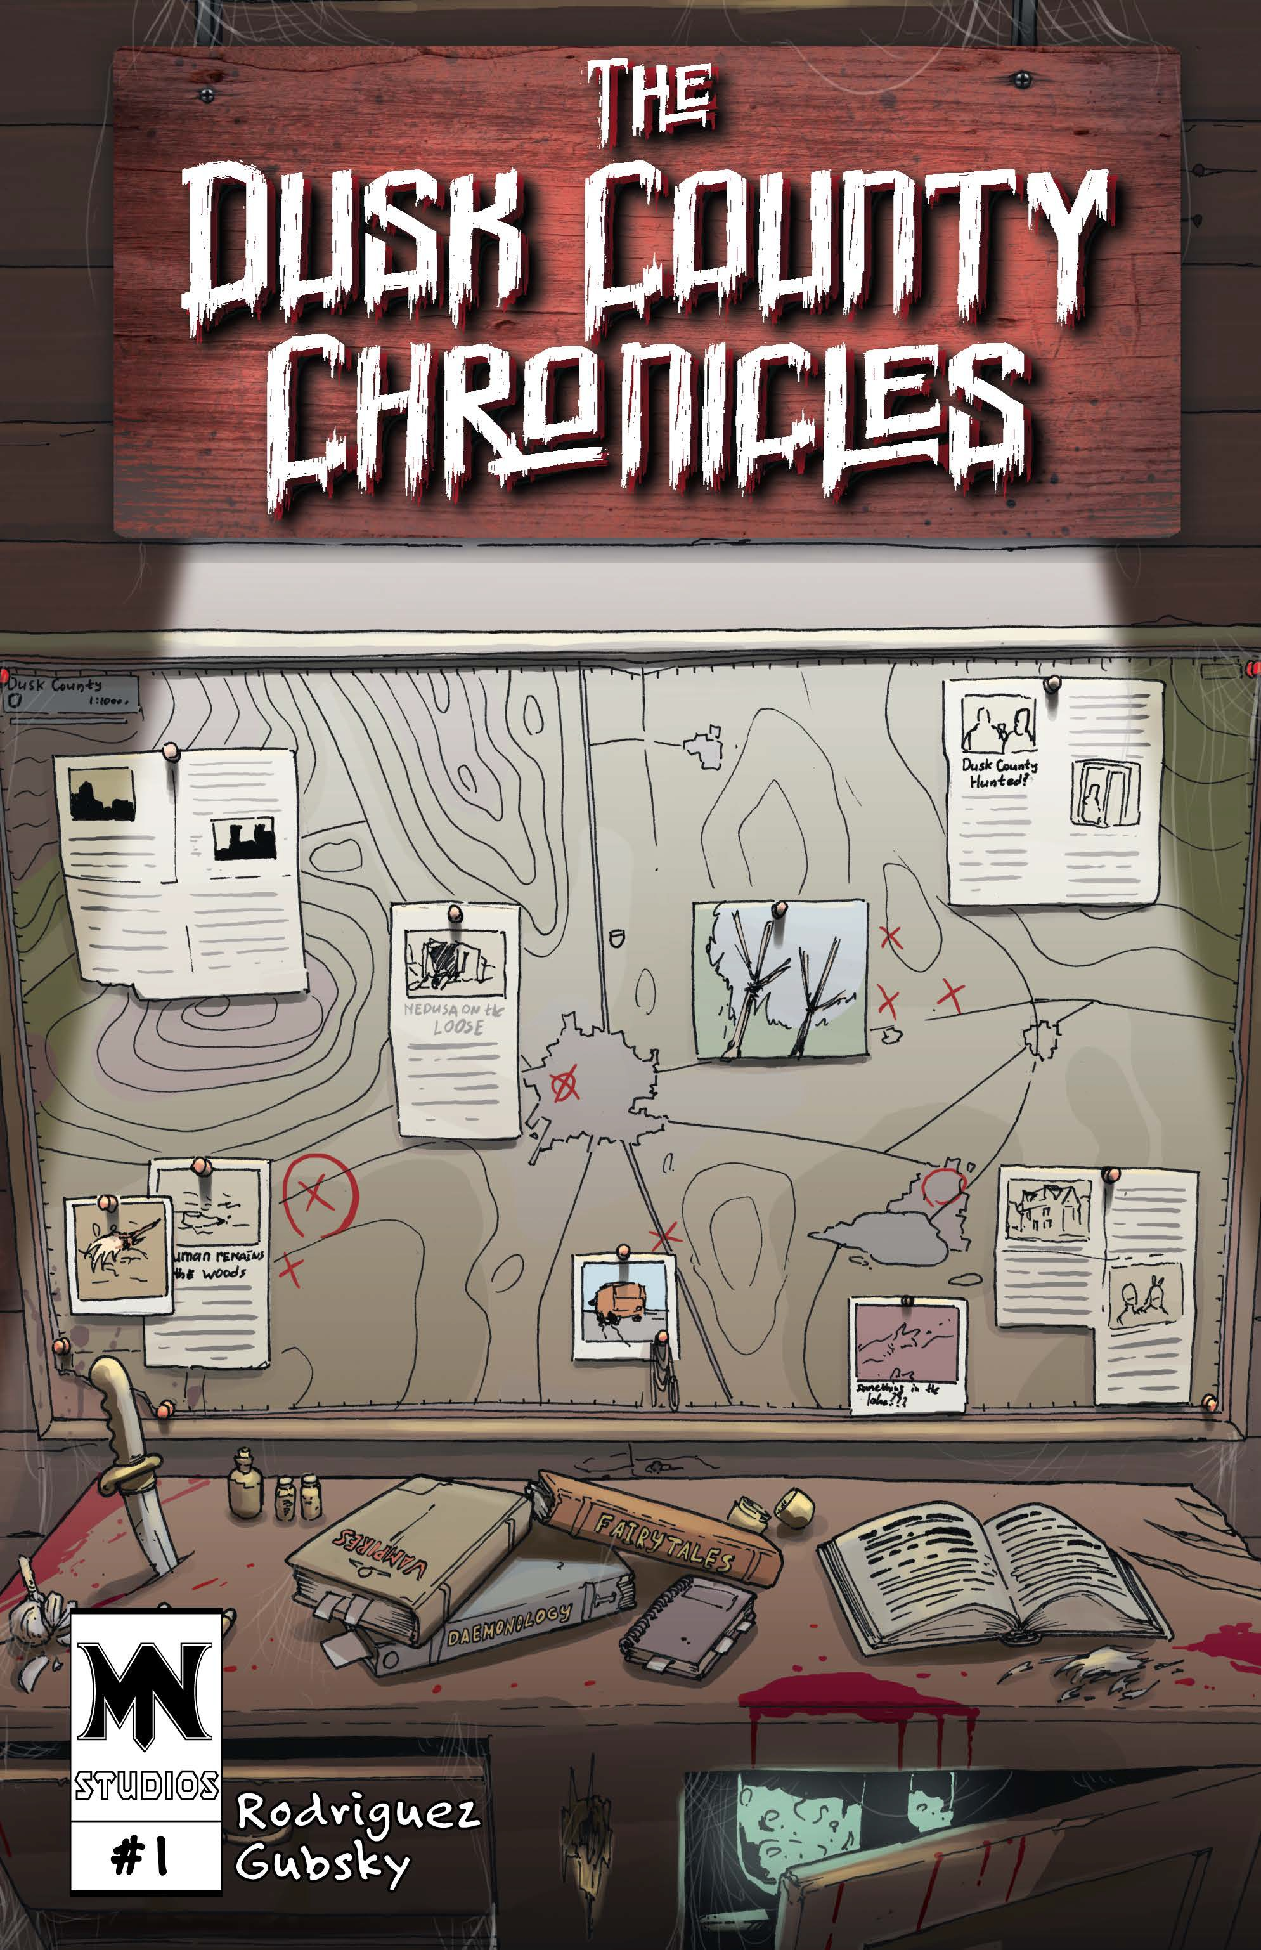

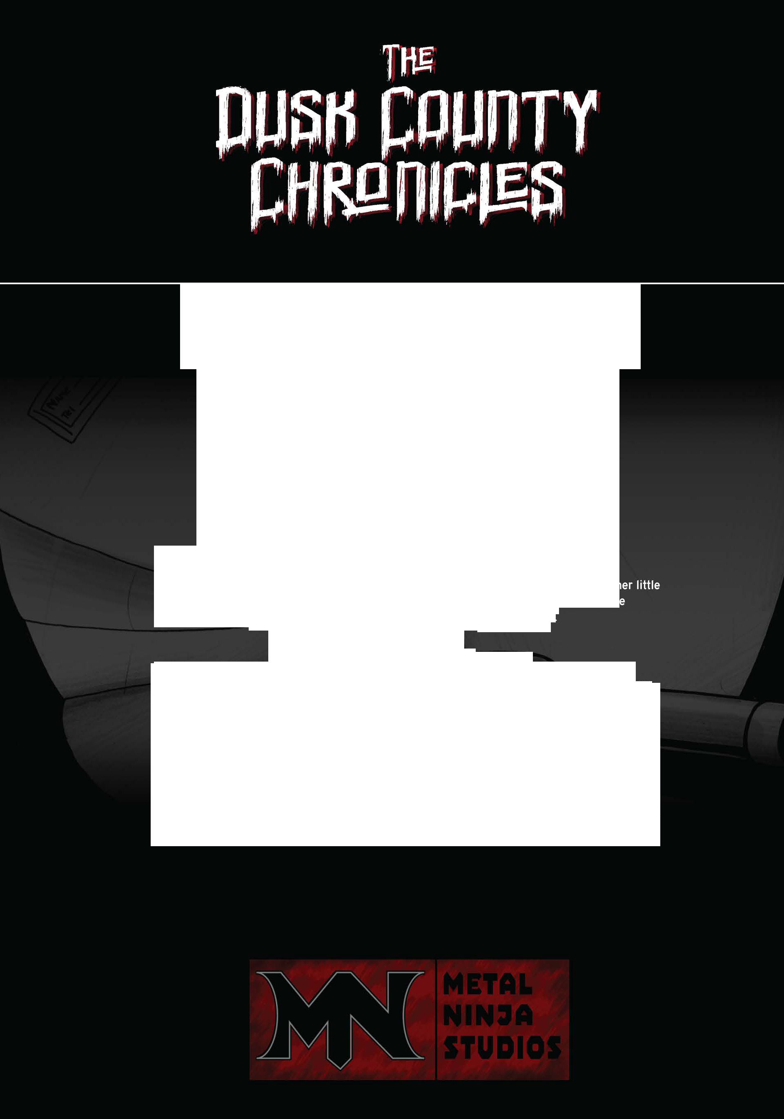
Writer I Letterer
Joel Rodriguez
Artist I Cover Artist
Roman Gubsky
Friend in Me
., -
,,.
life of a toy is not all fun and games.
A small group of toys learns this hard lesson as they are stranded in a van
on the sid_e of a country road and begin to be viciously murdered
1,-.;-_,i;.by one of their own.
1/·-:
../.,. .·
Scared and alone. witness their fight for survival!
-
Forever Youn
to reconnect with someone that you've lost?
Jenny's relationship with her mother never quite recovered after the clisap!)earance of her little
brother. Miles , and father years before. These rocky g _u_!1d s are tested even more
_ _ when Miles returns with a plan to reumt, them at a cost
Mind ames - -
.
THE COMMANDER
County. He
d
defends the innocent. Recently though. super vill.a ins have begun
ious -
, ...,.. _.._..,_
...,_
without a
·.
Isthere something sinister hidden behind the smile of the savior?
Just Ri ht
Lacey is lost. While traveling for an interview she takes a wrong turn and ends up stranded within Dusk County. A bad situa tion quickly worsens when her car breaks down
on a dark road in the forest. After wandering aimlessly. she stumbles upon a cabin in the woods.
What horror will she discover within the shambles of the old shack?
THE DUSK COUNTY CHRONICLES , #1 FIRST EDITION. MARCH 2019. Published by Metal Ninja Studios. All rights reserved. All Contents
names, characters, and person, whether living or dead, events, and/or
This is a work of parody as defined in the fair use provisions of the US Copyright Law. For more information on Metal Ninja Studios, visit the website at www.metalninjastudios.com
may be copied or transmitted in any form without the express permision of creators, except for excerpts for journalistic and review purposes.
Copyright 2019 by Metal Ninja Studios, Inc. All characters, events and institutions depicted herein are fictional. Any similarity between any of the

Institutions
is uninended and purely coincidental. No portion of this book

defeats the
corrupt an
to disappe2 ,r ,i my
ster

trace.
ways. Gone
is the hero of justice within Dusk

How
far
would you
go

The

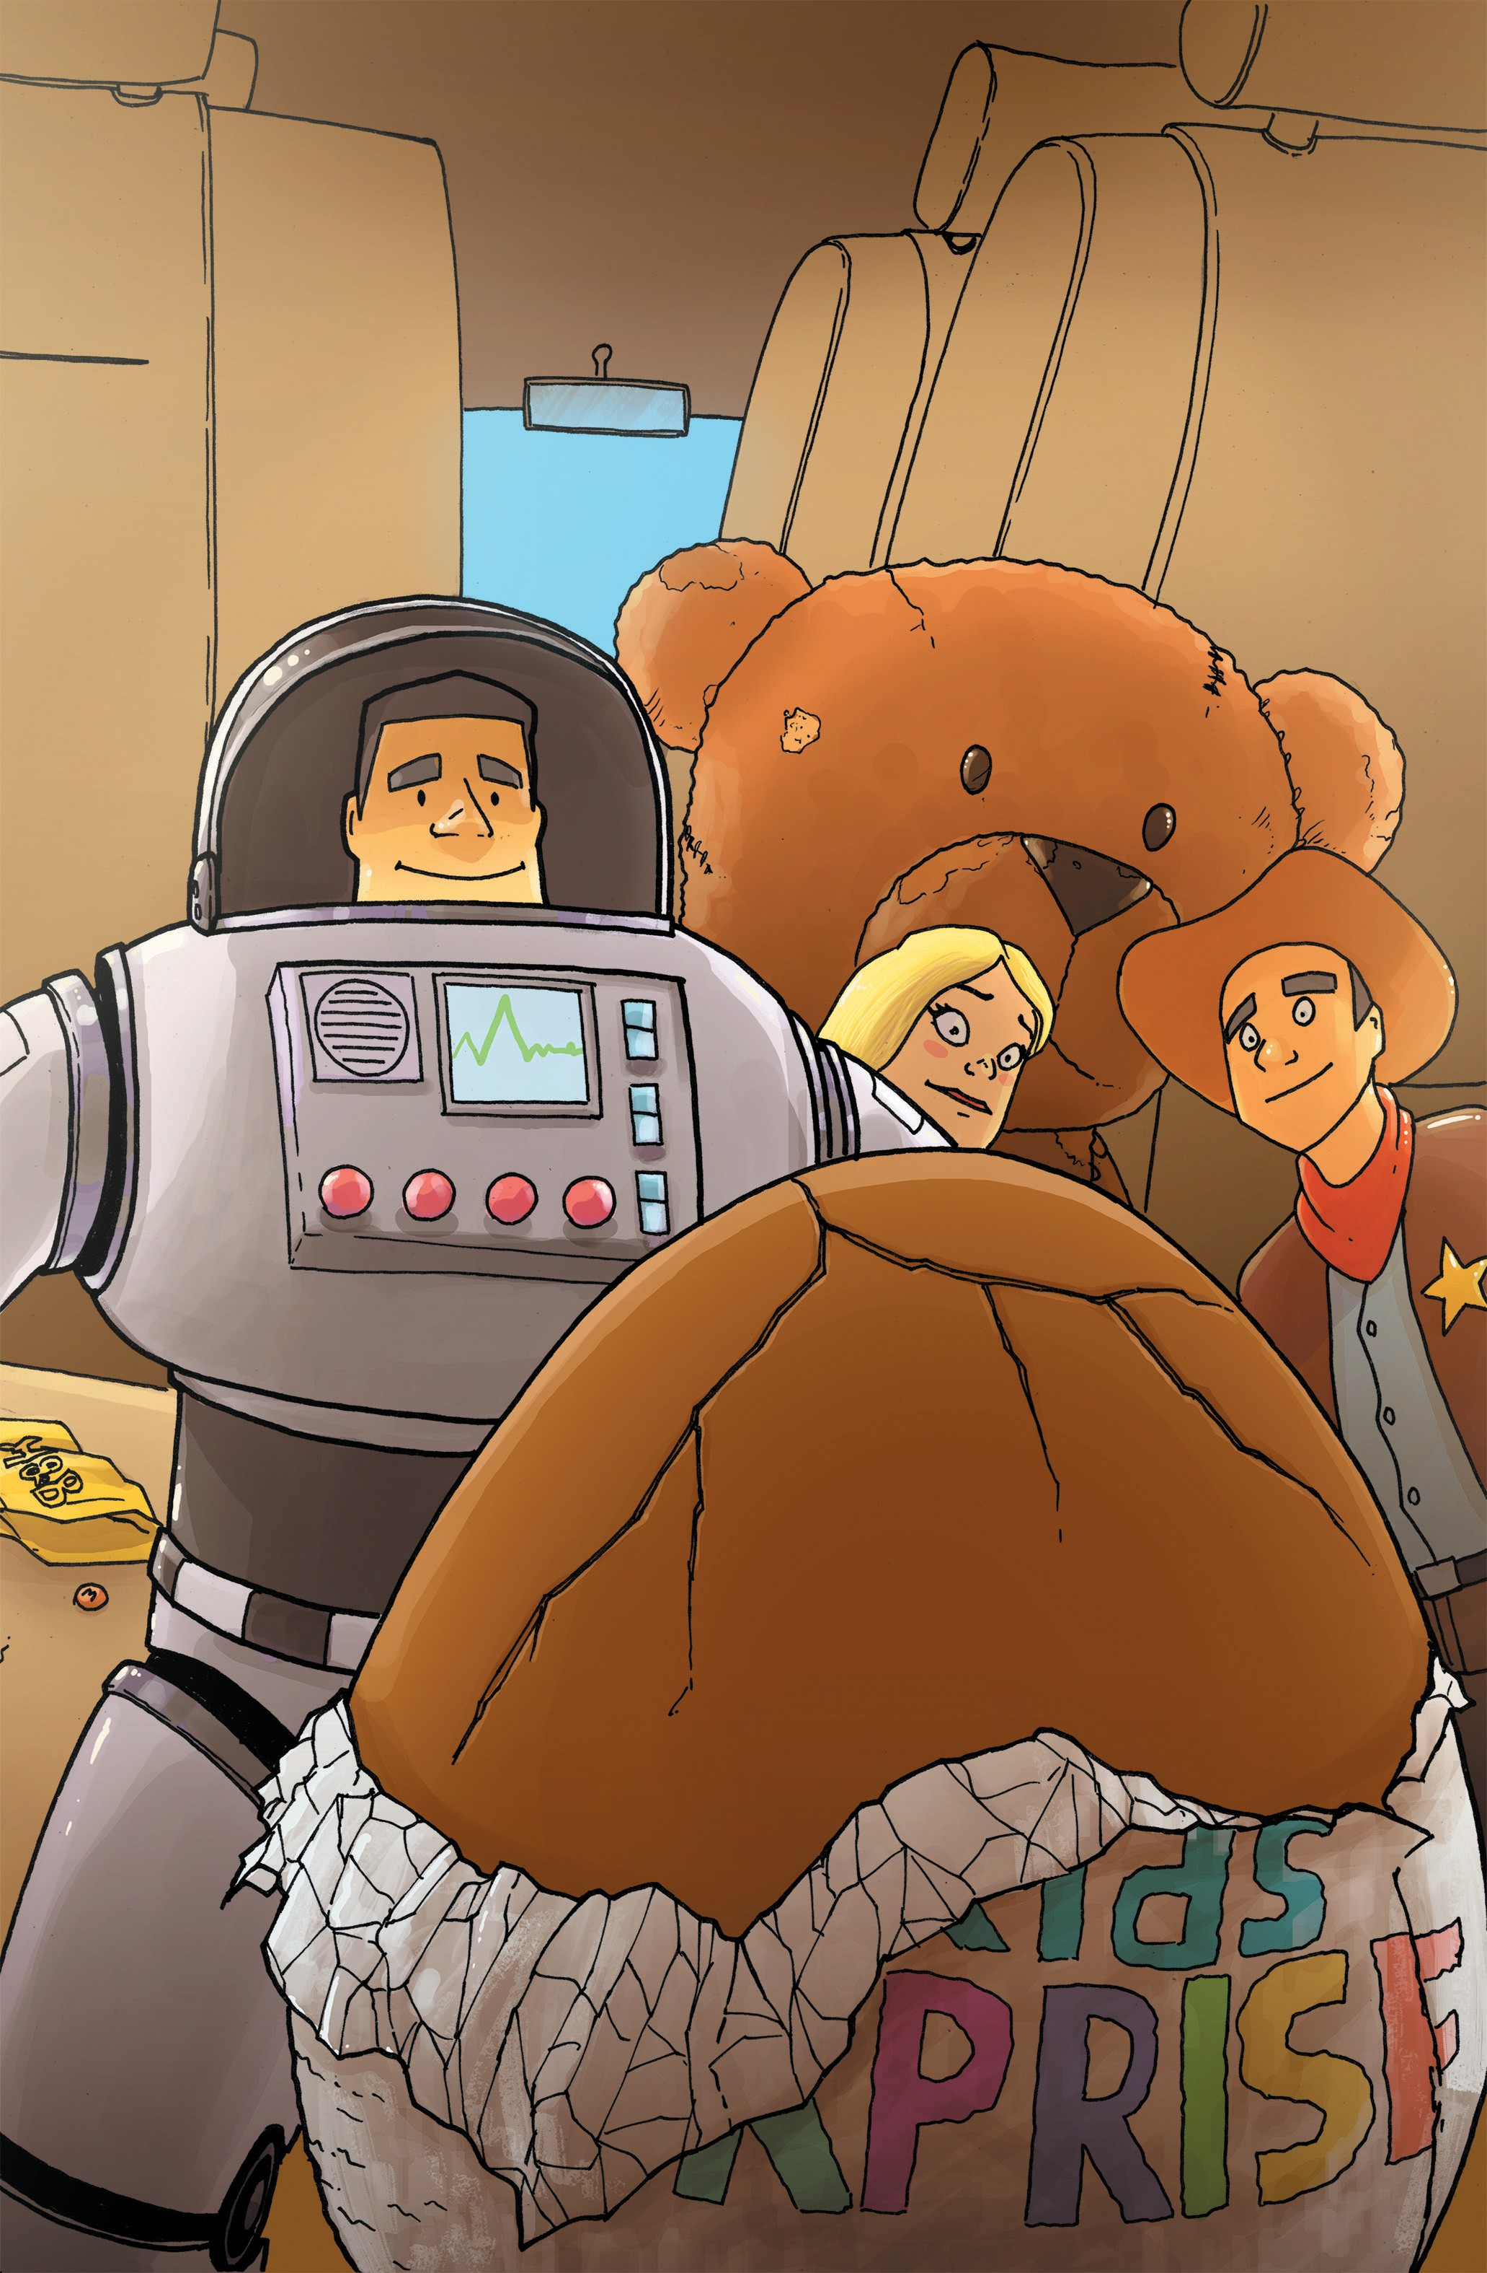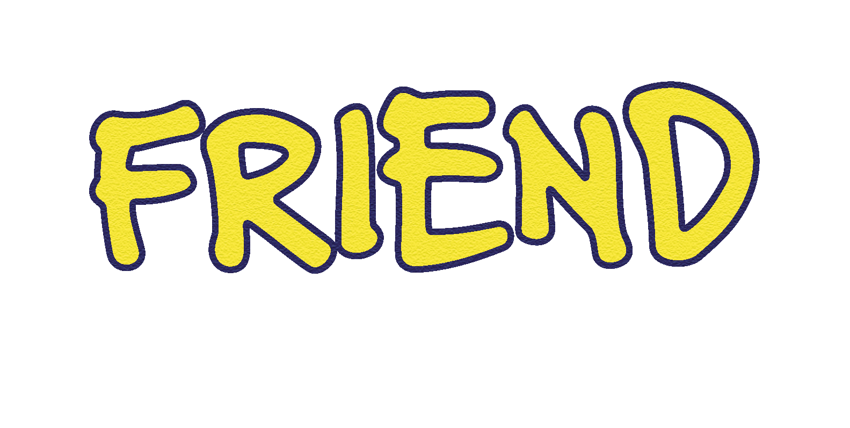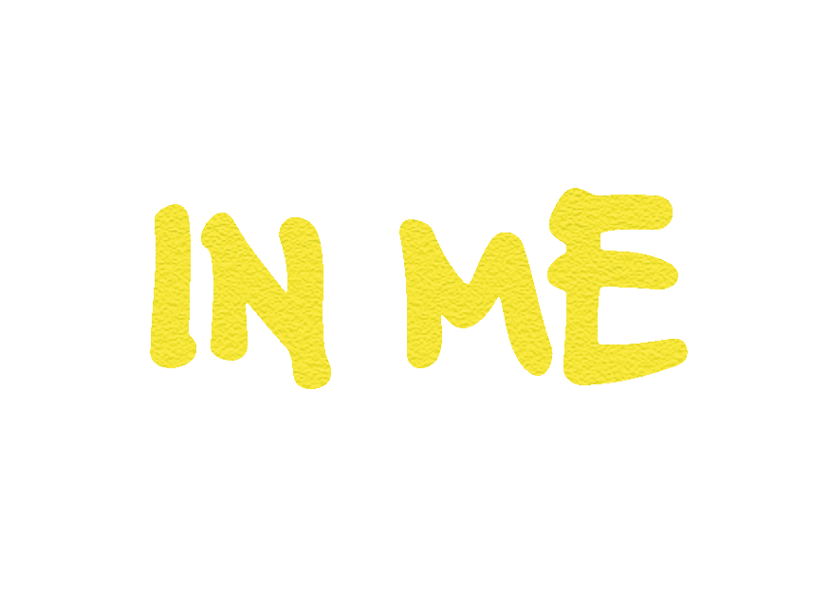
Rodriguez
Gubsky

Story 1 of 4 EXCITING tales of Dread from... The Dusk County Chronicles

1.1

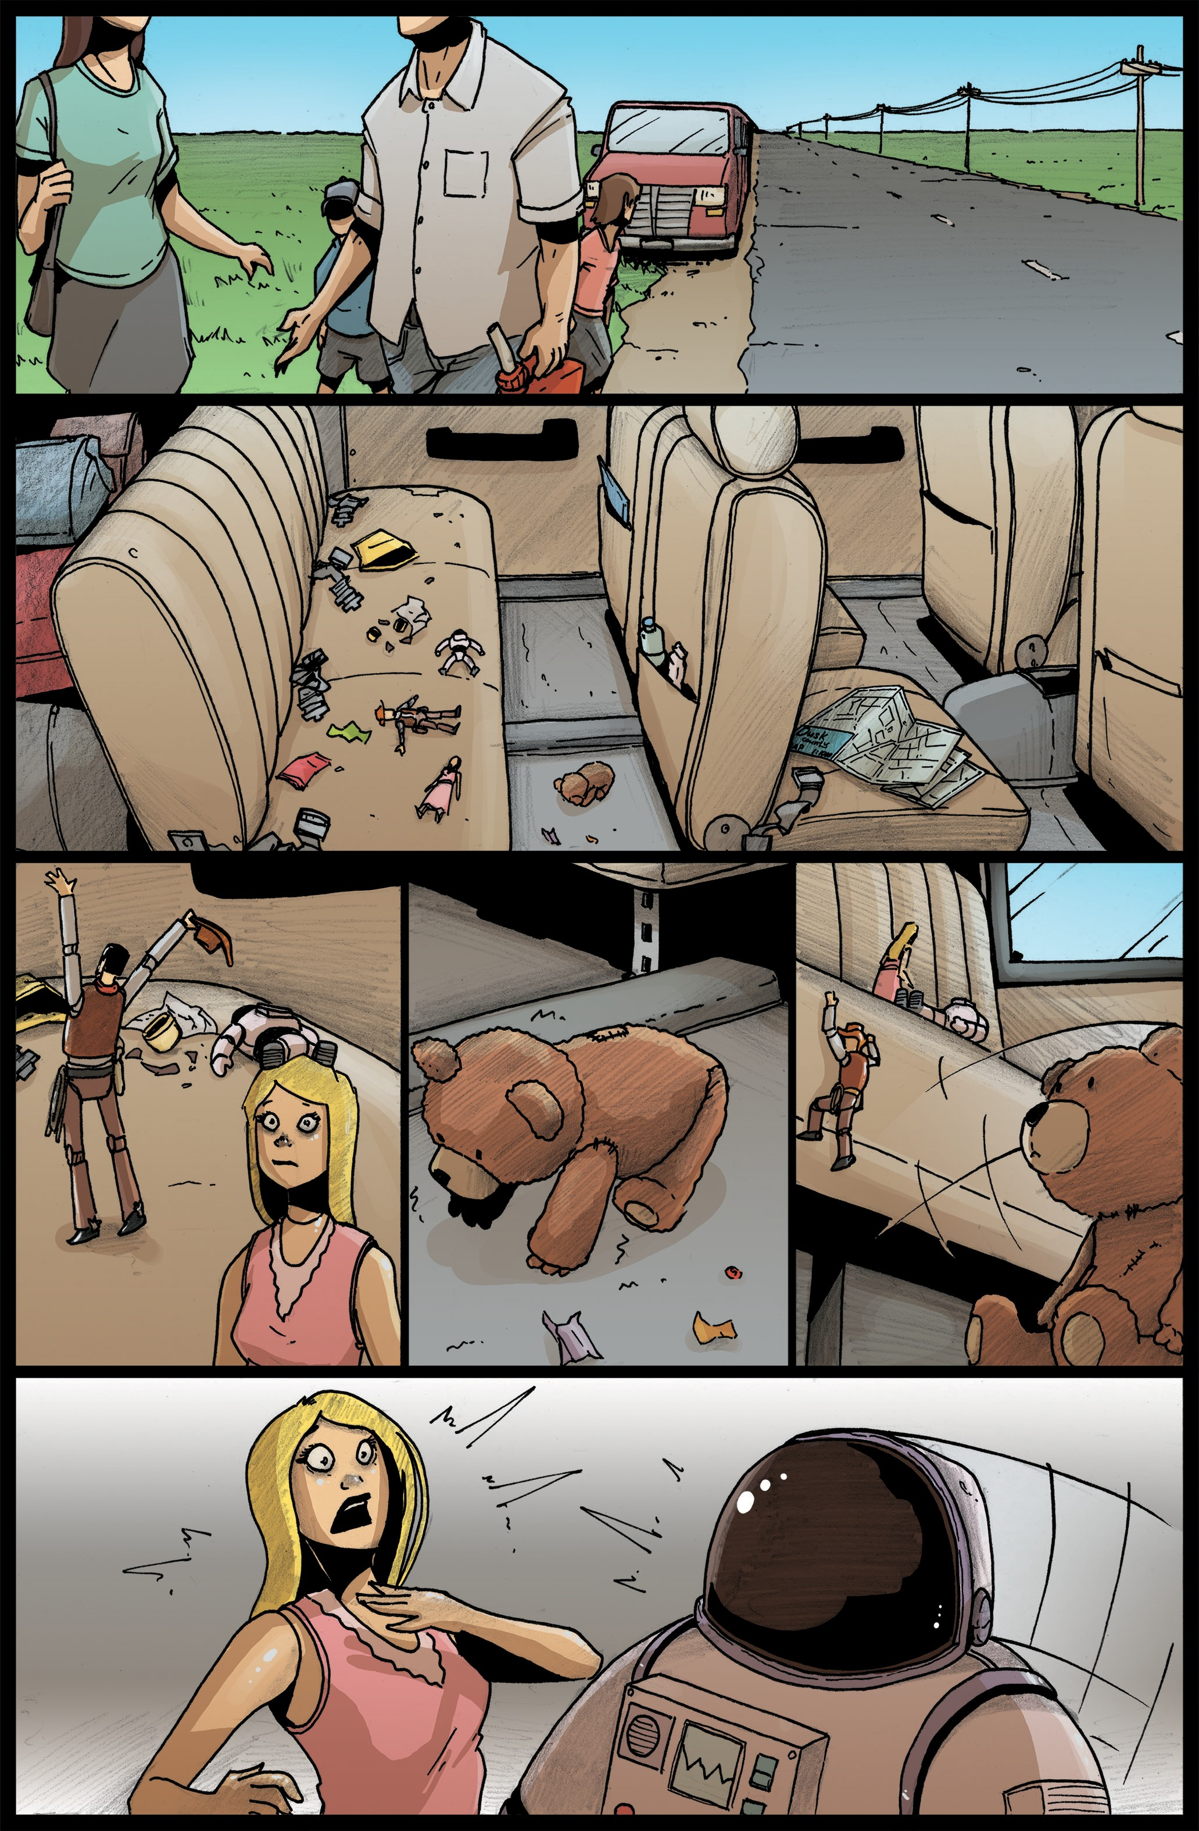
C'MON EVERYONE.
STATION CAN'T 6E MORE'N l=IVE MILES !=ROM
'ERE.
CLEAR?
r
COME, MY l=RIEND.
IT IS TIME TO WAKE.
r
TELL YA,
MA'AM.
BELIEVE
so.
TJ.IESE I-IERE
.)OINTS AIAl'T MEANT
!=OR SITTING!
/NAU.YI

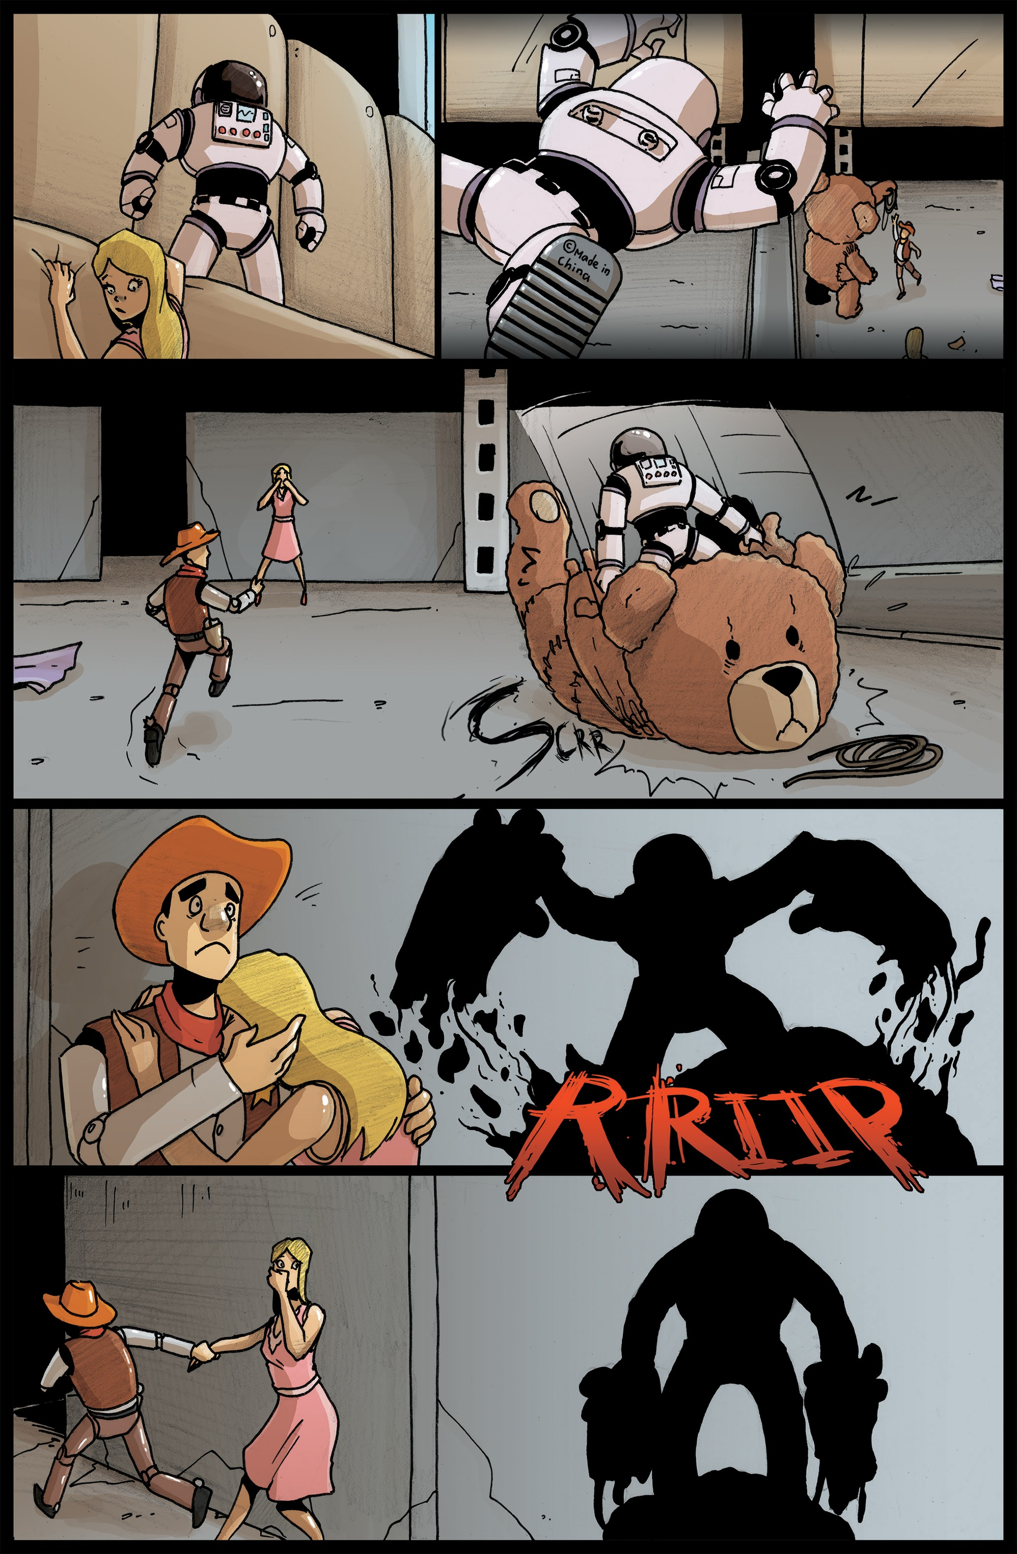
GIVE IT
BACK!
YA BIG BUCKET A l=UZZ
A!STRO??
GOOD
/..ORD.
I , ,.
, , ,
,
.--.,:,'
I RECKOtJ WE tJEED TO GO...
..JJOW!!f

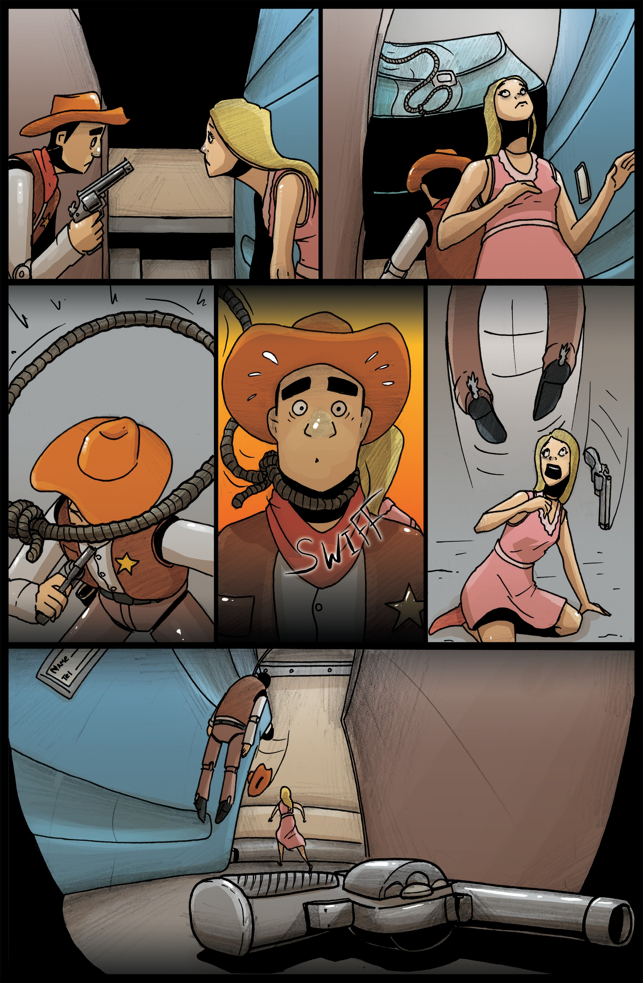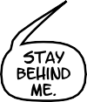
YA 01(
MA'AM?
. .. TEDDY.
IIUGII/./!
I-IUl-1?
AUUI!!

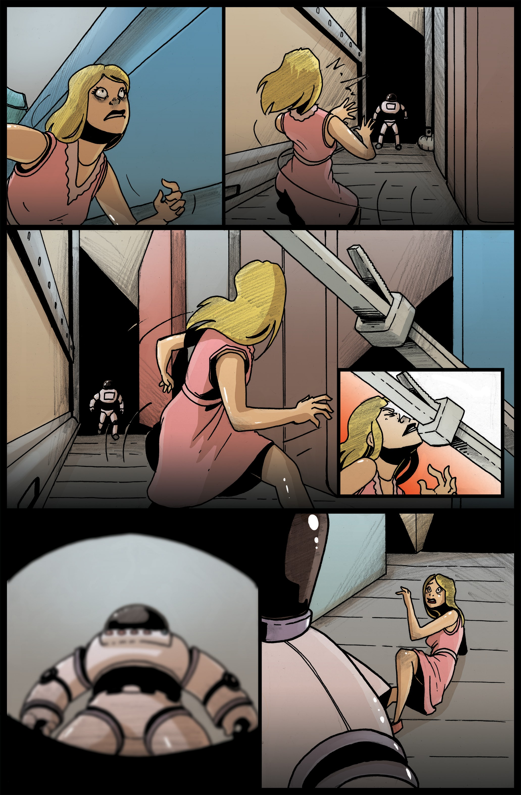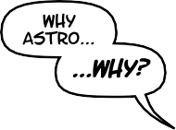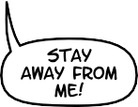

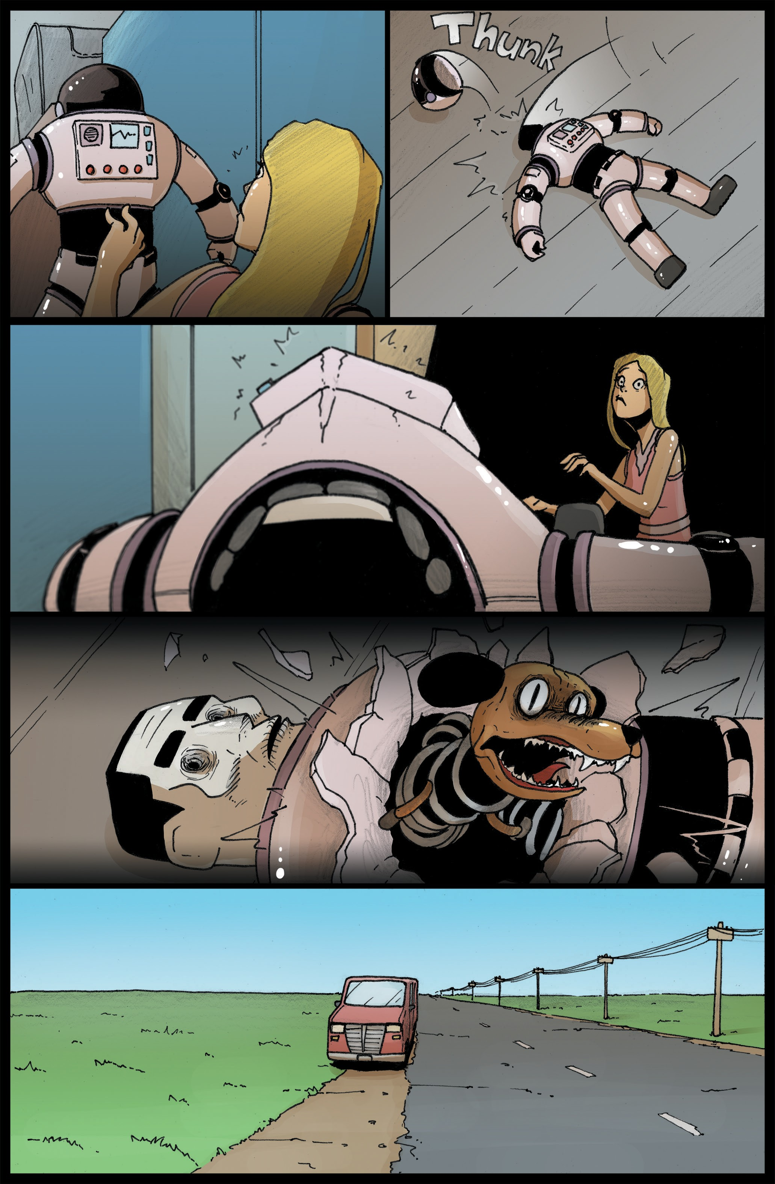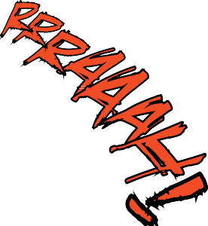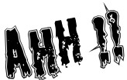
W Y ARE YOU DO/AJG Tl-115?
W T
lij Tl-IE...
- . .J.IEU.?
ijO...
...fJO!!

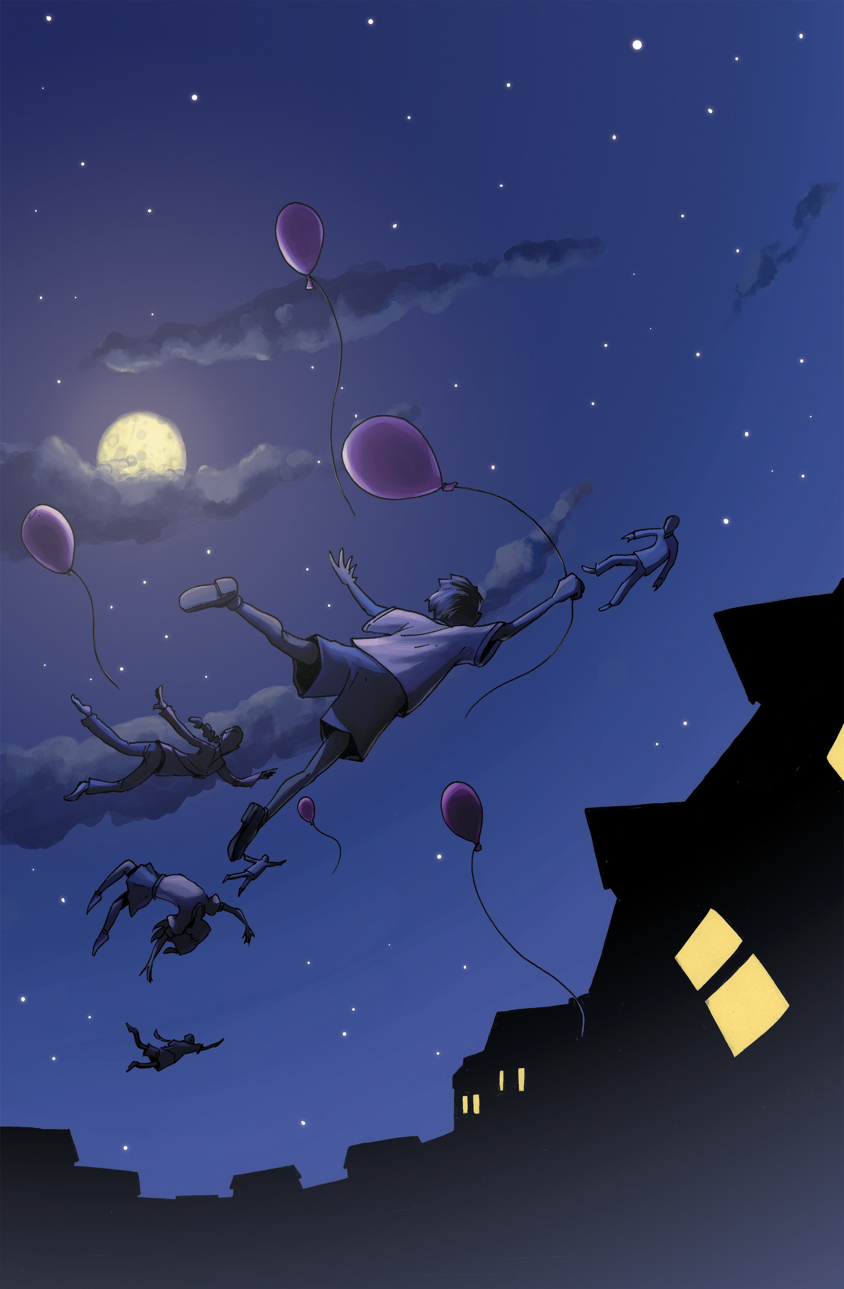
Rodriguez Gubsky
Story 2 of 4 EXCITING tales of Dread from... The Dusk County Chronicles

sTUDiOS
1.2

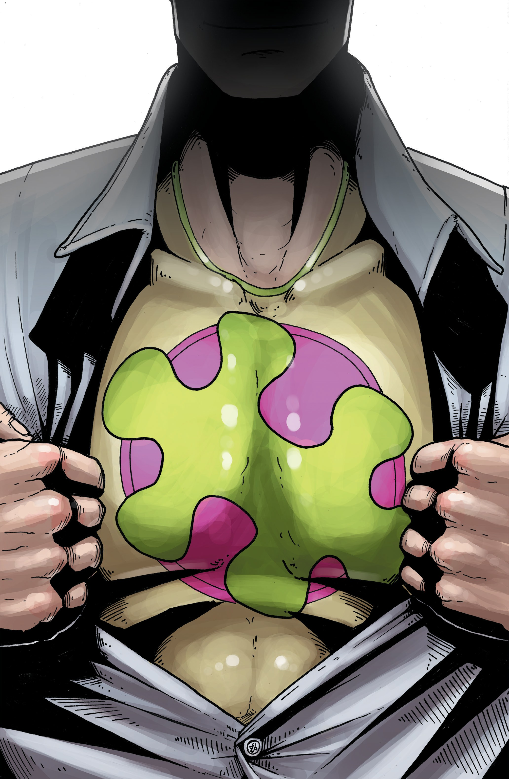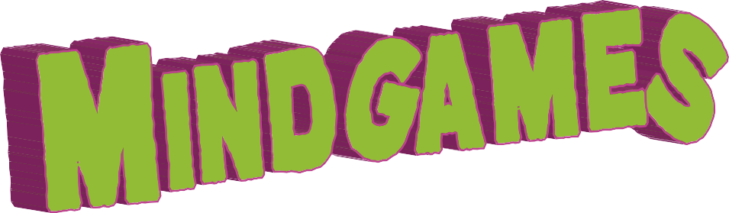
.
Rodriguez
Gubsky
Story 3 of 4 EXCITING tales of Dread from... The Dusk County Chronicles

1
3

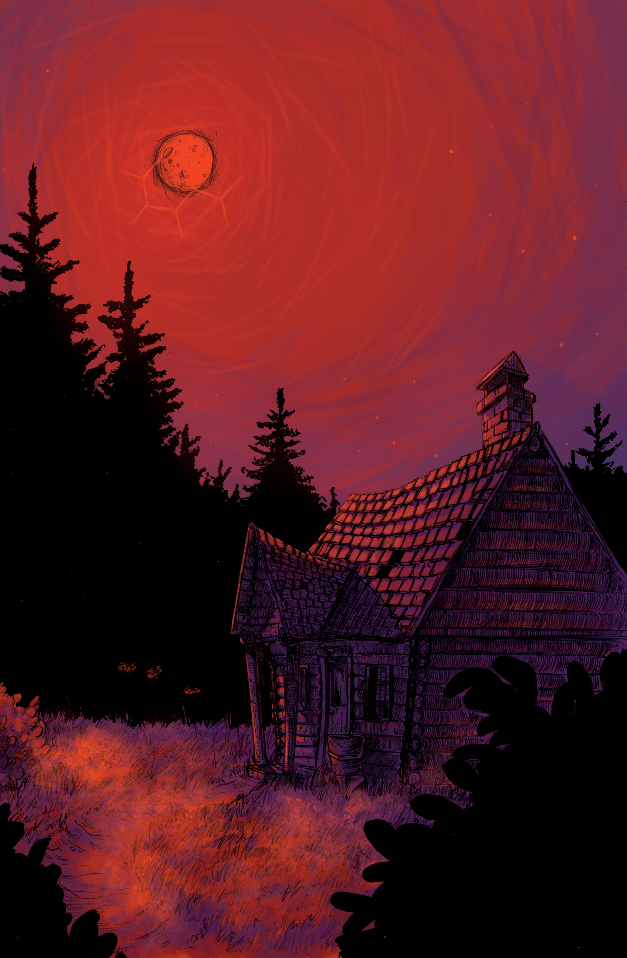
Rodriguez Gubsky
Story 4 of 4 EXCITING tales of Dread from... The Dusk County Chronicles

sTUDiOS
1.4

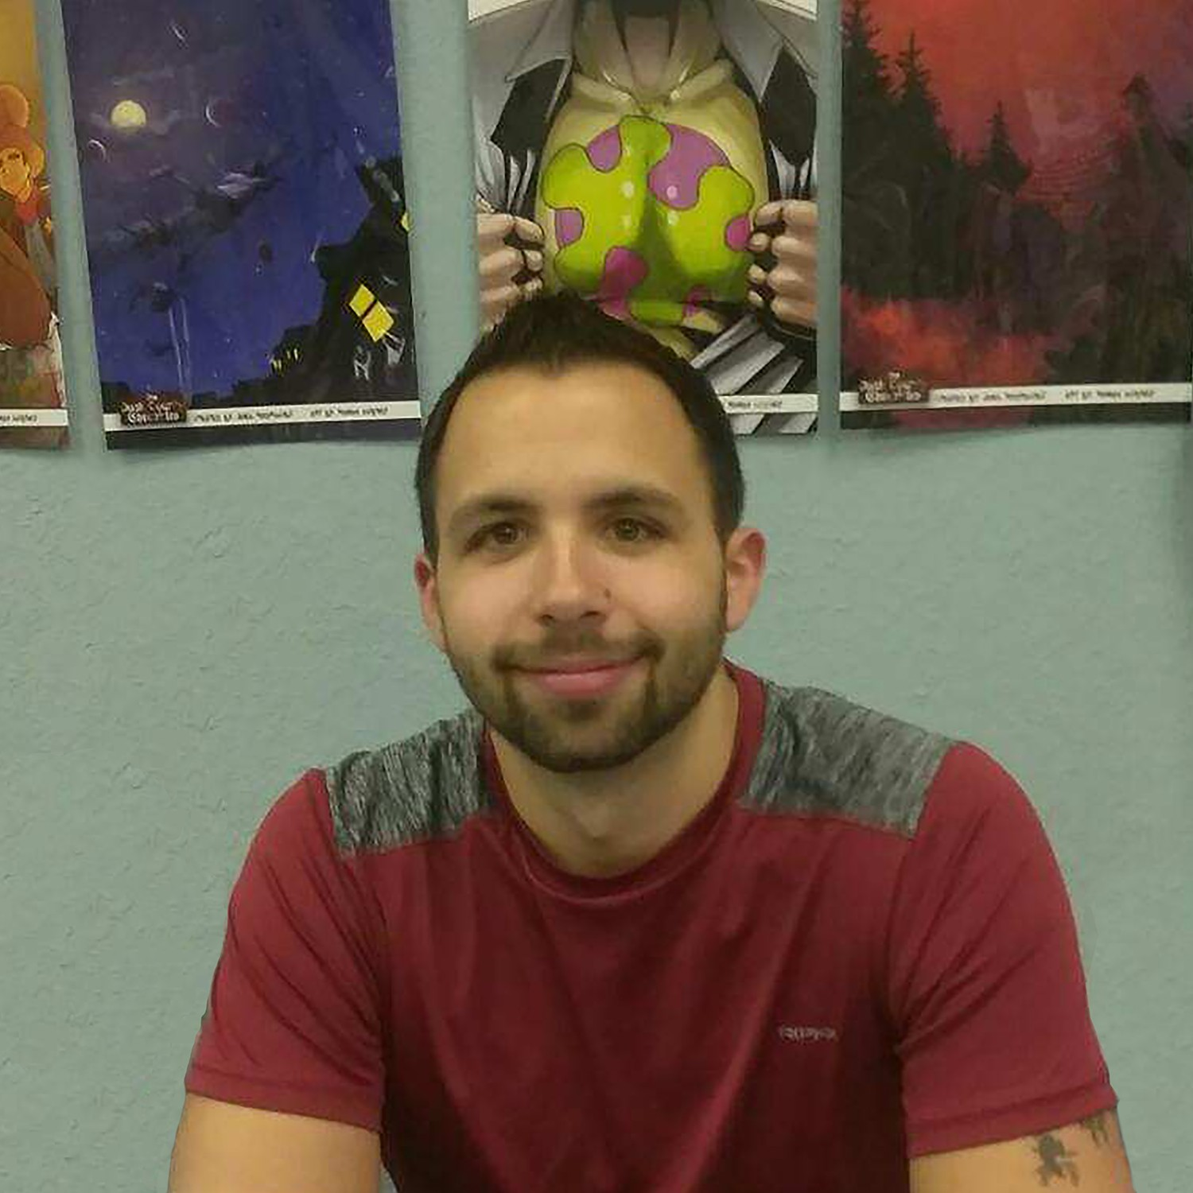

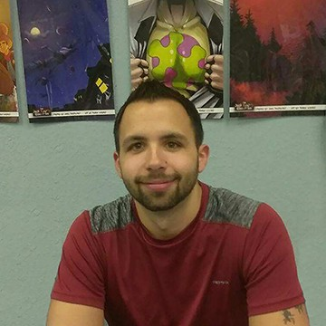

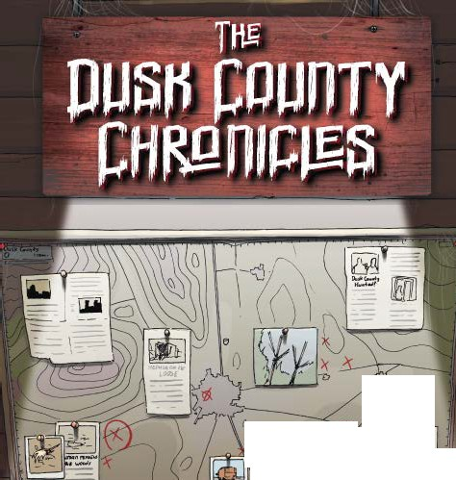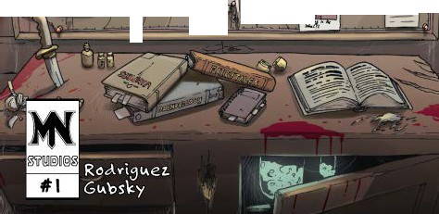
,,
_,,.., ,: =
,,--
1 (
/ r,:::
.' =
= . I
=
-6
=£I\

