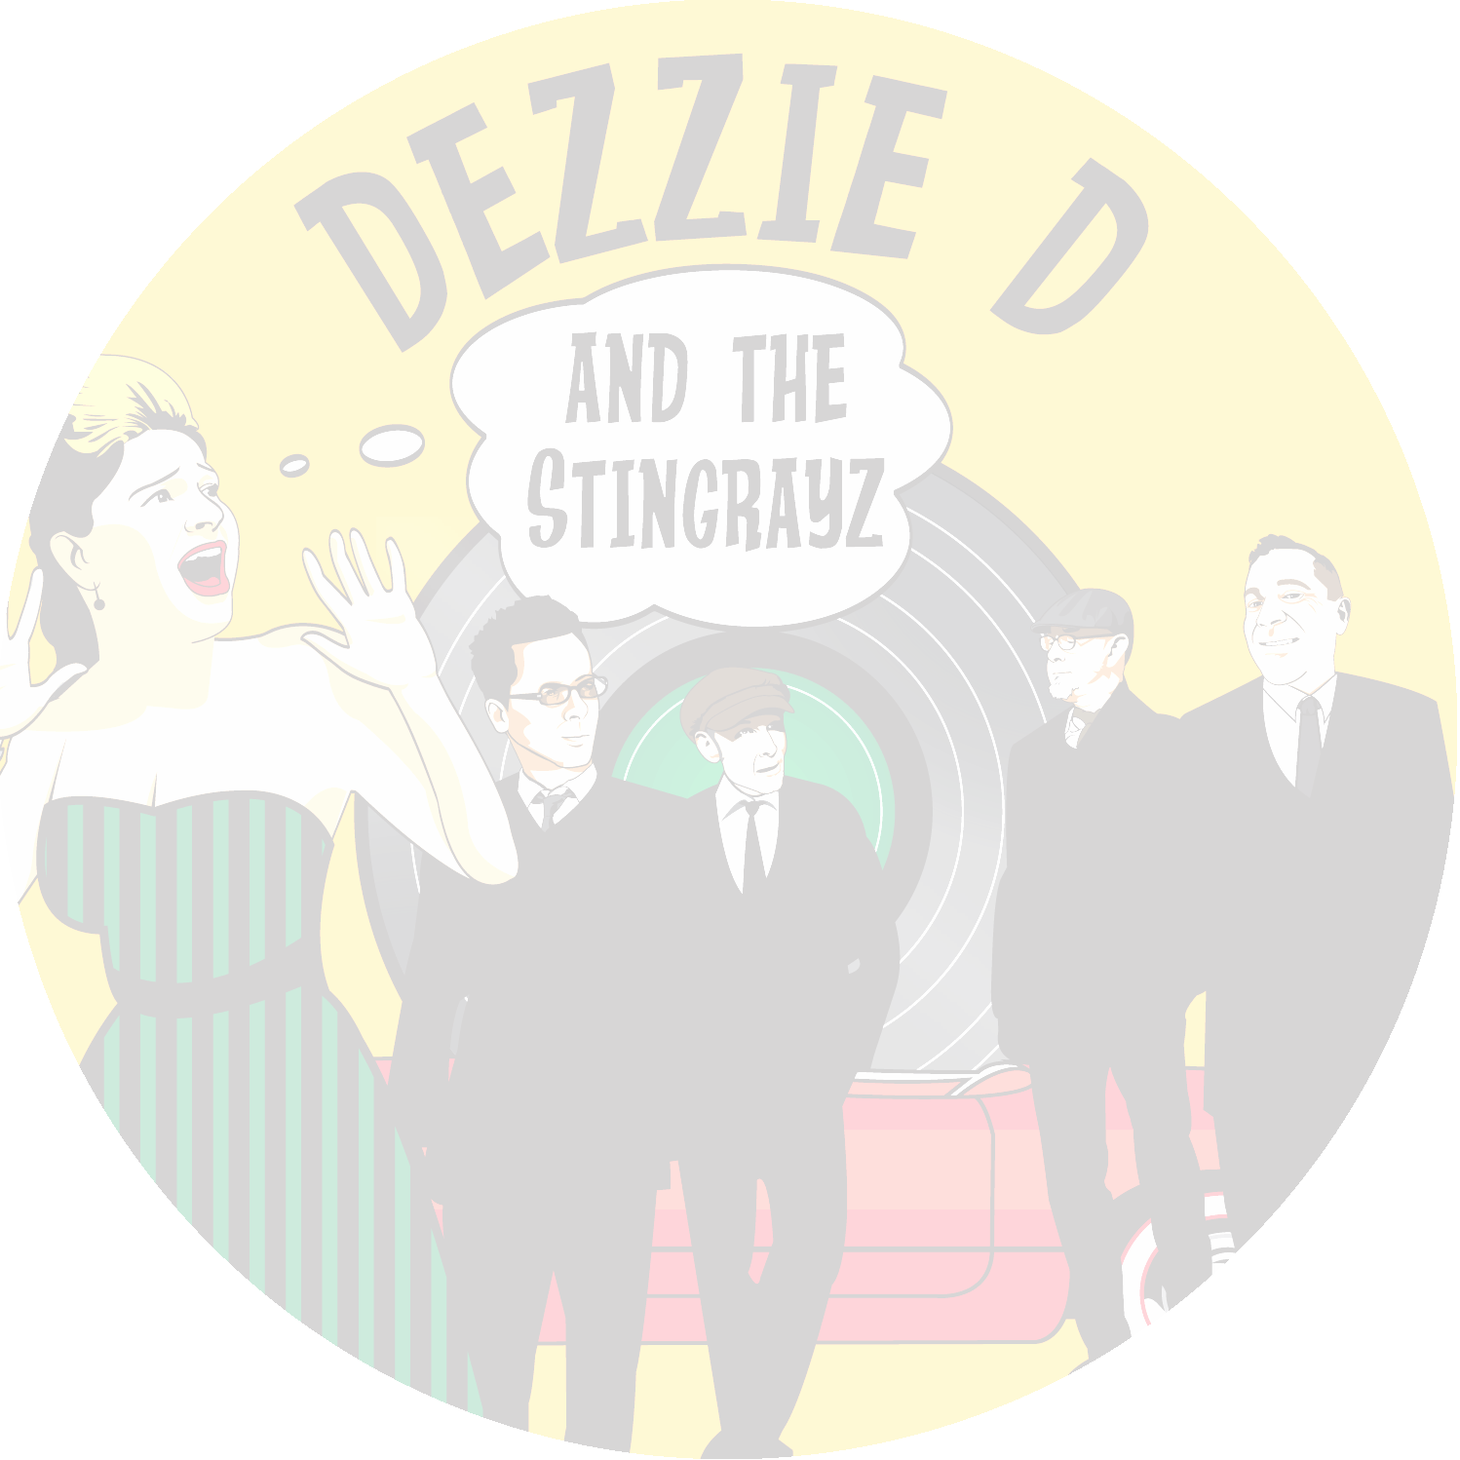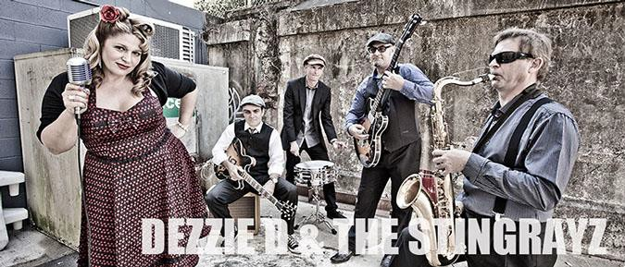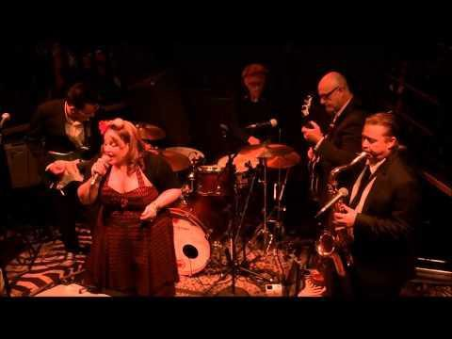
ARTIST ELECTRONIC PRESS KIT [EPK]
1
ARTIST PERFORMER DETAILS | DEZZIE D and the STINGRAYZ
Management Contacts:

- Stephen Done: +61 424 180 783
- Desley Done: +61 412 310 893
- Email: sjdone@optusnet.com.au
- Location: Brisbane, Queensland Aust
Band Name:
- Dezzie D and the STINGRAYZ
Band Description, Genre: Performers:

- Rhythm & Blues, 40s and 50s
  - Desley Done - Lead Vocal
  - Chris Harvey - Lead Guitar
  - Grant Watson - Bass Guitar
  - Shaun Ballagh - Saxophone
  - Greg Baikaloff – Percussion
Band Bio: Short bio appropriate for festival publishing and website (Max 200 words)

Quick Link Video - LIVE

Welcome to the STINGRAYZ with (Front Woman)
Dezzie D on lead vocal. This 5 piece Rhythm & Blues outfit has taken to the stage and creates a unique sound that transports you back to the 40s and 50s, "the era of Rhythm and Blues". Their renditions of unforgettable musical arrangements captures the audiences’ imagination which takes you on a journey of pure bliss and that uncontrollable urge to hit the dance floor. "A performance showcase not to be missed"

Hailing from Brisbane Queensland, Dezzie D and the STINGRAYZ onstage presence, high energy performances and Sax Driven brass section leaves you in no doubt, this band is going to "Swing you off your feet". Regarded as one of the hottest LIVE Rhythm & Blues performances in town and with appearances at Blues on Broadbeach, Mitchell Creek Blues n Rock Festival, Australia Day Celebrations South Bank Piazza and the Bayside Blues Festival they are definitely the "must see band" for live
Rhythm & Blues.

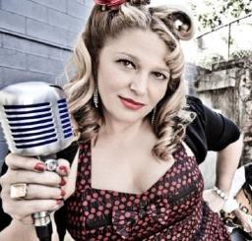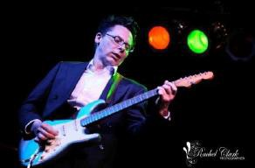
The Band
2
Desley Done Lead Vocal

Desley Done is definitely a rising star in the East Coast blues scene. She has been around for several years performing in professional bands such as Blonde on Blue and Little Kitty Big Meow. She has performed at Sunshine Coast Blues Festival, Broadbeach Blues Festival, Mitchell Creek Blues Festival, Redlands Bayside Blues Festival, Australia Day Celebrations and is gradually becoming known as “Queensland’s Queen of Blues”.

Dez has a big smile, a big personality, a big voice and has a great vibe on stage. Dez delivers her repertoire with sass and energy and really loves imparting her love for the music and sharing her passion with the audience. She draws her inspiration from such artists as Etta James, Koko Taylor, Ruth Brown, Ann Cole, Little Willie John and many other artists from the 40s and 50s genre.

Chris “Harvey” Lead Guitar

As a journeyman guitarist, Harvey drew influences from the likes of Jimmie Reed, Howling Wolf, John Lee Hooker, Muddy Waters and Lightning Hopkins and formed his first blues band at 19 in London.

He scored shows supporting Steve Marriott and toured Europe and the UK with Dino Baptiste but in 1998 Australia beckoned, and Harvey threw himself into its thriving blues scene. His impeccably tasteful and dynamic guitar-playing complemented acts like Big Kitty And The Scaredy Cats, Steppin' Out and Mama Voodoo and an album co-written with Cath Butler earned him two Chain Awards in 2010.

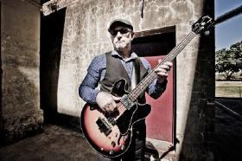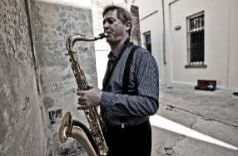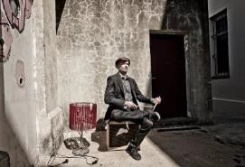
3
Grant Watson Bass Guitar

Grant has played most of the blues festivals on
Australia’s east coast including Broadbeach Blues Festival, Brisbane Blues Festival, Queensland Festival of the Blues, Sunshine Coast Blues Festival, Sydney Blues Festival, and the Australian Blues Music Festival.

Now part of a new engine room, Grant is totally enjoying the cool old school Rhythm & Blues grooves Dezzie D and the STINGRAYZ are famous for.

Shaun Ballagh Saxophone

Shaun began his journey in music in 1986-1993. He was a member of the Australian Army Band during these years and gained experience with a variety of instruments including Alto, Tenor & Baritone Sax and also clarinet, flute and voice. From 1993 to 1998 Shaun was a music teacher with some of his students performing professionally today.

From 2001-2004 Shaun studied a Bachelor of Music (Jazz) under the tuition of Tony Hobbs and studied his degree at the Queensland Conservatorium of Music. He has had experience working in shows, recording studios and Blues bands. Throughout his musical career he has been influenced by artists as contrasting as Charlie Parker, B.B King, Stevie Ray Vaughan and David Sanborn which has contributed to Shaun’s diversity as a musician.

Shaun is a generous performer with a massive, warm tenor sound who plays from his heart. His energy and enthusiasm for the music is evident in his performance and also contagious. This helps generate an atmosphere which audiences can’t help but get caught up in.

Greg has played behind Aussie blues luminaries, Dutch Tilders, Ray Beadle, Jeff Lang, Phil Manning, Kate Meehan, Phil Emmanuel, and Gail page. He has worked with local Brisbane blue legends, Mojo Webb, Lil Fi, Blind Dog Donnie, JB Lewis, Sweet Felecia, Doc Span, Buzz and the Blues Band.

Over the years, he has kept the drum throne warm in Brisbane working bands, Black Cat Bone, Helta Delta, Mike Frost and the Icemen, Shakey Shaun and the Intemperate Few, Mick Diggles' Blues Doctors, Morningside Fats, and the Andrew Baxter Band.
Greg also spent a year or two playing the Rockabilly scene with Dangerous Dan and the Starlite Ramblers, and West Texas Crude.

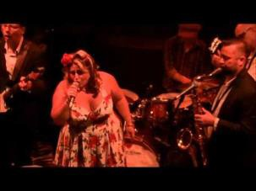
4
Images for use in related advertising:

Venue Poster Download Link:
http://www.dezziedandthestingrayz.com/2.jpg http://www.dezziedandthestingrayz.com/promo_image.jpg http://www.dezziedandthestingrayz.com/dezziedandthestingrayz 22_.jpg

http://www.dezziedandthestingrayz.com/stingrayz_promo_Poster.pdf

Website: Facebook: YouTube 1:
YouTube 2:
YouTube 3:
YouTube 4:
YouTube 5:

http://www.dezziedandthestingrayz.com/index.html https://www.facebook.com/DezzieDAndTheStingrayz https://www.youtube.com/watch?v=oG-3O7m9ryU https://www.youtube.com/watch?v=cMB1_2cpjDI http://www.youtube.com/watch?v=Tyn12K_TxTk http://www.youtube.com/watch?v=ui00ffdYMps http://www.youtube.com/watch?v=IW3I5U_kiDU

Stage Plot:

Performers Public Liability: Duck for Cover $20,000,000

ABN:

http://www.dezziedandthestingrayz.com/Stage_Plot_Dezzie_D_and_the_St ingrayz.pdf
Download to view certificate of currency http://www.dezziedandthestingrayz.com/Public_Liability_2015_Dezzie_D_a nd_the_Stingrayz.pdf

2586 1541 064 > Stephen Joseph Done on behalf of Dezzie D and the STINGRAYZ

OFFICIAL IMAGES AND WEBSITE MEDIA INFORMATION

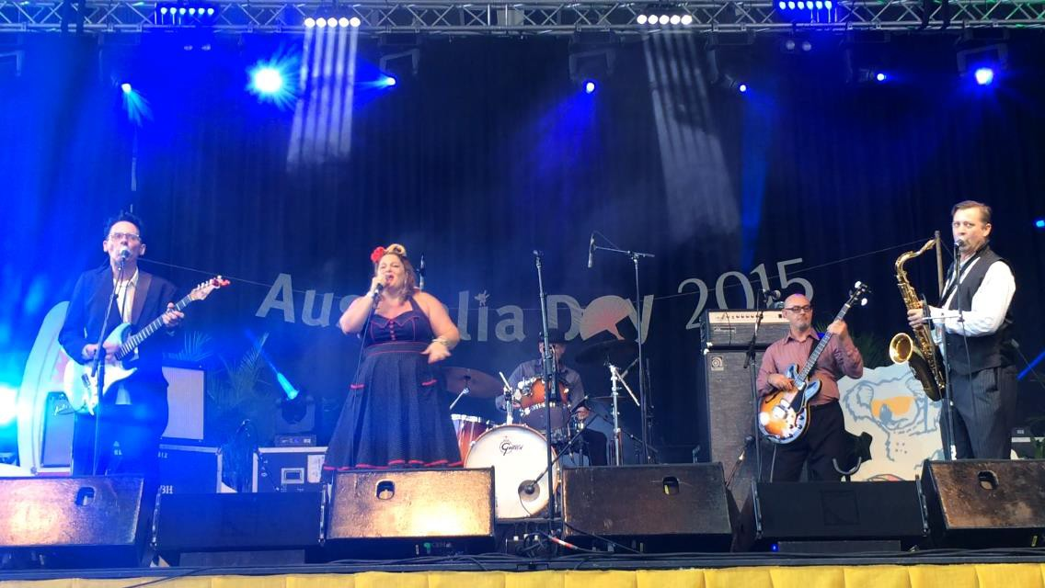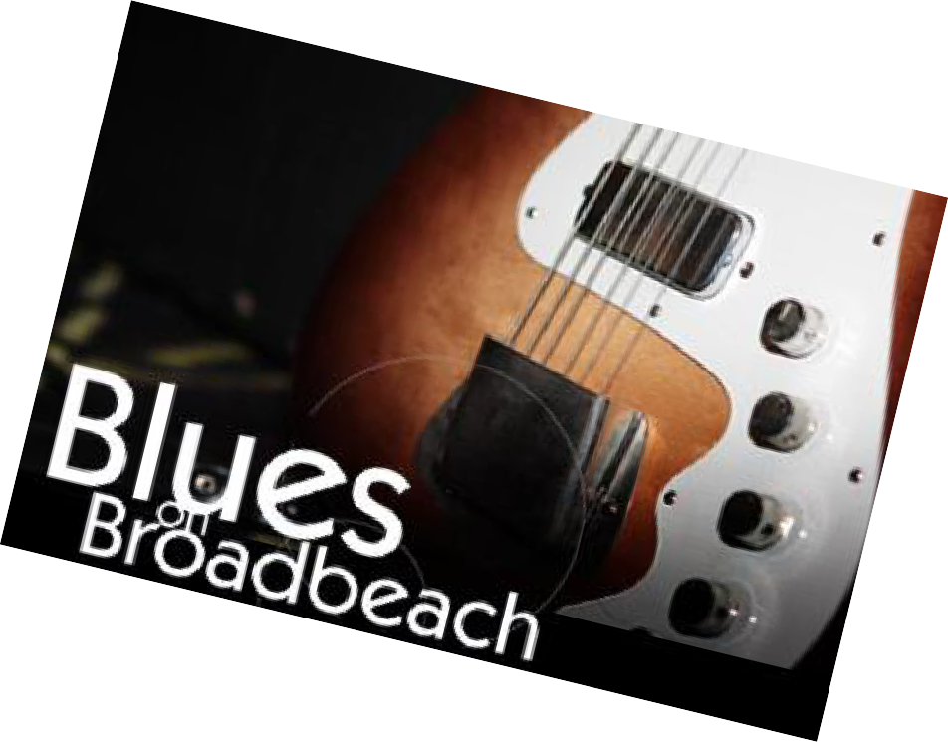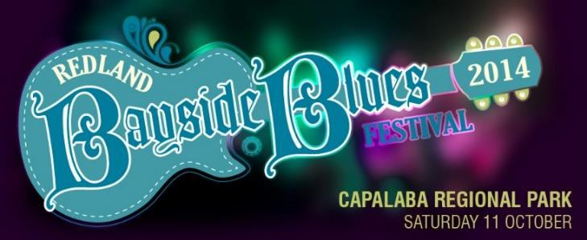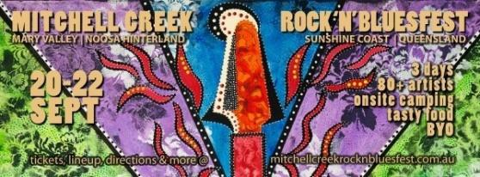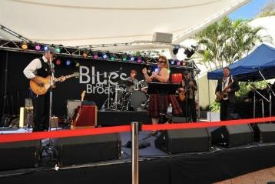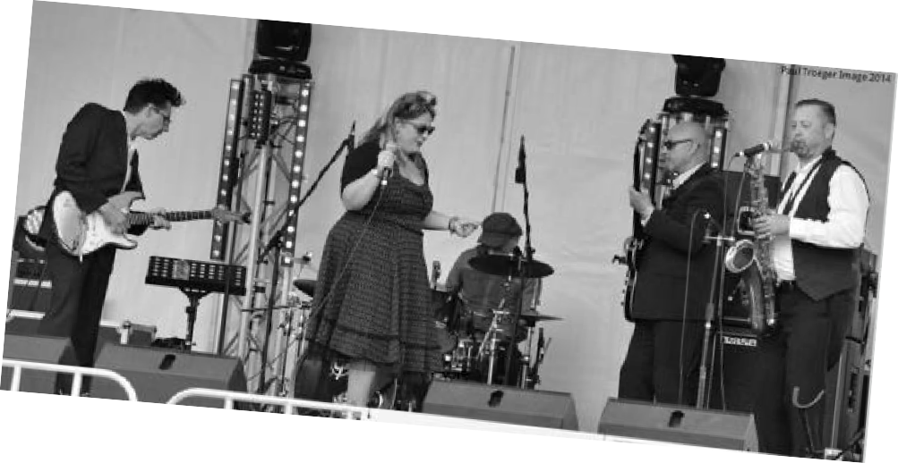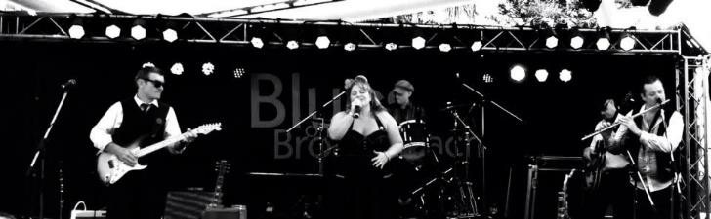
EVENTS /
FESTIVALS / FUNCTIONS / VENUES
5

