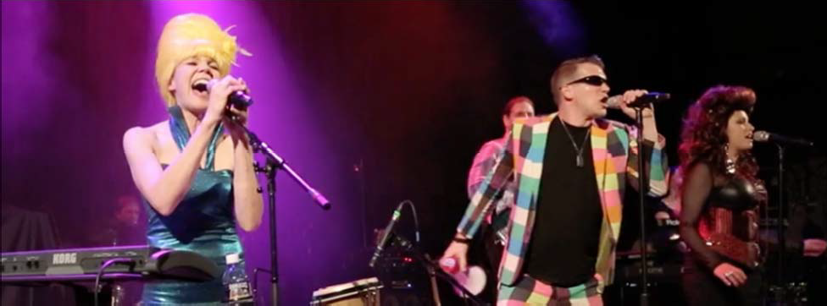

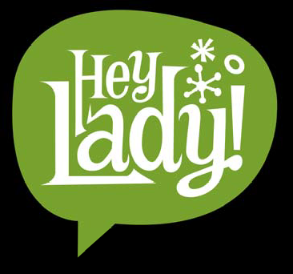

Electronic Press Kit

The world’s 2nd greatest party band!
A Tribute to The B‐52s
Booking Info:
Deb Britton, info@heyladyband.com

www.heyladyband.com

“Hey, Lady!”, winners of the 2018 and 2012 Leftapalooza Mile High Tribute Band Competitions, was founded in 2009 by sister/brother duo Deb Britton and Steven Blasinsky with the mission to spread the love, the fun and the wacky party spirit of the B-52s across Colorado and beyond!
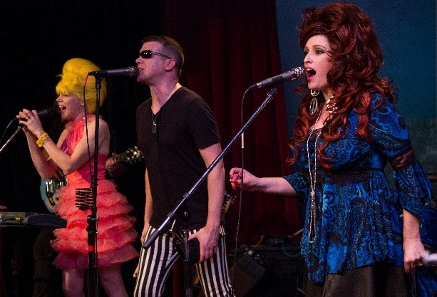

This is not your average background-music cover band. “Hey, Lady!” is an EVENT BAND; captivating
and entertaining audiences of all ages with their passion and energy. Their concert-style shows provide special effects, outrageous wigs and costumes, spunk and contagious B-52s’ dance grooves that will take your special event to the ultimate level of celebration.
From outdoor festivals and fundraisers to club dates and corporate events, “Hey, Lady!” has been raising audience eyebrows and heart-rates. They have even caught the attention of the B-52s own Fred Schneider!
-From Fred Schneider III’s Twitter account: “Hey, check out 'Hey, Lady!' on YouTube. A B's cover band. They're fantastic! Steve has me totally right! Love them & they're great people!”
For additional information and the latest “Hey, Lady!” news, log on to www.heyladyband.com
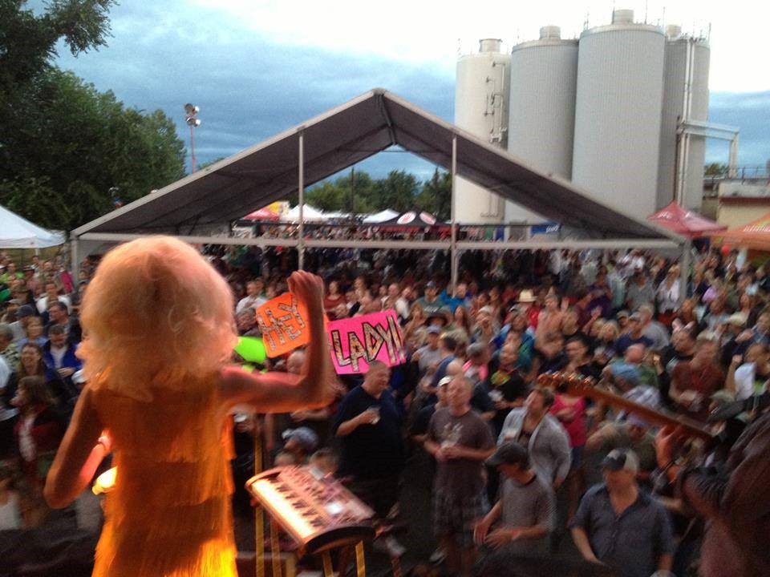

Steven Blasinsky - Vocals, Glockenspiel, Toy Piano,
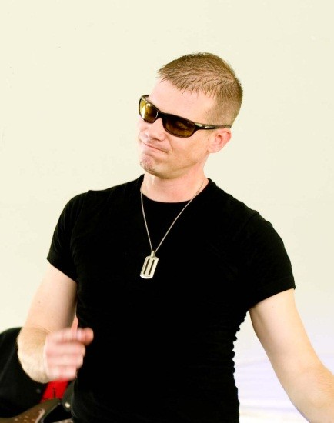

Cowbell
"Hi, I'm Steven and I'm a Leo. I like Dark Shadows and monkeys dressed
like people."

No B-52s tribute band would be complete without someone who can replicate the unmistakable voice of Fred Schneider. Steven Blasinsky, our front man and “Fred” does just that! Many have tried and none have succeeded in karaoke style “Fred-offs” with Steven…

Deb Britton - Vocals, Percussion

"Hello, I'm Deb and I'm a Leo. I like Mexican food and videos of people walking into plate glass windows."
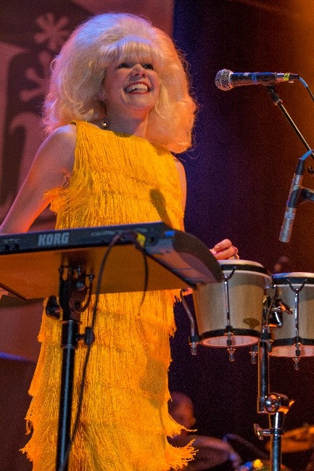

Hey, Lady! leader and “Cindy Wilson”, Deb Britton, is a graduate of Berklee College of Music and has been playing music since she was 10 years old. Although she’s played everything from trumpet and oboe to keyboards and drums, she finds donning a wig and wailing “Tin roof rusted!” one of the most enjoyable music experiences possible.

Lisa Morgan - Vocals, Tambourine
"Hi, I’m Lisa and I’m a Scorpio. I love scary movies and sleeping with the
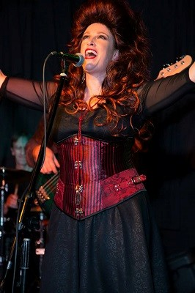

lights on."

Lisa began playing piano at age 5, and after realizing she was claustrophobic while holed up in a CU practice room, decided instead to sing - in wide open spaces. Since then she has performed with local acts such as The Linda Lewellyn Band, Saving Juliet, and The Legendary 4Nikators. Lisa discovered the B-52s in high school with the release of Cosmic Thing, and immediately fell in love with the powerful voice of Kate Pierson. She relishes the opportunity to bring her interpretation of that voice (and the dance moves!) to audiences everywhere.

John Britton – Guitar
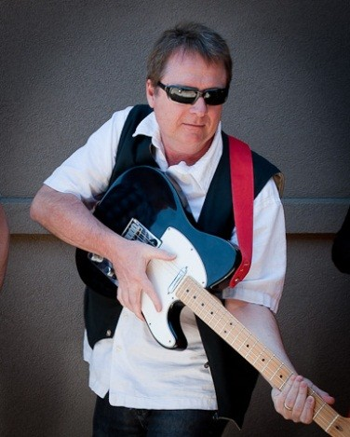

"Hello, I'm John and I'm a Libra from Fernandina Beach, F-L-A. I enjoy mixology and funky white-boy groove things."

Since age 14, John has been playing bass in bands ranging from country to punk jazz. In college, he composed and performed with the fusion band Seismo, who opened for Kool and the Gang. He played in similar bands in Hollywood, as well as with Hunter, a dance-rock band featured on the legendary radio station, KROQ. Moving to guitar for Hey, Lady! has been a welcomed challenge.

Jane Frederick – Keyboards
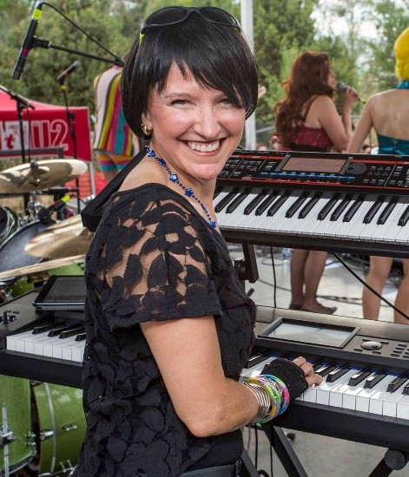

"Howdy! I’m Jane. I’m a dog-loving Sagittarius, and I like dark chocolate with sea salt."

Jane is a classically trained musician who best describes her music career as a professional hobby. Although she entered the band scene 20 years ago as a studio musician, she’s only played with a handful of bands since then. Jane also plays keys and sings female backup vocals in the Foreigner tribute band, Project Foreigner.

Brian Kauffman – Drums
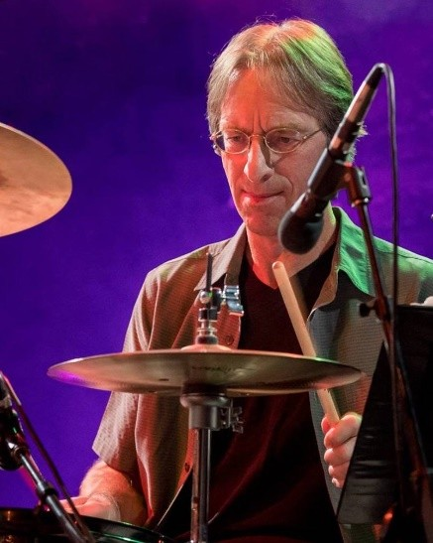

"Hi my name’s Brian and I'm from Wisconsin. I like poblano peppers and
Buffy the Vampire Slayer."

Brian began drumming at age five, got his first kit in middle school, played his first paying club gig at age 18 and has been playing non-stop ever since. Brian has made the rounds, playing in blues bands, power-trios, country, prog-rock, pop-rock, R&B, jam-bands, ambient/industrial, classical Hindustani (tabla) and indie/alternative bands.

Tim Powell – Bass
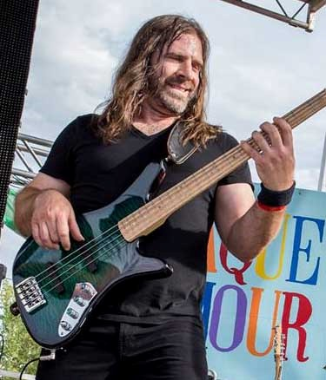

"Hey there, this is Tim. I'm a paintball shooting Sagittarius and I like things that are loud."

Tim has played electric bass and upright in many jazz and rock cover bands, and currently plays in arena rock cover band, Last Men on Earth. He also assisted in the jazz program at Stanford University.
Although Tim’s musical talents are many, some Hey, Lady! fans are more interested in how much Tim can bench press…

"HEY LADY[S AND GENTLEMEN], HEY LADY IS MY FAVE B-52S TRIBUTE BAND. STEVE DOES A GREAT JOB SINGING IN MY STYLE. SO REFRESHING TO HEAR A GOOD TRIBUTE RATHER THAN LISTEN TO SOMEONE WHO THINKS THEY SOUND LIKE ME, BUT REALLY JUST SOUND OBNOXIOUS WITH A SINUS PROBLEM! GO HEY, LADY!"
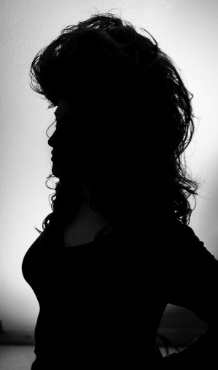

- Fred Schneider, The B-52s

“I...love...you...guys. AMAZING. I'm a groupy...please tell me about every show.”
- Random Hey, Lady! Fan

“Gave an energy packed performance with terrific sound. They were professional and a pleasure to work with, and they even specialized (the) lyrics to-
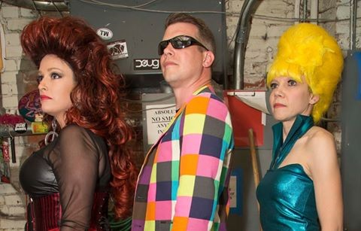

coincide with our event.”

-Bobby Roetzel, Regional Operators Association Chairman, McDonald’s

"The High Note Thursdays with live music
in Winter Park are traditionally well attended and well liked, but when Hey, Lady! stepped on the stage, the crowd had a little extra cheer that day. Hey, Lady! performed with great enthusiasm and energy for several hundred people in the Rocky Mountains and the dancing and singing in front of the stage reflected that. Hey Lady! stays highly recommended!"

-Tamara Davis, Special Events Director Winter Park & Fraser Chamber, Winter Park, CO
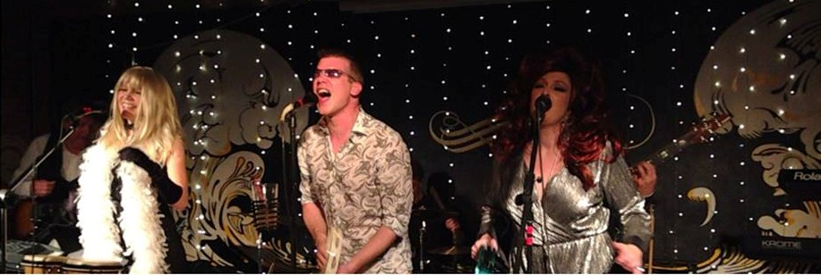

e-mail: info@heyladyband.com www.heyladyband.com

Hey, Lady! plays a mix of B-52s radio hits, cult classics, and songs from the 2008 release,
Funplex. Below is a sampling of what you might hear at a Hey, Lady! performance:

52 Girls
6060-842
Big Bird Bushfire Butterbean Channel Z Cosmic Thing
Dance This Mess Around Dancing Now Deadbeat Club
Debbie Deviant Ingredient
Devil in My Car Funplex
Give Me Back My Man Good Stuff
Hot Corner
Hot Pants Explosion Juliet of the Spirits
June Bug
Keep This Party Going Love in The Year 3000 Love Shack
Lava Mesopotamia
Party out of Bounds Planet Claire Private Idaho
Pump Quiche Lorraine Revolution Earth
Roam Rock Lobster
Song for a Future Generation Strobe Light
There’s a Moon in the Sky Whammy Kiss
Wig

e-mail: info@heyladyband.com www.heyladyband.com

