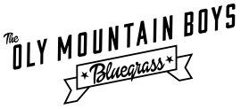

BAND BIO
The Oly Mountain Boys play bluegrass with high- energy drive and a Pacific Northwest bent, mixing traditional tunes with revolutionary original bluegrass compositions. By combining picking prowess with tight three- part vocal harmonies, the band aims to showcase the power and appeal of a truly American musical form.

ELECTRONIC PRESS KIT

Photo credit: Jim Oas
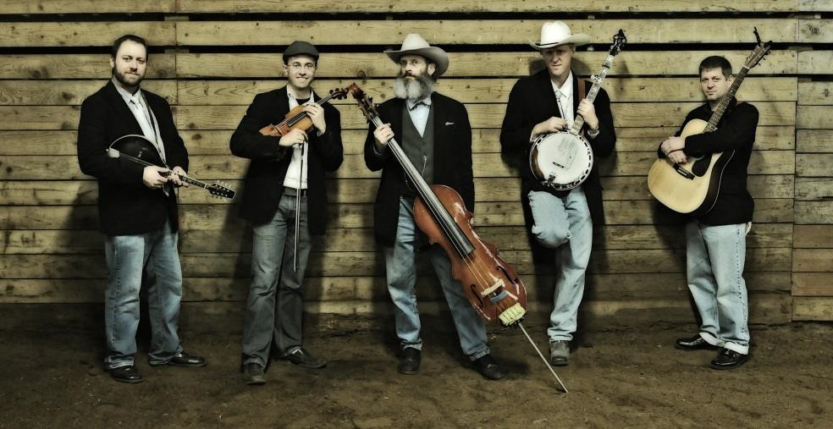

With their latest album "White Horse" the Oly Mountain Boys have set out to do something unprecedented: a concept album that tells a life story from beginning to end through original bluegrass. The album honors tradition by centering its story in Washington's frontier past, while looking to the future of bluegrass music with fresh, original songwriting.

VIDEO

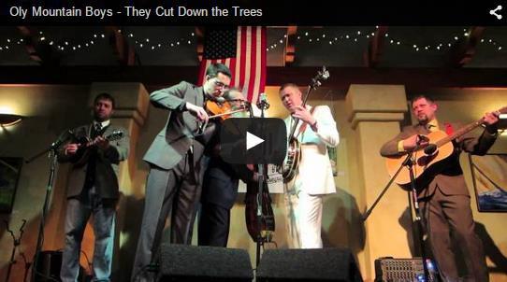


PHOTOS
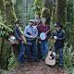
Photo credit: RC Ridge

Voted "Best Bluegrass Band" in Weekly Volcano's Best of Olympia 2015

Bluegrass concept album White Horse voted among the Top Ten Northwest Albums of 2014

PRESS QUOTES
ELECTRONIC PRESS KIT

"Banjo. Fiddle. Mandolin. Guitar. Whether you are a seasoned bluegrass aficionado or totally new to the genre, you want to hear the music of the Oly Mountain Boys. Serious about music and fun, the Oly Mountain Boys are happy to provide you with an introduction to bluegrass, Pacific Northwest style. The five members of this high-octane group share a love for bluegrass music that is infectious, and their musical chops have helped them gain a strong following in Olympia and beyond." - ThurstonTalk

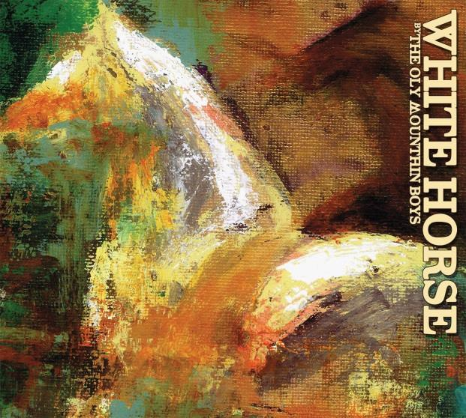

NOTABLE PAST PERFORMANCES
Bill Monroe 100th Birthday Celebration, Olympia WA
Washington 125 Celebration, Olympia WA

Festivals
Steamboat Stringband Jamboree, Olympia WA Oly Old Time Festival, Olympia WA
Olympia Acoustic Festival, Olympia WA Folklife, Seattle WA
Mount Saint Helens Festival, Toledo WA Bluegrass from the Forest, Shelton WA Wintergrass Showcase, Bellevue WA
River City Bluegrass Showcase, Portland OR High and Dry Bluegrass Festival, Bend OR Bainbridge Island Bluegrass, Bainbridge WA Proctor Arts Fest, Tacoma WA
Brewgrass, Anacortes WA
Taste of Edmonds, Edmonds WA
DB Cooper Music Festival, Olympia WA Brewfest, Joint Base Lewis-McChord WA

TECHNICAL RIDER

"If you like your bluegrass complex, melodic and focused on weighty matters such as the hard life of Washington state living in the early 20th century, have I found something you're going to love.
Olympia bluegrass outfit The Oly Mountain Boys has released their new, epic concept album, White Horse, for your consideration. … White Horse gallops to traditional bluegrass influenced by the music of Bill Monroe, Ralph Stanley and Earl Scruggs. The album, The Oly Mountain Boys' fourth, draws from the mildew and forlorn, straight from the Olympic National Forest. This is the best brand of bluegrass: energetic and thoroughly heartbroken." - Weekly Volcano

Venues
Rhythm and Rye, Olympia WA South Bay BBQ, Olympia WA
McMenamin's Olympic Club, Centralia WA Doyle's Public House, Tacoma WA
Spar Tavern, Tacoma WA Conor Byrne Pub, Seattle WA Nectar Lounge, Seattle WA Sirens, Port Townsend WA
Green Frog Acoustic Tavern, Bellingham WA Axe & Fiddle, Cottage Grove OR
Alberta Street Pub, Portland OR Everybody’s Brewing, White Salmon WA Double Mountain Brewing, Hood River OR
McMenamin's Grand Lodge, Forest Grove OR Caldera Tap House, Ashland OR
The Lucky Horseshoe, San Francisco CA Frog and Peach Pub, San Luis Obispo CA

