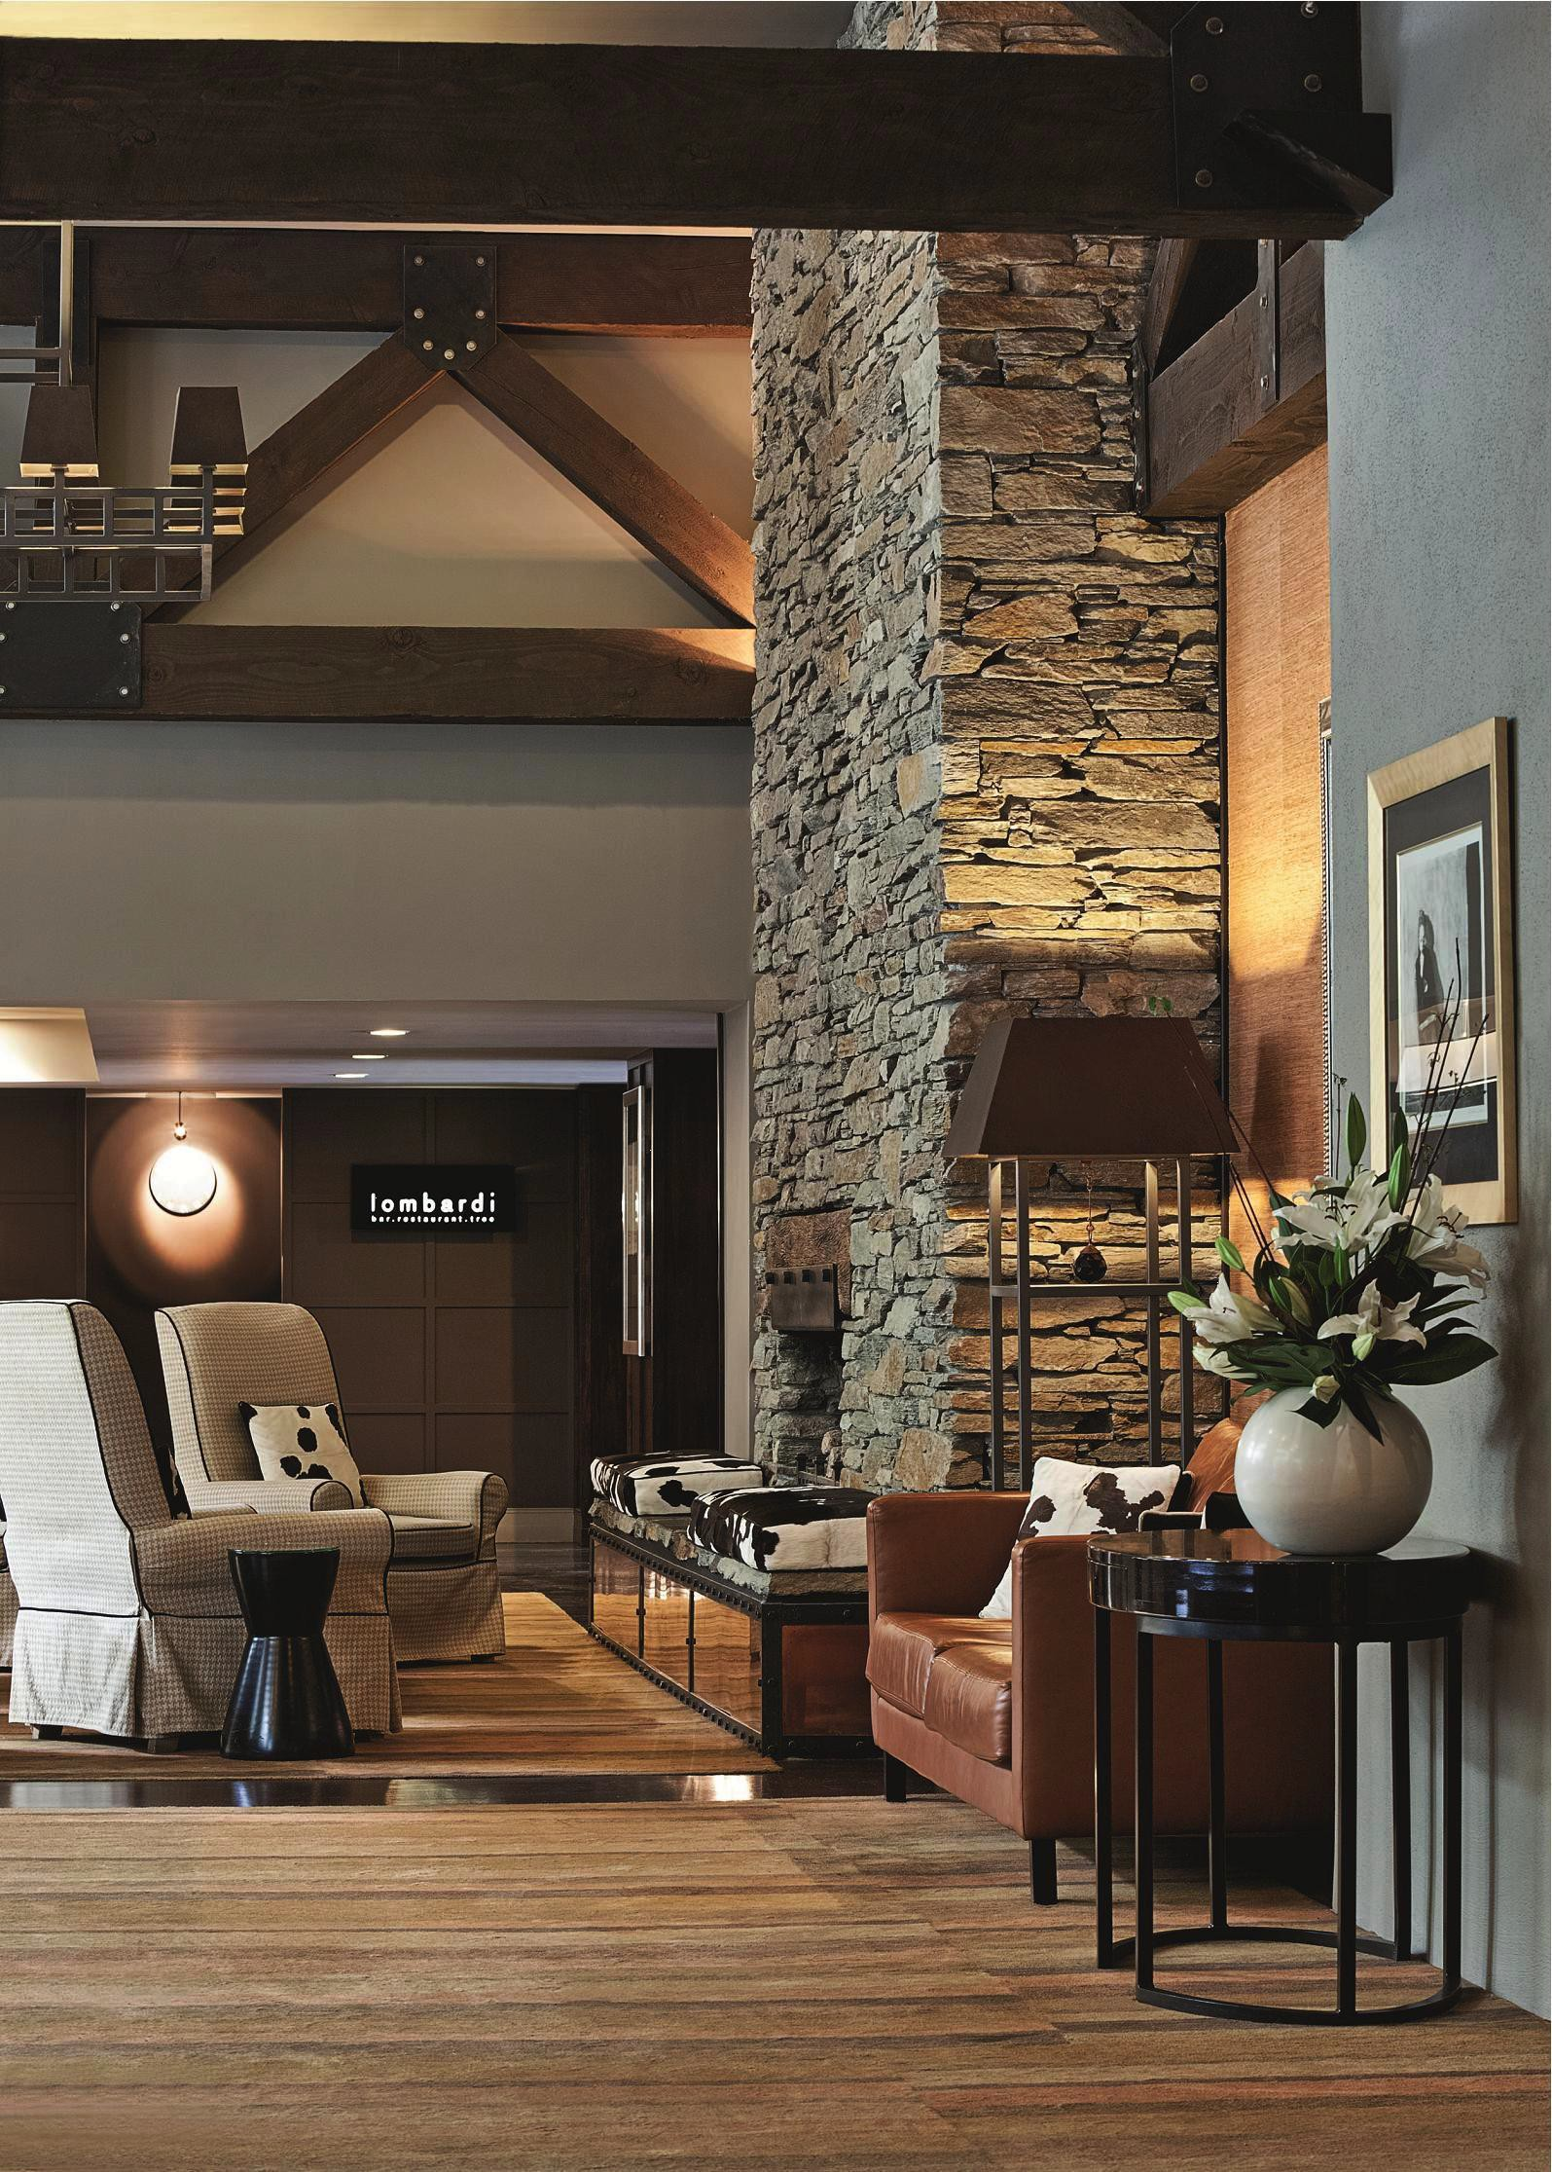
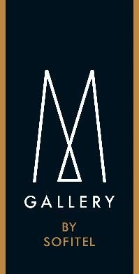

HOTEL ST MORITZ
Press Kit

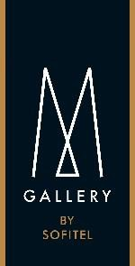

CONTENTS

AN ALPINE LEGEND WITH NATURAL BEAUTY

-------

A SERENE RESIDENCE IN THE HEART OF MAJESTIC QUEENSTOWN

------

A DINING EXPERIENCE TO SAVOUR

------

KEEPING QUEENSTOWN BEAUTIFUL

------ “MEMORABLE MOMENT”
------ PRACTICAL DETAILS
------

HOTEL ST MORITZ IN PICTURES

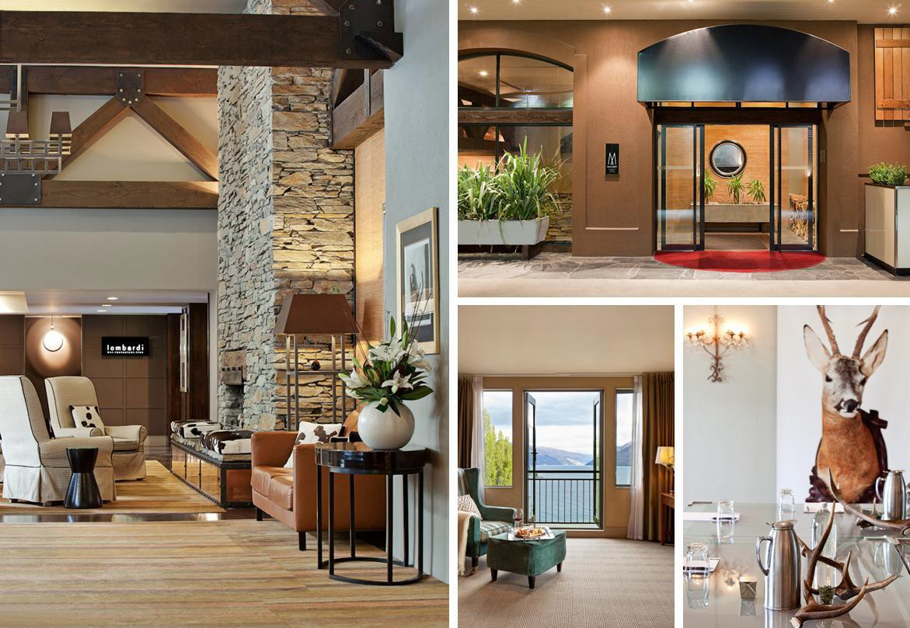
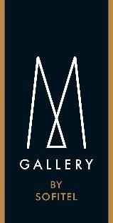

AN ALPINE LEGEND WITH NATURAL BEAUTY

TIMELESS, SOPHISTICATED, ENCHANTING

Idyllically located in the heart of delightful Queenstown, New Zealand’s premier four season lake and alpine resort, Hotel St Moritz embodies the spirit of its location. With breathtaking views overlooking Lake Wakatipu and The Remarkables mountain range, Hotel St Moritz has gained somewhat of an iconic status.

A founding member of Accor’s small yet distinctive MGallery collection; Hotel St Moritz embodies the essence of the collection, offering an original upscale hotel experience authentic to its location. In possession of an atypical character and personality, Hotel St Moritz appeals to those who require their hotel to be an integral part of their travel experience.
Combining a refreshing blend of stylish understatement overlaid with warmth and genuine hospitality – there is little pretence here, allowing guests to immerse fully into the natural alpine environment of the Queenstown region.

Sophisticated interiors are reminiscent of an upscale mountain lodge, and the classic lodge facilities include an outdoor hot tub garden, boutique gymnasium, and sauna. Hotel St Moritz offers a choice of rooms, suites, and apartments, each handsomely appointed to cleverly blend timeless classics with modern essentials.

The multi award-winning Hotel St Moritz was honoured to be inducted into Tourism New Zealand’s Hall of Fame in 2004 for winning ‘Premium Hotel’ in New Zealand for three consecutive years. After a mandatory stand down period, the hotel was the first to re-enter the awards to celebrate the hotel’s 10th birthday, refurbishment and entry into Accor’s exclusive MGallery collection – winning ‘Best Hotel and Resort’ and ‘Best Visitor Accommodation’ at the 2008 New Zealand Tourism Awards.

Queenstown is considered New Zealand’s capital of adventure – a destination for a voyage of discovery at the bottom of the world. The resort is a popular destination with skiers and snowboarders in the winter and cyclists, hikers and outdoor enthusiasts year round.

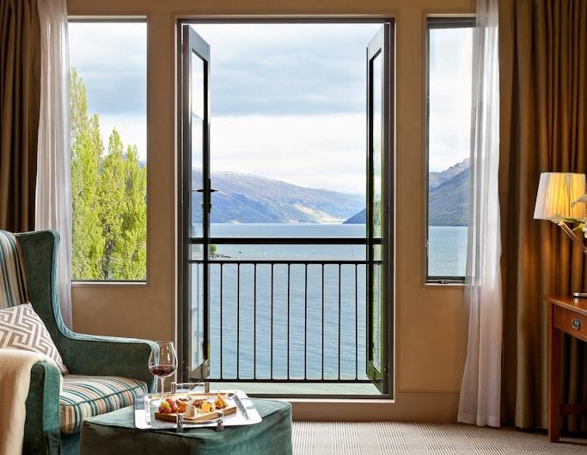
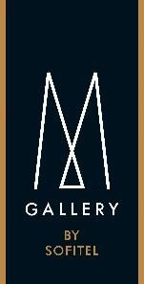

A SERENE RESIDENCE IN THE HEART OF MAJESTIC QUEENSTOWN

ROOMS AND SUITES

The interior design and decor of Hotel St Moritz’s 134 rooms, suites and apartments convey an understated elegance which is complemented by richly decorated and wooden furnishings. An eclectic mix of colour and texture create a sense of warmth set against the backdrop of dramatic lake views.

The spaciousness of the guest rooms are a defining element of the hotel, with the suites and apartments a true residence from which to explore the surrounding region.

All guest rooms at Hotel St Moritz feature king size beds, ensuite bathrooms, bespoke bathrobes, high speed internet access, a dedicated work area, spacious dining and living areas in suites, iPod docks, a mini-bar and luxury Aigner bathroom amenities.

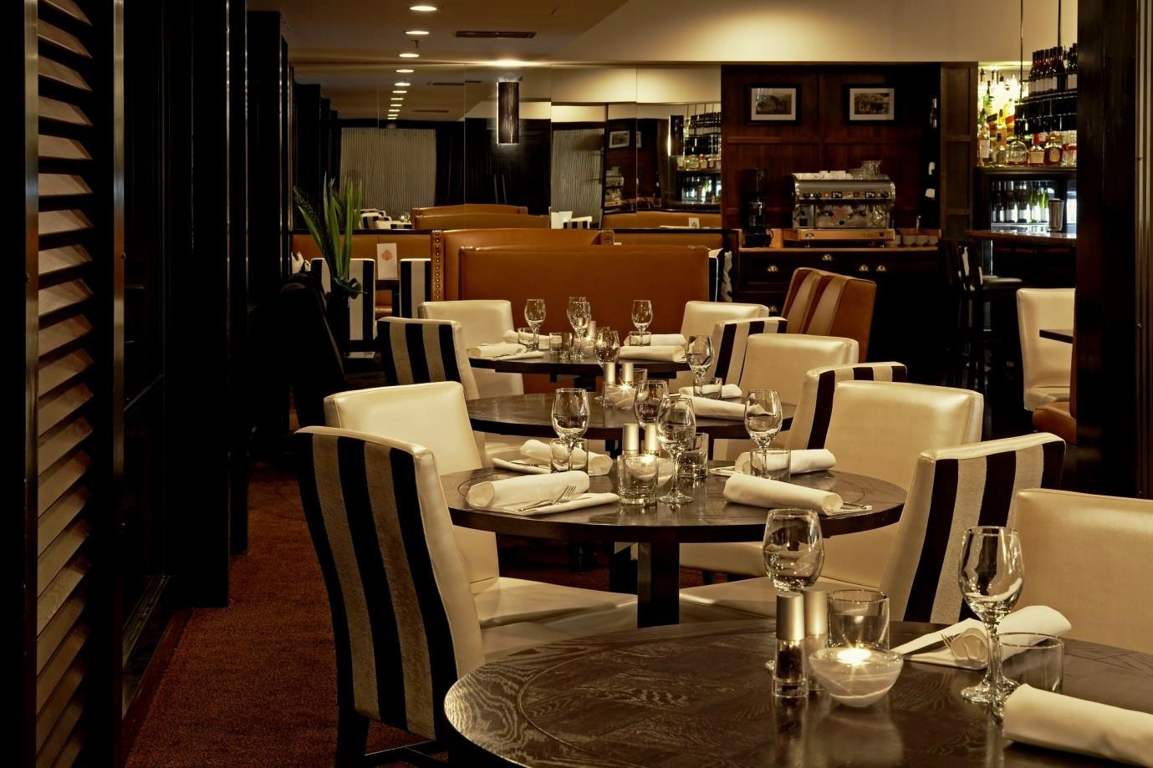
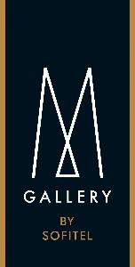

A DINING EXPERIENCE TO SAVOUR

A CULINARY ADVENTURE IN THE SOUTH

The award-winning Lombardi Restaurant boasts enthralling views of dramatic mountains, lake and the charming township of Queenstown. Attracting locals and in-house guests alike, the offering here is compelling. From the relaxed and convivial bar to the brassiere-style dining room, Hotel St Moritz offers a choice of dining style to suit mood and moment. The Library also serves as a private dining room for intimate occasions.

Lombardi Restaurant and Bar presents a carefully crafted wine list that focuses on the famous Pinot Noir variety renowned in the Central Otago region.

Hotel St Moritz has won numerous accolades for its fare including Best Restaurant in Queenstown, Chef of the Year – Monteiths’ Wild Food Challenge and most recently, Best Lamb Dish in Central Otago at the New Zealand Beef and Lamb Awards.

South

Catering to conference and incentive groups, Hotel St Moritz launched an informal Private Dinner menu named “South”. Served in The Den, the fare is entirely organic and matched with an organic wine selection. Perfect for up to 40 guests, dishes are served to the table in a succession of courses in classic St Moritz style to taste and share. Drawing on all the senses, this dining experience is made complete with its own soundtrack and scent (from fresh thyme).

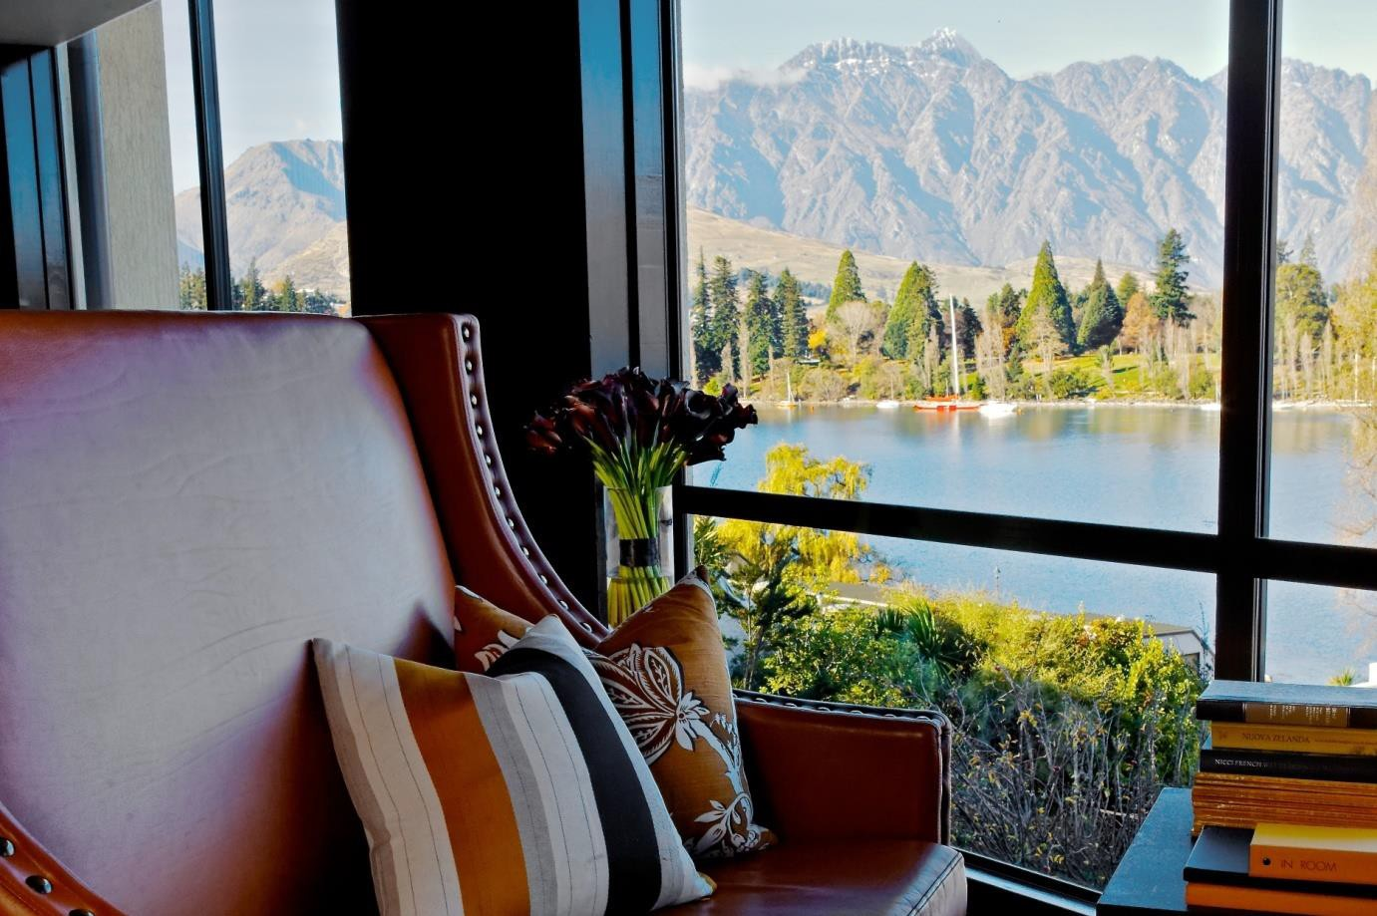
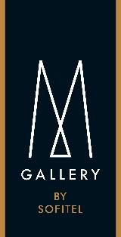

KEEPING QUEENSTOWN BEAUTIFUL

Hotel St Moritz has been awarded the highest accolade for responsible tourism in New Zealand, the Qualmark Enviro-Gold certification.
TAKING CARE OF OUR ENVIRONMENT

St Moritz has implemented a raft of environmental initiatives, some of which are designed to encourage guests to become more involved in reducing their impact on the environment. For example, each room has recycling bags for paper and plastics, a guest recycling receptacle is situated in the car park, and guests can opt to reuse towels and sheets as part of “Trees for Survival”, an initiative by Accor that involves the local primary who will grow and nurture native seedlings for planting in key neighbourhood areas.

The hotel has also installed water restrictors in all showers, water efficient toilets, collects and recycles cooking oil, recycles ink cartridges and closely monitors energy usage. Lombardi Restaurant sources local produce where possible and even makes homemade house feta. The unique South dinner also features organic local fare.

With over 30 hotels across New Zealand, Accor’s in-room guest programme will provide a significant donation on top of what will be achieved for Cure Kids and other local charities. In addition, participants of the Accor Kiwi Trek to Cure Kids will launch the Trees for Survival programme within schools communities located throughout Christchurch, Wellington and Auckland.

Now, the Hotel St Moritz experience not only encompasses a dramatic mountain lake setting and a warm and distinctive style, but the assurance that your travels leave less of an imprint on the planet.

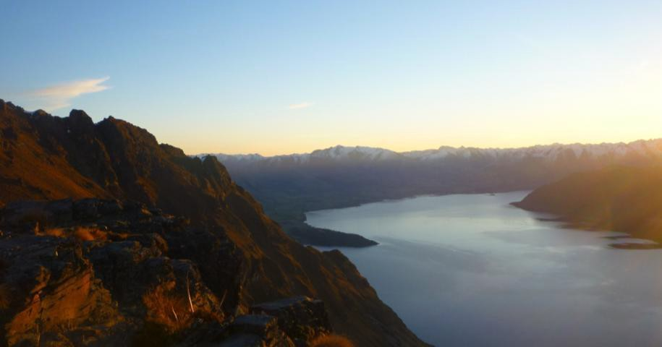
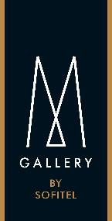

“MEMORABLE MOMENT”

AN EXCLUSIVE, UNFORGETTABLE EXPERIENCE

One of the unique features of MGallery hotels through the world is that guests are offered a “Memorable Moment” – an exclusive, unforgettable experience or activity unique to each establishment. With these original, innovative experiences and very special moments, each hotel in the collection proposes a special activity that leaves unforgettable memories in the minds of those lucky enough to experience them.

‘A sacred and sensory moment in the Southern Alps’

In Queenstown, nature enfolds the land with a gentle sense of inner peace. Here, everything seems quite, as if captured in the very serenity of paradise.

Hotel St Moritz’s Memorable Moment unsurprisingly, ties in with its idyllic location, among the natural beauty and landscape of New Zealand’s Southern Alps mountain range. Hotel St Moritz invites you on a magical excursion to the heart of a sacred natural world.

To experience this perfect communion with the beauty of the landscape, Hotel St Moritz invites you on a magical excursion to the heart of a sacred natural world. Dawn rises over Lake Wakatipu. At your leisure, you will fly by private charter helicopter to “The Ledge” on Cecil Peak for a magical half hour of tranquillity. There, overlooking The Southern Alps you will enjoy a delicious picnic prepared by Lombardi Restaurant.

An incredible sensory moment, where the imposing scale of nature is awe-inspiring…

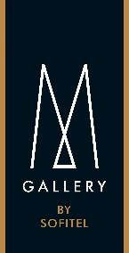

PRACTICAL DETAILS

Hotel Name Hotel St Moritz
General Manager Jo Finnigan
Category 5-star

Number of rooms 134 Rooms, Suites and Apartments
Restaurant Lombardi Restaurant, Bar and Library
Leisure facilities Gymnasium and sauna Hot tub garden
Library

24-hour reception, room service and concierge services

Conference facilities Private dining and gatherings for up to 90 people
Rates Guest rooms from NZD$229/night
One Bedroom Alpine Suites from NZD$263/night

Two Bedroom Apartment Lake View from NZD$510/night

Contact details Hotel St Moritz
10-18 Brunswick Street, Queenstown, 9300, NEW ZEALAND Tel +64 3 442 4900
Fax +64 3 442 4667

Bookings www.stmoritz.co.nz www.accorhotels.com

Access 5 minute walk from Queenstown CBD
10 minute drive from Queenstown International Airport


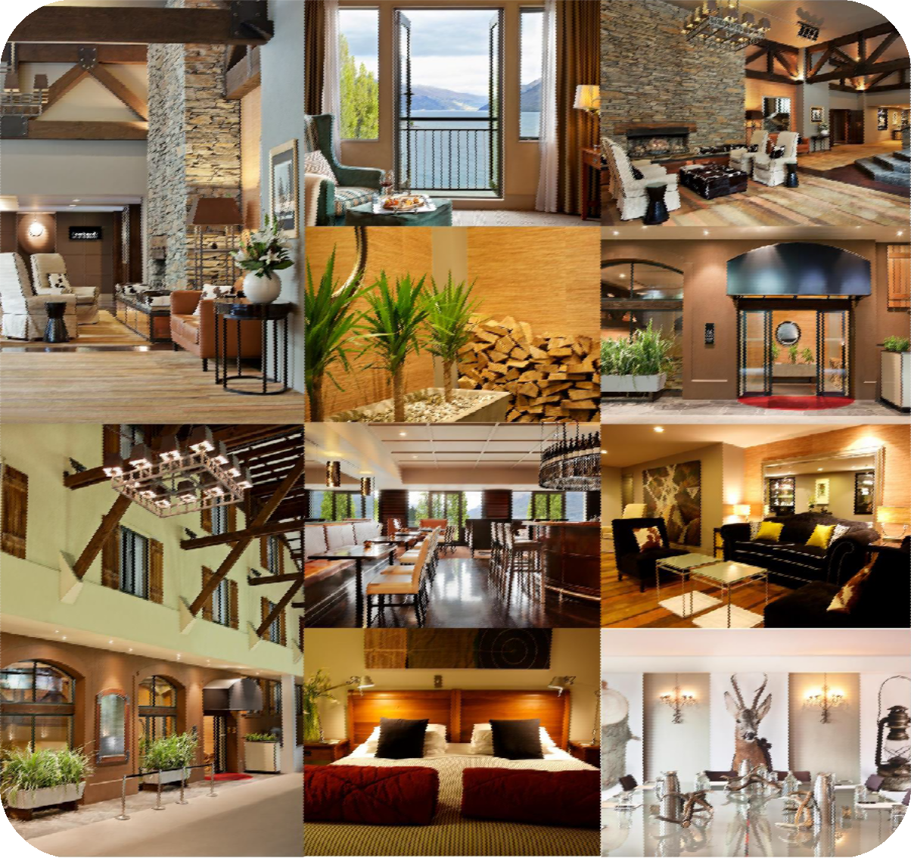

HOTEL ST MORITZ IN PICTURES

PRESS CONTACT Ginni Ryan – Communications & PR, Asia Pacific, Tel: +61 2 9280 9874, ginni.ryan@accor.com
mgallery.com

