PRODUCT SALES SHEET


BL0838
Pro-Tec

Features
- Carpet Protectant
- Forms an Invisible Protective Barrier Against Spots & Stains
- Concentrated Liquid
- Covers Up to 200 Sq. Ft./Gl
- Nonflammable

Floor Care


Description
This fluoropolymer protective barrier for textile fibers helps to retard soiling and improve stain resistance to keep carpets, mats and rugs looking cleaner longer. This highly concentrated product is an economical treatment that dries to an invisible transparent film which encapsulates each fiber. Treated areas stay cleaner longer and are free of streaks and spots. The innovative technology outperforms conventional protective products to help provide maximum longevity to valuable textile floor coverings. Water based, this product is virtually odorless and is completely nonflammable.

Label Datecode: 08/09
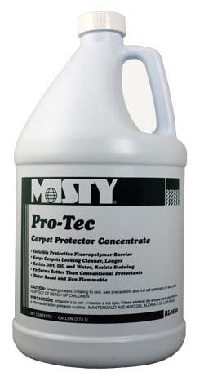

TECHNICAL INFO:
Physical Properties | Appearance | Cloudy Liquid
Physical Properties | Color | Straw
Physical Properties | Odor/Fragrance | Sweet
Physical Properties | pH | 7.0-8.0
Physical Properties | Freeze/Thaw Stability | Good
Environmental Profile | Glycol Ether Content | None
Environmental Profile | Biodegradability | No
Environmental Profile | Chlorinated Solvents | None
Environmental Profile | Enviro Standard | N/A
Environmental Profile | Recyclable Packaging | Yes
Regulatory Compliance | % VOC By Weight | 2.5
Regulatory Compliance | VOC Restricted Regions | None
Regulatory Compliance | Food Processing Suitability | N/A
Regulatory Compliance | EPA # | N/A
Regulatory Compliance | Flammability per CPSC | N/A
Regulatory Compliance | Flash Point | None to Boiling

Packages Available:



990 Industrial Park Drive • Marietta, GA 30062 800-241-7766 • 770-422-2071 • Fax: 770-422-1737


www.amrep.com

