Contents





New! Bestseller Sale
Action!
Not available



Code | Description | Price | Page
Women's Bags 2
WB001 | AMELIEGALANTI 2016 new casual women shoulder bags famous brand Colors:White,Beige[+5],Blue;Set:Shoes[+100] |  | 2
WB002 | SheIn Bags Handbags Women Famous Brands Ladies Fashion |  | 2
WB003 | 2016 New fashion shoulder bags handbags women famous brand |  | 2
WB004 | Fashion Small Bag Women Messenger Bags Soft PU Leather Handbags |  | 2
WB005 | Famous Brand Luxury Women Leather Handbags Women's Trunk | $ 55,66 | 3
WB006 | Realer brand women bag hollow out ombre handbag floral |  | 3
WB007 | New Arrival Women Fashion Faux Leather Satchel Bowknot | $ 12,00 | 3
WB008 | 2016 New Fashion Women PU Leather Handbag High Quality | $ 34,00 | 3
WB009 | Ladsoul 2016 women handbag pu leather women shoulder |  | 4
WB0010 | Famous Brand Ladies Hand Bags Women PU Leather Bag Brown |  | 4
WB0011 | 2016 New fashion women bag vintage handbags crossbody | $ 67,00 | 4
WB0012 | New Brand Bags For Women Leather Women Messenger | $ 54,00 | 4
WB0013 | INLEELA 2016 Fashion Scrub Women Bucket Bag Vintage | $ 32,00 | 5
WB0014 | Women Shoulder Bag Candy 10 Colors Fashion Brand | $ 44,00 | 5
WB0015 | Hot selling! Women Fashion Small Shell Leather Plaid | $ 56,00 | 5
WB0016 | Fashion 2016 Designers Women Messenger Bags Females | $ 78,00 | 5
Women's Bags - More 5
WB0017 | Mance Summer Canvas Women Beach Bag Fashion Color | $ 98,00 | 6
WB0018 | 2016 new woman handbag famous brands shoulder bag Ladies | $ 66,00 | 6
WB0019 | FLYING BIRDS! women leather handbag messenger bags shoulder | $ 54,00 | 6
WB0020 | Bolsa Bolsos Carteras Mujer Marca Women PU Leather Cat | $ 34,00 | 6
WB0021 | 2016 NEW Fashion Famous Brand PU Leather Woven Shoulder | $ 52,00 | 7
WB0023 | New Fashion Alligator Lady Embossing Messenger Crocodile | $ 23,00 | 7
WB0022 | All-Match Fashion Female Package 2015 Winter Elegant Women | $ 61,00 | 7
WB0024 | 2016 Women Messenger Bag Hollow Out bolsa feminina bolso | $ 56,00 | 7
WB0025 | 2016 New Luxury Women Leather Handbags Rivet Woman | $ 77,00 | 8
WB0026 | 2016 new Brand Monkey kiple Nylon Women's Messenger | $ 93,00 | 8
WB0027 | 2016 Vintage Women bag Lady PU Leather Cross Body | $ 49,00 | 8
WB0028 | ESUFEIR 2016 Fashion Panelled Leather Women Handbag Multicolor | $ 46,00 | 8
WB0029 | New arrival fashion women messenger bags shoulder bags | $ 29,00 | 9
WB0030 | 2016 New Women Tote Bag Luxury Brand Bags Handbags Woman | $ 73,00 | 9
WB0032 | Vogue Star Saffiano bag 2016 Fashion Design women leather | $ 55,00 | 9

DEMO-CATALOG Page 1/12

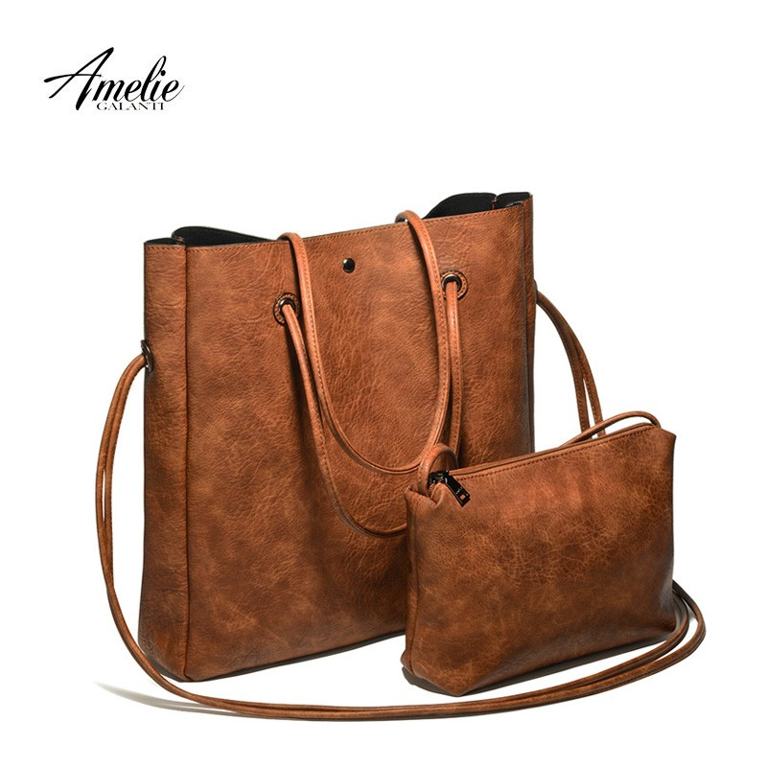

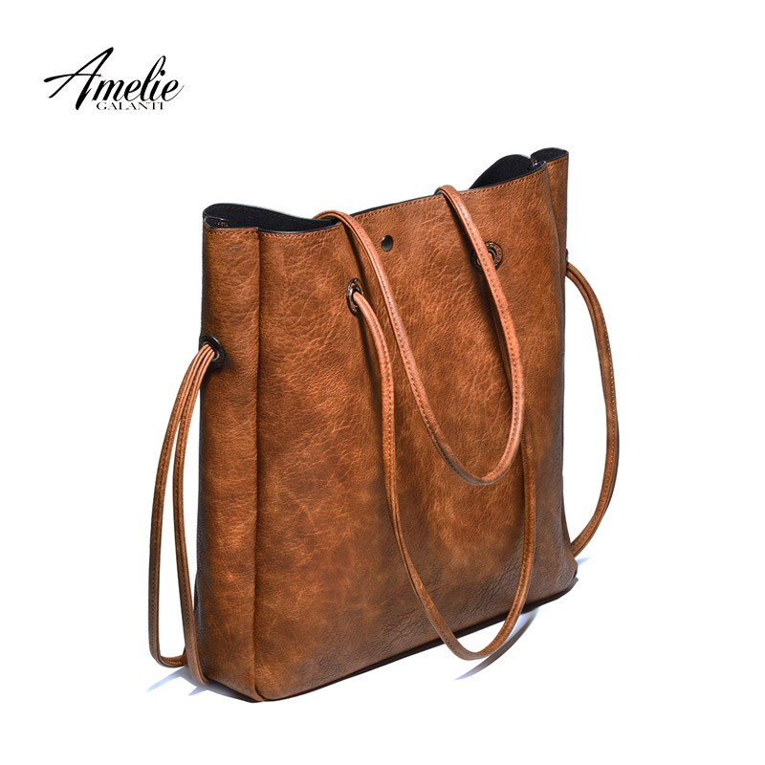

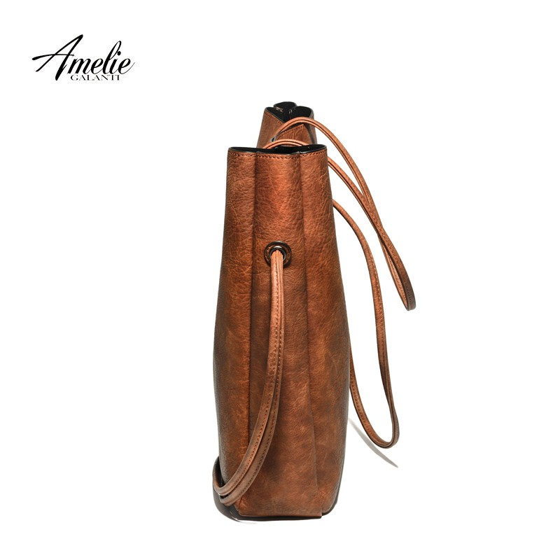

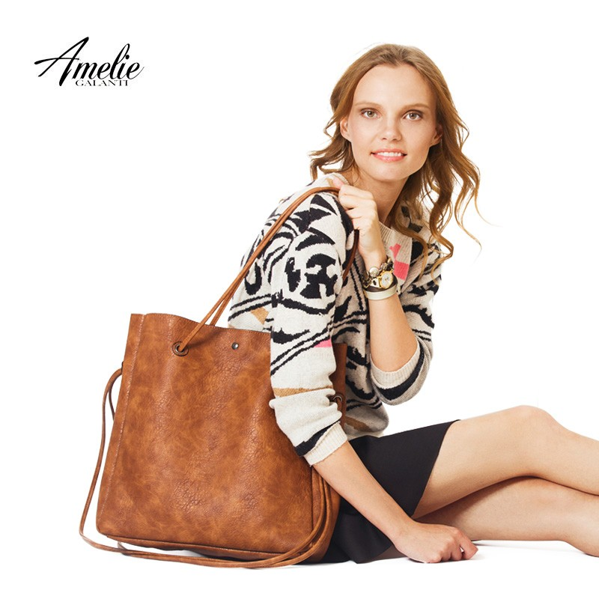

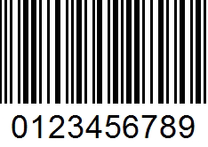
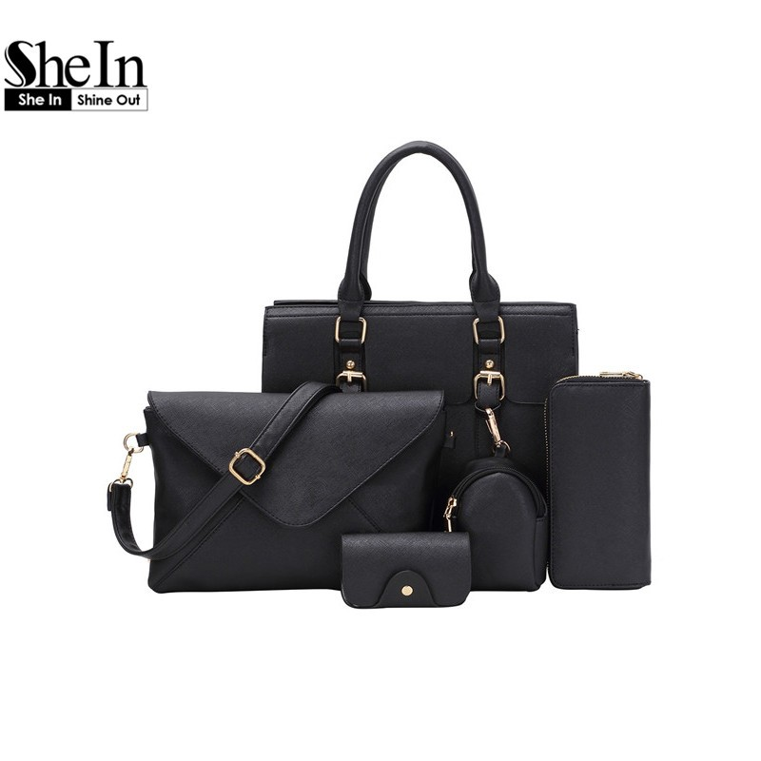
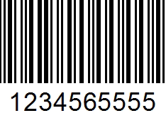
1
2
3
4
WB001 AMELIEGALANTI 2016 new casual women shoulder bags famous brand
Colors: White, Beige[+5], Blue
Set: Shoes[+100]
The quick brown fox jumps over the lazy dog.
Jackdaws love my big sphinx of quartz. The five boxing wizards jump quickly.
24,00
$12,00
WB002 SheIn Bags Handbags Women Famous Brands Ladies Fashion
24.00

$16,00

Column 2 | Column 3

Column 2 | Column 3

Column 2 | Column 3

Column 2 | Column 3

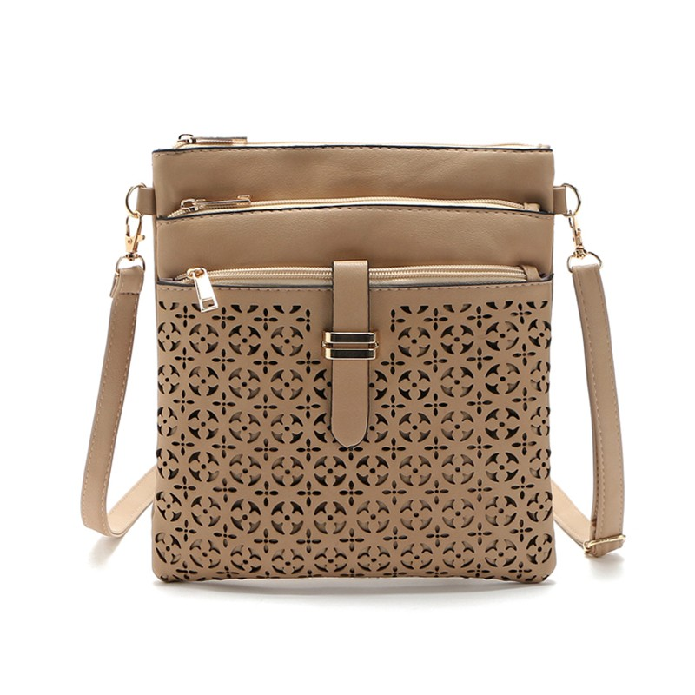
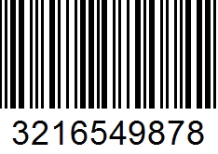
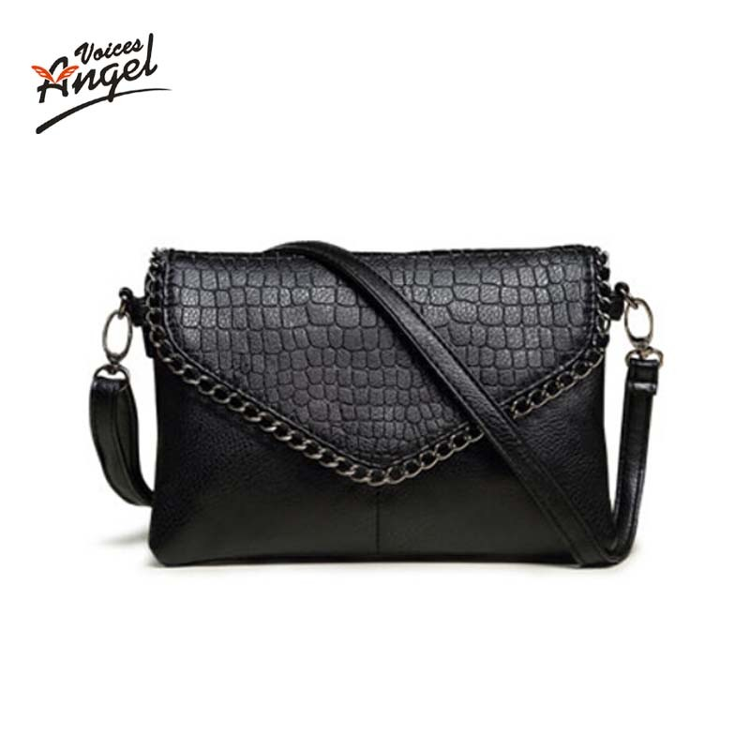
Page 2/12
WB003 2016 New fashion shoulder bags handbags women famous brand
22.50

$17,00
WB004 Fashion Small Bag Women Messenger Bags Soft PU Leather Handbags
30.00

$22,00

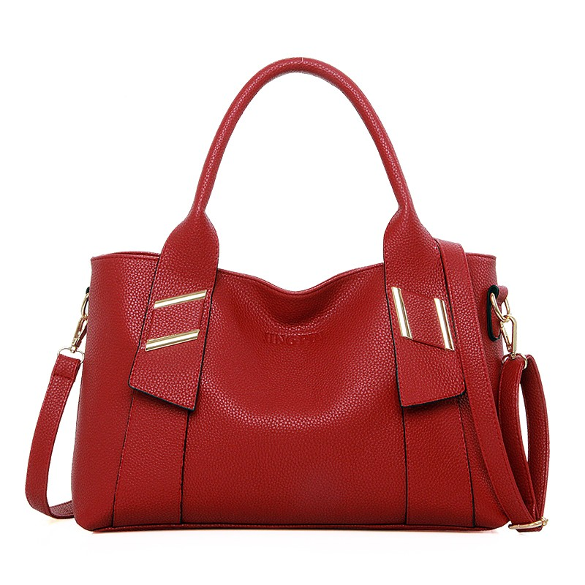
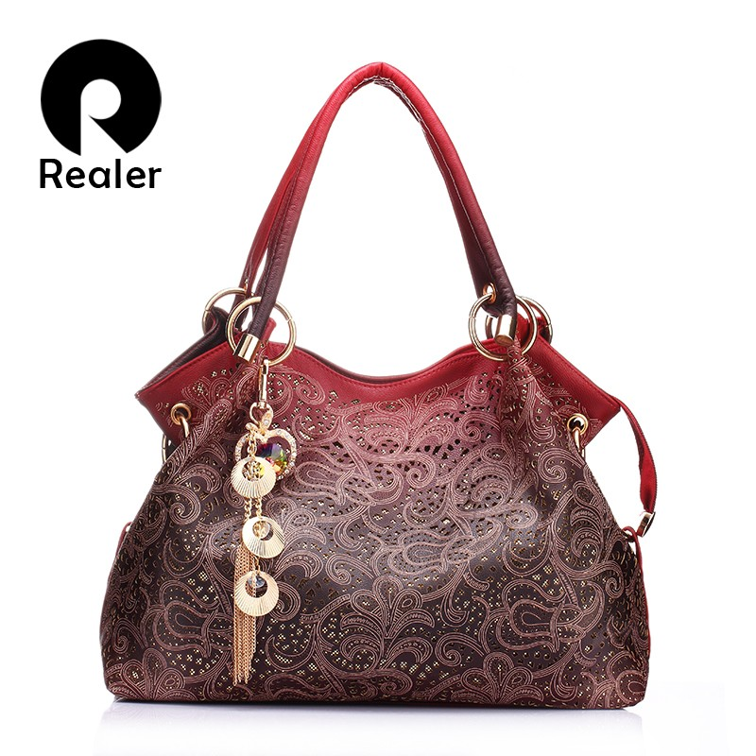
WB005 Famous Brand Luxury Women Leather Handbags Women's Trunk
$55,66
WB006 Realer brand women bag hollow out ombre handbag floral
25

$22,00

Column 2 | Column 3

Column 2 | Column 3

Column 2 | Column 3

Column 2 | Column 3

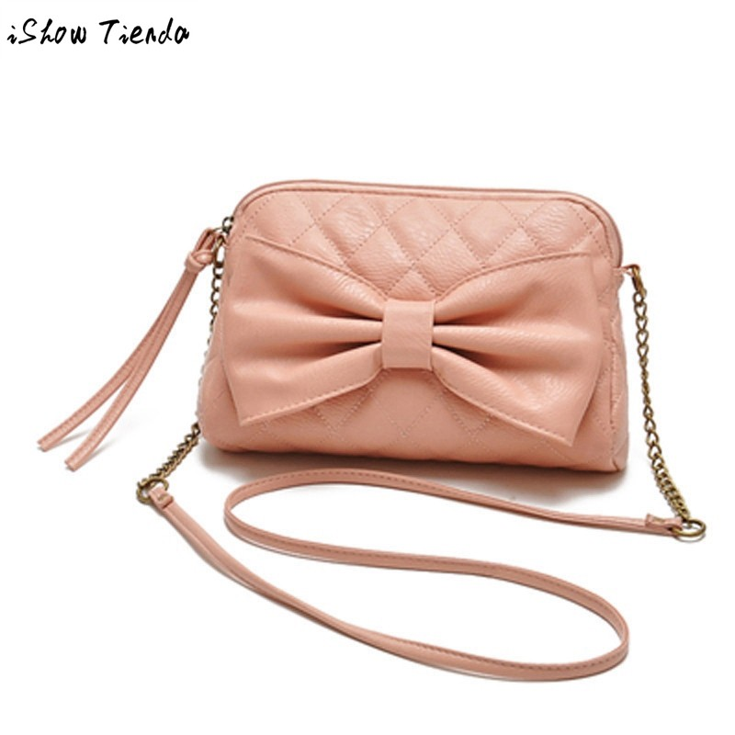
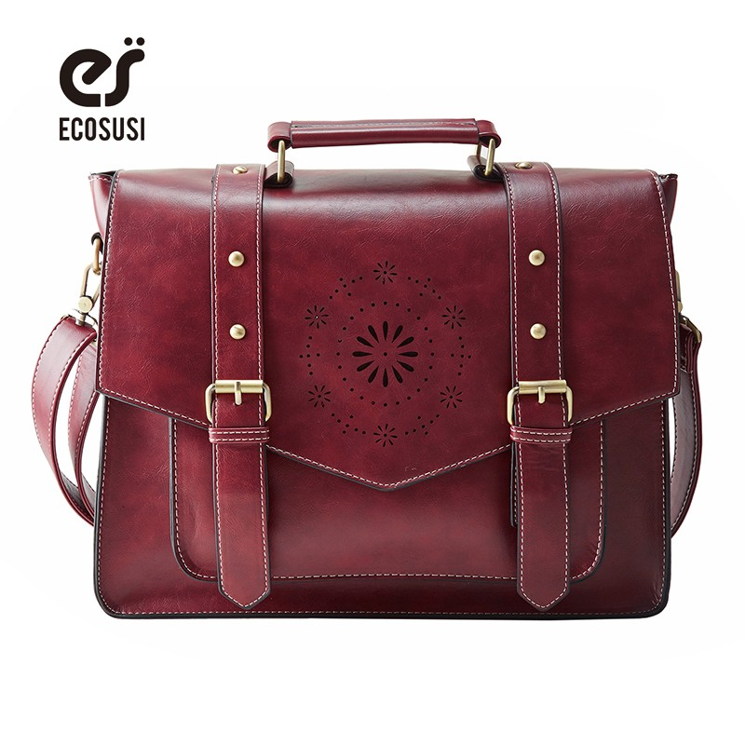
Page 3/12
WB007 New Arrival Women Fashion Faux Leather Satchel Bowknot
$12,00
WB008 2016 New Fashion Women PU Leather Handbag High Quality
$34,00

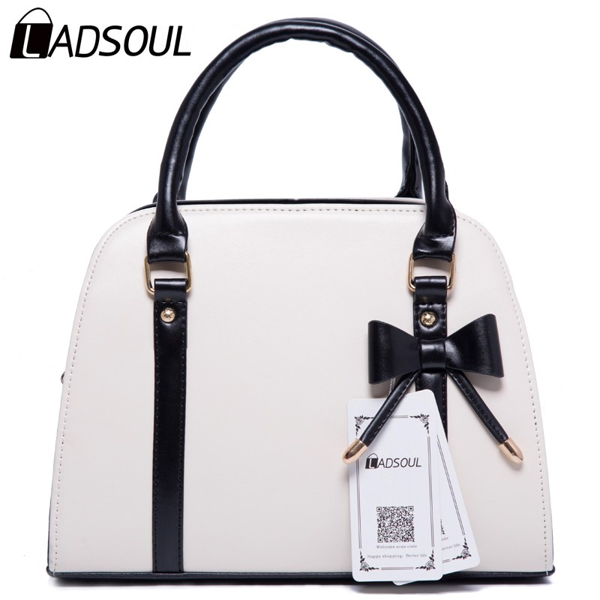
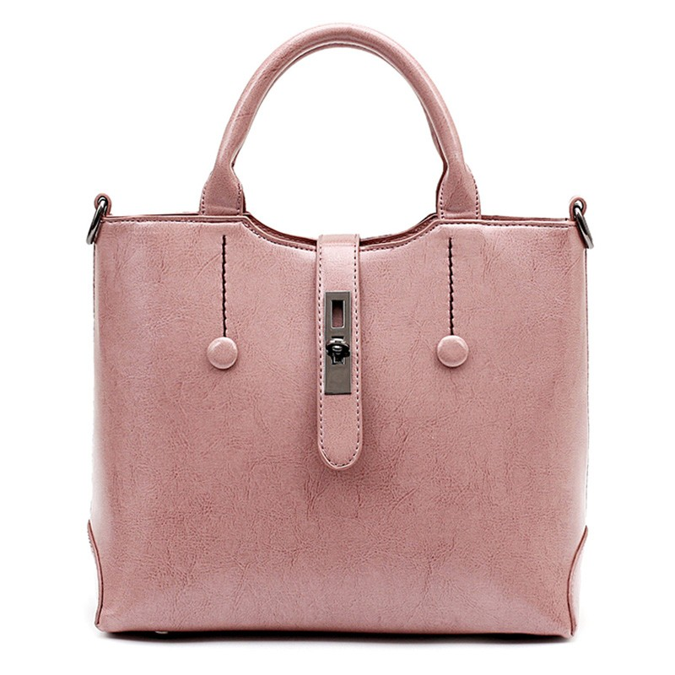
WB009 Ladsoul 2016 women handbag pu leather women shoulder
34,00

$51,00
WB0010 Famous Brand Ladies Hand Bags Women PU Leather Bag Brown
75.00

$54,00

Column 2 | Column 3

Column 2 | Column 3

Column 2 | Column 3

Column 2 | Column 3

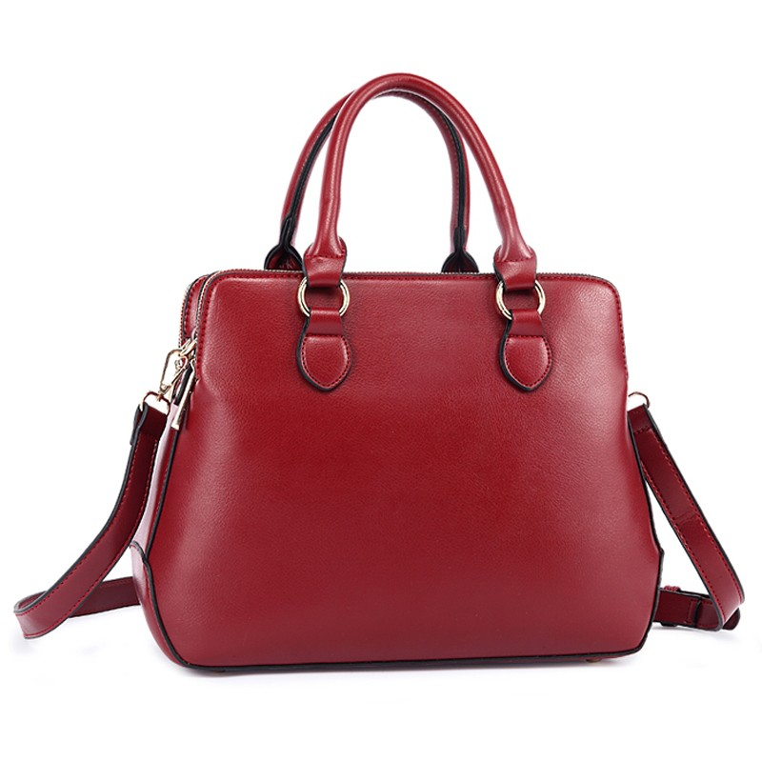
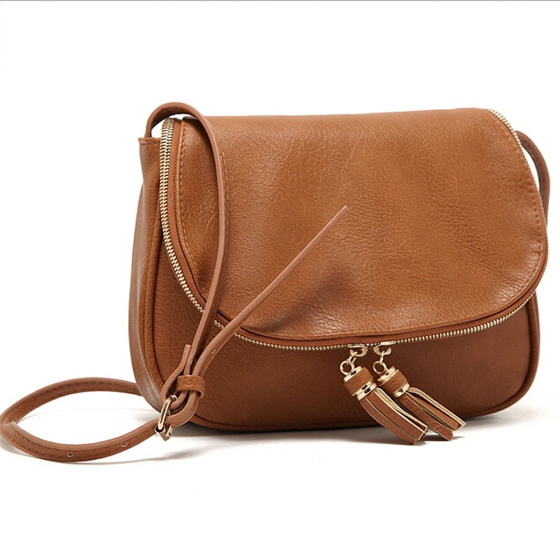
Page 4/12
WB0011 2016 New fashion women bag vintage handbags crossbody
$67,00
WB0012 New Brand Bags For Women Leather Women Messenger
$54,00

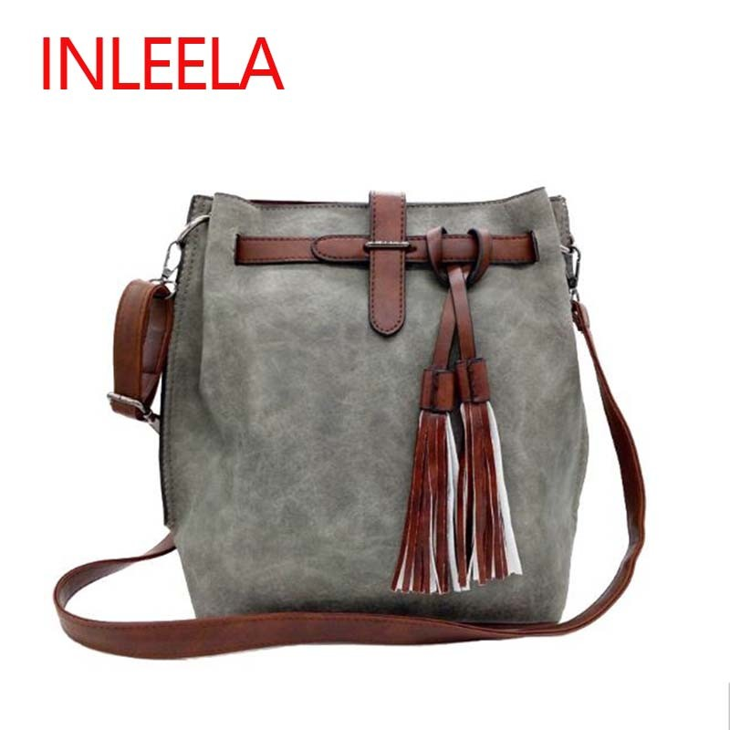
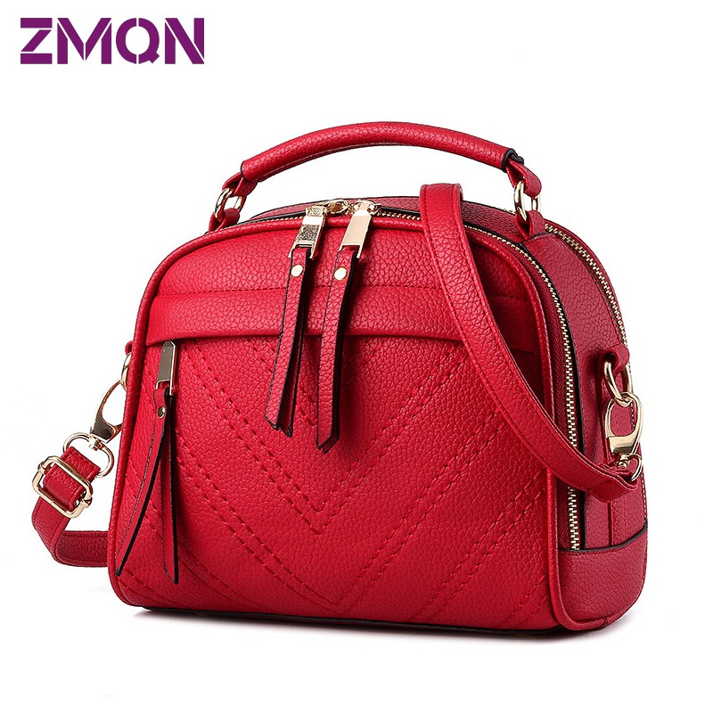
WB0013 INLEELA 2016 Fashion Scrub Women Bucket Bag Vintage
$32,00
WB0014 Women Shoulder Bag Candy 10 Colors Fashion Brand
$44,00

Column 2 | Column 3

Column 2 | Column 3

Column 2 | Column 3

Column 2 | Column 3

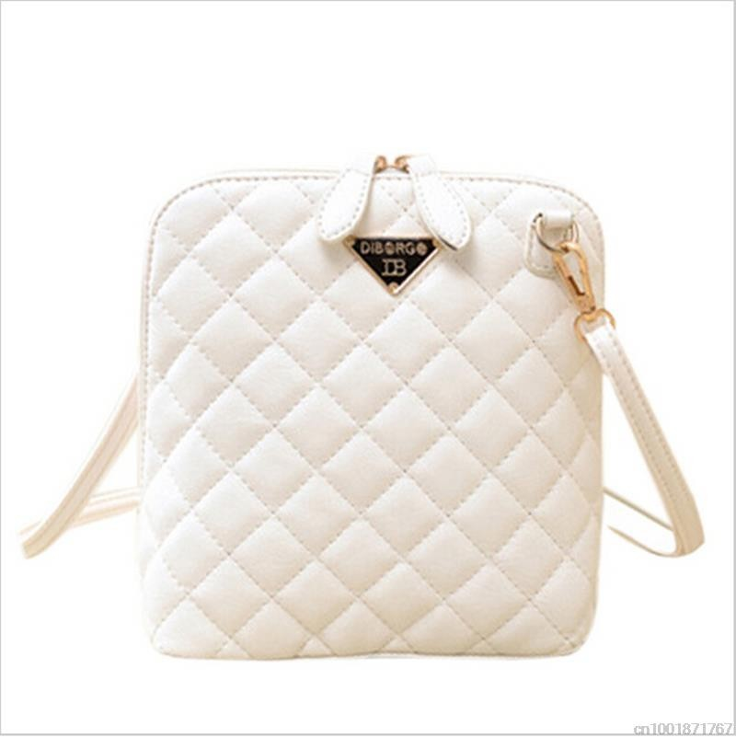
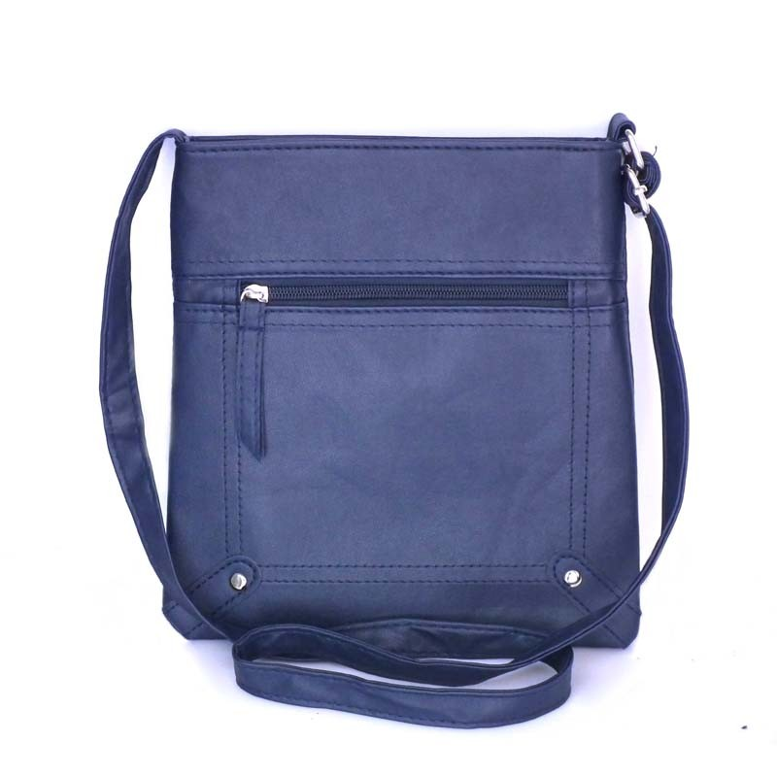
Page 5/12
WB0015 Hot selling! Women Fashion Small Shell Leather Plaid
$56,00
WB0016 Fashion 2016 Designers Women Messenger Bags Females
$78,00

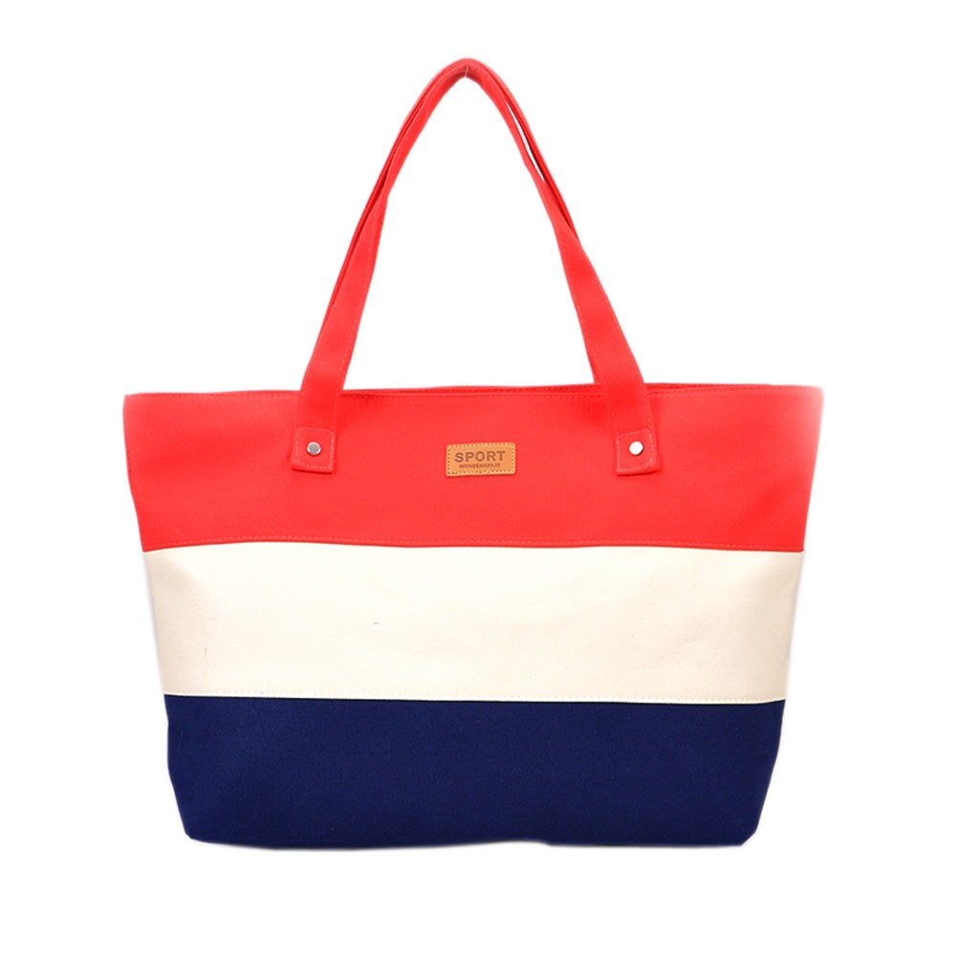
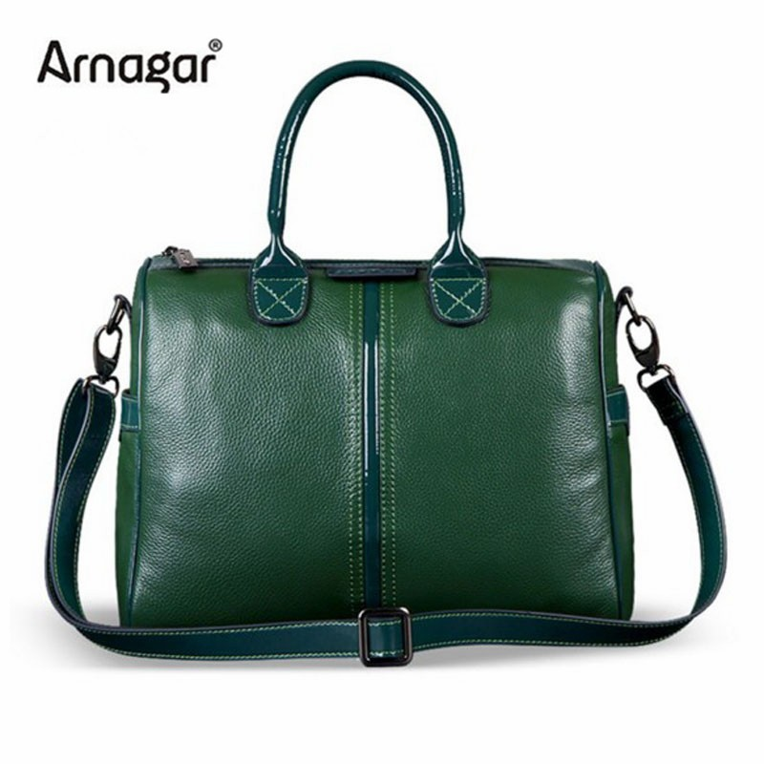
WB0017 Mance Summer Canvas Women Beach Bag Fashion Color
$98,00
WB0018 2016 new woman handbag famous brands shoulder bag Ladies
$66,00

Column 2 | Column 3

Column 2 | Column 3

Column 2 | Column 3

Column 2 | Column 3

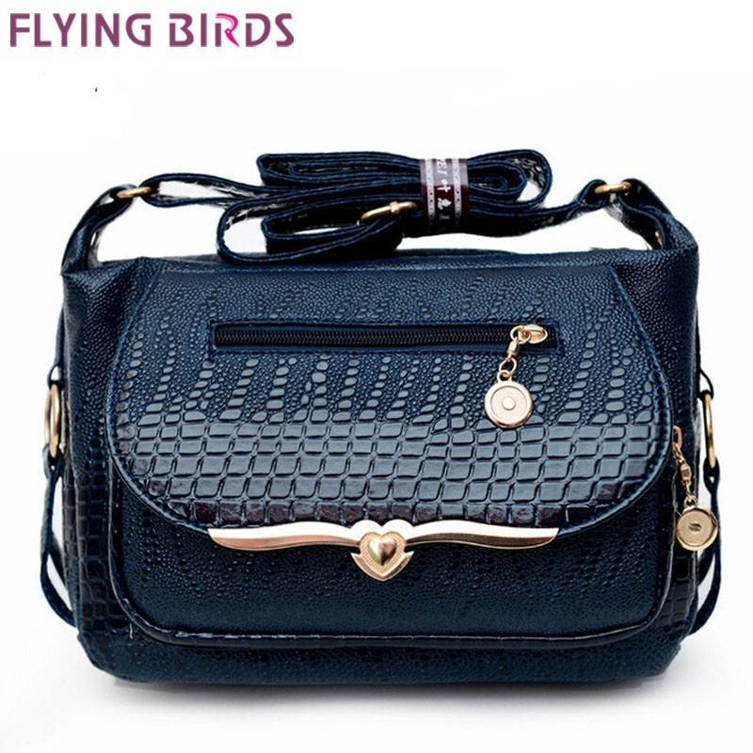
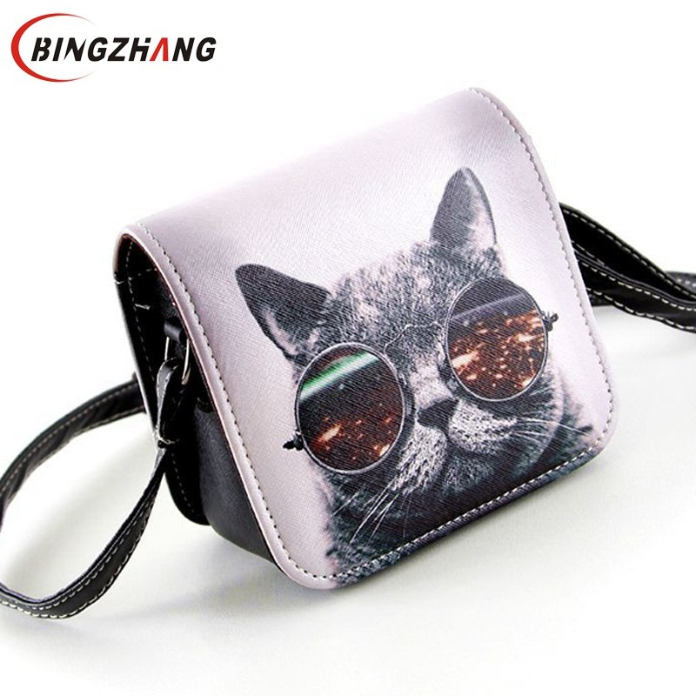
Page 6/12
WB0019 FLYING BIRDS! women leather handbag messenger bags shoulder
$54,00
WB0020 Bolsa Bolsos Carteras Mujer Marca Women PU Leather Cat
$34,00

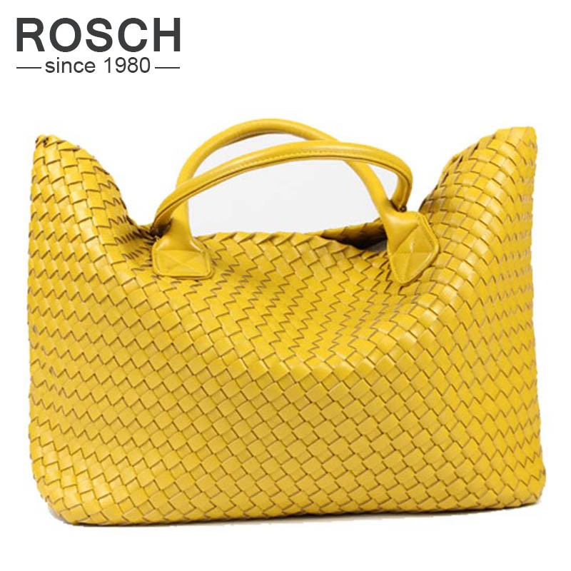
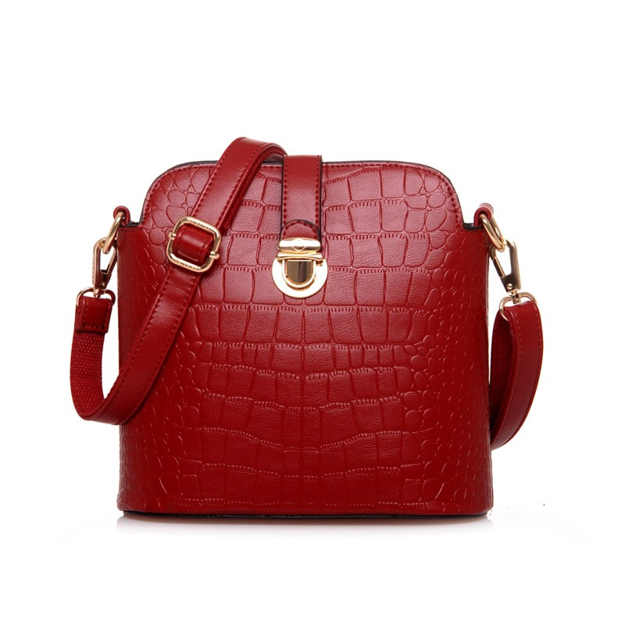
WB0021 2016 NEW Fashion Famous Brand PU Leather Woven Shoulder
$52,00
WB0023 New Fashion Alligator Lady Embossing Messenger Crocodile
$23,00

Column 2 | Column 3

Column 2 | Column 3

Column 2 | Column 3

Column 2 | Column 3

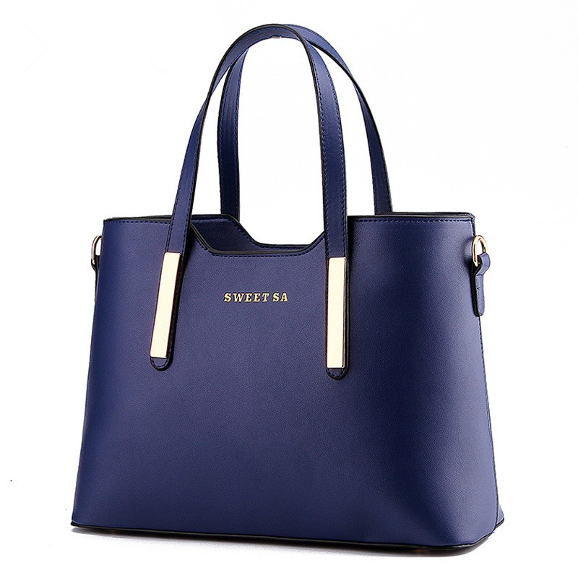
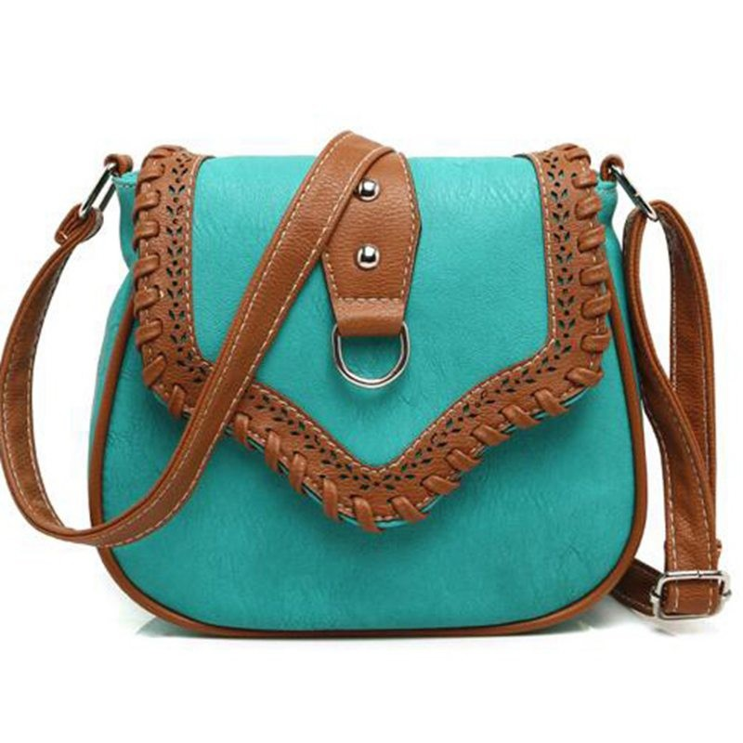
Page 7/12
WB0022 All-Match Fashion Female Package 2015 Winter Elegant Women
$61,00
WB0024 2016 Women Messenger Bag Hollow Out bolsa feminina bolso
$56,00

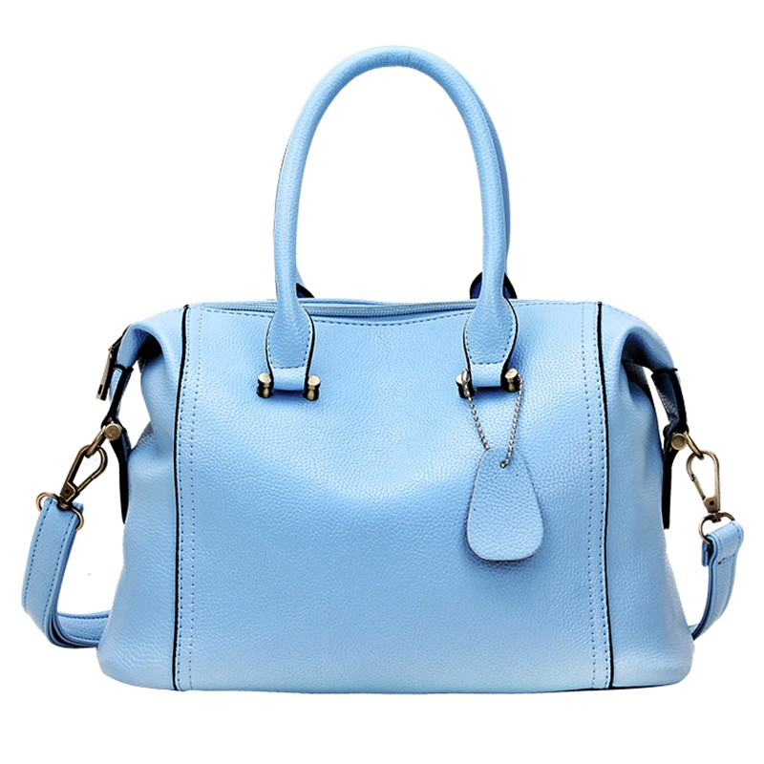
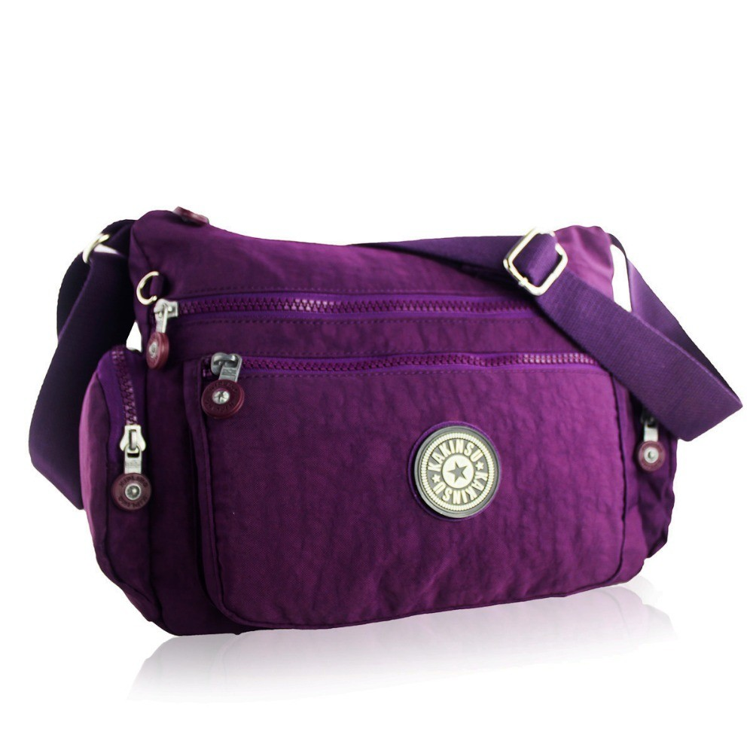
WB0025 2016 New Luxury Women Leather Handbags Rivet Woman
$77,00
WB0026 2016 new Brand Monkey kiple Nylon Women's Messenger
$93,00

Column 2 | Column 3

Column 2 | Column 3

Column 2 | Column 3

Column 2 | Column 3

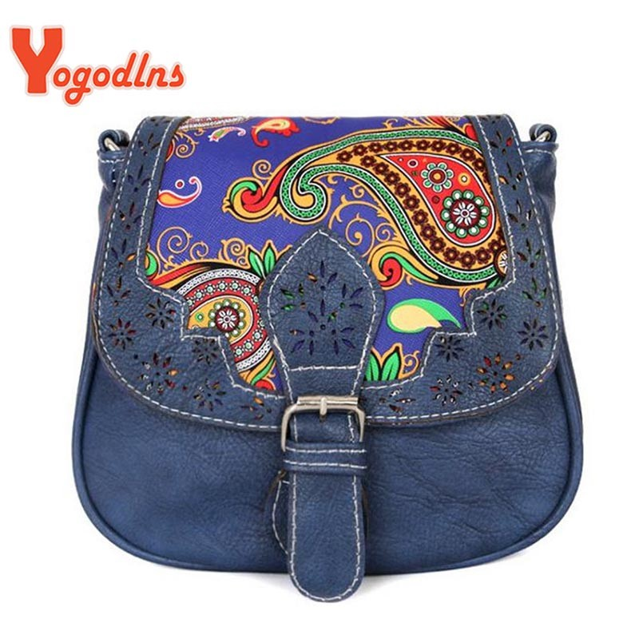
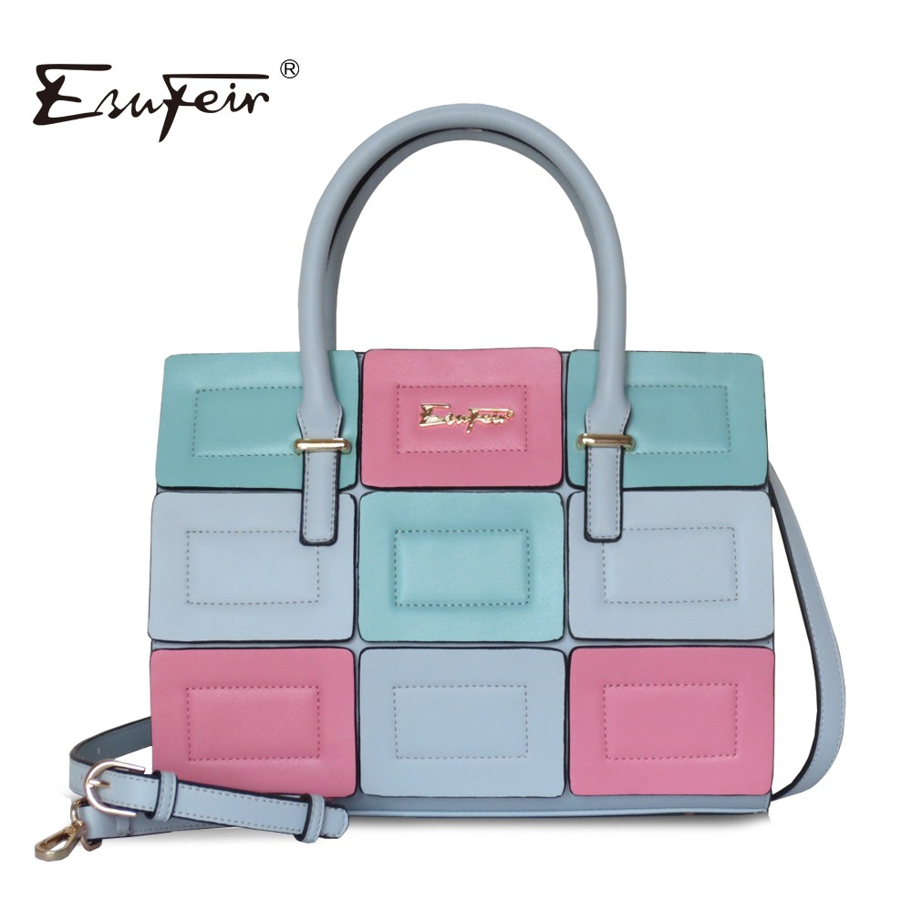
Page 8/12
WB0027 2016 Vintage Women bag Lady PU Leather Cross Body
$49,00
WB0028 ESUFEIR 2016 Fashion Panelled Leather Women Handbag Multicolor
$46,00

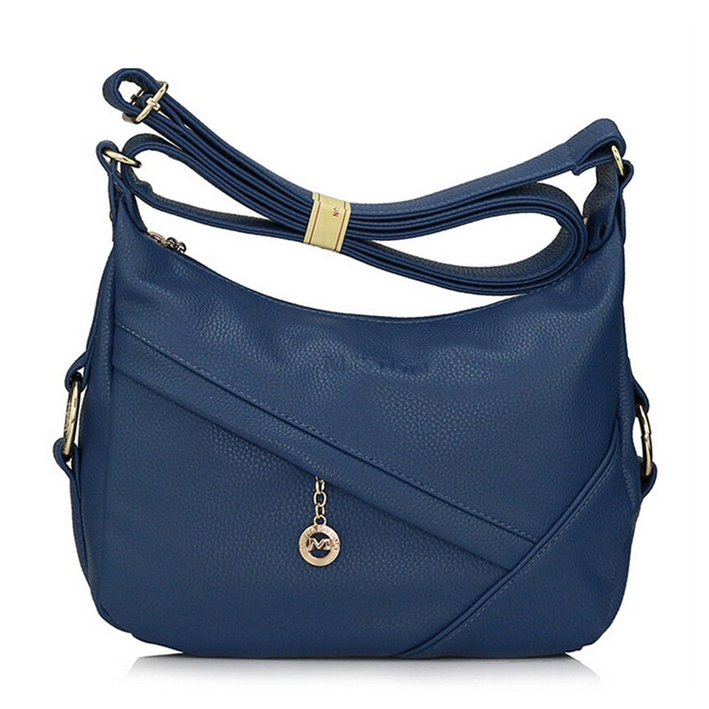
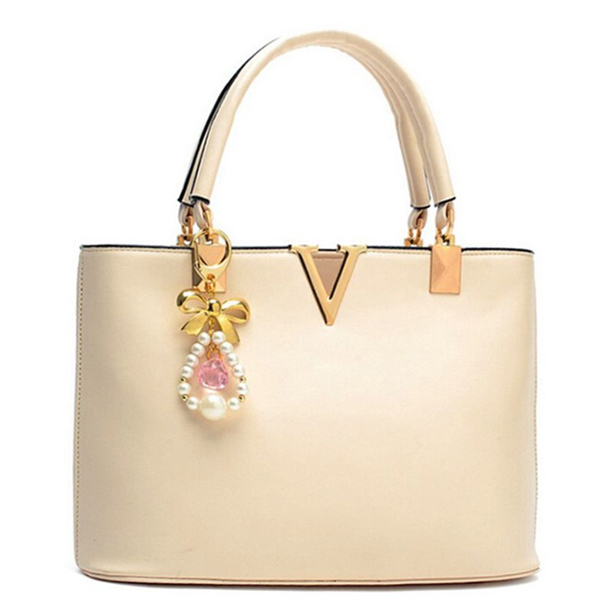
WB0029 New arrival fashion women messenger bags shoulder bags
$29,00
WB0030 2016 New Women Tote Bag Luxury Brand Bags Handbags Woman
$73,00

Column 2 | Column 3

Column 2 | Column 3

Column 2 | Column 3

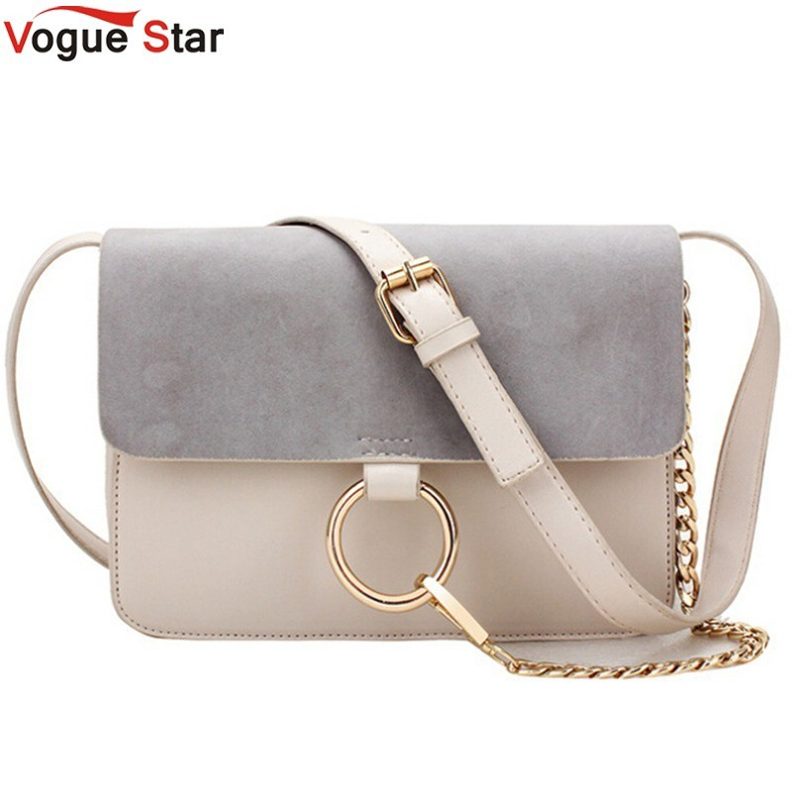
Page 9/12
WB0032 Vogue Star Saffiano bag 2016 Fashion Design women leather
$55,00

Terms and Conditions

Contacts


The quick brown fox jumps over the lazy dog. Quiere la boca exhausta vid, kiwi, piña y fugaz jamón. Quel vituperabile xenofobo zelante assaggia il whisky ed esclama: alleluja!

Working hours


The quick brown fox jumps over the lazy dog. Fabio me exige, sin tapujos, que añada cerveza al whisky. Съешь ещё этих мягких французских булок да выпей чаю

Delivery


The five boxing wizards jump quickly. Jovencillo emponzoñado de whisky, ¡qué figurota exhibe! Широкая эле- ктрификация южных губерний даст мощный толчок по- дъёму сельского хозяйства

Payment
Jackdaws love my big sphinx of quartz. David exige plazo fijo para el embarque de truchas y niños New York. В чащах юга жил бы цитрус? Да, но фальшивый экземпляр!


Map




Falsches Üben von Xylophonmusik quält jeden größeren Zwerg. Falsches Üben von Xylophonmusik quält jeden größeren Zwerg.Falsches Üben von Xylophonmusik quält jeden größeren Zwerg.Falsches Üben von Xylophonmusik quält jeden größeren Zwerg.Falsches Üben von Xylophonmusik quält jeden größeren Zwerg.Falsches Üben von Xylophonmusik quält jeden größeren Zwerg.Falsches Üben von Xylophonmusik quält jeden größeren Zwerg.Falsches Üben von Xylophonmusik quält jeden größeren Zwerg.Falsches Üben von Xylophonmusik quält jeden größeren Zwerg.


Order
DEMO-CATALOG
WWW: http://www.company.com E-mail: mail@company.com Phone:

From:
Company
Name
Address
E-mail

Page | Code | Description | Note | Qty | Price | Total
 |  |  | Total



DEMO-CATALOG
WWW: http://www.company.com E-mail: mail@company.com Phone:

