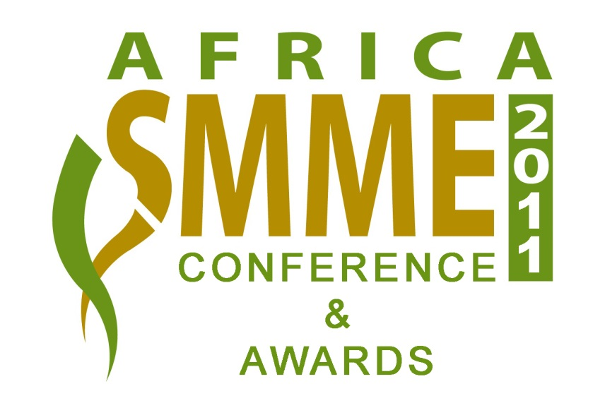

SPONSORSHIP PROPOSAL

2011 Africa SMME Conference

Theme:
Sustaining Africa’s SMMEs in a Globally Competitive Market

&

Africa SMME Awards

Date : 13 October 2011
Venue : Gold Reef City Hotel, Gauteng

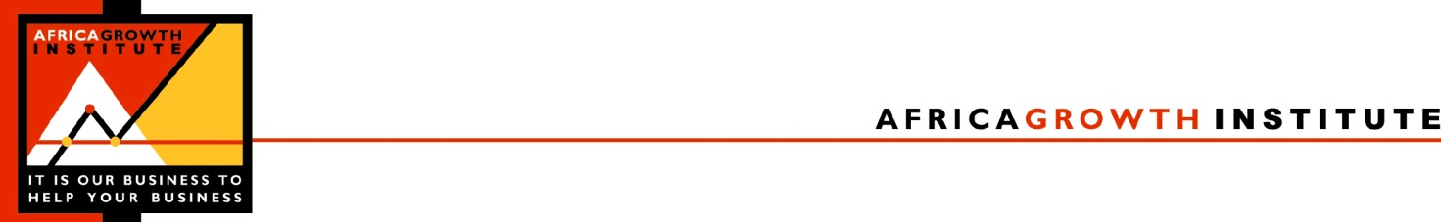

2 February 2011

Dear Sir/Madam

Africagrowth Institute will host the 4th Africa SMME Conference and Awards on the 13 October 2011, at the Gold Reef City Hotel, Gauteng: Sustaining Africa’s SMMEs in a Globally Competitive Market. The conference will address the financial, marketing, research & development, governance and innovation needs of SMMEs in Africa. The conference will also discuss success stories, best practices and key challenges that face Africa’s SMMEs in the global market.

The Africa SMME conference will once again host the Africa SMME Awards at a Banquet, during which top SMMEs in Africa will be honoured. To ensure the success of this event Africagrowth Institute is seeking partnerships, financial support and key stakeholder’s involvement to support and promote this important and unique African event. We, therefore, take this opportunity to invite you to partner with us and be part of this rewarding continent-wide event. Below is more information on the conference and a table of benefits and opportunities for potential partners and sponsors.

We shall be grateful if you could take a few minutes of your time to look at the sponsorship opportunities enclosed and generously support this unique and vital African initiative. We look forward to discussing the partnership opportunities with your company and look forward to working with you to promote Africa’s entrepreneurial spirit.

Yours sincerely

N Biekpe DPotgieter
Professor Nicholas Biekpe Dina Potgieter
President : Africagrowth Institute Manager : SMME Project

Board of Directors : Professor Jimnah Mbaru (Kenya); Mr. Phil Molefe (South Africa); Ms. Vuyo Mahlati (South Africa); Mr. Mumba Kapumpa (Zambia); Dr. Mohammed Jahed (South Africa); Dr. Agatha Biekpe (UK); Professor Nicholas Biekpe (South Africa)
2011 AFRICA SMME CONFERENCE AND SMME AWARDS

- INTRODUCTION

SMMEs play a crucial role in the economy of Africa. It is estimated that the sector, excluding government, provides more than 90% of the workforce of the continent and contributes significantly to the GDP of its economy. In a nutshell the sector is the heart that pumps the economic blood to the vital organs of the Africa’s economy. To acknowledge and appreciate the important role the sector plays in promoting wealth and prosperity in the continent, Africagrowth Institutes, in partnership with African governments and government-institutions, Private Sector Institutions, NGOs and SMME support agencies is pleased to introduce the 2011 Africa SMME Conference and Awards. The idea behind the Awards is to identify and recognise the best performing SMMEs in the continent. The Award ceremony showcases the continent’s best SMMEs in the trade, services and industrial sectors. The overall winner will receive the African SMME of Year Award. The Awards ceremony will take place on the 13th of October 2011.

- AIMS AND OBJECTIVES OF CONFERENCE AND AWARD CEREMONY

This important event aims to achieve the following specific objectives:
- To showcase Africa’s successful SMMEs;
- To promote and highlight the role that SMMEs play in economic development of the continent;
- To present case studies and research findings in the SMME sector;
- To bring together governments, development institutions, investors, academics and private sector institutions with interest in the SMMEs sector;
- To discuss best practices in the SMMEs sector;
- To bring big business and SMMEs together “under one roof”; and
- To help promote SMMEs Research and Development.

- THE SPONSORSHIP

The 2011 Africa SMME Awards ceremony aims to recognise the success and vitality of the Africa SMME sector. This unique annual awards program has been established specifically to acknowledge, encourage and celebrate excellence amongst African SMMEs by giving them the opportunity to gain valuable exposure and well-deserved recognition for their national and global expansion ambitions. The Awards are the highest honours that can be bestowed to SMME owners in the continent. The main goal of the Award program is, therefore, to help the Africa SMME business sector grow and prosper, and to market Africa as an investment destination for the rest of the world.

The organisers of this important initiative greatly acknowledge and salute your organisation’s support and contribution to promoting development in the continent and would be very honoured if you could consider sponsoring the event. The event attracts investors, entrepreneurs and high profile speakers and participants from private sector institutions, Government, SMME sector, small and medium enterprise support agencies, and other development institutions throughout the country.

- Benefits to Sponsor: (see the attached Table of sponsorship options)

2011 AFRICA SMME CONFERENCE
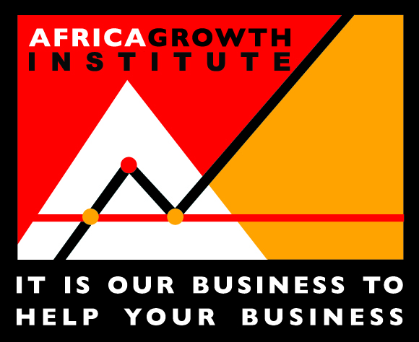

SPONSORSHIP OPTIONS FOR THE 2011 AFRICA SMME CONFERENCE

The table below shows the different sponsorship opportunities available at the 2011 SMME Conference and the benefits that the sponsor will enjoy.

CONFERENCE | Contribution  (excl. VAT) | Speaking opportunity on relevant topic | Delegates to attend the Conference and Awards banquet for free | Advertisement in Conference Brochure  Full page Half Page  (A4) (A5) |  | Advertisement in Africagrowth Agenda Magazine  Full Page Half Page  (A4) (A4) |  | Interview with Senior Manager to be published in Africa Growth Agenda Magazine | Display banner and promotional article(s) at conference or banquet | Logo in Conference brochure, on conference website and on presentation screen | Free Subscription to the Africagrowth Growth Publication for 1 year
Platinum Sponsor | R100 000 | √ | 10 | √ |  | √ |  | √ | √ | √ | √
Gold Sponsor | R50 000 | √ | 5 |  | √ |  | √ |  | √ | √ | √
Silver Sponsor | R30 000 |  | 3 |  | √ |  | √ |  | √ | √ | √
Bronze Sponsor | R20 000 |  | 2 |  | √ |  |  |  | √ | √ | √
Speaker Gifts & Conference Bags | R10 000 |  | 2 |  |  |  |  |  |  | √ | √
Refreshment Break | R 6 000 |  | 2 |  |  |  |  |  |  | √

√ Benefits included in package

Note that all amounts are excluding VAT

2011 AFRICA SMME AWARDS

SPONSORSHIP OPTIONS FOR THE 2011 AFRICA SMME AWARDS

The table below shows the different sponsorship opportunities available at the SMME Awards Banquet and the benefits that the sponsor will enjoy.

SMME AWARDS | Contribution  (excl. VAT) | Guest Speaker at the SMME Awards | Speaking opportunity on relevant topic at the conference | Delegates to attend the Awards banquet for free | Advertisement in Awards Brochure (A5)  Full page Half Page  (A5) (A5) |  | Advertisement in Africagrowth Agenda Magazine  Full Page Half Page  (A4) (A4) |  | Interview with Senior Manager to be published in Africa Growth Agenda Magazine | Display banner and promotional article(s) at Awards banquet | Logo in Awards brochure, on Awards website and on presentation screen | Company Name printed on Award Trophy
Ambassador Sponsor | R200 000 | √ | √ | 15 | √ |  | √ |  | √ | √ | √ | √
All Sector Awards | R180 000 |  | √ | 10 | √ |  | √ |  | √ | √ | √ | √
Africa SMME of the year award | R50 000 |  | √ | 5 | √ |  | √ |  |  | √ | √ | √
Individual & Sector Awards (6) | R30 000 |  |  | 3 | √ |  |  | √ |  | √ | √ | √
Décor at banquet | R30 000 |  |  | 3 | √ |  |  | √ |  | √ | √ | √
Table Sponsor | R6 000 |  |  | 8

Note that these amounts exclude VAT

Sectors: Industrial Sector, Trade Sector, Services Sector:

Individual Awards: Best New Business Award, Most Innovative Enterprise Award, Young Enterprise Award

