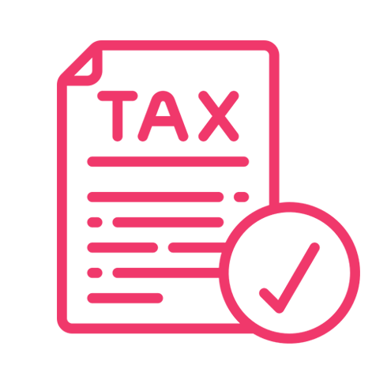
10 years experience in tax
Call us at 0491 570 158
Lorem ipsum dolor sit amet, consectetur adipiscing elit, sed do eiusmod tempor incididunt ut labore et dolore magna aliqua. Ut enim ad minim veniam, quis nostrud exercitation ullamco laboris nisi ut aliquip ex quis nostrud exercitation ullamco laboris nisi ut aliquip
ad minim veniam, quis nostrud exercitation ullamco laboris nisi ut aliquip ex quis nostrud exercitation ullamco laboris nisi ut aliquip
Refund guaranteed
Quality services
24/7 Customer support
TAX SERVICES
Tax Service
0491 570 158

Tax Service
0491 570 158

Tax Service
0491 570 158

Tax Service
0491 570 158

Tax Service
0491 570 158

Tax Service
0491 570 158

Tax Service
0491 570 158

Tax Service
0491 570 158

Tax Service
0491 570 158

Tax Service
0491 570 158

Tax Service
0491 570 158

Tax Service
0491 570 158

