

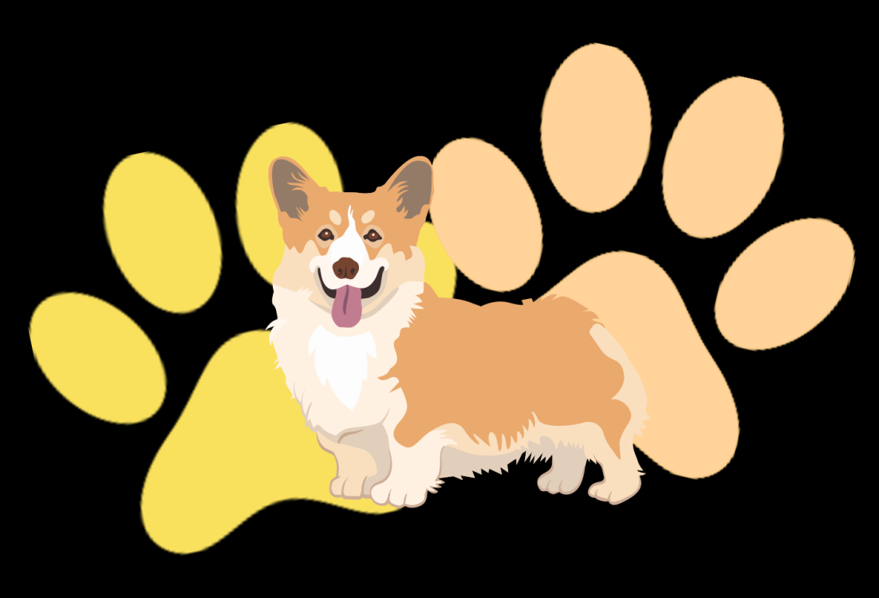
NEED A
DOG WALKER?
Dogwalker.com
0491 570 158
Dogwalker.com
0491 570 158
Dogwalker.com
0491 570 158
Dogwalker.com
0491 570 158
Dogwalker.com
0491 570 158
Dogwalker.com
0491 570 158
Dogwalker.com
0491 570 158
Dogwalker.com
0491 570 158
Dogwalker.com
0491 570 158
Dogwalker.com
0491 570 158
Dogwalker.com
0491 570 158
Dogwalker.com
0491 570 158
Dogwalker.com
0491 570 158
Available daily
5+ Years experience
Affordable Rates

