Emergency Management

Business Continuity Template



The Regional Municipality of Wood Buffalo would like to give credit to the Calgary Emergency Management Agency (CEMA) and the Calgary Chamber of Commerce as the authors of the source material for this guide.

Foreword
The Regional Municipality of Wood Buffalo recognizes the importance of the business sector as an essential part of our community. The resumption of business activities is a critical component of overall community recovery following a disaster.

Following a disaster, businesses that have not prepared for disruptions with a business continuity plan are at risk of having to close temporarily, or, at worst, being unable to resume operations. This business continuity guide is intended to assist small- and medium-sized businesses plan for the continuity and resumption of business operations following a disruption.

2 | rmwb.ca/bcp

directions
- Read the Business Continuity Guidebook to learn about the different components of a Business Continuity Plan (available for download at rmwb.ca/bcp).

- Fill out the Business Continuity Plan Template.

- Create duplicates and/or expand sections as needed (e.g. Action Plan Template, Exercise Log).

- Save and print your Business Continuity Plan.

List oF abbreviations
aeMa Alberta Emergency Management Agency

bcP Business Continuity Plan bcM Business Continuity Manager drP Disaster Recovery Program rto Recovery Time Objective

introduction

Sign up to receive alerts during an emergency with Alberta Emergency Alert.

emergencyalert.alberta.ca
4 | rmwb.ca/bcp
There are six steps to developing an effective Business Continuity Plan:

steP one: Analyze your business
6
5
4
3
2
1

steP two: Assess the risks

steP tHree: Develop strategies

steP Four: Make a plan

steP Five: Exercise your plan

steP siX: Review your plan

To develop an effective Business Continuity Plan, tailor it according to the nature of your business and its operations. You are encouraged to customize this template to meet your business’s needs.



contents

Foreword 2
directions 3
List oF abbreviations 3
introduction 4
business continuitY PLan inForMation 7
revision List 8
distribution List 9
vitaL inForMation 10
Associated Policies, Documents, and Procedures 10
Staff Contact Numbers 11
Emergency Contact List 12
Supplier Contact List 13
Customer Contact List 14
steP one: anaLYZe Your business 15
Employee Roles and Responsibilities 17
Key Business Functions 18
Recovery Time Objective (RTO) 19
Impact 20
steP two: assess tHe risKs 23
Risk Matrix 24
steP tHree: deveLoP strateGies 27
steP Four: MaKe a PLan 30
Evacuation Procedures and Routes 30
Action Plan Example 31
Action Plan Template 32
steP Five: eXercise Your PLan 38
Exercise Process 38
Types of Exercises 38
Workshops 38
Tabletop 38
Full-Scale 38
Exercise Log 39
steP siX: review Your PLan 41
Plan Review Cycle 41
staY inForMed 44

business continuitY PLan inForMation

COMPANY NAME
BUSINESS CONTINUITY
MANAGER
CONTACT INFORMATION
ALTERNATE MANAGER
CONTACT INFORMATION
BUSINESS CONTINUITY PLAN LOCATION

revision List

REVISION NUMBER | DETAILS | REVISED BY | REVISION DATE

distribution List

NAME | DETAILS | DATE

vitaL inForMation

BUSINESS LICENCE NUMBER
GST NUMBER
INSURANCE POLICY NUMBER
CRITICAL PAPER RECORDS LOCATION
BACK-UP COMPUTER RECORDS LOCATION

associated PoLicies, docuMents, and Procedures

FILE | LOCATION | DATE UPDATED

staFF contact nuMbers

NAME | TITLE | PHONE#1 | PHONE#2

eMerGencY contact List

NAME | TITLE | PHONE#1 | PHONE#2

suPPLier contact List

NAME | COMPANY | PHONE#1 | PHONE#2

custoMer contact List

NAME | COMPANY | PHONE#1 | PHONE#2

steP one:
anaLYZe Your business

what is the purpose of your business?
what products and services do you provide?

How do you provide your products and services? (e.g. web store, shop, delivery)

do your service providers have business continuity plans in place?

what are your resource requirements? (e.g. suppliers, equipment, records)

who is involved in the daily operations? (e.g. employees, suppliers)
who are your customers?

eMPLoYee roLes and resPonsibiLities

POSITION | ROLES AND RESPONSIBILITIES

KeY business Functions

BUSINESS FUNCTION | STAFF REQUIREMENTS | RESOURCE REQUIREMENTS

recoverY tiMe objective (rto)
This table will assist you in prioritizing the key business functions that are critical to your operations. Check the maximum timeframe for which a key business function can be interrupted.
Staff
IT
Vital Records
Internet
Facilities

BUSINESS FUNCTION | <24 HRS | 48 HRS | 72 HRS | 1 WEEK | 2  WEEKS | 1  MONTH
Vendors
Vendors
Vendors
Vendors
Vendors
Vendors
Vendors
Vendors
Vendors
Vendors
Armed with a better understanding of your key business functions, make a plan to ensure that these functions return to operation within the specified RTO.
Communications
Transportation
Equipment
Suppliers
Vendors
For example, a bakery may survive a supplier disruption for up to 48 hours. It may continue operating with the existing inventory stock of baking ingredients. However, the company will be unable to contin- ue operations without further shipments from its suppliers past 48 hours.

iMPact (1 oF 2)

BUSINESS FUNCTION | POTENTIAL IMPACTS

iMPact (2 oF 2)

BUSINESS FUNCTION | POTENTIAL IMPACTS

notes:

steP two:

assess tHe risKs
There are different types of risks to consider, such as: natural hazards, human- caused hazards, and technological hazards. Each potential risk carries unique needs which may require special planning.
security
Theft, vandalism, cyber attack, fraud, sabotage


security
Theft, vandalism, cyber attack, fraud, sabotage
Personnel
Pandemic, loss of staff, labour action
infrastructure
Fire, hazardous materials, power outage, loss of utilities

severe weather
Flooding, tornado hail, windstorm, lightning
operational
Supply chain, transportation, IT and telecommunications disruptions

The following demonstrates the risks and hazards that your business may be vulnerable to. Assess each risk and imagine how they could potentially affect your ability to continue operating.
security
Theft, vandalism, cyber attack, fraud, sabotage

risK MatriX
Consider the different hazards in the previous page and use the risk assessment matrix below to assess the potential hazards to your business.

risK LeveL score
extreme | 16
High | 8 – 12
Medium | 3 – 6
Low | 1 – 2

very Likely | Medium | High | High | extreme
Likely | Medium | Medium | High | High
unlikely | Low | Medium | Medium | High
very unlikely | Low | Low | Medium | Medium
 | insignificant | Minor | serious | Major

severity
vaLue LiKeLiHood descriPtion
Likelihood
4 | very likely | very likely to occur in the foreseeable future
3 | Likely | Likely to occur in the foreseeable future
2 | unlikely | not likely to occur in the foreseeable future
1 | very unlikely | will only occur in exceptional circumstances

iMPact on KeY business Functions FinanciaL recoverY & inFrastructure iMPact tiMe
vaLue severitY
4 | Major | Loss of key business functions and extensive damage to infrastructure | Major | 1+ month
3 | serious | significant impact on key business functions and damage to infrastructure | significant | 1+ week
2 | Minor | Minimal impact on key business functions and little to no impact on infrastructure | Limited | 1-3 days
1 | insignificant | negligible impact on key business functions and no impact on infrastructure | none | immediate

To calculate the risk level, multiply the hazard’s likelihood value by the severity value (likelihood x severity = risk level). Prioritize your planning based on the risk value.

HAZARD | RISK LEVEL | PLANNING MEASURES
 | Low (1-2)
 | Low (1-2)
 | Low (1-2)
 | Low (1-2)
 | Low (1-2)
 | Low (1-2)
 | Low (1-2)
 | Low (1-2)
 | Low (1-2)
Choose and item
Choose and item
Choose and item
Choose and item
Choose and item
Choose and item
Choose and item
Choose and item
Choose and item

notes:

steP tHree: deveLoP strateGies

what strategies can you implement BEFORE a disruption occurs?

what strategies can you implement DURING a disruption?

what strategies can you implement AFTER a disruption has occurred?

steP Four: MaKe a PLan

evacuation Procedures and routes

evacuation Procedures:
To calculate the risk level, multiply the hazard’s likelihood value by the severity value (likelihood x severity = risk level). Prioritize your planning based on the risk value.

cease all other activities (phone calls, meetings, etc.)
- remain calm and follow directions from floor wardens or emergency services personnel

do not return to your workspace for personal possessions; evacuate from where you are
- walk, do not run, to nearest safe exit. use stairwell, not elevators

direct all visitors to the nearest safe stairwell
- Know the alternate evacuation routes

check doors for heat, using the back of your hand before opening. if a door is hot, use an alternate route
- close all doors behind you and proceed to the muster point

remain at the muster point and do not re-enter the building until instructed by emergency personnel

evacuation routes:
Draw or print out a map showing the muster points and exit routes in the space provided below.

Muster Point: Secondary:

Exit Route: Secondary:

action PLan – eXaMPLe

RISK | Power outage
RISK LEVEL | Medium
RTO | Less than 24 hours
BUSINESS FUNCTIONS  AFFECTED | Vital records, internet, communications, computer equipment, cash registers, sales
ACTION | - Turn on generator  - Call the building manager Jack: 780-000-1111  - Notify the owner  Jill: Mobile: 587-222-3333  Home: 780-444-5555  - Determine the likely duration of the power outage Call ATCO Electric: 1-800-668-5506  - If it is an extended outage, maintain fuel levels Call fuel delivery: 780-666-7777
RESOURCES | Landline, mobile phone, generator

if you suffer an interruption, you may wish to make an insurance claim.
- Phone your agent as soon as possible to discuss the situation.

- If your business has suffered a flood, ask your agent if you should take a sample of the floodwater, and if your insurance covers the cost of analyzing the data.

- Photograph the damage. Ideally, you should photograph everything before you start cleaning up, as you clean up, and when you’re finished.

- Keep all receipts for repairs and document all funds spent. If you have to dispose of anything, record what you dispose of. Keep a log of the time you spend on clean-up.

action PLan teMPLate

RISK
RISK LEVEL
RTO
BUSINESS FUNCTIONS AFFECTED
POTENTIAL IMPACT
action | BEFORE
action | DURING
action | AFTER
RESOURCE REQUIREMENTS
STAFF REQUIREMENTS

RISK
RISK LEVEL
RTO
BUSINESS FUNCTIONS AFFECTED
POTENTIAL IMPACT
action | BEFORE
action | DURING
action | AFTER
RESOURCE REQUIREMENTS
STAFF REQUIREMENTS

RISK
RISK LEVEL
RTO
BUSINESS FUNCTIONS AFFECTED
POTENTIAL IMPACT
action | BEFORE
action | DURING
action | AFTER
RESOURCE REQUIREMENTS
STAFF REQUIREMENTS

RISK
RISK LEVEL
RTO
BUSINESS FUNCTIONS AFFECTED
POTENTIAL IMPACT
action | BEFORE
action | DURING
action | AFTER
RESOURCE REQUIREMENTS
STAFF REQUIREMENTS

RISK
RISK LEVEL
RTO
BUSINESS FUNCTIONS AFFECTED
POTENTIAL IMPACT
action | BEFORE
action | DURING
action | AFTER
RESOURCE REQUIREMENTS
STAFF REQUIREMENTS

RISK
RISK LEVEL
RTO
BUSINESS FUNCTIONS AFFECTED
POTENTIAL IMPACT
action | BEFORE
action | DURING
action | AFTER
RESOURCE REQUIREMENTS
STAFF REQUIREMENTS

steP Five: eXercise Your PLan eXercise Process

develop exercise
- Exercise design
- Scenario

- Drills, tabletop exercise, orientation, full scale exercise

evaluate exercise
- Ask for feedback from participants
- Evaluate staff preparedness
- Evaluate systems and equipment performance

conduct exercise
  - Test the plan
  - Test staff, equipment, and procedures
  - Train staff, clarify roles and responsibilities

types of exercises

workshops

revise bcP
- Update the plan to amend noted weaknesses and gaps

Workshops are designed to familiarize the employees with their roles and responsibilities as defined in the business continuity plan. Workshops are normally conducted in a classroom setting.

tabletop
Tabletop exercises are designed to test a hypothetical business disruption. The focus is on training, familiarization with roles, responsibilities, and procedures. Tabletop exercises are guided by a facilitator that walks the employees through the process. It is conducted in a stress-free and informal environment where participants are encouraged to ask questions.

Full-scale
Full-scale exercises attempt to simulate a real business disruption. This is as close as it gets to a real event. This exercise takes place on location where the hypothetical disruption has occurred. Actual equipment, personnel, and business partners are often included in a full- scale exercise.

eXercise LoG

EXERCISE NAME
DATE
DURATION
SCENARIO
BUSINESS FUNCTIONS TO BE
EXERCISED
PARTICIPANTS
COMMENTS AND
FINDINGS
RECOMMENDATIONS

EXERCISE NAME
DATE
DURATION
SCENARIO
BUSINESS FUNCTIONS TO BE
EXERCISED
PARTICIPANTS
COMMENTS AND
FINDINGS
RECOMMENDATIONS

steP siX: review Your PLan PLan review cYcLe
To ensure that your Business Continuity Plan remains accurate and up-to-date, it is suggested to review your plan at least once a year.

PLAN REVIEW CYCLE FREQUENCY
DATE OF PLAN REVIEW
PERSONNEL INVOLVED IN PLAN REVIEW
OVERVIEW OF CHANGES/UPDATES
NEXT PLAN REVIEW DATE

notes:

notes:

staY inForMed:

MuniciPaL

regional Municipality of wood buffalo website | rmwb.ca
In the event of an emergency, the Regional Municipality of Wood Buffalo website will have up-to-date information.

regional Municipality of wood buffalo Facebook | facebook.com/ rmwoodbuffalo
Receive the latest Regional Municipality of Wood Buffalo updates on Facebook.

regional Municipality of wood buffalo twitter | @rMwoodbuffalo
Receive the latest Regional Municipality of Wood Buffalo updates on Twitter.

PuLse: wood buffalo | 780-743-7000
PULSE: Wood Buffalo is a 24/7 Call Line that provides ‘real person’ support for all inquiries, requests and complaints. Please note that this number does not replace 911.

ProvinciaL

alberta emergency alert @ab_emergalert | emergencyalert.alberta.ca
Alberta Emergency Alerts are issued to warn people about potential risks to their health and safety.

FederaL

Public safety canada @safety_canada | publicsafety.gc.ca
Public Safety Canada works to keep Canadians safe from risks such as natural disasters, crime and terrorism.

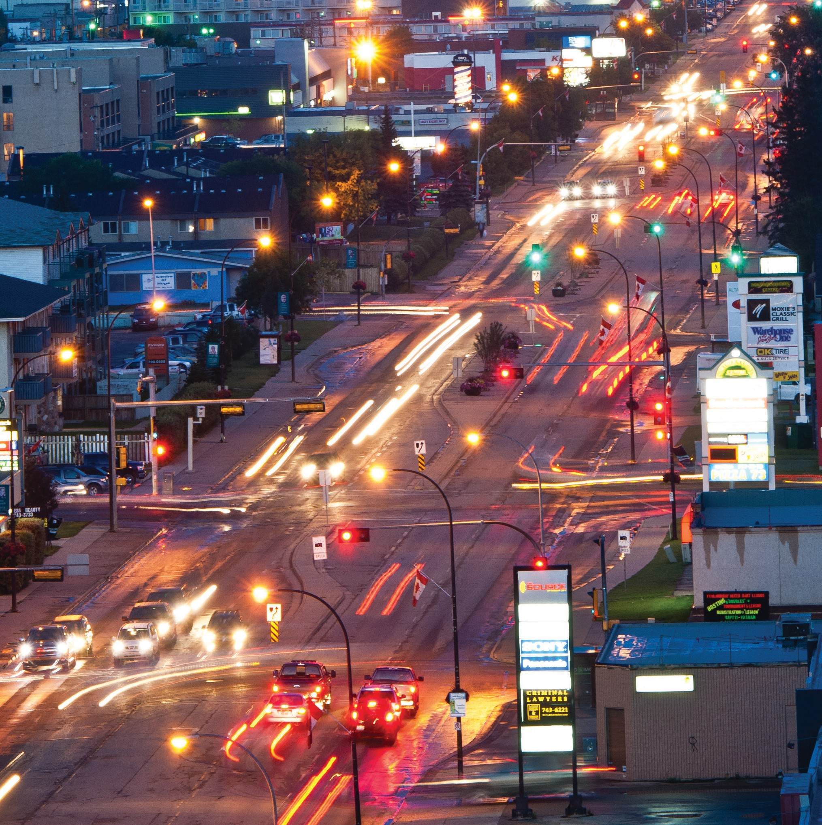in an eMerGencY, diaL 911

For more information on business continuity planning, go to: Regional Municipality of Wood Buffalo rmwb.ca/bcp Alberta Emergency Management Agency aema.alberta.ca Public Safety Canada publicsafety.gc.ca

