Business Continuity Plan Components and sequencing description

This document is designed to help explain the contents of an example Business Continuity Plans, so that team members will have a better understanding of how to relate a Business Continuity Plan contents to the efforts needed to create them.

It is an evolutionary document that will be distributed to team members for their review and update. Eventually the document will contain fully vetted information and will have grown into a working document that can be used to help future team members grasp project tasks and deliverables more quickly and accurately, while reducing the amount of time needed by other team members to help bring new team members up to speed.

Created by:

Thomas Bronack, CBCP

Table of Contents

Cover Page 4
Header Information 5
Footer Information 5
Plan Status 5
Business Units Covered in this Plan 6
Business Unit Contacts 6
Business Unit Locations: 6
Revision Tracking 6
Table of Contents 7
Recovery at a Glance 8
Business Overview 8
General Information, including 9
General Recovery Information, including 9
Recovery Site Information, including 10
Critical Dependencies 10
Types of Disasters to Consider 10
Recovery Strategy 11
Functions to Recover 11
Initial Response 12
Notification Checklist 12
Declaration Procedures 14
Disaster Time 14
Declaration Statement 14
Declaration Authorization 15
Roles and Responsibilities 16
Management Recovery Team 16
Business Recovery Coordinator(s) 16
Business Unit Recovery Team 17
Business Unit Organization Chart 18
Calling Trees 18
Alternate Site 19
Recovery Site Checklist 19
Relocation Information / Instructions 20
Layout of Recover Facility 21
Transportation 21
Requirements Matrix 22
Applications needed for each business function 23
Vital Records 24
Vital Equipment 25
Recovery Procedures 26
General Recovery Activities 26
Initial Recovery 26
Telecommunications 26
Voice Recovery tasks including 26
Data Recovery tasks including 26
Vendor Connectivity tasks including 27
Platform Restoration 27
Server Applications restoration tasks including 27
Desktop Applications / WAN Disk restoration tasks including 27
Retrieval of Vital Records tasks including 27
Reconstruction Procedures 28
Interim Operating Procedures tasks including 28
Validating Restored Applications tasks including 28
Processing Backlogged Work tasks including 28
Alternate Processing Procedures 29
ACD Logon Procedures including 29
Voice Mail Instructions including 29
Printer Selection Instructions including 29
Restoration / Migration 30
Relocation Checklist 30
Move to Interim Site 30
Return to Primary Site 31
Call Lists 32
Application Support 32
Associates 32
Customers 33
Other Departments 33
Vendors 34
Regional Support Teams 34
Other Contacts 34
Documents Needed at time of Disaster 35
Request for Credit Card Increase 35
Increase in Credit Limit 35
Expense Log 36
Recovery Hours Log 37
Recovery Status Report 38
Forms Requirements 40
Required Reports 41

Cover Page

LOGO

Business Continuity Plan
For

Name, Division, and Department or Location that plan is created for

Plan ID:

Last Revision Date: _

Other unit names and numbers within department:
OTHERS DEPARTMENTS OR UNITS INCLUDED IN PLAN
The Cover Page should include the following information: States the Line of Business Name

State Business Unit Name Plan ID Number
Last Creation or Revision Date
Other Business Unit Names and Numbers within the Department

Header Information
This information is located at the top of every page. An example would be:

LOGO WORK AREA RECOVERY PLAN
PLAN VERSION DATE 08-20-2008 | Customer Support Services Financial Department  Plan 5306


Information contained within the Header should include: Company Logo
Plan Type (Work Area Recovery Plan) Plan Version Date:
Business Unit Name Plan ID Number

Footer Information
This information is located at the bottom of every page, with page numbers advancing.

BCCM Template Rev. CONFIDENTIAL & PROPRIETARY Page - 5
BCCM Template Revision. 08/30/2008 Confidential & Proprietary

Page #

Plan Status

Business Continuity Requirements | * Frequency | Date | By Whom
BIA | Annual
Last Test | Annual
Plan | Annual
Plan Quality Review | Annual
Call Lists | Monthly
* Frequency denotes minimum requirement, however review/revisions should also occur when there are significant changes within the business that impact the content of any of these documents or information.

Business Units Covered in this Plan

This section of the BC Plan is used to describe the Business Units included in the Plan.

Business Unit Contacts

Hierarchy Point | Business Unit | Responsible Manager | Phone | * BRC | Phone
 | Primary:
 | Secondary:
* BRC Business Recovery Coordinator) has responsibility for 1) ensuring plan information for their area remains current and is reviewed by the manager periodically, 2) ensuring associates within their area are kept informed of plan content, when significant plan changes occur, and where plan is located, 3) ensuring that their responsibilities related to this plan are passed on to new BRCs, when plan responsibilities change, and 4) ensures Information Security/Card Services Business Continuity representative receives revised plan documentation, as changes occur.

Business Unit Locations:
For each business unit, indicate number of associates by city & state.

Business Unit | Location (City, State) | # Associates | Comments

Revision Tracking
Log all updates made to your plan including update type and page number.
Date | Updated by | Updated Info

Table of Contents

- Recovery at a Glance Business Overview Recovery Strategy
Functions to Recover
- INITIAL RESPONSE / Escalation Procedures
Notification Checklist Escalation Procedures Business Unit Recovery Teams Calling Trees
- ALTERNATE SITE
Recovery Site Checklist
Relocation Information/Instructions MAPS/DIRECTIONS/ACCESS FLOORPLANS TRANSPORTATION
Requirements Matrix Vital Records
Vital Equipment Offsite Storage
- Recovery Procedures
General Recovery Activities Telecommunications
VOICE RECOVERY DATA RECOVERY
VENDOR CONNECTIVITY
Platform Restoration
SERVER APPLICATIONS
DESKTOP APPLICATIONS / WAN DISK
Retrieval of Vital Records Reconstruction Procedures
INTERIM OPERATING PROCEDURES VALIDATING RESTORED APPLICATIONS
IDENTIFYING AND RE-ENTERING LOST TRANSACTIONS PROCESSING BACKLOGGED WORK
Alternate Processing Procedures
ACD LOGON PROCEDURES VOICE MAIL INSTRUCTIONS PRINTER SELECTION
- RESTORATION / MIGRATION
Relocation Checklist:
- CALL LISTS
Applications Support Associates Customers
Other Departments Vendors
Regional Support Teams Other Contacts
- DOCUMENTATION NEEDED AT TIME OF DISASTER Request for Credit Card Increase
Expense Log Recovery Hours Log
Recovery Status Report Forms Requirements Required Reports




Recovery at a Glance

This section of the current Business Continuity Plan is used to describe the Business Unit(s) that will be recovered by following this plan and what recovery actions will be performed in response to a business interruption.

Business Overview

Provide an overview of the Business to familiarize recovery personnel with the relative importance of the business unit and the impact its loss would have on the business.

General Information | Group Name:  Division Name:  Business Unit Name:  Business Unit Number:  Business Unit Mail Code:  Business Unit Main Phone Number: Business Unit Fax Number:  Senior Division Manager Name, Phone, and Pager: Division Unit Manager Name, Phone, and Pager: Business Unit Manager(s) Name, Phone and Pager:
General Recovery Information | Evacuation Assembly Site (Include picture from Google map is Possible)  Alternate Assembly Site  Business Recovery Coordinator Name, Phone, Cell and Pager Alternate Business Recovery Coordinator Name, Phone, Cell and Pager  Emergency Representative Name, Phone, and Pager  Alternate Emergency Representative Name, Phone, and Pager Business Continuity Planner Name, Phone, Cell, and Pager Alternate Business Continuity Planner name, Phone, Cell, an Pager
Recovery Site Information | Address  Contact Names, Phone, Cell, and Pager Numbers Include directions to site (MapQuest, Google, etc.)  Define who can declare a disaster by Name, Title, Phone, Cell, and Pager
Critical Dependencies | Describe the critical dependencies associated with the Business Unit like time dependencies, exposure to fines or compliance violations, loss of reputation, loss of revenue, loss of customers, etc..

General Information, including:

Group and Division Name Business Unit Name Business Unit Number Business Unit Address Business Unit Mail Code
Business Unit Main Phone Number Business Unit Fax Number
Senior Division Manager Name, Phone and Pager Division Unit Manager Name, Phone and Pager Business Unit Manager(s) Name, Phone and Pager

General Recovery Information, including:

 Evacuation Assembly Site (Include picture from Google map if Possible, then use Print Screen and Paste functions)
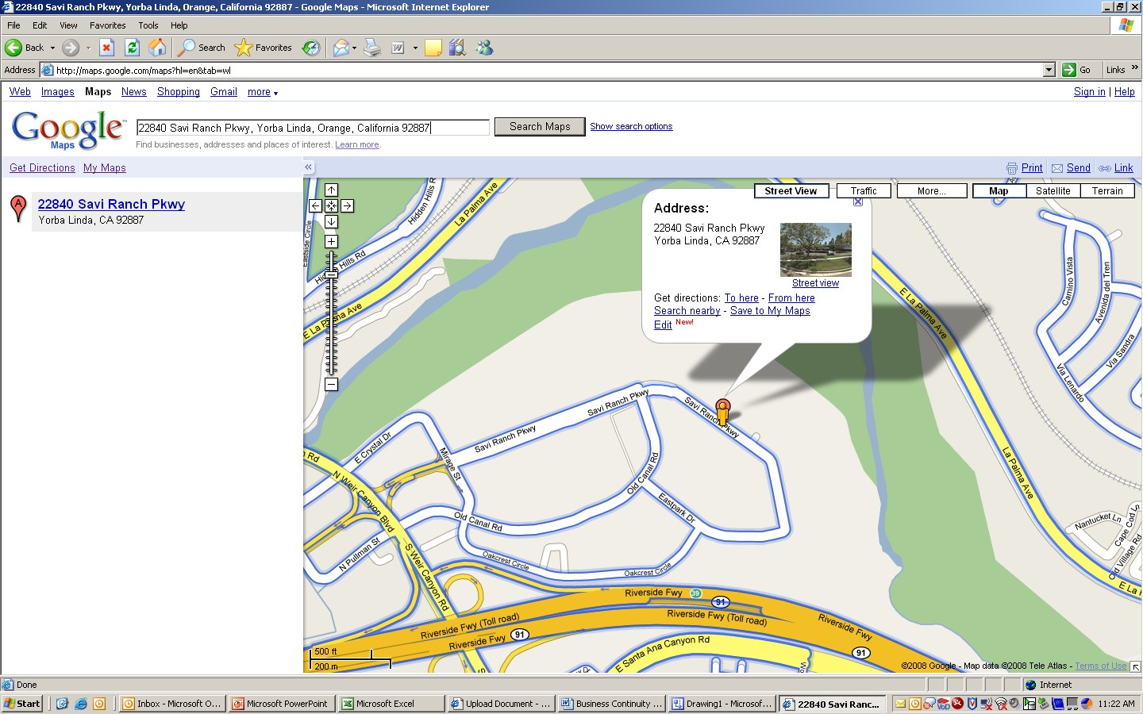

Alternate Assembly Site
Business Recovery Coordinator Name, Phone, Cell and Pager
Alternate Business Recovery Coordinator Name, Phone, Cell and Pager Emergency Representative Name, Phone, and Pager
Alternate Emergency Representative Name, Phone, and Pager Business Continuity Planner Name, Phone, Cell, and Pager Alternate Business Continuity Planner name, Phone, Cell, an Pager

Recovery Site Information, including


Address
Contact Names, Phone, Cell, and Pager Numbers Include directions to site (MapQuest, Google, etc.)
Define who can declare a disaster by Name, Title, Phone, Cell, and Pager

Critical Dependencies

Describe the critical dependencies associated with the Business Unit

Types of Disasters to Consider

Describe the types of events that would lead to a Disaster Declaration. The personnel authorized to declare a disaster are listed in the Initial Response section of this document along with their names and phone contact information in the order that they should be called. Examples of events that could lead to a Disaster Declaration are:

Type of Disaster | Severity | Actions to be taken
Loss of Power | High | Contact Building Management, Declare Disaster
Flood
Can not Access Building
Fire
Bomb Threat
Unavailability of Personnel

The types of disaster listed above will all have different impacts on the Business Unit’s ability to continue functioning, so a guideline has been established to help you decide when, and if, to declare a disaster and move operations to the recovery facility. Disaster Time is based on Criticality and Recovery Time Option (RTO). If you have a RTO of 4 hours and the First Responders say that your site will be lost for 12 – 18 hours, then you should initiate recovery procedures right away.

Recovery Strategies will be developed to respond to any of the Disaster Types listed above. These strategies must first protect people, then company business processes, applications, and locations.

Recovery Strategies will be based on 1 Day, 3 Day, 5 Day, Weeks 1-3, and Week 4-6 disaster event durations and the tasks to be performed at that time of the event.

Recovery Strategy

Describe the recovery strategies associated with the site / business unit for a disaster event. Include descriptions of activities associated with various time periods like:


Day 1
Day 3
Day 5
Weeks 1 through 3
Weeks 4 through 6

Functions to Recover

Describe each function that has to be recovered; their Primary Processing Site, their Recovery site, and the Recovery Time Option (RTO) associated with the business function being recovered.
Columns included in this area are:

Functions to Recover | Processing Site | Recovery Site | RTO
Function 1 | Local Site | Recovery Site | 24 Hours
Function 2 | Local Site | Recovery Site | 48 Hours
Accounts Receivable | NYC Data Center | NJ Data Center | 24 hours

Initial Response

Notification Checklist

This checklist will be used to guide the initial response to a disaster. Many of the tasks may be performed concurrently, and are not necessarily taken in the order presented. Not every task on this list may be appropriate to a particular situation. All actions should proceed from an assessment of the specific situation.

No. | Task | Responsibility | Date/Time | - Done
1. | Call local authorities.  Call local emergency number (911, or 9-911, as appropriate.
2. | Notify Security  Call the 24-hour number 1- -------------------  Call ----------- external or internal.
3. | Notify building management.  Notify enterprise wide building maintenance at --.  Notify building management office Larry Simcoe -------------
4. | Notify the business unit manager.
5. | Initiate evacuation procedures.  Evacuate the premises, if appropriate.
6. | Account for associates.  Assemble at a pre-designated assembly site for the post- evacuation head count; ensure that the business unit has updated home telephone listings for all associates.
7. | “Alert” recovery site.  “Alert” hot site of possible disaster declaration. Follow vendor procedures.
8. | Assess severity of situation.  If the situation is obviously long-term, send home associates not required for the initial recovery effort.
9. | Notify the recovery team leaders.  Use call lists.
10. | Convene the recovery team.  The recovery team leaders will meet to assess the situation, discuss options, and make decisions.
11. | Escalate the problem.  Recovery team leaders notify senior management, Business Continuity, and the Regional Support Team representative of the disaster.
12. | Activate the recovery plan.  Recovery team leaders together with their senior managers will decide if it is necessary to declare a disaster and activate the recovery plan.
13. | Declare Disaster with Recovery.  As appropriate, notify recovery site or cancel the “alert” status.

No. | Task | Responsibility | Date/Time | - Done
14. | Set up command post.  Recovery team leaders and designated associates set up command post to monitor activities.
15. | Notify Corporate Travel.  If travel arrangements are needed, contact Corporate Travel at 800-841-8048
16. | Notify business unit associates.  Notify business unit associates of disaster status, telephone number and location of the command post, and any action required by the associates.
17. | Notify key departments/clients.  The recovery team leaders or designated associates will notify key clients and departments of the disaster and any changes in procedures.
example notification script:
 For Email and telephone delivery:
Due to (name the event) on (date), the (name the business unit) will be unavailable for (name period of time or date, if known). For further assistance please call (contact name and phone number).
18. | Notify critical vendors.  The recovery team leaders or designated associates will notify  critical vendors of the disaster and any changes in procedures that may result.
19. | Liaison with Regional Support Team.  The recovery team will contact the Regional Support Team to coordinate the recovery effort.
20. | Notify key customers.  Recovery team leaders or designated associates will notify key customers of the disaster and any changes in procedures that may result.
21. | Mass communications with customers.  Corporate communications will handle all media responses. See call list.

Declaration Procedures

Disaster Declaration procedures are an important topic because it initiates procedures to transfer operations from a Primary Site to an Alternate Site and redirects Associates and other Personnel to perform their normal duties in a different manner. When a Disaster is declared the Alternate Site Vendor will begin charging and they will initiate Procedures to prepare to receive personnel and supplies from the Primary Site. For these reasons, and more, it is important to develop and implement Disaster Declaration Procedures as described here.

Disaster Time

A disaster declaration will be made within hours of the incident that disrupted normal business operations, unless the time needed to clear the disaster event is less that the time needed to move operations to the Recovery Facility.

Disaster Time is based on Criticality and RTO. It is used as a guideline for estimating the time needed to declare a disaster, after the event has occurred and you have weighed all available information from First Responders and other Enterprise Resiliency personnel.

Declaration Statement

A disaster declaration is a formal notification to the recovery site manager that the business unit is experiencing a disaster and wants to move to the recovery facility.

Provide samples of declaration statements so that the Authorized Associate will know what best to say when declaring a disaster to the recovery site vendor representative.

Disaster declaration procedures will vary by recovery site. Refer to the procedures established by the internal work area recovery site, or your external hot site vendor, as appropriate.

Include a written procedure for declaring a disaster under the General Recovery Activities - Recovery Procedures, section 4 of your Business Recovery Plan.

Declaration Authorization

The following is the calling order of associates authorized to declare a disaster and activate the recovery site. If the first associate on the list is not available, call the next associate; continue calling down the list until an AUTHORIZED ASSOCIATE is contacted:

 | Authorized Associate | Work Phone | Home Phone | Pager | PIN
1.
2.
3.

The AUTHORIZED ASSOCIATE must then call the recovery facility and notify the site manager, or other parties as documented in the business unit’s disaster declaration procedure.

In the case of declaring to the vendor for the hot site and/or RRC, there is an approved list of associates authorized to make the declaration statement and from whom the vendor will accept a declaration statement.

Roles and Responsibilities

Management Recovery Team

Management Team
Planning Tasks | - Appoints a business recovery coordinator to oversee plan development, maintenance and testing activities.  - Confirms the essential business functions and acceptable “downtime” for each function as identified by the business impact analysis.  - Accepts the risk for exposures, which they elect not to address, that have been identified in business impact studies or by internal and/or external auditors.  - Approves all alternate site decisions for the relocation of the business functions.  - Reviews business continuity plans to ensure compliance with corporate goals and priorities.  - Sets test objectives; reviews test plans to determine that essential requirements are met.  - Reviews test results and audit reports, ensuring corrective measures are detailed and actions are taken.
Recovery Tasks | - Assesses the level of the disaster.  - Activates the disaster recovery plan.  - Monitors the recovery process; provides regular reports on recovery status to appropriate groups i.e., Senior Line Management, Regional Team Representative, etc.  - Approves expenditures relating to recovery process.

Business Recovery Coordinator(s)

Business Recovery Coordinator(s)
Planning Tasks | - Coordinates plan development, maintenance and testing activities.  - Coordinates the planning activities of the business unit recovery team.  - Ensures that business impact analysis are performed and documented to identify the maximum acceptable time frames in which essential business functions could be inoperable without jeopardizing the company’s reputation or financial position.  - Ensures that all required equipment and facilities are provided at the alternate site.  - Determines that all records and resources required to support restoration of essential business functions, within the appropriate time frames, are available and kept offsite.  - Coordinates tests of recovery plan; initiates corrective actions resulting from tests.  - Updates business the recovery plans on a periodic basis, or as changes are made to business functions; distributes updates to those on plan distribution list.

Recovery Tasks | - Initiates disaster notification process; i.e., calling within business unit.  - Serves as liaison between business unit and Senior Management Team; escalates issues to Senior Managers.  - Acts as team leader for business unit recovery team.  - Tracks actual progress/completion of recovery activities against the projected sequence of recovery events.  - Submits final disaster assessment reports and actions plan to Senior Management Team.

Business Unit Recovery Team

Business Unit Recovery Team
Planning Tasks | - Develops procedures to recover essential business functions. (If no essential business functions are identified, ensures the minimal level of planning preparedness by ensuring notification lists and evacuation procedures are developed.)  - Identifies the resources needed to support restoration of essential business functions, within the appropriate time frames.  - Works with the technical support team to plan and execute disaster recovery exercises to determine whether essential business functions can be recovered within acceptable timeframes as outlined in the business recovery plan.  - Ensures that all staff members are familiar with departmental business continuity plans, recovery procedures and their assigned responsibilities  - Develops test plans; reviews test results and audit reports; plans and oversees corrective actions, as required.
Recovery Tasks | - Sets up alternate site.  - Oversees recovery logistics, travel, meals, and communications.  - Activates additional sub teams as needed depending on the circumstances

Business Unit Organization Chart

Provide a Business Unit Organization Chart with Associates names, Titles, and Responsibilities. This chart should be completed in either Visio or PowerPoint.

Insert an Organization Chart for the Business Unit Recovery Team and their functional titles.

Calling Trees

Provide a “Call List” of Business Unit Recovery Team members, the Business Unit Representative, and Alternate Business Unit Representative. Columns that should be included are:

Business Unit Associate is in

Associate Name | Title | Work Phone Number | Home Phone Number | Cell Phone Number

Alternate Site

Recovery Site Checklist

These steps should be assigned to recovery team members. In many cases, these steps are performed concurrently and not necessarily in the order given.

Task | Source/Reference | ☑  Done

1. | Confirm move to recovery site
 | a) Site availability
 | b) Transportation and Lodging

2. | Verify site requirements:
 | a) Facility (HVAC, accessibility)
 | b) Telecommunications | Site Agreements, Voice/Data Procedures
 | c) Furniture | Site Agreements, Requirements Matrix
 | d) Equipment | Site Agreements, Requirements Matrix
 | e) Security | Site Agreements, Requirements Matrix

3. | Verify operating requirements:
 | a) Staffing assignments / schedules
 | b) Systems accessibility | Requirements Matrix, Telecom Procedures
 | c) Redirection of reports | Requirements Matrix, Procedures
 | d) Retrieval of vital records/offsite materials
 | e) Supplies/Forms
 | f) Reroute phones/data lines | Telecommunications Procedures

4. | Notify:
 | a) Associates | Calling Trees, Call Lists
 | b) Applications Support / Technology Support | Calling Trees, Call Lists
 | c) Administrative areas (mail delivery,  interdependent departments) | Calling Trees, Call Lists
 | d) Key Customers | Calling Trees, Call Lists
 | e) Critical Vendors | Calling Trees, Call Lists
*Please note communication to any media source shall follow Corporate Communication policy guidelines.
5. | Periodically, report status to management.

☞ Customize the checklist for your business unit. In the Source/Reference column, list any Source Documents or Contacts that will be needed to complete the task. This will expedite the recovery process.

Relocation Information / Instructions

Provide detailed directions to the Recovery Facility via MapQuest or Google driving instructions or if distance is great compile detailed flight / car rental and local driving instructions to Recovery Facility. Include address of Recovery Facility and Contact information (Name, Phone, Cell, etc.).

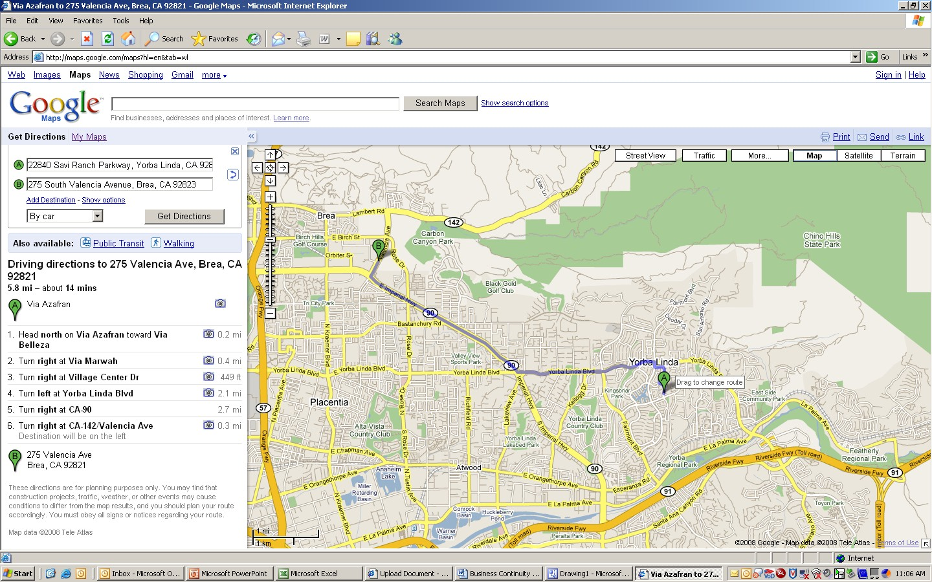

The above directions are provided by Google and this screen allows you to search for specific businesses like Hotel, Diners, Restaurant, etc. So by using Google, you not only get directions, but you solve other needs as well.

Layout of Recover Facility

Provide a Floor Plan of the Recovery Facility and the Seats that have been assigned to the Recovery Team Members.
Provide a detailed description of the facilities provided at the Recovery Facility Seat, including; RRC
Suite
Seat Number
LOB Functional Name Host name
Model Project Type OS
Set Model Phone Number Voice Features
BC Consultant Name

Transportation

Provide information regarding the use of transportation to the recovery site including: List of Rental Car Companies
Other modes of transportation that can be used (Train, Air, etc.) as needed.

Requirements Matrix

Provide a list of requirements by time period, including: Requirement
Number needed at each time interval (days, weeks, etc.) Totals
Specifics (Name, Make, Model, Speed, etc.)
This information should be provided for Associates and Equipment.

This table lists the equipment, connectivity, and personnel needed at designated intervals of time in the event of a disaster. The requirements are incremental; i.e., the requirements in each interval are in addition to the requirements in earlier intervals.

 | NUMBER NEEDED AT EACH INTERVAL
REQUIREMENTS | < 1  day | 3 Days | 5 Days | 1 – 3  Weeks | 4 – 6  Weeks | Totals | SPECIFICS  (Name, Make, Model, Speed, etc.)
Associates | 6 |  | 3 |  |  | 9 | Grp1 – 4, Grp2 – 2 Day 5 – Grp3, Grp4  Depend on seating may need to work swing shift
Equipment:
PCs/Configuration | 27 |  |  |  |  | 27 | See Application list on BIA
Terminals | 6 |  | 1 |  |  | 7
Mainframe | 6 |  | 1 |  |  | 7
Other (specify)
Telephone Handsets | 6 |  | 1 |  |  | 7 | Enable conference call feature on PBX on 6 phones after arrival on  I-Order
Features -
ACD
VRU
Voice Mail | 6 |  | 1 |  |  | 7
Headsets

Modems (Make, speed)
Printers:
Mainframe - VPS
LaserJet | 1 |  |  |  |  | 1
Other: (Specify)
Fax Machines | 1 |  |  |  |  | 1
Copiers | 1 |  |  |  |  | 1
Software
Network |  |  |  |  |  |  | Network Access
Internet Explorer |  |  |  |  |  |  | Internet access and Explorer NEED TO INCLUDE ALL SOFTWARE FOR ALL ASSOICATES IN  BUSINESS SUPPORT
Voice Lines | 6 |  | 1 |  |  | 7
Data Lines
Fax Lines | 1 |  |  |  |  | 1
Applications:
Mainframe (specify) | 6 |  | 1 |  |  | 7
Midrange (specify)
Standalone PC |  |  |  |  |  |  | Stand alone PC not needed

Applications needed for each business function

Provide a list of equipment and applications needed to support each business function being relocated to the recovery facility. This information should be total and complete for every business function and the associate being relocated to the recovery facility. The equipment and applications will be used to support business operation from the remote facility and everything the associate needed to perform his functional responsibilities and support the business should be provided.

Vital Records

A complete list of all Vital Records needed to support business unit operations should be provided and made available to the recovery team. Vital Records include documents, computers, fixed assets, and stationary as needed by associates and business unit managers. Information included in this section should include;

Business Unit Name Business Unit Manager
Contact(s) name, Phone, and Cell numbers Internal Mail Code
Description of Item Priority (1, 2, 3) Media Type
Specific Location (specific enough for fireman, building management, or security can locate them.

Example of Vital Records and Vital Equipment Form

Business Unit Name:
Business Unit Manager:
Contact(s):
Internal Mail Code:

Description of Item | Priority (1,2, 3) | Media Type | Specific Location
Laptops | 1 | Desk(s) of:
Paper, Pens, Pencils, staplers and push pins | 1 | Desk(s) of:
Paper work and boxes with no lids | 3 | Desk(s) of:

Vital Equipment

List of equipment that is vital to the operation of the business unit at a remote recovery facility, including:


Business Unit Name Business Unit Manager
Contact(s) name, Phone, and Cell numbers Internal Mail Code
Description of Item Priority (1, 2, 3)
Specific Location (specific enough for fireman, building management, or security can locate them.

Vital Equipment Form
Business Unit Name:
Business Unit Manager:
Contact(s):
Internal Mail Code:

Description of Item | Priority (1,2, 3) | Media Type | Specific Location

Recovery Procedures

General Recovery Activities

Provide a list of recovery activities associated with a General Recovery incident, including:

Initial Recovery
Responsibility
Action

Telecommunications

Voice Recovery tasks including
Responsibility
Action

Data Recovery tasks including:
Responsibility
Action

Vendor Connectivity tasks including
Responsibility
Action

Platform Restoration

Server Applications restoration tasks including:
Responsibility
Action

Desktop Applications / WAN Disk restoration tasks including:
Responsibility
Action

Retrieval of Vital Records tasks including:
Responsibility
Action

Reconstruction Procedures

Interim Operating Procedures tasks including:
Responsibility
Action

Validating Restored Applications tasks including:
Responsibility
Action

Processing Backlogged Work tasks including:
Responsibility
Action

Alternate Processing Procedures

ACD Logon Procedures including:
Responsibility
Action

Voice Mail Instructions including:
Responsibility
Action

Printer Selection Instructions including:
Responsibility
Action

Restoration / Migration

Relocation Checklist

These steps should be assigned to recovery team members. In many cases, these steps are performed concurrently and not necessarily in the order given. Decisions at time of a disruption should follow the dictates of common sense and should be based on sound management principles.

Move to Interim Site

No. | Relocation Tasks |  | Responsibility | Date/Time | Done  ☑
Move to Interim Site/ Return to Home Site
1 | Evaluate/Select interim sites
2 | Plan the relocation.
3 | Furnish the interim Site.
4 | Install the technology infrastructure.
5 | Hire a moving company.
6 | Schedule move to interim site.
7 | Pack.
8 | Forward mail.
9 | Notify.

Return to Primary Site

No. | Relocation Tasks |  | Responsibility | Date/Time | Done  ☑
Move to Interim Site/ Return to Home Site
1 | Evaluate/Select Primary sites
2 | Plan the return / relocation.
3 | Furnish the Primary Site.
4 | Install the technology infrastructure.
5 | Hire a moving company.
6 | Schedule return move to Primary site.
7 | Pack.
8 | Forward mail.
9 | Notify.
10 | Return to Primary Site
11 | Unpack
12 | Validate everything is working
13 | Notify support and suppliers to reroute to Primary

Call Lists

Application Support

Application | Contact | Work Phone | Address | Other Phone Pager
MS Office Suite
MS Outlook
Call Tree Product
Intranet/Internet
Novell
Executive Software Diskeeper
Adobe 6.0 Professional
Adobe Reader 6.0
Acrobat Distiller 6.0
Transfer Data
Etc….
Please list a primary and alternate contact for each application.

Associates

Name | Dept. | Address | Work Phone  Home Phone | Pager  Cell Phone | Comments  Logon ID

Customers

DO NOT DISCUSS DETAILS OF THE PROBLEM WITH INDIVIDUALS EXTERNAL TO THE COMPANY.
*Please note communication procedures shall follow Corporate Communication policy guidelines.

Company | Contact | Work Phone | Address | Other  Phone / Pager

Other Departments

Department | Contact Name | Work Phone Home Phone | Address | Cell Phone Pager
Chargeback Dept.
Cash Research Dept.
ICA Liaison

Vendors

DO NOT DISCUSS DETAILS OF THE PROBLEM WITH INDIVIDUALS EXTERNAL TO THE CORPORATION.
*Please note communication procedures shall follow Corporate Communication policy guidelines.

Vendor | Contact | Work Phone | Address | Other  Phone / Pager | Product / Service
Vendor Management
Security Metrics
Iron Mountain

Regional Support Teams

Name | Department | Work Phone | Pager | Home Phone
 | Support Team Leader
 | Alternate for Regional Support Team

Other Contacts

Name | Department | Work Phone | Pager | Home Phone

Documents needed at time of Disaster

  - Expense Log
  - Recovery Hours Log
  - Recovery Status Report
  - Forms Requirements
  - Required Reports/Applications

Request for Credit Card Increase

Manager
{Business Unit Name}
{Date}

Commercial Card Services/Customer Service Phone: (000) 000-0000
Fax: (000) 000-0000

Increase in Credit Limit

As a result of the {disaster description} in {state}, it has become necessary to raise the credit limit on account number {card number} to $ {amount} effective immediately. Upon completing our mission in this state, we will contact you to lower this limit to the card's assigned status.

{Printed name of approver}
{Title}
{Phone Number}

Expense Log

Business Unit Manager:
Business Unit Location: | Internal Mail Code
G/L Company No. | G/L Cost Center No.

DATE | ITEM | VENDOR | COST | APPROVED  BY | PURPOSE /  COMMENTS

Recovery Hours Log

Employee Name: |  | SSN:
Payroll Company: |  | Telephone:
Payroll Cost Center: |  | Page | of
The purpose of the Hours Log is to document hours worked or missed as a direct result of a Bank disaster. The information reported on this form will be used in the filing of the insurance claim for business interruption loss.
Each employee directly affected by the disaster is asked to complete the following schedule and submit it to the Business Recovery Coordinator who will forward it to the Finance Division contact.

DATE | REASON | Hours Missed  (Due to Disaster) | Hours Worked  (Disaster Related) | Overtime Worked  (Disaster Related) | Total Hours
 | TOTAL HOURS

Recovery Status Report

 Send completed report to Customer Group Business Continuity Planner

Business Unit Name:
Business Unit Manager:
Completed By: |  | Date:
Phone Number: |  | Time:

1 | Disaster Location:
2 | Associate Status:
3 | Recovery Status:
4a | Did you move associates to alternate work locations? | - Yes | - No
4b | Are associates still in the alternate work locations? | - Yes | - No
4c | Please list business functions moved and number of people for each.
5 | Recovery Location/Alternate Site:
6a | Did you implement other workarounds? | - Yes | - No
6b | If yes, please list. Indicate which workarounds are still being used.
7a | Do you still have a backlog of work related to outage disruption? | - Yes | - No
7b | When do you expect backlog to clear?
7c | Please list types of work and amount of backlog.
8a | Was there direct customer impact? | - Yes | - No
8b | Is there still direct customer impact? | - Yes | - No
8c | Please list types of impact.
9a | Did you experience legal / regulatory impact? | - Yes | - No
9b | Are you still experiencing legal / regulatory impact? | - Yes | - No
9c | Please list types of impact.
10a | Did you experience significant financial impact? | - Yes | - No
10b | Are you still experiencing significant financial impact? | - Yes | - No

10c | Please list types of impact.
11a | Are there major impacts to any highly critical projects? | - Yes | - No
11b | What impact do you expect the outage to have on month-end processing and/or year-end processing?
12 | Do you anticipate any issues associated with a move back to your home site? | - Yes | - No
 | If yes, please list.
13a | Have you incurred any expenses as a result of the outage? | - Yes | - No
13b | Have you documented any expenses incurred? | - Yes | - No
13c | List types of expenses.

Please explain all answers in detail. Use separate sheet of paper, if necessary.

Forms Requirements

A sample of each form requested must be attached to any order submitted to Corporate Procurement!

Form  Number | Form Name | UOM* | Quantity | Offsite  (Y/N)**

* UOM (Unit of measurement, box, each, packet, etc)
** Make sure any forms stored offsite are listed in the items to be retrieved from off-site storage in the event of a disaster.

DELIVER TO:

Name
Address
Phone Number
Bank/Cost Center
Approval (BRC)

Required Reports

Report (Application) | Number | Number | Name | # of Copies | Backcopies (# Days) | 1 | 2 | 3

Location at which reports are printed: | Paper Reports -
Contact Name/Phone:
Procedures for Rerouting:
Location at which reports are printed: | Microfiche -
Contact Name/Phone:
Procedures for Rerouting:

