


Template Courtesy of:
Cloudnition LLC
55 W. 22nd St Suite 115 Lombard, IL 60148 (630) 297-4090 www.cloudnition.com

1


- Introduction
- Purpose
- Priorities

- About your business

  - Business description
  - Current IT environment
  - Current network services descriptions
  - Define critical business processes
- Risk assessment scorecard

- Disaster recovery and business continuity
  - Goals

  - Define objectives
  - Checklist
  - Gaps

- Establish teams

  - Key business stakeholders
  - Disaster recovery team
  - Calling tree
  - Outside vendors

3.3Key areas of preparation

  - Call center
  - Emergency messages
  - Passwords, product keys, warranty info
  - Network connectivity
  - Backups

  - Inventory of systems
  - Remote workers (Hot Sites)
  - Redundancy/High availability

- Declare emergency
- Mobilize DR team
- Notify employees

- Restoration process

  - Restore critical processes for emergency level of service

  - Restore processes for key business services
  - Restore to business as usual
- Scenarios
  - Loss of power (Example Scenario 1)

  - IT systems failure (Example Scenario 2)


2

  - Loss of access to building (Example Scenario 3)

  - Create more scenarios

- Damage and assessment
- Insurance

- Financial impact / BIA
- Recovery success evaluation
- Suggest improvement to plan

6.1 Distribution
6.1 Repository

- Accessibility

- Change management
- Alternate versions



Appendix A- Systems Inventory

3




This document is a comprehensive disaster recovery plan prepared documenting the key systems and resources that must be recovered in the case of an IT systems failure.

Do not restrict yourself to the version of this document, which Cloudnition has provided. This template is a starting point; as disaster recovery plans naturally evolve with time, you are encouraged to make changes to the template to best fit your business. Add sections that fall outside the scope of Cloudnition’s expertise and remove sections that to not apply to your business.


The purpose of this exercise is to provide a structured methodology and framework for a disaster recovery plan that will allow the user to continue and recover critical business processes in the event of a disaster that compromised IT systems.

This document will be used to assess and mitigate your current level of risk, develop a disaster recovery team, gather and organize critical contact information, gather and organize critical systems information, identify and prioritize key business practices, set disaster recovery objectives, create an executable recovery plan, and report and track recovery in the event of a disaster.


This document will assist in defining the critical priorities for continuing or restoring your business operations whether it be customer communications, website functionality, storefront on main street, or whatever your specific business needs are. This document will also prioritize IT systems essential to critical business processes. Based on these critical priorities and the business continuity solutions in place, this document will also assist in creating disaster recovery objectives.

A short business description that should include industry, number of employees, organization chart, list of departments, etc.

4



What is your current technology infrastructure comprised of?

Include: Upload/download speed, number of internet connections, number of providers, type of network, backup providers, description of provided services.

5


Every business is different, here we will identify each of the key business practices that you choose and rank them starting with most critical to your business.

Key Business Process | Importance/Rank | Priority Level | Dependencies

What disasters are most likely? Most impactful?

Potential disasters have been assessed as follows:

Probability: 1=Very Low, 5=Very High |  | Impact: 1=Minor Annoyance, 5=Total Destruction
Potential Disaster/DR Plan Triggering Events | Probability |  | Impact | Brief Description Of Potential Consequences
Potential Disaster/DR Plan Triggering Events | Rating |  | Rating | & Remedial Actions

Business Continuity is devising a plan that allows a business to function during or quickly after a disaster. Disaster Recovery is a portion of business continuity that focuses IT resources.

6


What are your goals for disaster recovery? Is there a business process that should be uninterrupted during disaster?

Set goals for your recovery which are specific to your businesses needs as well as its capabilities.

Recovery Level Objective (RLO): Prioritize your recovery, after disaster strikes it is unlikely that you can recover everything instantly and simultaneously. What do you need for emergency level of service? What do you need to launch key business processes? What do you need for business as usual? Will your objectives be categorized into more than three groups?

Recovery Time Objective (RTO): For each level of recovery provide a recovery time objective. Be aware of what your capabilities are, granular recovery of important emails is much faster than recovering entire exchange servers.

Level of Recovery | Recovery Time Objective

Establish an emergency level of service within

Restore Key Services within

Recover to BAU within

7

Recovery Point Objective (RPO):

The recovery point objective is the point back in time to which you wish to restore from. This will be your most recent backup. For example if you want to restore data to the way it looked an hour before the disaster then you should be backing up every hour. The way you set your RPO will dictate how often you should perform backups. Your Recovery Point Objective could be different for each file system; those, which are mission critical, should be backed up continuously or very often. Less important, or non-mission critical, files can be backed up less frequently.


What technologies do you currently have in place to aid in the disaster recovery process? Are there any you want to add? Any you are curious about?

Business Continuity Process | Yes | No | I want that | What is
 |  |  |  | that?

Local Backups

Cloud Backups

Call Rerouting Capabilities

Fully Redundant Hot Site

Uninterrupted Power Supply

Backup generator

4G wireless internet connection


Is there any solution you need to implement to reach the objectives set in 3.1.2

8



Your disaster recovery team should be fully capable of restoring your key business processes after a disaster. The disaster recovery process should be overseen by key business stakeholders. The stakeholders are typically c-level members of the organization who have a stake in their department. The disaster recovery team should be comprised of members from each department of your company and should be fully capable.

The key business stakeholders are usually department heads, c-level executives, and principals. These people may have a financial interest in recovering quickly. At most mid sized and large organizations these people will not directly contribute to the recovery process; however, at small and very small businesses these people will likely be an integral part of both the key business stakeholders and the disaster recovery team.

Name, Title | Contact Option | Contact Number
IT Systems | Work
 | Alternate
 | Mobile
 | Home
 | Email Address
 | Alternate Email
Financial | Work
 | Alternate
 | Mobile
 | Home
 | Email Address
 | Alternate Email
Sales | Work
 | Alternate
 | Mobile
 | Home
 | Email Address
 | Alternate Email
HR | Work
 | Alternate
 | Mobile
 | Home
 | Email Address
 | Alternate Email
Marketing | Work
 | Alternate
 | Mobile
 | Home
 | Email Address
 | Alternate Email

9



Disaster Recovery Coordinators are the most important people on the day of a disaster. Usually these are IT managers, operations managers, and financial managers. They have the capabilities to restart and reconfigure systems, resume key business processes, open communications, and make critical financial decisions. After selecting coordinators, the rest of the team should be filled with other employees capable of helping the coordinators execute the disaster recovery plan.

Name, Title | Contact Option | Contact Number
DR Coordinator | Work
 | Alternate
 | Mobile
 | Home
 | Email Address
 | Alternate Email
DR Coordinator 2 | Work
 | Alternate
 | Mobile
 | Home
 | Email Address
 | Alternate Email
 | Work
 | Alternate
 | Mobile
 | Home
 | Email Address
 | Alternate Email
 | Work
 | Alternate
 | Mobile
 | Home
 | Email Address
 | Alternate Email
 | Work
 | Alternate
 | Mobile
 | Home
 | Email Address
 | Alternate Email
 | Work
 | Alternate
 | Mobile
 | Home
 | Email Address
 | Alternate Email

10


Always have backups!

Name, Title | Contact Option | Contact Number
Alternate Coordinator | Work
 | Alternate
 | Mobile
 | Home
 | Email Address
 | Alternate Email
Alternate Coordinator 2 | Work
 | Alternate
 | Mobile
 | Home
 | Email Address
 | Alternate Email
 | Work
 | Alternate
 | Mobile
 | Home
 | Email Address
 | Alternate Email


Cloudnition suggests building a call tree, we also suggest having this calling tree in section 4.2 of this document.

11


Keep a list of important outside contact information. The following list has been filled in, feel free to customize it for your organization. (examples)

Name, Title | Contact Option | Contact Number
Landlord / Property Manager
Account Number None
 | Work
 | Mobile
 | Home
 | Email Address
Power Company
Account Number | Work
 | Mobile
 | Home
 | Email Address
Telecom Carrier 1
Account Number | Work
 | Mobile
 | Fax
 | Home
 | Email Address
Telecom Carrier 2
Account Number | Work
 | Mobile
 | Home
 | Email Address
Hardware Supplier 1
Account Number | Work
 | Mobile
 | Emergency Reporting
 | Email Address
Server Supplier 1
Account Number. | Work
 | Mobile
 | Fax
 | Email Address
Workstation Supplier 1
Account Number | Work
 | Mobile
 | Home
 | Email Address
Office Supplies 1
Account Number C3095783 | Work
 | Mobile
 | Home
 | Email Address

12

Name, Title | Contact Option | Contact Number
Insurance – Name
Account Number | Work
 | Mobile
 | Home
 | Email Address
Site Security –
Account Number | Work
 | Mobile
 | Home
 | Email Address
Off-Site Storage 1
Account Number | Work
 | Mobile
 | Home
 | Email Address
Cloud Storage
Account Number | User ID
 | Password
 | Home
 | Email Address
HVAC –
Account Number | Work
 | Mobile
 | Home
 | Email Address
Power Generator –
Account Number | Work
 | Mobile
 | Home
 | Email Address
Other –
Account Number | Work
 | Mobile
 | Home
 | Email Address

13



Usually communication is number one priority for a company. Do you have a call center that you need to relocate after a disaster, or can you reroute calls to an alternate call center. How do you plan on fielding calls?


Do you have the ability to disperse outgoing messages to your employees and contacts? What medium of communication do they use? How do you initiate the messages?


You can report non-private passwords here or password locations; otherwise, password owners can be identified with contact info provided. Critical and private passwords should be kept offsite in a safe or safety deposit box.

Passwords
System | Username/Login | Password/Password Owner
Program License Keys
Program | License Key | Other

14

Warranty Info

Product Warranty Exp Receipt/Warranty Information

Date

Diagram your network architecture in a drawing. Include ISP. Type of internet, modem, routers, switches, servers, firewalls, SAN, WAN, VoIP


Record the location where backups are stored, document the backup schedule, and description of backups.

 | Onsite | Offsite | Description | Frequency of Full | Frequency of
KEY BUSINESS PROCESS | Onsite | Backup | Bare metal/File & | Backups | Incremental
KEY BUSINESS PROCESS | Backup
 | Backup |  | Folder |  | Backups

15


It is important to know what hardware you are currently running your systems on. This information could be critical if you need to replace some of your hardware. You must identify and record technical specifications, physical locations, model numbers, disk size, vendors, applications, warranty information, and other critical information.

Prepare and designate alternate/remote work sites

In the event that the office is inaccessible, it is a good strategy to have an alternate site, or a location where you can temporarily resume emergency or key business processes until a permanent location is secured. This may be another branch office, a stand by emergency office, the nearest Starbucks, or a work from home arrangement.


A cold site is the most inexpensive type of backup site for an organization to operate. It does not include backed up copies of data and information from the original location of the organization, nor does it include hardware already set up. The lack of hardware contributes to the minimal start-up costs of the cold site, but requires additional time following the disaster to have the operation running at a capacity close to that prior to the disaster.

-or-


A hot site is a duplicate of the original site of the organization, with full computer systems as well as near-complete backups of user data. Real time synchronization between the two sites may be used to completely mirror the data environment of the original site using wide area network links and specialized software. Following a disruption to the original site, the hot site

16

exists so that the organization can relocate with minimal losses to normal operations. Ideally, a hot site will be up and running within a matter of hours or even less.

EXAMPLE 1 – FULLY MIRRORED HOT SITE

Key business processes and the agreed backup strategy for each are listed below. The strategy chosen is for a fully mirrored recovery site at ___________________________. This strategy entails the maintenance of a fully mirrored duplicate site, which will enable instantaneous switching between the live site (headquarters) and the backup site.

KEY BUSINESS PROCESS | REDUNDANT CLONE or HIGH AVAILABILITY
KEY BUSINESS PROCESS | STRATEGY

IT Operations

Tech Support - Hardware

Tech Support - Software

Development/Engineering

QA

Monitoring

Facilities Management

Email

Purchasing

Disaster Recovery

Finance

Contracts Admin

Warehouse & Inventory

Product Sales

Business Development

Human Resources

EXAMPLE 2 – HIGH AVAILABILITY VIRTUALIZATION AND HYBRID CLOUD


17



Person identifying disaster should immediately contact the DR Leaders. Define any other protocols you may find necessary for this person after indentifying a disaster.

How will you mobilize your Disaster Recovery Team? Calling trees are usually your best option. Don’t forget cell phone numbers and alternates coordinators. Other methods include e-mail, collaboration tools, SMS tools, etc.


Once the disaster recovery team gets to work, how will you notify the rest of your employees. What instructions would you likely give them.

18


Document the order in which to restore processes.
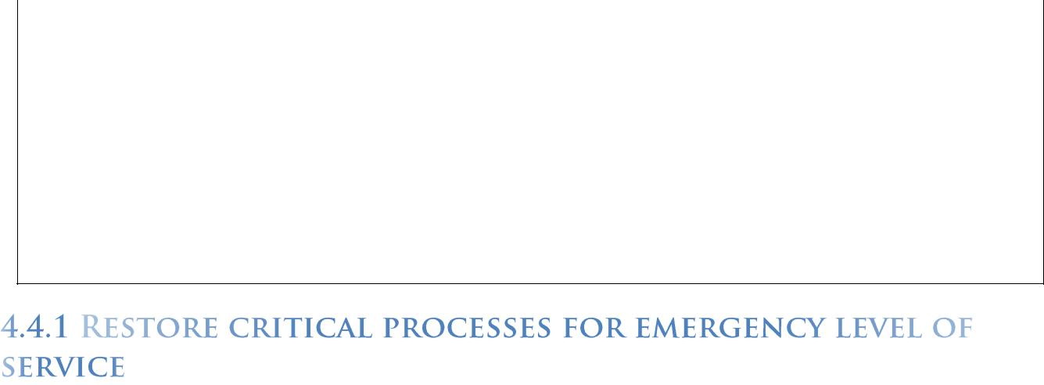

Decide beforehand which business processes are required to provide an emergency level of service to your customer. You can find some of this information from section 2.1.4. What is absolutely essential to you making money or keeping customers from leaving? What dependencies do those processes have? And what steps must be taken to recover said processes?

Rank | Business Process | Dependencies | Other Instructions

Rank | Business Process | Dependencies | Other Instructions

19


Rank | Business Process | Dependencies | Other Instructions


Choose some scenarios and create predesigned responses for them. Identify where you are most vulnerable. What will you experience often and what will hurt you most?

[Snow Storms, Robbery, Fire, Gas Leak, Flood, Flu Outbreak]

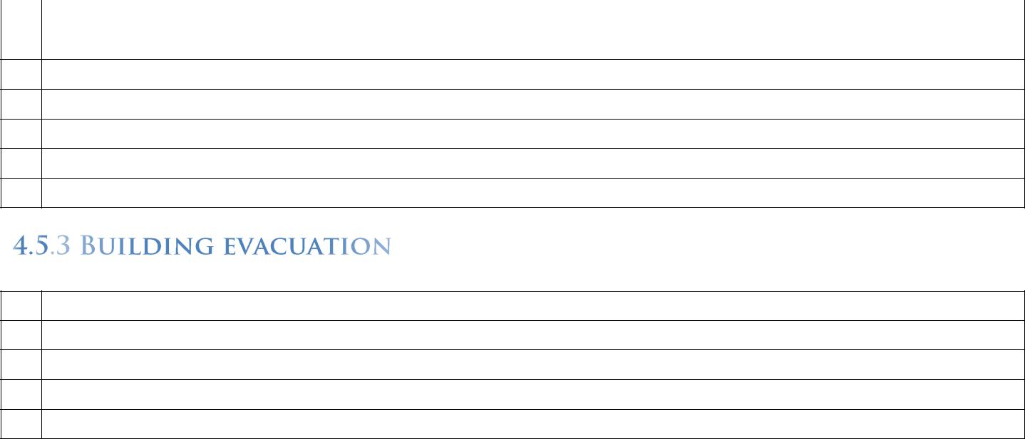

20

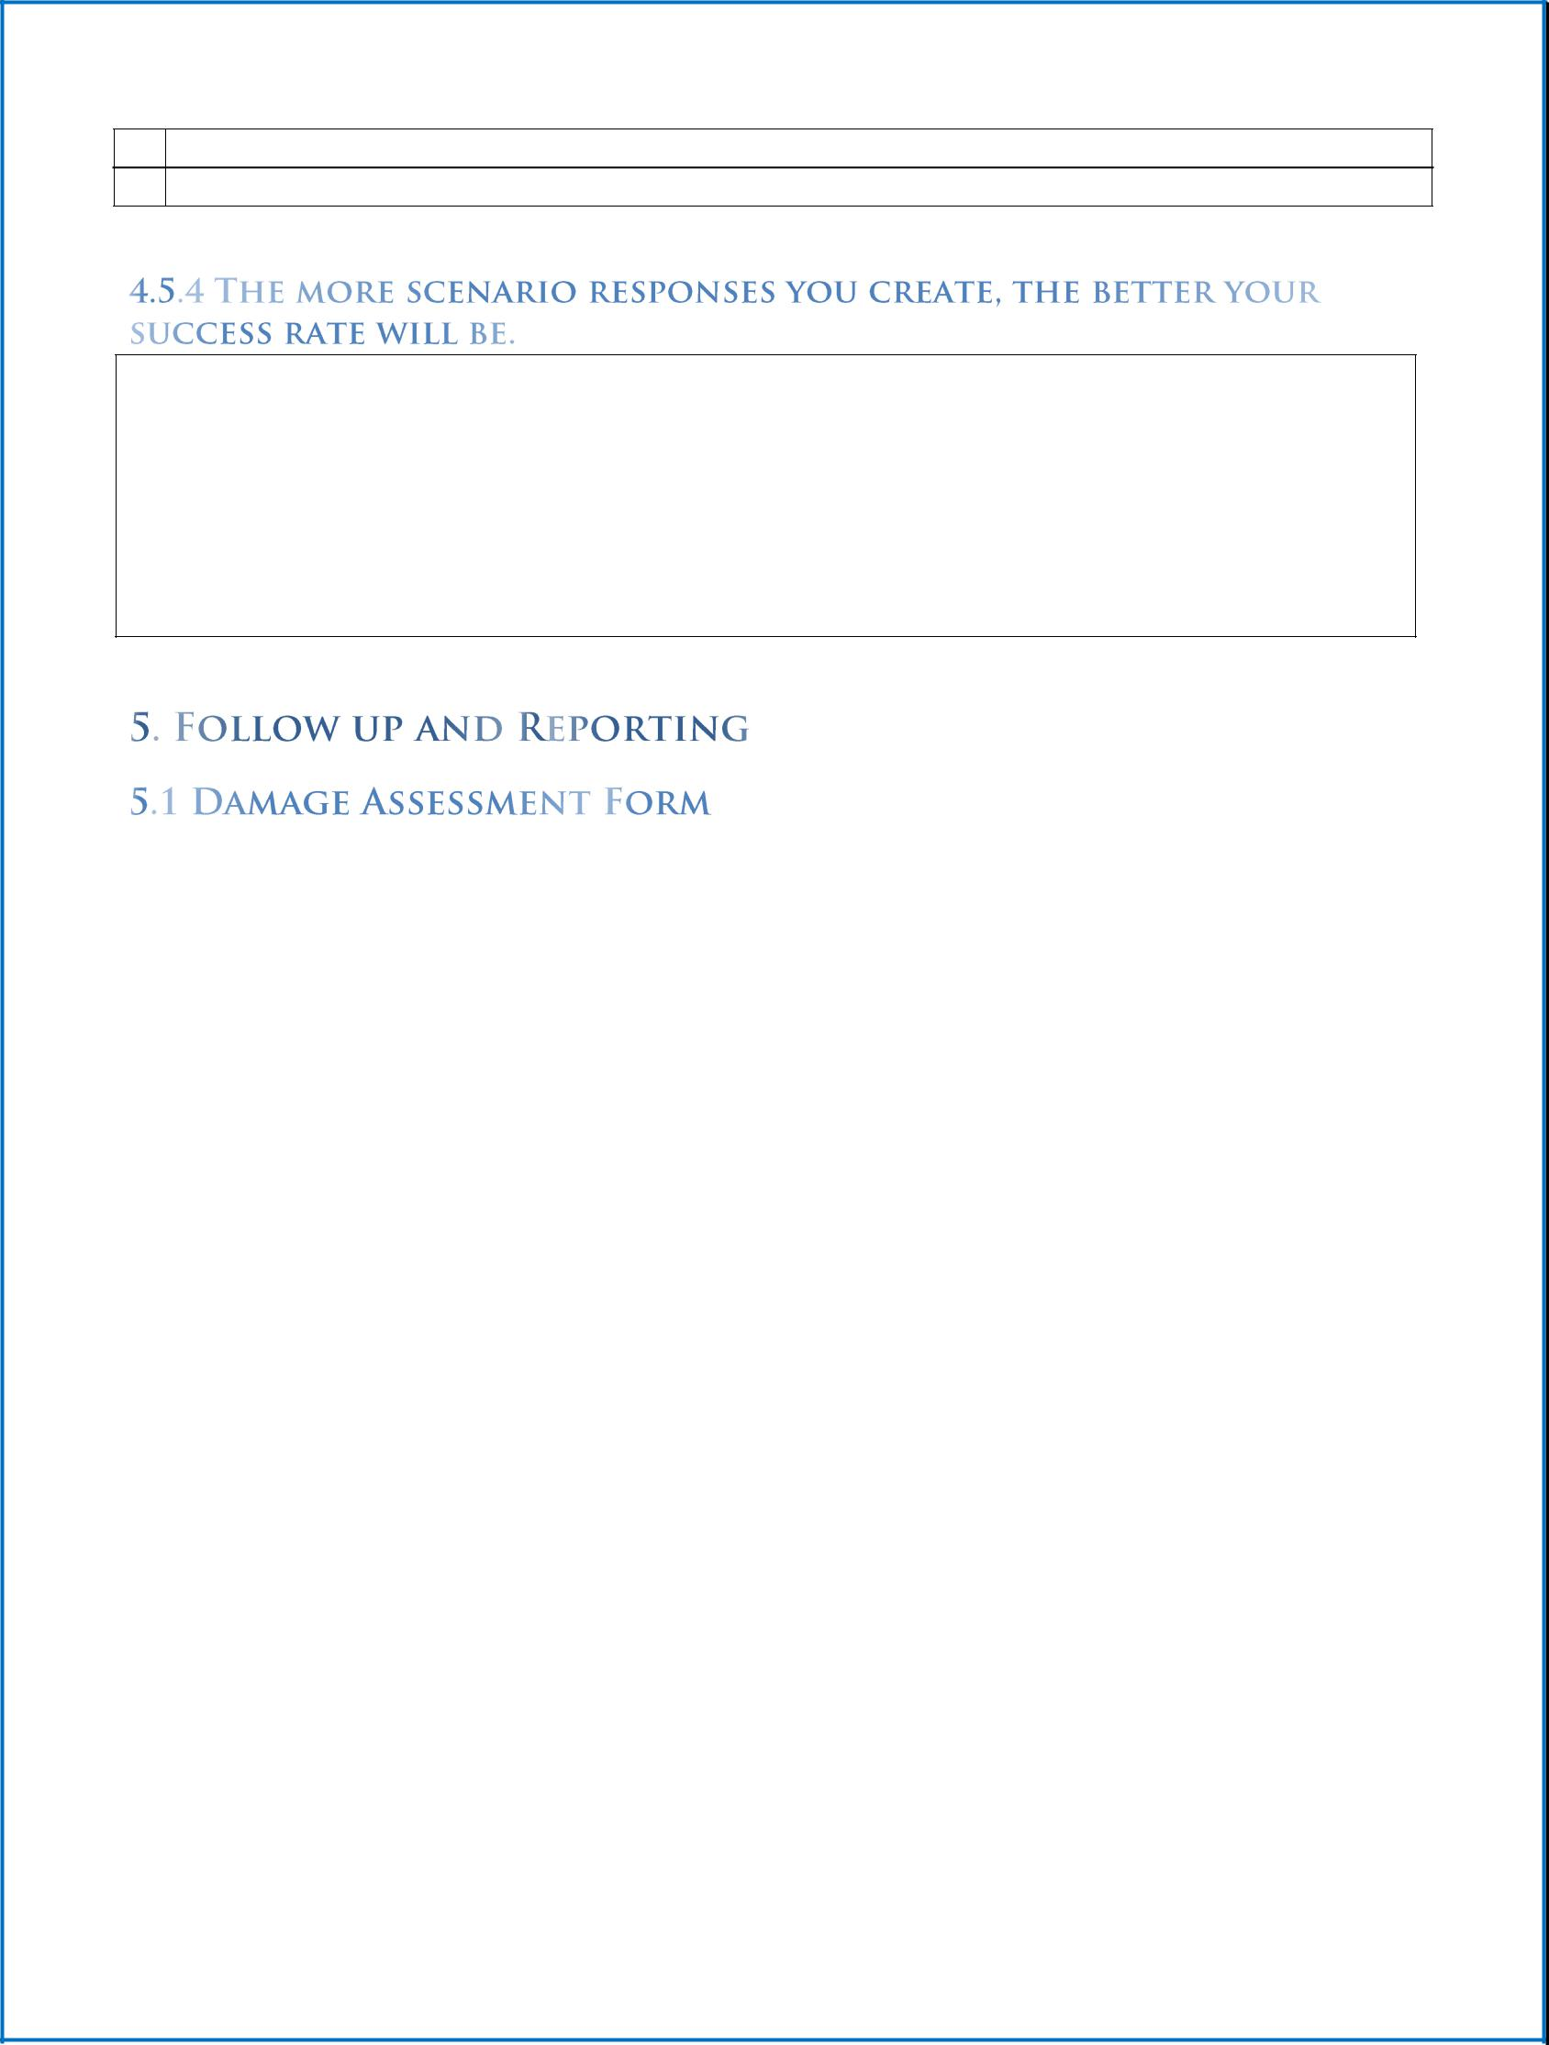

Key Business | Description Of Problem | Extent Of Damage
Process Affected | Description Of Problem | Extent Of Damage


As part of the company’s disaster recovery and business continuity strategy a number of insurance policies have been put in place. These include errors and omissions, directors & officers liability, general liability, and business interruption insurance.

If insurance-related assistance is required following an emergency out of normal business hours, please contact: ____________________________________________

 |  | Coverage | Amount Of | Person | Next Renewal
Policy Name | Coverage Type | Coverage | Amount Of | Responsible | Next Renewal
Policy Name | Coverage Type | Period | Coverage | Responsible | Date
 |  | Period | Coverage | For Coverage | Date

21


Use this section to assess financial impacts the disaster has on your business

Financial Impact | Description | Exact/Estimated Cost
Lost sales
Lost customers
Compliance/Regulatory
Reputation damage
Hardware damage
Productivity
Physical Damage

Create a list of everything that had to be recovered, whether the recovery was successful, and how long it took.

System | Success/Fail | Time to Recovery
 |  | (actual/objective)

Fill out suggestions on how to improve this plan after disasters and drills.



Each employee should have a hard copy both at home and the office.

22


An electronic version should be distributed which should be stored onsite and backed up to the cloud for remote access.


We also suggest publishing an online .pdf form on your website or employee portal.

Some of the information in this document will change over time. This is an IT DR plan so we suggest that your disaster recovery coordinator who is in the IT department be responsible for that aspect. This person is likely most familiar with the plan and on the disaster day he/she is the one who will depend on this plan. Document new hardware, software, service providers, and personnel.

This disaster recovery plan may hold sensitive information. Will each employee have the same version? Employees with different responsibilities or clearance levels may receive different versions of this plan.

Schedule regular drills, every 6 months or more often. Run drills as if they are real disasters and always make upgrades and modifications to improve the disaster recovery documents. This should be a living-breathing document that evolves with your business to provide the best possible outcome from unexpected IT disasters. Next Scheduled DR Drill:

23

Appendix – Systems Inventory

3.3.6 Inventory of Systems – APPENDIX

SERVERS

SYSTEM

OVERVIEW
PRODUCTION SERVER |  | Location:
 |  | Server Model:
 |  | Operating System:
 |  | CPUs:
 |  | Memory:
 |  | Total Disk:
 |  | % Used:
 |  | System/Admin Handle:
 |  | System/Admin Password:
 |  | System Serial #:
 |  | DNS Entry:
 |  | IP Address:
 |  | Other:
 |  | Warranty Information:
HOT SITE SERVER |  | Provide details if applicable
APPLICATIONS
(Use bold for Hot Site)
ASSOCIATED SERVERS
KEY CONTACTS
Hardware Vendor
System Owners
Database Owner
Application Owners
Software Vendors
Offsite Storage
BACKUP STRATEGY FOR
SYSTEM ONE
Daily
Weekly
Monthly

24

SERVER ONE

DISASTER RECOVERY
PROCEDURE

Provide details

Scenario 1

Total Loss of Data

Provide details

Scenario 2

Total Loss of HW

ADDENDUM - Internal contact information for help troubleshooting server solutions

CONTACTS

File Systems <date>

 | File System as of |  |  |  | Filesystem | kbytes | Used | Avail | %used | Mounted on
 | <date>
 |  |  |  |  | <Provide details> | Critical file directories must be restored first, depending an
 | Minimal file systems to |  |  |  | how much data you have full restoration could be too long to wait for some of
 | be created and restored |  |  |  | your files. Based on estimated speed to recovery (5mbs for online restore)
 | from backup: |  |  |  | prioritize files to be restored, small files can be restored in less than a second,
 |  |  |  |  | large folders could take hours, plan accordingly.
 | <List>
 | Other critical files to
 | modify
 | Necessary directories to
 | create
 | Critical files to restore
 | Secondary files to
 | restore
 | Other files to restore

25

Local Area Network

SYSTEM

OVERVIEW
Firewall | Internet Service Provider:
 | Account information:
 | Device Type:
 | Model Number:
 | Technical Specifications:
 | Power Requirements:
 | System Serial #:
 | DNS Entry:
 | IP Address:
 | VPN:
 | Port Settings:
 | Other:
HOT SITE EQUIPMENT
SPECIAL APPLICATIONS
ASSOCIATED SERVERS
KEY CONTACTS
Hardware Vendor
System Owners
OVERVIEW
Modem | Internet Service Provider:
 | Internet Type:
 | Account information:
 | Device Type:
 | Model Number:
 | Technical Specifications:
 | Power Requirements:
 | System Serial #:
 | DNS Entry:
 | IP Address:
 | Other:
HOT SITE EQUIPMENT
SPECIAL APPLICATIONS
ASSOCIATED SERVERS
KEY CONTACTS
Hardware Vendor
System Owners

26

OVERVIEW
Router | Device Type:
 | Model Number:
 | Technical Specifications:
 | Power Requirements:
 | System Serial #:
 | DNS Entry:
 | IP Address:
 | Routing Protocols:
 | Passwords/Security Type:
 | Wi-fi Security Protocol:
 | Other:
HOT SITE EQUIPMENT
SPECIAL APPLICATIONS
ASSOCIATED SERVERS
KEY CONTACTS
Hardware Vendor
System Owners
OVERVIEW
Switch | Device Type:
 | Model Number:
 | Technical Specifications:
 | Power Requirements:
 | System Serial #:
 | DNS Entry:
 | IP Address:
 | Routing Settings:
 | Other:
HOT SITE EQUIPMENT
SPECIAL APPLICATIONS
ASSOCIATED SERVERS
KEY CONTACTS
Hardware Vendor
System Owners
 | You can backup your running configurations. Firewall settings, switch
BACKUP STRATEGY for | configurations, router configurations, etc
SYSTEM TWO
Daily
Monthly
Quarterly

27

SYSTEM TWO

DISASTER RECOVERY
PROCEDURE

Provide details

Scenario 1

Stops Working

Provide details

Scenario 2

Damage/Loss of HW

ADDENDUM

CONTACTS

Systems Inventory for Voice Communications

SYSTEM

28

OVERVIEW
EQUIPMENT |  | Location:
 |  | Provider:
 |  | Phone Type: PBX, VoIP
 |  | Manufacturer:
 |  | Model No.:
 |  | Technical Specifications:
 |  | Mac Address
 |  | Network Interfaces:
 |  | Power Requirements;
 |  | System Serial #:
 |  | DNS Entry:
 |  | IP Address:
 |  | Other: Local Lines, 800 numbers, PRI SIP POTS, tel #s, fax#s, alarms,
 |  | private lines, point to point lines, personal lines
HOT SITE EQUIPMENT |  | Provide details
SPECIAL APPLICATIONS
ASSOCIATED DEVICES
KEY CONTACTS
Hardware Vendor
System Owners
Database Owner
Application Owners
Software Vendors
Offsite Storage
Network Services Provider
BACKUP STRATEGY for
SYSTEM TWO
Daily
Monthly
Quarterly

29

SYSTEM TWO

DISASTER RECOVERY
PROCEDURE

Provide details

Scenario 1

Loss of Network

Provide details

Scenario 2

Loss of Hardware

ADDENDUM

CONTACTS

Support Systems <date>

Support system

Critical network assets

Critical interfaces

Critical files to restore

Critical network services to restore
Other services

30

