

Disaster Recovery Plan Template

Section 1: Plan goals

The major goals of this plan are:

- To minimize interruptions to the normal operations.
- To limit the extent of disruption and damage.

- To minimize the economic impact of the interruption.

- To establish alternative means of operation in advance.
- To train personnel with emergency procedures.

- To provide for smooth and rapid restoration of business operations.

Section 2: Disaster recovery procedures

For any disaster recovery plan, the following three elements should be addressed.

Emergency Response Procedures
- To document the appropriate emergency response to a fire, natural disaster, or any

other activity in order to protect lives and limit damage.
Backup Operations Procedures

- To ensure that essential data processing operational tasks can be conducted after the disruption.

Recovery Actions Procedures
- To facilitate the rapid restoration of a business operations following a disaster.

Section 3: Company personnel

Name Position Address Telephone

1 | P a g e

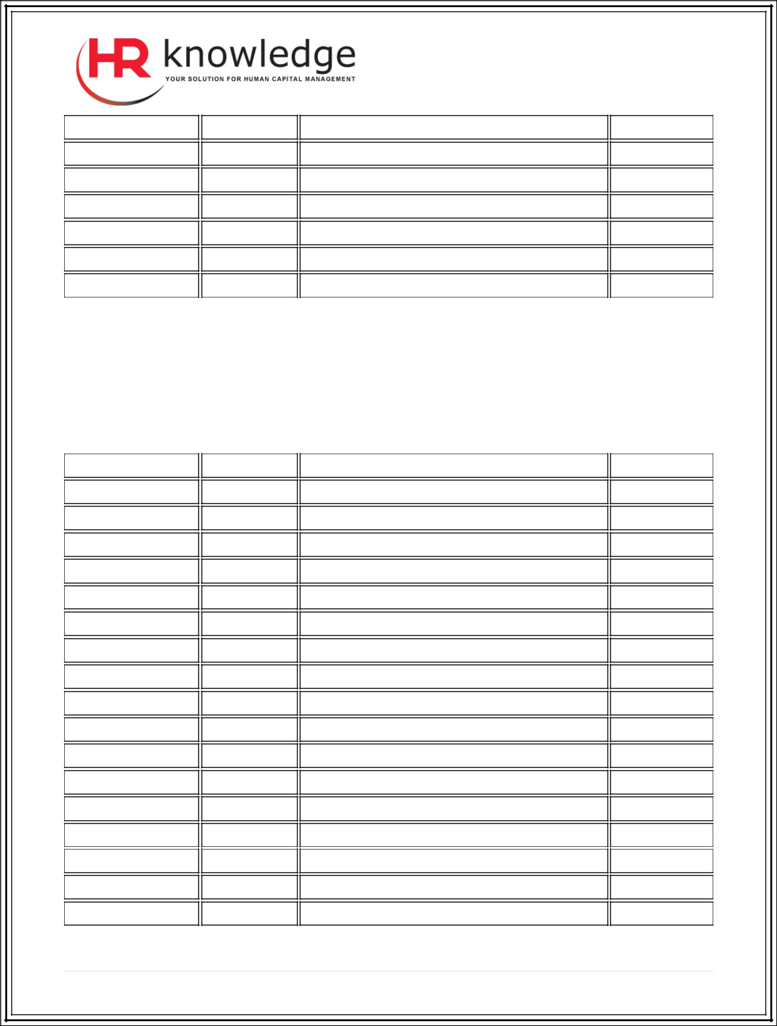

Note:
Attach a copy of your organization chart to this section of the plan.

Section 4: Vendors to be notified

Name Company Address Telephone

2 | P a g e

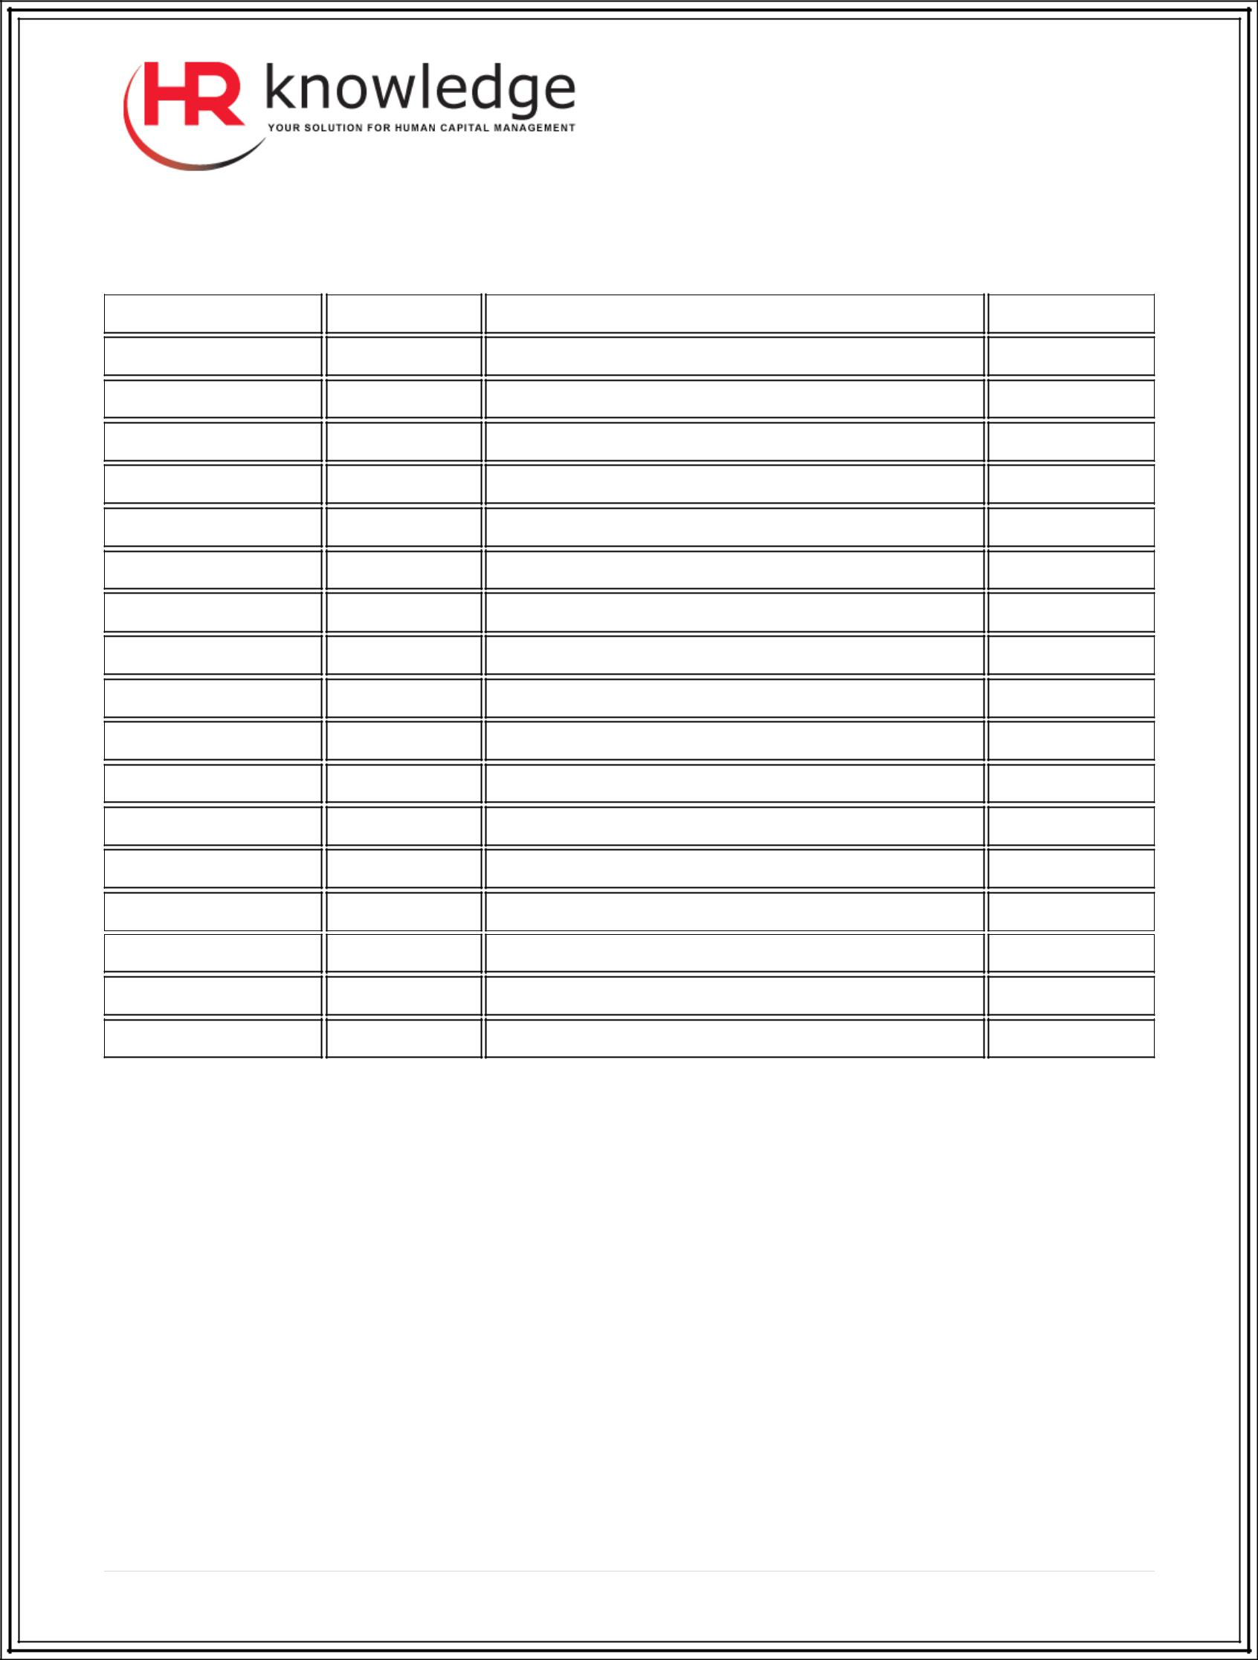

Section 5: Customers/Clients to be notified
Name | Company | Address | Telephone

Section 6: Communications plan

Identify person(s) responsible for making notifications to staff, vendors, customers, and other important parties. Determine the various means of communication with your employees, customers, and critical business constituents. Keep a list of 24-­‐hour emergency numbers for all your employees, and develop a call tree to keep employees informed.

Section 7: Information services backup procedures

- Back-­‐up files daily/weekly/monthly.
- All saved media is stored off-­‐site at ________ (location).

- It is recommended that all personal computers be backed up. Copies of the personal computer files should be uploaded to the server on ________ (date) at ________ (time), just before a complete save of the system is done. It is then saved with the normal

3 | P a g e



system save procedure. This provides for a more secure backup of personal computer-­‐ related systems where a local area disaster could wipe out important personal computer systems.

Section 8: Time table to restoration of normalcy:

Evaluate the time and duration for this arrangement and when systems will be back to normal. Keep clients/vendors informed and give them those estimates and keep them posted.

Section 9: Testing the disaster recovery plan

- In successful contingency planning, it is important to test and evaluate the plan regularly. Keep your plan current. Keep records of changes to your plan, contact lists, backup schedules and procedures.

Disaster Recovery Plan Checklist

- Plan Initiation

  - Notify senior management
  - Contact and set up disaster recovery team

  - Determine degree of disaster

  - Implement proper recovery plan dependent on extent of disaster

  - Monitor progress

  - Contact all necessary personnel

  - Contact vendors

  - Contact customers/clients

  - Set up temporary office and workspace, if needed

- Follow-­‐Up Checklist

  - List teams and tasks of each
  - Obtain emergency cash and set up transportation to and from backup site, if necessary

  - Set up living quarters, if necessary

  - List all personnel and their telephone numbers

  - Establish user participation plan

  - Set up the delivery and the receipt of mail

  - Establish emergency office supplies

  - Rent or purchase equipment, as needed

  - Determine applications to be run

4 | P a g e

- Set up primary vendors for assistance with problems incurred during emergency
- Plan for transportation of any additional items needed at backup site

- Ensure that all personnel involved know their tasks

- Notify insurance companies

5 | P a g e

